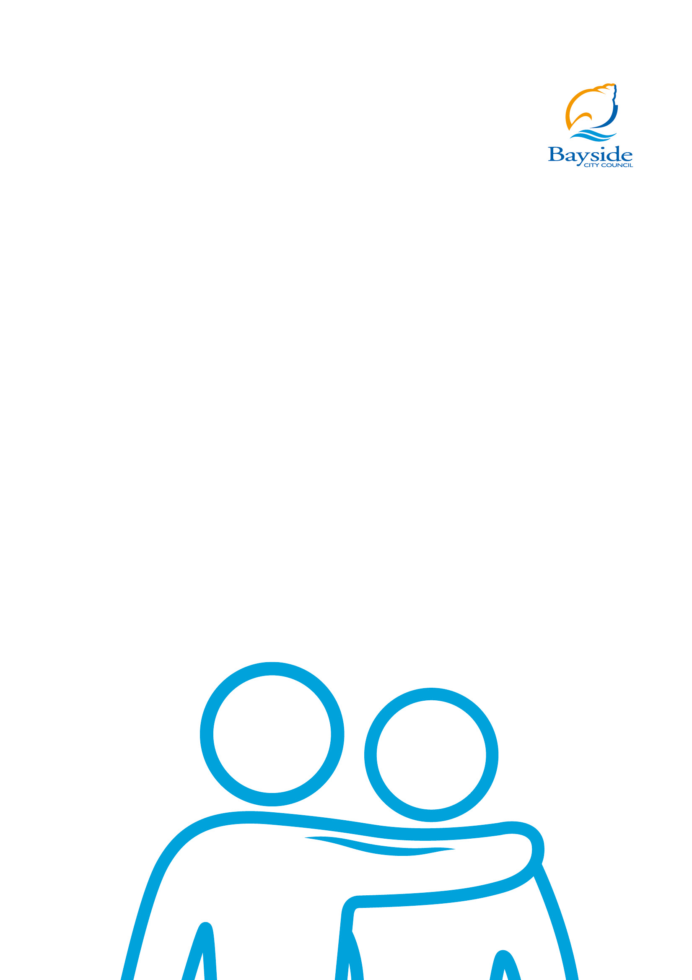

Bayside City Council

Wellbeing
for All Ages
and Abilities Strategy

2017-2021
Contents
Bayside City Council 1
Executive Summary 3
Background information 5
Integrated planning for wellbeing 5
Bayside City Council Planning Framework 6
Bayside community profile 8
How this strategy was developed 11
Government policy and legislation context 13
Underlying principles and concepts 14
Goal 1 – An engaged and supportive community 15
Goal 2 – A healthy and active community 16
Goal 3 – Safe and sustainable environments 17
Implementation, monitoring and evaluation 18

An integrated approach to maintain and improve public health and wellbeing at a local community level

Executive Summary
Bayside’s Municipal Public Health and Wellbeing Plan known as the ‘Wellbeing for All Ages and Abilities Strategy’ 2017-2021 outlines the health and wellbeing priorities for Bayside City Council over the next four years. The Strategy builds upon strengths from the previous plan and is a key strategic planning tool to maintain and improve public health and wellbeing at a local community level.
The Wellbeing for All Ages and Abilities Strategy meets the requirements of the Public Health and Wellbeing Act 2008 whilst streamlining and integrating Council’s planning across services. The Strategy has been developed aligned with the Bayside City Council Plan 2017-2021 and the Bayside Community Plan 2025 and is one of three major strategic plans aimed at improving Liveability in Bayside.
The Wellbeing for All Ages and Abilities Strategy has been developed in close consultation with the local community and through wide-ranging collaboration with key agencies, partners and stakeholders.
Implementation of the Strategy will be driven by four Action Plans which will be designed and delivered in partnership with key stakeholders. Progress against the Action Plans will be monitored, with reports made to Council and the community on the achievements.

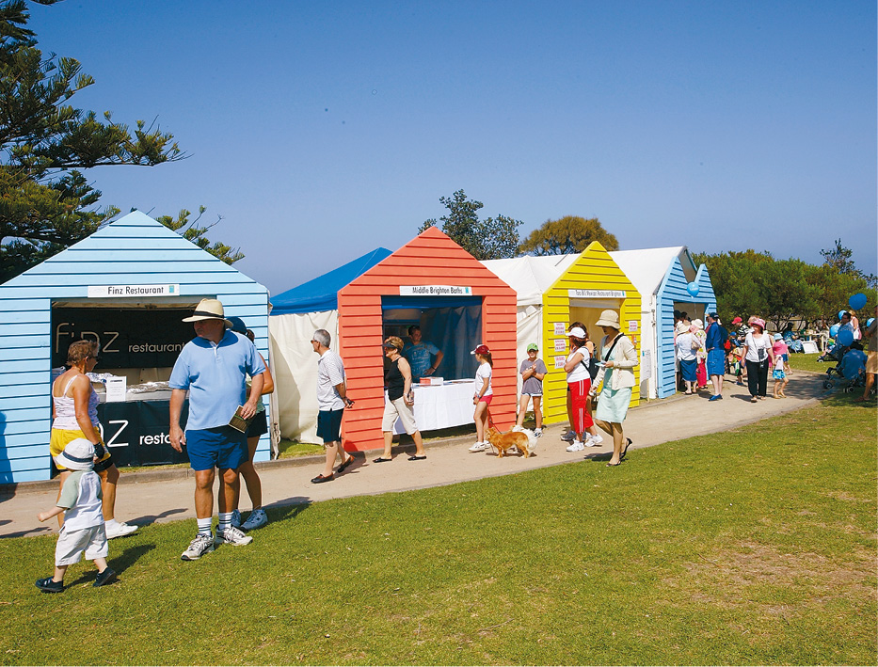

The following three goals and twelve objectives have been identified:

Goal 1 An engaged and supportive community
1.1 Improve mental health and resilience
1.2 Support opportunities that build social networks and community connections
1.3 Strengthen volunteerism
1.4 Improve access to affordable, appropriate and inclusive services

Goal 2 A healthy and active community
2.1 Increase physical activity opportunities
2.2 Increase healthy eating
2.3 Increase participation in health assessments and self-care

Goal 3 Safe and sustainable environments
3.1 Reduce family violence
3.2 Reduce consumption of alcohol and other drugs
3.3 Improve community safety
3.4 Improve environmental sustainability
3.5 Improve community resilience to extreme weather events

Background information

All Victorian councils are required under Section 26 of the Public Health and Wellbeing Act (2008) to develop a Municipal Public Health and Wellbeing Plan within twelve months of Council elections.
The Wellbeing for All Ages and Abilities Strategy is a key strategic planning tool that aims to maintain and improve public health and wellbeing at a local community level. The Strategy will be utilised by Council, local health service providers and community organisations to set policy and partnership priorities for the next four years, focusing on health issues that have the greatest impact on the community.

Integrated planning for wellbeing
Council takes an integrated planning approach to community health and wellbeing through the Wellbeing for All Ages and Abilities Strategy. The Strategy sets out goals and objectives with specific Action Plans for different population groups including: early years, youth and older people. Underpinning values such as diversity, gender equity, inclusion and disability are reflected across each action plan and address the Disability Act 2006 (refer to figure 1).
The development and delivery of each Action Plan will be the responsibility of the following areas of Council: Early Years, Youth, Aged and Disability, and Community Wellbeing. This will ensure a collaborative approach is undertaken to identify and deliver opportunities to improve health and wellbeing across population groups and service delivery areas.
Figure 1: Integrated planning for wellbeing framework

Wellbeing for All Ages and Abilities Strategy 2017-2021
- Early Years Action Plan
- Youth Action Plan
- Healthy Ageing Action Plan
- Healthy Community Action Plan
Diversity, gender equity and disability inclusion

Bayside City Council Planning Framework

The Wellbeing for All Ages and Abilities Strategy 2017-2021 sits within the Bayside Planning Framework and is one of three major strategic plans that directly aligns with the Council Plan 2017-2021 and Community Plan 2025 to improve Liveability in Bayside.
Figure 2 illustrates the relationship between Council’s Community Plan 2025, Bayside Council Plan 2017-2021, Municipal Strategic Statement, Environmental Sustainability Framework and the Wellbeing for all Ages and Abilities Strategy 2017-2021.

Figure 2: Bayside Strategic Planning Framework

Bayside Community Plan 2025 Domains of Liveability
- Open Space
- Local Economy and Activity Centres
- Environment
- Infrastructure
- Transport
- Housing and Neighbourhoods
- Community Health and Participation

Big Picture Influences
- State and Federal policy Funding, infrastructure, planning
- Demographic drivers Ageing population, new communities
- Technological advances Virtual world, online business
- Sustainable world Finding resource solutions
- Diminishing habitat Protecting land and biodiversity
- Consumer expectation Experiences and social relationships

Elected Council Priorities Council Plan 2017-2021

Major Strategic Plans

Natural
Environmental Sustainability Framework 2016-2025
Built
Municipal Strategic Statement

Social
Wellbeing for All Ages and Abilities Strategy 2017-2021
Close proximity to the beach, access to open space and a strong sense of community are key factors for living in Bayside.

Bayside community profile

The City of Bayside is located 16km south-east of Melbourne along the coastline of Port Phillip Bay. The municipality is characterised by its stunning foreshores, beautiful parks, open spaces and vibrant retail centres.
Bayside’s 97,087 residents enjoy the leafy surrounds of the municipality and have previously identified the close proximity to the beach, access to open space and a strong sense of community as key factors for living in Bayside.
Many Bayside households are family households (36.5 per cent) comprising couples with children. This is followed by couples without children (24.2 per cent) and lone person households (23.3 per cent) with this number expected to increase over the next four years with an ageing population.
Bayside is an ‘older’ community compared to metropolitan Melbourne with the average age of 44 years compared to 36 years in metropolitan Melbourne. There is also a substantially higher percentage of frail aged persons in Bayside (85 years and over) when compared to metropolitan Melbourne. However Bayside has fewer younger adults (25 to 34 years) residing in the area, as reports show those aged 25-34 tend to leave Bayside seeking more affordable housing or areas closer to work and entertainment opportunities.
Overall, the Bayside community is relatively advantaged in socio-economic terms with 35.8% of households earning $3000 or more per week. However it is recognised that Bayside has small scattered areas experiencing substantial disadvantage, which are masked by the affluence across the municipality. Almost all disadvantaged areas in Bayside are consistent with public housing estate locations, with most residents receiving a pension or benefit as their income sources.
It is anticipated that there will be an increase in the number of people with a disability over the next four years in Bayside. About 4 per cent of residents reported that they needed assistance in their day-to-day lives due to disability, long-term health condition or old age. Currently, 9,800 Bayside residents are also providing unpaid care to family members or others because of a disability or illness.

Our population
High percentage of frail aged persons: 3.6% of Bayside compared to 1.6% of Melbourne.

Wealth
35.8% of households earn more than $3,000 per week.

Bayside community characteristics are further explored in the
City of Bayside: Health and Wellbeing Profile 2017-2021.
The full profile is available via: www.bayside.vic.gov.au/health-and-wellbeing-bayside
(Source: Australian Bureau of Statistics, Census of Population and Housing 2016)

We are mostly very healthy…

Life expectancy
Male: 84 years
Female: 87 years

Youth resilience
Young people in Bayside;
- Feel safe and secure: 91% | 88% National Average
- Adult role model: 86% | 81% National Average
- Socially responsible: 93% | 88% National Average
- Keep fit: 79% | 70% National Average

Health
- Fruit: 1.7 serves per day | Victorian average 1.6
- Vegetables: 2.5 serves per day | Victorian average of 2.2
- Medical: High screening rates for breast cancer, cervical cancer and bowel cancer.
- Smoking: Low smoking rates – 15.4% of males and 10.3% of females

Active lifestyles
- Over half of people in Bayside exercise more than 4 times a week. Higher than the Victorian average

But did you know...

Wealth
- Bayside is one of the wealthiest municipalities
- A large proportion of households earn over the weekly Victorian average

Government subsidies
- 7,800+ Bayside residents use an age pension concession card
- 1,232 Public housing properties
- Just under 3,000 residents have healthcare cards

Our population
- High percentage of frail aged persons: 3.6% of Bayside compared to 1.6% of Melbourne
- High proportion of families with secondary school aged children
- High proportion of retirees and pre retirees

We know that we need to work on…

Social responsibility
Areas of concern for Bayside youth:
- Worry: 31% | 33% National Average
- Stress: 33% | 33% National Average
- Lack of purpose: 33% | 33% National Average
- Sleep deprived: 31% | 39% National Average
- Late night texting : 49% | 45% National Average
- Eating disorders: 6.6% | 2.5% Victorian Average

Active concerns
- 57.1% – Bayside males ranked number 1 for being overweight (pre obese) among local government areas in Victoria
- 42.3% Residents in Bayside considered overweight (pre obese) or obese
- 39.8% Residents in Bayside sit for at least 7 hours per day. higher than the Victorian average

Social responsibility
With an ageing population there is an increase in mobility and disability issues.

Health concerns
40.2% of Residents are at risk of short-term harm from alcohol. Victorian estimate 29.4%.

At risk
Increase in the number of reported cases of family violence.

Future issues
Diabetes, Dementia and our Ageing population.

How this strategy was developed

The Wellbeing for All Ages and Abilities Strategy 2017-2021 was developed following extensive research, analysis and consultation with the Bayside community. The process included:

July 2016

Internal working group
An internal working group was established comprising of Council staff from various areas of service delivery including: early years, youth, aged and disability, metro access, arts and culture, libraries and environmental sustainability. This ensured a collaborative approach was undertaken to identify opportunities to improve health and wellbeing through Council’s services. Members of the working group are now responsible for implementing action plans and strategies relevant to their area.
August 2016

Review of previous plan
A review of the previous Wellbeing for All Ages and Abilities Strategy was undertaken in late 2016 where recommendations were identified to inform the future direction of the Wellbeing for All Ages and Abilities Strategy.
The review highlighted the success of the Wellbeing for All Ages and Abilities framework as an integrated wellbeing approach to community health and wellbeing.
October-November 2016

Literature review
The evaluation of the 2013-2017 Strategy was followed by a comprehensive review of Council’s key policies and strategies. An in-depth review of relevant literature was conducted and an analysis of key Commonwealth, State and Local Government policies was undertaken. A review of other Council’s Public Health and Wellbeing Plans was also completed.
November 2016

Data Analysis
Comprehensive data analysis was undertaken using census data, Victorian Population Health data, VictorianHealth Indicators as well as other relevant sources to develop an updated Bayside Health and Wellbeing Profile. For a full report on the Bayside Health and Wellbeing Profile please contact Council.
November-December 2016

Survey
A door-to-door survey was conducted in November 2016 with a representative sample of 400 residents across the Bayside municipality. The survey focused on understanding local health and wellbeing priorities and behaviours. All survey data was analysed and used to inform the development of the Wellbeing for All Ages and Abilities Strategy. For a full report on the responses please contact Council.

January-March 2017

Community Consultation
532 residents from Bayside participated in a targeted consultation process between January and March 2017. A key objective was to engage targeted community members (early years, young people, those with a disability or long term illness, older adults and vulnerable people) to provide a clear direction on planning for key life stages.
A new approach to consultation was adopted which involved attending already organised Council and non-Council events, workshops and information sessions. A range of engagement tools were used during this consultation process.
The wider Bayside community were also invited to provide input into the strategic direction for health and wellbeing through online tools. A total of 163 residents completed an online survey.
June 2017

Stakeholder workshop
A Discussion Paper was developed which provided an opportunity for local health services, organisations and groups to provide input into Council’s strategic direction regarding health and wellbeing in Bayside. External stakeholders were invited to attend a workshop ‘Planning for a Healthier Bayside’ in June 2017 to help identify partnership opportunities to address health priorities over the next four years.
A total of 50 attended the workshop including representatives from local schools, senior groups, community health, early years, community centres and disability organisations. Council also worked closely with the Southern Melbourne Primary Care Partnership which consists of community health, local government, women’s health services and other state and commonwealth funded organisations responsible for promoting public health and coordinating health services outside hospitals in the region.
532 residents participated in a targeted consultation in early 2017. The process ensured a collaborative approach.
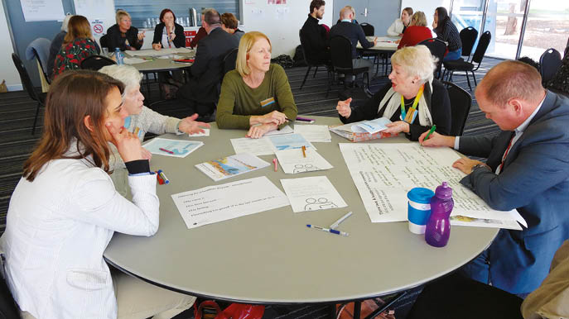

Government policy and legislation context

The issues included in the Wellbeing for all Ages and Abilities Strategy are all complex areas of public policy, with different levels of responsibility, funding and regulation by all tiers of government as well as private sector and not-for-profit community sector involvement.
Victorian government legislation places particular emphasis on the role of local government in community wellbeing. Council is required by the Local Government Act 1989, the Public Health and Wellbeing Act 2008, the Disability Act 2006 as well as by its own Council and Community Plans to advocate and plan for community wellbeing.
The Public Health and Wellbeing Act 2008 (Vic) outlines the role of Council to ‘protect, improve and promote public health and wellbeing within the municipal district’. Councils are required to develop a Municipal Public Health and Wellbeing Plan every four years. The plan must be based on evidence, involve the community in its development, and set out goals and strategies for people to achieve maximum health and wellbeing, in partnership with the Department of Health and other community agencies.
Councils are also required to consider the Climate Change Act 2017 and Recommendation 94 from the Victoria Government’s Royal Commission into Family Violence. Both of which play a key role in defining actions for the Wellbeing for All Ages and Abilities Strategy.
The Victorian Public Health and Wellbeing Plan 2015-2019 establishes a population health vision for Victoria aiming to reduce inequalities in health and wellbeing. To achieve this vision, the Victorian Public Health and Wellbeing Plan 2015-2019 identifies place-based approaches as a key platform for change to support action on a range of key priorities. This Plan supports a systems approach to prevention to tackle the underlying determinants of poor health and health inequity, and advocates a collective effort by multiple stakeholders to address the complex issues facing communities.

Protect, Improve and promote public health and wellbeing within the municipal district.
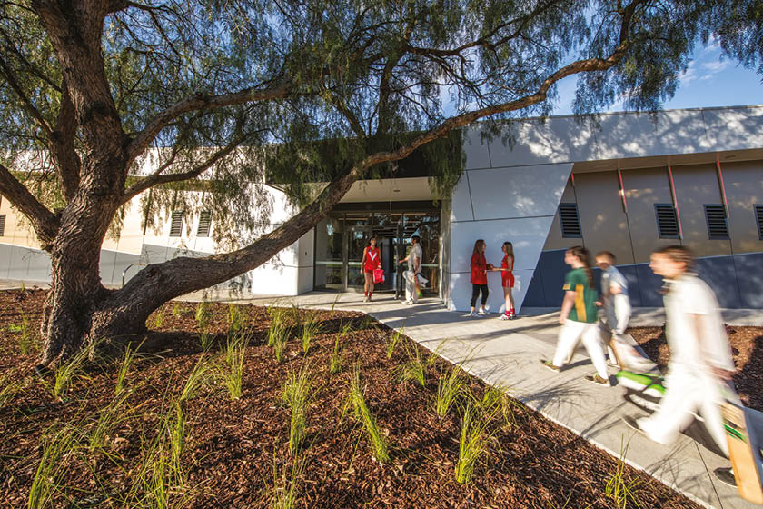

Underlying principles and concepts

Six principles underpin the goals and objectives in the Wellbeing for All Ages and Abilities Strategy and will guide implementation of the Action Plans.

1
Addressing the broader determinants of health, recognising that health is influenced by more than genetics, lifestyles and provision of health care, and that political, social, economic and environmental factors are critical.

2
Basing activities on the best available data and evidence, both with respect to why there is a need for action in a particular area and what is most likely to impact sustainable change.

3
Acting to reduce social inequities and injustice, helping to ensure every individual, family and community group may benefit from living, learning and working in Bayside.

4
Emphasising active community participation, to enable and encourage people to have a say about what influences their health and wellbeing and what would make a difference.

5
Empowering individuals and communities, through information, skill development, support and advocacy to be able to mobilise resources necessary to take control of their own lives.

6
Working in collaboration, through partnerships, to build on the capacity of a wide range of sectors to deliver quality actions; and to reduce duplication and fragmentation of effort.

(source: Integrated Health Promotion: A practice guide for service providers. State Government of Victoria 2003. Available at http://www.dhs.vic.gov.au/phkb)

Goal 1 – An engaged and supportive community

Objectives
1.1 Improve mental health and resilience
1.2 Support opportunities that build social networks and community connections
1.3 Strengthen volunteerism
1.4 Improve access to affordable, appropriate and inclusive services appropriate and inclusive services

An engaged and supportive community allows people from all ages and abilities access to services and resources that enhance their wellbeing and enable them to live full lives.
At one level it represents the degree to which individuals feel connected with their community, however more broadly it is the strength and resilience within communities that sustains positive mental health. Social connectedness and social inclusion have also been identified as key contributing factors to ensuring an engaged and healthy community.

Why is this important for Bayside?

- A key community aspiration identified in Bayside’s Community Plan 2025 is that members of the community feel connected and involved regardless of age, gender, cultural background, abilities or relative income.
- Bayside has an ageing population and it is anticipated that there will be an increase to the number of lone person households in Bayside over the next four years.
- Older residents and those with a disability or long term illness reported low scores for community connectedness and were more likely to report isolation compared to the general population.
- Mental health is a key issue for young people within Bayside. Youth Resilience Survey results show that many young people in Bayside are losing sleep through worry, do not feel good about themselves and have poor management of stress compared to the national average.
- Bayside has 1,232 public housing dwellings and 3,000 residents with healthcare cards.
- Community feedback from consultation activities in early 2017 show a need for better access to information, education and support about programs and services.
- Bayside residents expressed the importance of opportunities for social connections including intergenerational activities, programs for vulnerable population groups and young people.
- The community expressed a strong interest in taking a coordinated approach to volunteering in Bayside. Currently, there is a wide range of volunteer opportunities that connect people together and also promote activity outdoors in the natural environment.

Government subsidies
- 1,232 Public housing properties
- Just under 3,000 residents have healthcare cards

Goal 2 – A healthy and active community

Objectives
2.1 Increase physical activity opportunities
2.2 Increase healthy eating
2.3 Increase participation in health assessments and self-care

Eating well and being physically active is important to maintain and protect the longevity of good health and wellbeing.
Regular physical activity provides people of all ages and abilities substantial physical, social and mental health gains. It also reduces the risk of premature mortality and chronic diseases such as: Type 2 diabetes, heart disease, depression, osteoporosis, stroke and some cancers. Good nutrition benefits people of all ages and helps the body function at optimal efficiency and maintain a healthy weight.

Why is this important for Bayside?

- A key community aspiration identified
in Bayside’s Community Plan 2025 is that members of the community feel supported and engaged to live an active and healthy lifestyle regardless of geographic location, personal circumstance or physical ability.
- Bayside residents have high levels
‘of weekly physical activity, however sedentary activity is a concern with many residents sitting for over seven hours per day.
- The daily consumption of fruit and vegetables could be improved to ensure all residents are meeting national guidelines.
- There is room to improve breastfeeding rates with a focus on support during the antenatal and postnatal period.
- With an ageing population, there is a need to create opportunities to maintain and support independence of older people.
- There are bodyweight issues in Bayside which predominantly concern adult males.
- There is an increase in diabetes and cardiovascular cases within Bayside.
- There is strong evidence that supports contact with nature and the importance of outdoor activities.

Health
- 1.7 serves per day. Victorian average 1.6
- 2.5 serves per day. Victorian average of 2.2
- High screening rates for breast cancer, cervical cancer and bowel cancer.

Goal 3 – Safe and sustainable environments

Objectives
3.1 Reduce family violence
3.2 Reduce consumption of alcohol and other drugs
3.3 Improve community safety
3.4 Improve environmental sustainability
3.5 Improve community resilience to extreme weather events

A safe environment where people can live, work and play has a direct impact on the community’s physical, social and emotional wellbeing.
Whilst Bayside is one of the safest municipalities in Victoria, issues relating to crime, family violence, and safety in the home and in public places do occur and can have an impact on individuals, families and the broader community.
Extreme weather events relating to climate change may also impact on the safety of the community, specifically vulnerable groups such as older adults and disadvantaged residents. Health impacts of increasing temperatures may include; increases in heat stress and dehydration and changes in fresh food and production and consumption.

Why is this important for Bayside?

- A key community aspiration identified
in Bayside’s Community Plan 2025 is that both community and Council be environmental stewards, taking action
to protect and enhance the natural environment and balance appreciation and use with the need to protect natural assets for future generations.
- Perception of safety is relatively high, however women and older people
are less likely to feel safe. The general community is more likely to feel unsafe at foreshores, parks and reserves
at night.
- Family violence incident reports continue to increase in Bayside, a trend reflected across Victoria. Young people, non-English speaking households and those aged over 75 years were less likely to be aware of how to best help someone experiencing violence.
- Bayside has a higher than average proportion of persons who consume alcohol at risky levels, of particular concern is consumption of alcohol
by females.
- Climate change may affect Council infrastructure and property (i.e. community centres, libraries and sporting pavilions), which may restrict access and impact on the community’s ability to use Council assets for social and physical activities.
- With increasing temperatures predicted, trees play an important role in the provision of shade and respite in Council’s parks and streetscapes.

Health Concerns
- 40.2% of Residents are at risk of short-term harm from alcohol | Victorian estimate 29.4%

Implementation, monitoring and evaluation

Health and wellbeing is everybody’s business. The Wellbeing for All Ages and Abilities Strategy provides direction for the whole of community.
Actions will involve or be led by a wide range of stakeholders, including: health organisations; care and education providers; and community centres and volunteer groups.
Council’s role in implementing the Strategy and Action Plans will include direct programs and services, facility planning and coordination, partnerships and strengthening community capacity, and advocacy and information.

Figure 1: Integrated planning for wellbeing framework

Wellbeing for All Ages and Abilities Strategy 2017-2021
- Early Years Action Plan
- Youth Action Plan
- Healthy Ageing Action Plan
- Healthy Community Action Plan
Diversity, gender equity and disability inclusion.

Action Plans
Four Action Plans will support the implementation of the Strategy; Early Years, Youth, Healthy Ageing and Healthy Communities. Activities targeting people with disabilities will be integrated in each Action Plan. The Action Plans will outline how Council and partners will address the relevant goals and objectives of the Strategy for particular groups. Each Action Plan will include comprehensive evaluation measures. Reporting on the action plans will occur annually.

Implementation and partnerships
The Wellbeing for All Ages and Abilities Strategy and Action Plans will be implemented in partnership with networks, organisations and groups who contributed to its development and with the broader community, in line with Council’s Community Engagement Policy.

Monitoring and evaluation
The Wellbeing for All Ages and Abilities Strategy will be reviewed annually, in conjunction with Action Plans and will respond to any emerging health and wellbeing needs. A detailed evaluation will be conducted in 2021 at the end of the four-year strategy and will be used to inform the next four-year plan.
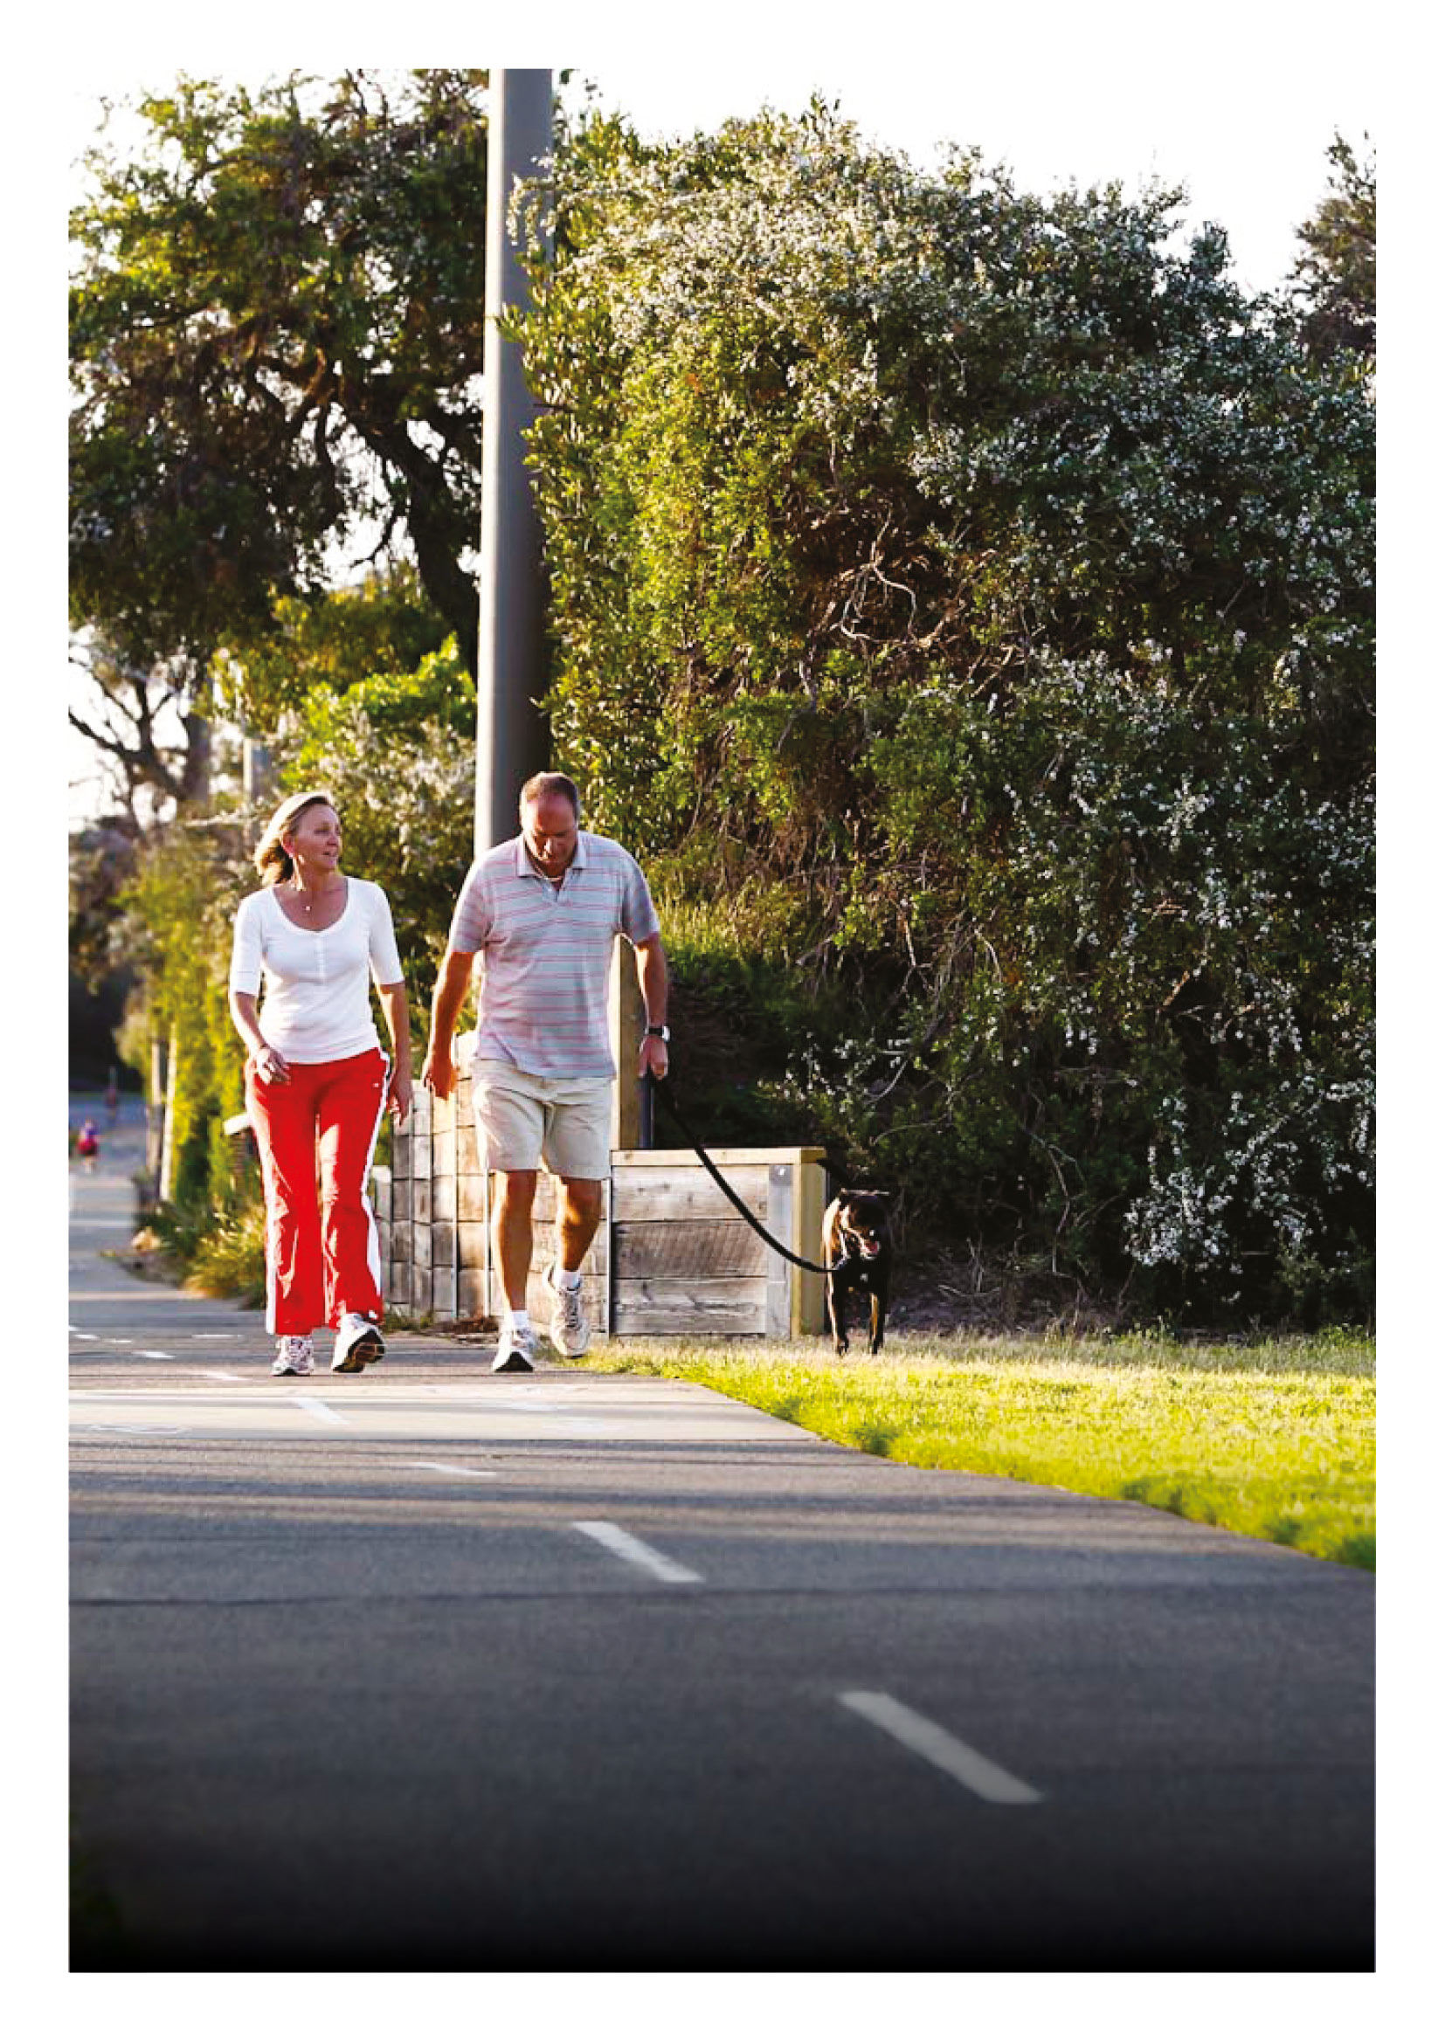
Working together, Council and the community will use this strategy to
achieve the highest standard of health
and wellbeing in Bayside.
Bayside City Council
76 Royal Avenue
Sandringham VIC 3191
Tel (03) 9599 4444
enquiries@bayside.vic.gov.au
bayside.vic.gov.au

