Council trees as Council Assets are protected under Local Law 62(2), 51(2), the Summary Offences Act 1966 s9(1)(c) and Vegetation Protection Overlays (VPOs)
PERMIT HOLDERS are responsible for breach of permit conditions resulting in damage to Council Assets

Basic information regarding Council trees
Maintenance – Requests for pruning will be undertaken by Council’s authorised tree-care contractors. https://www.bayside.vic.gov.au/request-public-tree-prune
Tree removal – For permission to remove a tree to facilitate development, see current Street and Park Tree Management Policy on the Bayside City Council website :
https://www.bayside.vic.gov.au/sites/default/files/trees_parks_and_beaches/street_and_park_tree_management_policy_2020_2.pdf

ROOT PRUNING

TREE ROOTS GREATER THAN 50mm MUST NOT BE CUT unless endorsed as a condition on a Planning Permit or authorised by Bayside’s Open Space Arborist in writing.

A penalty applies for damage to Council assets under Local Laws :
62(2) ‘a person must not destroy, damage, remove or interfere with any trees or plants on or within a municipal place; and
51(2) ‘A person must not, remove, prune or damage any street tree as a result of a vehicle crossing’s construction, installation, removal or alteration.’

Exclusion Zone has been developed to provide a guide for possible excavation adjacent to Council trees. Mechanical excavation or trenching is not permitted inside the Exclusion Zone.

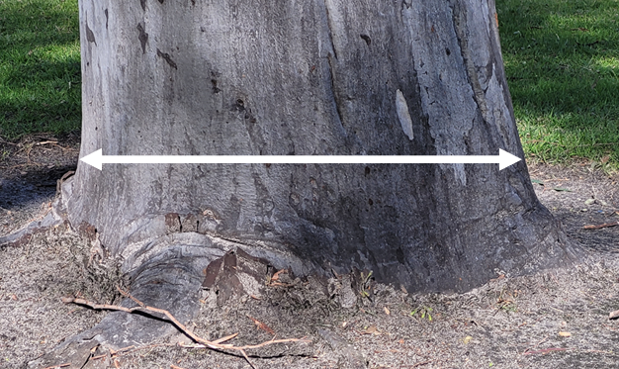 | EXCLUSION ZONE distances for different tree sizes
 | Diameter at Base of Tree  measured from base of tree | EXCLUSION ZONE  No excavation permitted
 | Up to 25 cm | 2.0 m from tree base
 | 25–50 cm | 3.0 m from tree base
 | 51 cm – 65cm | 3.5 m – 4m from tree base
 | ≤65cm | 5m from tree base

INSTALLATION OF INFRASTRUCTURE

- Utilities/Services Council’s Open Space Arborist must be contacted with a plan of the proposed works and include the address, tree location and proposed service location. Send plans to: enquiries@bayside.vic.gov.au, marked Attention: Open Space Arborist. Please allow at least 10 ten working days from date received at Council for response.
Proposed site of excavation should be identified in the plans for installation of services and vehicles crossings.
Boring must be used where there is potential conflict with large tree roots within the zone listed above.
- Vehicle Crossings (including Planning and Building permit referrals) – The location of a vehicle crossing inside a Council tree’s TPZ will be determined by non-destructive digging (hydro or air space) along the proposed line of excavation adjacent to the tree. Mature size and future growth of the tree must be taken into consideration. The Open Space Arborist will assess each application for final approval.
- Civil works undertaken by Council’s approved contractors – careful excavation must be undertaken where there is obvious conflict with tree roots. Citywide Treecare to be contacted for all required root pruning. Root pruning to be undertaken with a clean sharp saw, roots <50mm with a hand saw.

Nature Strip Planting Policy provides guidance for undertaking works on nature strips. Removal of soil around street trees should not be undertaken without prior approval by the Open Space Arborists.
https://www.bayside.vic.gov.au/sites/default/files/nature_strip_planting_guidelines_leaflet.pdf

TREE PROTECTION FENCING is required at all times during the period of the development, e.g. from demolition to completion of landscaping works - see back of this guideline for specific details.

Tree Protection Fence requirements:
The tree protection fence must :
- Securely attached on all sides to stop access by persons, vehicles or machinery to the area it encloses
- Be a minimum height of 1.5 metres
- Be Rectangular/square in shape - follow the outline of the nature strip by extend up to (but not over) the back of kerb, edge of footpath and edge of vehicle crossing OR as identified in an approved Tree Protection Management Plan (TPMP).
- The Open Space Arborist MUST approve tree protection conditions in TPMP’s concerning Council tree protection.
- Be maintained throughout the entire demolition and construction period

Tree protection fencing may be moved to enable :
- vehicle crossing construction as approved by permit.
- grass inside fenced area to be cut

No Chemical/herbicide treatment is to be undertaken for grass/weed control inside the fence.
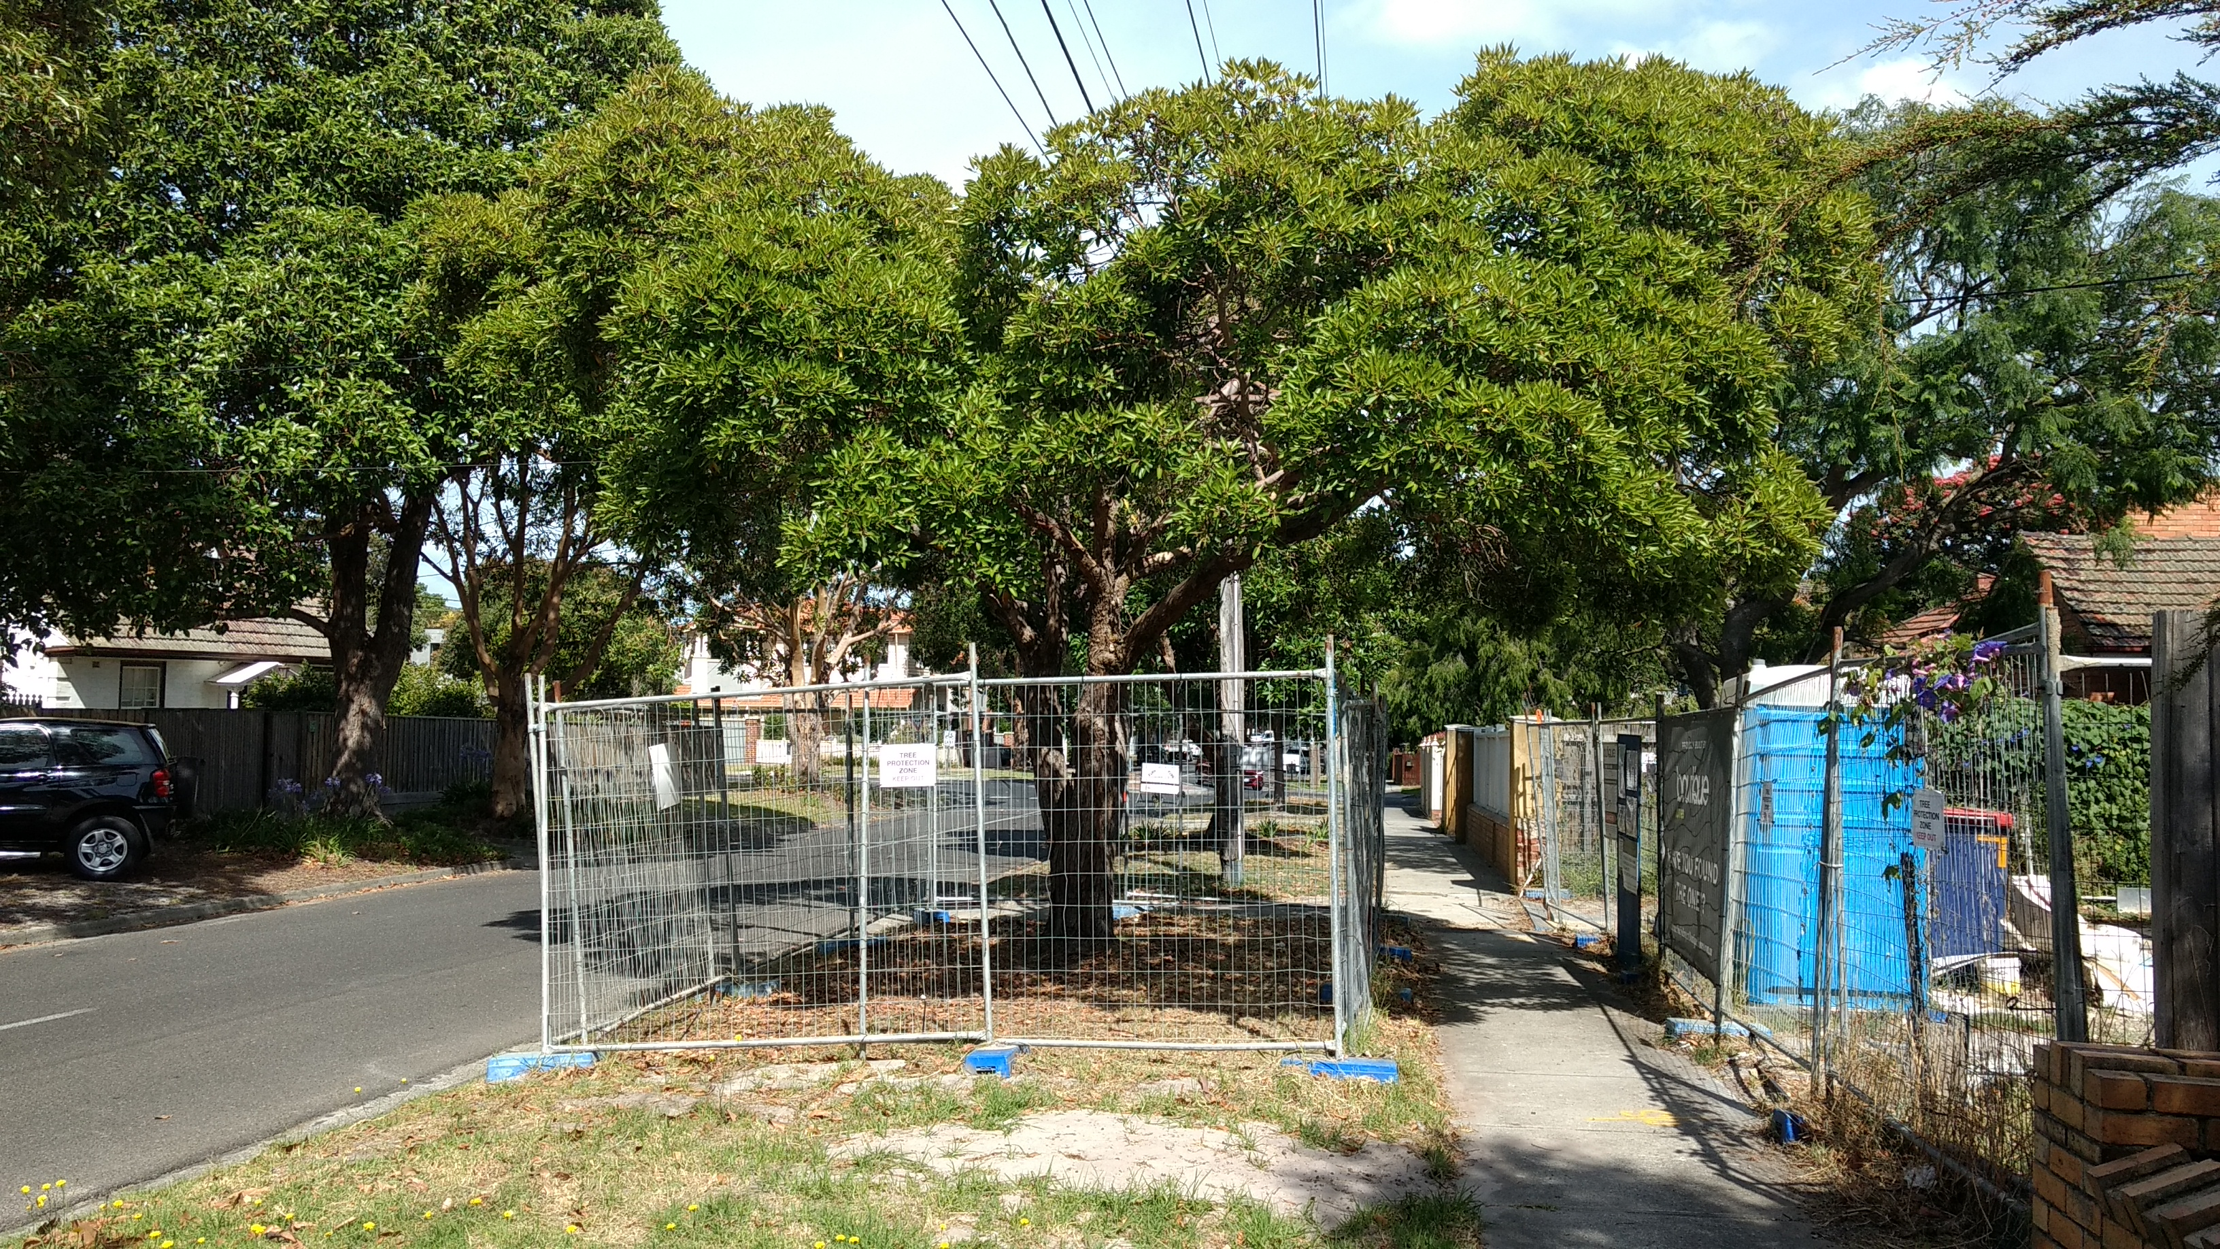 | 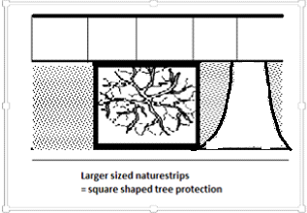  WIDE NATURESTRIP  Existing Vehicle Crossing | Design of vehicle crossing is indicative only.
Wide nature strips require square-shaped tree protection fencing
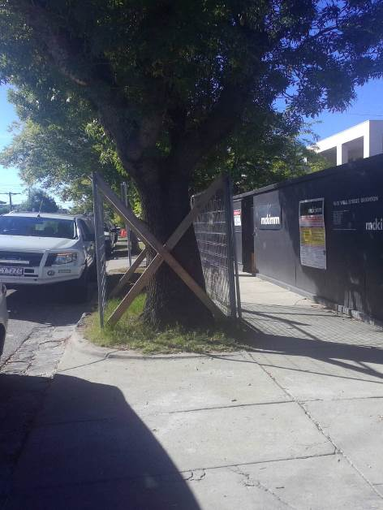 | NARROW NATURESTRIP | 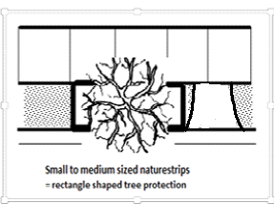  Existing Vehicle Crossing
Small to medium sized nature strips require rectangular tree protection fencing

