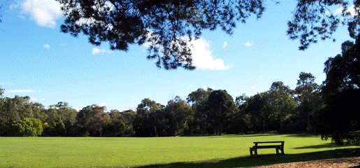

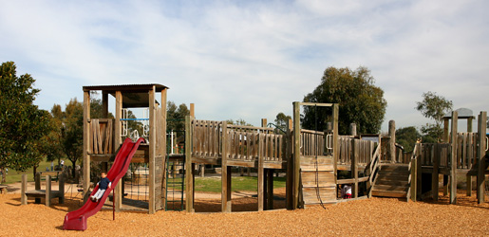

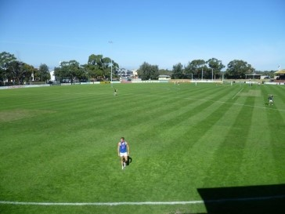

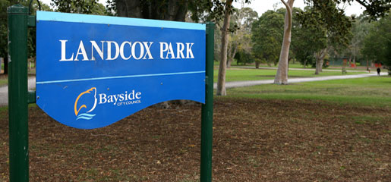



**Recreation and Open Space**

Service Driven Asset Management Plan

June 2016

Recreation & Open Space Asset Management Plan

Contents

Executive Summary 5

1.0 Introduction 9

1.1 Scope and Purpose 9

1.2 Assumptions 10

1.3 Glossary and Abbreviations 10

1.4 Key Stakeholders 11

1.5 Legislative Requirements 13

1.6 Key issues with Asset Based Recreation and Open Space Services 14

2.0 Asset Function & Levels of Service 15

2.1 Function of Recreation and Open Space Assets 15

2.2 Functional Hierarchy 16

2.3 Design Standards 17

2.3.1 Disability Discrimination Act (1992) 17

2.3.2 Playground Standard AS 4685:2014 17

2.3.3 Council Footpath Treatments Within The Road Reserve Policy 17

2.3.4 Place Design Manual 17

2.3.5 Electricity Safety (Electric Line Clearance) Regulations 2015 17

2.4 Levels of Service 18

2.4.1 Community Levels of Service 18

2.4.2 Technical LOS 20

2.4.3 Maintenance Service Levels 21

2.5 Service Level Review 22

3.0 Future Demand 23

3.1 Population & Demographic Trends 23

3.2 Identifying Future Demand Factors 25

3.2.1 Legislative Change 25

3.2.2 Technological Change 26

3.2.3 Environmental Issues/Climate Change 26

3.3 Asset Upgrade Strategies 27

3.4 Demand Management Strategies 29

4.0 Lifecycle Management Plan 30

4.1 Asset Description and Quantity 31

4.1.1 Asset Quantities 31

4.2 Asset Age and Useful Lives 33

4.2.1 Asset Useful lives 33

4.2.2 Age Profile 34

4.3 Asset Condition 35

4.3.1 Lifecycle Condition Audit 35

4.3.2 Asset Condition Rating 35

4.3.3 Asset Condition 35

4.4 Risk Identification 36

4.5 Asset Data Storage Systems 37

4.6 Operations and Maintenance 37

4.6.1 Maintenance Arrangements 37

4.6.2 Inspections 38

4.7 Renewal, Upgrade and Disposal Plan 39

4.7.1 Renewal Strategy Prioritisation Process 39

4.7.2 Renewal Strategy 39

4.7.3 New and Upgraded Asset Requirements 39

4.7.4 Asset Upgrade Strategies 40

4.7.5 Strategic Service Reviews 44

4.7.6 Asset Disposal Plan 44

4.8 Recreation and Open Space Ownership Obligations 45

4.8.1 Council Owned Recreation and Open Space 45

4.8.2 Government Recreation and Open Space Managed by Council 45

4.8.3 Commercially leased or licensed for use by a Community Group 46

4.8.4 Community Usage Agreements 46

5.0 Strategic Financial Management 46

5.1 Current Financial Position 46

5.1.1 Maintenance Expenditure 47

5.1.2 Capital Expenditure 48

5.1.3 Funding Sources 49

5.2 Renewal Forecasts – Moloney Model Results 51

6.0 Inputs to the Recreation and Open Space Financial Forecast 55

6.1 Overview 55

6.2 Service Financial Forecasts 55

6.3 Key Assumptions 56

7.0 Asset Management Improvements 57

7.1 Improvement Plan 57

8.0 Standards, Manuals, Guidelines & Reports 59

9.0 Reference Documents 59

10.0 Appendices 60

Appendix 1 – Functional Recreation and Open Space Hierarchy Criteria 60

Appendix 2 – Functional Facility Hierarchy Classification 60

Appendix 3 - Response Times - Request for Service 60

Appendix 4 - General Service Levels 60

Appendix 5 – Condition rating scale 60

Appendix 6 – Key Assumptions in Moloney Modelling Expenditure Forecasts 60

# Executive Summary

Bayside City Council own, operate and maintain recreation and open space assets with a replacement value of $98.5 million that provide a range of services to the community. Council’s 2015/16 annual expenditure on recreation and open space assets is $17 million, representing 30% of Council’s total budget.

**Purpose of the Recreation and Open Space Asset Management Plan**

The purpose of the Recreation and Open Space Asset Management Plan (R&OS-AMP) is to document a robust business case for the continued investment into recreation and open space assets owned and operated by Council and the services those assets provide to the Community. In this sense, this document is a *Service-Driven* Asset Management Plan. This document demonstrates a commitment to *liveability* (creating a great place to be) through the *delivery of* *excellent services*, which are the key result areas of the Bayside Better Place Approach and aligns with the *Planning Infrastructure and Transport* outcome of the Bayside Community Plan. Furthermore, the R-AMP demonstrates the commitment to Goal 7 of the 2013-2017 Council Plan of a *financially responsible Council*.

The R&OS-AMP informs decision making through a focus on improved asset data, the testing and validation of asset management assumptions, and the prediction of long term financial renewal requirements. It also includes the drivers for upgrading existing assets and the construction of new assets to improve the levels of service provided by Council’s infrastructure in the future. As a demonstration of Council’s long term financial sustainability, the 10-year financial requirements for the operation and maintenance, renewal and upgrading of Bayside’s existing recreation and open space infrastructure in addition to the construction of new assets are presented in this document.

**Asset Description**

The assets covered in this R&OS-AMP include land improvements and an extensive network of recreation facilities ranging from sports grounds, parks, playgrounds and foreshore reserves to street trees and landscaping. Assets include, but are not limited to:

|  |  |
| --- | --- |
| * 18 social family recreational parks, | * 66 playground and skate parks, |
| * 26 sportsgrounds, | * 19 basketball practice courts, |
| * 40 relaxations parks, | * 39 conservation and foreshore reserves, |
| * 8 formal gardens, | * 56,534 street and park trees. |

Associated assets also include access infrastructure such as pathways, stairs, boardwalks and ramps; outdoor furniture including showers, seats and drinking fountains and foreshore assets comprising seawalls, boat ramps, piers and pontoons. Footbridges, carparks and buildings within parks and reserves are not considered within the scope of this document.

**Asset Function**

According to the Open Space Strategy (OSS), Bayside City Council recreation and open spaces are grouped into the following 9 functional categories:

|  |  |
| --- | --- |
| * Social family recreational parks, | * Recreation Facilities, |
| * Sports Grounds, | * Beaches, |
| * Relaxation Parks, | * Allocated School Sports Grounds, and |
| * Formal Gardens, | * Cemeteries. |
| * Conservation Reserves, |  |

It is noted that while open spaces are classified by a particular function, they are multi-service focused. In this respect, open space assets are different from other infrastructure assets such as the road network and stormwater drainage systems which have a singular service focus.

**Operations and Maintenance**

The 2015/16 cost of Council’s recreation and open space asset maintenance program is $10.5 million and is expected to increase to $14 million over the next ten years through inflation, annual cost escalation and the additional maintenance requirements of new assets created. This assumes there is no substantial change in ownership typically by selling or change of ownership (e.g. Parks Victoria or State Government).

**Renewal Financial Demand Forecast for Current Service Level**

Renewal financial forecasting using the Moloney Model, which is based on the age and condition distribution of the asset stock, predicts a current 2015/16 renewal demand for recreation and open space assets of $1.7 million rising annually to $2.2 million in 2024/25, equating to an average annual renewal cost of $2.2 million over the next 10 years. Council is committed to meeting the renewal demand by annually updating the Long Term Financial Plan (LTFP) with current renewal forecasts. Bayside does not have a renewal gap or backlog of renewal works to address if recreation and open space assets remain in their current state.

**Drivers for Improved Levels of Service**

Asset Upgrade Strategies guide investment into improving the level of service provided by recreation and open space assets. Several drivers for improved asset-based services that influence the settings within the LTFP are listed below:

The *Bayside Open Space Strategy* sets out Council’s direction for community open space management over the next decade. The OSS is a 20 year planning document for the period 2012-2032. It provides a policy position and strategy to guide decisions about how open space is used, developed, managed and maintained across the municipality. Both the R&OS-AMP and OSS inform Council’s Long Term Financial Plan to sustain and enhance Bayside open space and provide a link between strategic planning and the practical, operational delivery and management of Council managed parks, trails and reserves.

The *Active By The Bay* recreation strategy guides the planning, management and provision of Bayside’s recreation facilities and services for the period 2013-2022. The strategy considers the demographic trends within the municipality, analysis of relevant Council and external strategy and policy documents, research into recreation trends and best practice at local, state and na**t**ional levels and extensive engagement with the community, including residents and recreation and sporting groups. The strategy identified and ranked a range of infrastructure works and includes the renewal and upgrades to cricket nets, floodlighting and sportsground surfaces.

The *Playground Improvement Plan* sets out Council’s approach to the renewal and upgrade of its 66 playgrounds. While acknowledging that children play in a range of open space environments (including local parks, the beach, or beside a lake) the report focuses on built playgrounds. It develops a number of policy statements to assist Council in making decisions about future provision.

The *Coastal Management Plan* provides strategic direction and policy on coastal use, management and development for the foreshore area. The strategy provides a long term strategic vision for Bayside’s foreshore to Port Phillip Bay and formalises the 11 foreshore precinct areas features and opportunities. A detailed action plan will be prepared for each of the 11 foreshore precincts. Several plans have already been prepared, and a number are being prepared for completion in 2016.

Another planned Asset Upgrade Strategy to be included in a future revision of this document will be the Tennis Strategy, including a regional tennis centre feasibility study.

To ensure its services demonstrate best value to the Bayside community, Council commenced a rolling program of Strategic Service Reviews (SSRs) in 2014 and currently aims to complete four SSRs per annum. The six SSRs completed to date include:

* Home and Community Aged Care
* Statutory Planning
* Arts and Culture
* Youth Services
* Maternal and Child Health.

**Improvement Plan**

This R&OS-AMP includes an improvement plan (Section 7) with actions to address limitations in the scope of this AMP and drive improvements in asset management processes to ensure future versions of this document continue to support Council’s commitment to long term financial responsibility and the provision of affordable long term recreation and open space infrastructure-based services that meet the needs of the Bayside community. Improvement actions list include:

* Continue to develop and cross reference Asset Upgrade Strategies, Place-based Strategies and undertake Strategic Service Reviews that document the future service needs for recreation and open space infrastructure.
* Continue to clarify and review maintenance and renewal arrangements for lease and tenancy agreements and assess their impact on financial forecasts produced by Moloney Modelling and documented in this R&OS-AMP.
* Integration of Capital Valuation Record (CVR), Strategic Asset Management (SAM) and Geographic Information System (GIS). Align CVR with Authority and Moloney modelling.
* Undertake an assessment of structural assets and review lifecycle renewal implications.
* Identify assets not addressed within the scope of this R&OS-AMP based on a criticality assessment.
* Determine a program and propose a renewal allocation in the Capital Works Program for trees.

# 1.0 Introduction

## 1.1 Scope and Purpose

The purpose of the Recreation and Open Space Asset Management Plan (R&OS-AMP) is to document a robust business case for the continued investment into asset based recreation and open space services to the Bayside community. In this sense, this document is a *Service-Driven* Asset Management Plan.

This document is used to inform decision making about Council’s existing recreation and open space stock through a focus on improved asset data, the testing and validation of asset management assumptions and the prediction of long term financial renewal requirements. The R&OS-AMP also includes the drivers for upgrading the capacity or performance of existing recreation and open space and the construction of new assets to improve the levels of service provided by recreation and open space infrastructure in the future. As a demonstration of Council’s long term financial sustainability, the 10-year financial requirements for the operation and maintenance, renewal and upgrading of Bayside’s existing recreation and open space assets in addition to the construction of new assets are presented in this document.

Recreation and Open Spaces are a high priority for Bayside City Council. The Council Plan states, “We will improve the quality of our natural environment and open spaces to meet the challenges of climate change”. The Bayside 2020 Community Plan also makes a commitment to deliver recreation and leisure facilities to meet the needs of the community and to encourage healthy living through the use of Bayside‘s green spaces. The Bayside Municipal Strategic Statement includes a commitment to “provide open space and recreational opportunities of the community”, on the basis that, “the protection and enhancement of open space is key to the economic and environmental viability of the municipality”.

Recreation and open space assets owned by Bayside City Council comprise land improvements and infrastructure provided to the community for a range of uses and services. While recreational and open space assets include parklands, reserves, sportsgrounds and the foreshore, assets such as buildings, footbridges and carparks located within these areas are not included in the scope of this document and are otherwise considered in the respective Buildings and Roads Asset Management Plans.

Bayside City Council provides and is responsible for maintaining an extensive network of recreation and open space facilities that range from sports grounds, parks, playgrounds and foreshore reserves to street trees and street landscaping. The replacement value of the recreation and open space assets is $98.5 million. A breakdown of the number and value of open space assets by category is shown Table 4 in Section 4.1.1.

The R&OS–AMP covers the proposed levels of service, future demand, routine maintenance, renewal/replacement, acquisition/creation and decommissioning of Council’s recreation and open space facilities and infrastructure. It also outlines the financial requirements and the key assumptions made in financial forecasts. It is also a means of outlining the key elements involved in managing the recreation and open space asset stock. The R&OS-AMP combines management, financial, engineering and technical practices to ensure that the level of service required by the beneficiaries of the service is provided at the lowest long term cost to the community within the limits of any fiscal constraints that may be imposed by Council.

The key purpose of this R&OS-AMP are:

1. Identify the required asset management regime and forecast financial requirements for the current asset stock for the next 10 years.
2. Identify the likely growth or change in asset-based services identified by strategic service planning and predict the financial impact in capital works and operations / maintenance budgets of these changes over the next 10 years.
3. Identify improvement actions required to address limitations in the scope of the R&OS-AMP and drive improvements in the asset management process.

This revision of the R&OS-AMP is based on the best available information and represents the second generation of documenting Council’s sustainable management of service provided by recreation and open space assets to the Bayside community.

## 1.2 Assumptions

In developing this R&OS-AMP, several assumptions have been made including:

* Asset registers are accurate and complete
* Useful lives and predictive modelling (e.g. Moloney Model) are correct, however as further inventory and condition data for assets is collected it will be used to refine the model
* Current levels of service reflect the current community needs, unless an asset upgrade strategy has been adopted
* No known legislative changes or other influences that will impact on, or demand a change in level of service and associated funding throughout the period of the plan
* Operation and maintenance budgets in the 10 year financial plan allow for price escalation in subsequent years

## 1.3 Glossary and Abbreviations

CRC Current Replacement Costs

LCC Lifecycle Cost

OSS Open Space Strategy

R&OS–AMP Recreation and Open Space Asset Management Plan

SSR Strategic Service Review

UL Useful Life

WDV Written Down Value

## 1.4 Key Stakeholders

Assets controlled by Council are utilised by a broad cross-section of the community. It is therefore critical that assets are maintained based on need and are fit for purpose. The best person to judge whether an asset is fit for purpose is likely to be the user of the asset, hence asset users are key stakeholders of this R&OS-AMP.

Stakeholders identified in Table 1 of this Plan are the stakeholders that are likely to be consulted when Council seeks input in relation to determination of Levels of Service and intervention levels.

**Table 1: Key Stakeholders**

|  |  |
| --- | --- |
| Internal Stakeholders | |
| Stakeholder Group | Role or Involvement |
| Council | Custodian of the asset, with Councillors representing the residents and setting strategic direction as per the Council and Operational Plans. |
| Executive Team | To ensure that Asset Management policy and strategy is being implemented as adopted, and to ensure that long-term financial needs to sustain the assets for the services they deliver are advised to Council for its strategic and financial planning processes. |
| Manager Infrastructure Assets | Provides advice to the Service Area Managers such as Manager ESOS and Manager Recreation, Events and Social Development (asset custodians), to ensure asset management functions undertaken by these departments aligns with Council’s Service-Driven Asset Management strategy and is consistent with corporate asset management process. |
| Manager City Works | To ensure provision of the required/agreed level of maintenance services and renewal for asset components and delivery of upgrade and new capital works. |
| Service-driven Asset Management COG | To embed best practice in service-driven Asset Management across the organisation and to ensure Asset Management planning meets requirements that optimise useful asset life and service provision. |
| Manager Corporate Finance | To ensure that adequate financial information is provided to Council and to the relevant asset managers to facilitate sound management of the assets |
| Manager Information Services | To ensure that the relevant IT systems are functioning and that any data within the systems is secure and its integrity is not compromised. |
| Service Area Managers | Service managers are responsible for understanding expectations of levels of service through effective, ongoing engagement with the community (users of the service). Planning for changes to operations and maintenance, renewal and upgrade of existing recreation and open space assets depending on the outcomes of the community engagement and research on service level provisions. Service Area Managers are the Manager Recreation, Events and Social Development, and the Manager Environmental Sustainability and Open Space. |
| Manager Commercial Services | To ensure that risk management practices are conducted as per Council policy and assist operations managers with advice on risk issues. |
| Internal auditors | To ensure that appropriate policy practices are carried out and to advise and assist on improvements |

|  |  |
| --- | --- |
| External Stakeholders | |
| Stakeholder Group | Role or Involvement |
| Community | General users/beneficiaries of the service provided by the recreation and open space assets, including residents, tourists and visitors to the area. |
| Maintenance contractors (external) | To ensure provision of the required/agreed level of maintenance services for assets; |
| Utility Service Providers | Agencies that provide utility services such as electricity, gas, water, sewerage, telecommunications, necessary to facilitate recreation and open space services. |
| State and Federal Government Departments | Periodic provision of advice, instruction and support funding to assist with management of the drainage network. |
| Council’s Insurer. | Insurance and risk management issues. |

## 1.5 Legislative Requirements

The legislation relevant to the provision of services within Council’s recreation and open space assets is listed in Table 2 below. This list is not exhaustive, but includes the key overarching Acts and Codes.

**Table 2: Legislation Relevant to Management of Recreation and Open Space Assets.**

|  |  |
| --- | --- |
| **Recreation and Open Space Assets Legislation** | **Requirement** |
| Local Government Act 1989 | Sets out role, purpose, responsibilities and powers of local governments including the preparation of a long term financial plan supported by asset management plans for sustainable service delivery. |
| Public Health Act & Well Being Act 2008 | The purpose of this Act is to enact a new legislative scheme which promotes and protects public health and wellbeing in Victoria. |
| Building Act 1993 & Building Regulations 2006 | The Act sets out the legal framework for the regulation of construction of recreation and open spaces and other structures, recreation and open space standards and maintenance of specific recreation and open space safety features in Victoria.  The Regulations are derived from the Act and contain, amongst other things, the requirements relating to recreation and open space permits and recreation and open space inspections.  The Regulations call up the Building Code of Australia (BCA) as a technical reference that must be complied with. |
| Heritage Act 1995 | Provides for the protection and conservation of places and objects of cultural heritage significance and the registration of such places and objects. |
| Planning and Environment Act 1987 | The purpose of this Act is to establish a framework for planning the use, development and protection of land in Victoria in the present and long-term interests of all Victorians. |
| Council Planning Scheme | Planning matters as they relate to the siting and use of open space |
| Building Code of Australia (BCA) | Is a uniform set of technical provisions for the design and construction of buildings and other structures. |
| All other relevant Australian Standards | AS/NZ Standards such as Risk Management Standard. |
| Occupational Health and Safety Regulations | Includes Asbestos 2003; Manual Handling 1999; Noise 2004; Prevention of Falls 2003; and Lead 2000. |
| All other relevant State and federal Acts and Regulations | Where applicable, including Disability Discrimination Act (1992) |
| All Local Laws and relevant policies of the Organisation | Construction standards, Maintenance contracts, etc. |

## 1.6 Key issues with Asset Based Recreation and Open Space Services

Issues with asset based recreation and open space services are discussed in detail in Section 3. Several of the key issues are as follows:

* **Foreshore management**: There is conflict between the provision of foreshore access consistent with Council standards (i.e. sealing car parks, providing stairway access to beaches) and satisfying the expectations of local stakeholders who are concerned about aesthetic and environmental issues. Some of the key foreshore management issues are:
  + The impact of climate change on the foreshore, specifically impact of increased frequency and intensity of storms on sea walls, revetment wall and the erosion of cliff faces.
  + Increasing number of stakeholders using assets around the foreshore area. This may have an impact on the life of the asset and maintenance requirements (i.e. passive turf).
  + Issues of access to the foreshore areas (compliance of existing facilities such as stairways which provide access to the foreshore areas).
* **Multi-use of facilities:** Conflicts with users of facilities continues to be an issue. One specific example is dog owners who may allow dogs to roam off leash on facilities while programmed sports activities are taking place. Since the 2013 AMP, Council has attempted to understand who / which user groups are using open spaces to manage this use. The Bayside Community Summit (2012) greatly assisted Council’s understanding in this matter.  Personal trainers are one user group who are now better managed through Council policy and procedures. Dog owners continue to be a challenge.
* **Financial Constraints:** a period of budgetary austerity due to rate capping will limit Council’s capacity to provide resources to support new and upgraded facilities.
* **Maintenance / renewal obligations of leaseholders**. Clarifying these obligations is an ongoing challenge. The lack of clarity around obligations limits Council’s ability to identify and program works and seek grant funding. Council is addressing this challenge though development of the Strategic Service Reviews; for example the Tennis Strategy which is considered to be a test case for clarification of the maintenance / renewal obligations with leaseholders.
* **Legislative changes**: Council is operating in an environment of ever more demanding regulatory requirements. Some examples are:
  + DDA compliance: As a Council with a significant aging population compliance with DDA is an ongoing challenge. As mentioned DDA has presented a challenge in Council’s management of foreshore areas, specifically access to the beach. DDA consideration were central to the development of the Dendy and Hurlingham Park Master Plans. One key issue is connectivity between the facility and the car park, and also ensuring car parks themselves are DDA compliant.
  + Tree Management: There has been continual tightening of requirements for pruning trees around power lines (Offset distance between tree and live wire continually reduced). Electricity Safety (Electric Line Clearance) Regulations (2015)
* **Community risk tolerance:** Aligned with heightening legislative requirements are social changes with respect to risk tolerance and an increased public tendency to litigation present a challenge for Council. There is a requirement for increased frequency of Investigations to identify hazards. For example tree root inspection frequency has been increased from once in three years to once every two years.
* **Climate Change**: Climate change raises some specific issues for Council’s recreation and open space assets. The potential impacts of rainfall, wind and lightning events as well as increased temperature and solar radiation may damage and reduce the life of assets. One key climate challenge is the prolonged dry periods which can reduce asset life and condition. Council has prepared strategies for managing assets in dry conditions, for example, seeking alternative water sources such as stormwater harvesting.
* **Service Needs**: the long term service needs for sport and recreation need to be determined as a basis for improved asset planning and accurate future budget forecasts.

# 2.0 Asset Function & Levels of Service

## 2.1 Function of Recreation and Open Space Assets

Council owned recreation and open space assets represent a significant investment into a range of services that contribute to the liveability, health and wellbeing of the community.

According to the OSS, recreation and open space assets are categorized into nine functional classes. These are as follows:

* Social family recreational parks,
* Sports Grounds,
* Relaxation Parks,
* Formal Gardens,
* Conservation Reserves,
* Recreation Facilities,
* Beaches,
* Allocated School Sports Grounds, and
* Cemeteries.

## 2.2 Functional Hierarchy

The various categories of recreation and open space assets provide different services to the community. Unlike other infrastructure asset groups such as the road network and stormwater drainage system, which have a singular service focus, recreation and open space assets are multi service focused.

Each functional classification will have specific functional levels of service. Levels of service may vary from one subcategory to the next and also within a sub-category, depending on the priority given. In addition to the general levels of service, specific levels of service may be identified within Asset Upgrade Strategies for the various categories of recreation and open space assets.

The recreation and open space assets are also considered in terms of the functional hierarchy provided in Appendix 1 and Appendix 2. This hierarchy is a matrix of categories and criteria used to determine the strategic importance of the asset. The horizontal axis of the matrix includes the following four criteria:

1. Predominant Activity: The main service or purpose that a facility provides
2. Historical Significance: Heritage value as defined by national, state and local heritage registers.
3. Social/Cultural Value or Economic Benefit: The importance the community places on having the facility, or the level of economic benefit the facility either provides directly or indirectly by assisting in service delivery
4. Network: The facility forms part of a network of similar facilities across a given area i.e. the impact the facility has on the network if it is removed from service.

The vertical axis of the matrix includes the following classifications:

1. National/State Significance. Generally only one facility of this nature would exist in the state.
2. Regional Significance: i.e. a large proportion of users come from outside of the district.
3. District Significance: Used mainly by people living in and from adjacent municipal districts.
4. Local Area Significance: Used mainly by people living within a suburb, town, ward or local area.
5. Neighbourhood Significance: Mainly used by people within a block or two of where they live.

A service review is required to determine the extent to which the hierarchy influences expenditure on recreation and open space assets.

## 2.3 Design Standards

Each recreation and open space asset under Council’s control has complied with various design and construction standards relevant at the time of creation. However, Council faces the need to comply with new and changing standards over time.

### 2.3.1 Disability Discrimination Act (1992)

The Disability Discrimination Act (DDA, 1992) makes it a legal requirement for public places to be accessible for people with a disability. DDA compliance is a key consideration in the design and construction of any new or upgraded recreation and open space asset.

### 2.3.2 Playground Standard AS 4685:2014

Playgrounds must be designed and constructed in alignment with all relevant Australian Standards, such as AS 4685:2014.

### 2.3.3 Council Footpath Treatments Within The Road Reserve Policy

Footpaths within the road reserve that provide access to parks and reserves will be constructed in accordance with Council’s Footpath Treatments Within The Road Reserve Policy. Footpaths and trails in parks and reserves are commonly constructed of a variety of materials and maintenance reflects a range of service levels.

Within Victoria, the Equal Opportunity Act 2010 (the Act) applies to Council’s construction of new footpaths. The intent of this Act is to ensure that a person with a disability has a right to access and use public places in the same way that a person without a disability does. Places used by the public as defined within the Act include public footpaths. A person with a disability can make a complaint of discrimination if a place used by the public is not accessible to them.

### 2.3.4 Place Design Manual

Council standards for open space design are in accordance with Council’s place design manual[1].

### 2.3.5 Electricity Safety (Electric Line Clearance) Regulations 2015

Legislation concerning overhead electrical lines has become more stringent in recent years. The Electricity Safety (Electric Line Clearance) Regulations 2015 represents considerable consultation between Council’s, MAV, distribution retailers and Energy Safe Victoria. As one of the main infrastructure components in the road reserve, tree legislation has been reviewed to allow effective asset management without compromising the safety of line workers or the community.

## 2.4 Levels of Service

Council has determined the standard to which it will design, construct, inspect, maintain and repair recreation and open space assets. In developing these levels of service, Council has considered community expectations, current levels of service, the level of risk imposed and available resources.

A key objective of asset management planning is to align the level of service with the community’s expectations. The relationship with the cost of the service is evaluated to determine the optimum level of service the community is prepared to pay for. Current levels of service for maintenance are assumed to reflect the balance between customer expectations and financial affordability.

The target levels of service for the recreation and open space assets aim to reflect industry standards and are based on stakeholder consultation, Council Plan goals and priorities, the Long Term Financial Plan (LTFP), the 4-year Capital Works Program and legislative requirements.

General levels of service for recreation and open space assets are provided in Appendix 4. These will address most of the concerns raised in the above consultations. Detailed levels of service are required to be developed for each recreation and open space category in future revisions. Appendix 2 gives levels of service, the current performance and then the desired performance.

### 2.4.1 Community Levels of Service

Community Levels of Service relate to the community’s expectation and perception of the performance / quality of a service that is delivered by Council. It may include things such as function, style, performance, level of cleanliness, maintenance responsiveness, quality and type of consumables, safety and accessibility.

In assessing the value that a Council asset provides the community the following questions are considered relevant:

* Is the service delivery provided by the asset meeting Council’s service objectives and the needs and expectations of the community?
* Is the facility accessible, in the right location with a viable catchment area?
* Is the design of the asset appropriate, does it need upgrading?
* Could the asset be closed or relocated or provided elsewhere?
* How does the performance of the asset compare with industry benchmarks?
* Is future capital renewal or upgrade of the asset justified?

In order to address these issues, a Facility Benefit Model has been developed that assesses the value of the asset against agreed community benefit performance indicators that are based on asset management, community service, financial utilisation and environmental performance, which involve:

1. Meeting community needs and service objectives
2. Financial (operating and life-cycle costs, commercial potential, rate of return)
3. Design and functionality
4. Utilisation (compared with max capacity)
5. Future demand – ability to cope with growth and demographic changes

(Note: Each performance criterion is weighting based on its strategic importance.)

In the development of Asset Upgrade Strategies and Strategic Service Reviews (a summary is proved in Table 3 on P24) there is typically stakeholder consultation conducted during the data collection phase, and later with a draft strategy document and/or action plan. This process also applies to Council’s Community Plans – for the Bayside 2020 community plan, over 1140 people participated in the community planning process. Council is currently consulting with the community and stakeholder for the new 2025 Community Plan.

Each year, stakeholders have the opportunity to comment on the annual report and the draft budget including allocation for capital works and asset maintenance. The ongoing program of Strategic Service Reviews also considers feedback from service users regarding the programs, services and assets used to deliver the service.

Each year, Local Government Victoria co-ordinates the Local Government Community Satisfaction Survey for Victorian Local Government areas. The objective of the survey is to gauge the importance of Council services as assessed by the general community, and the performance of individual Council’s across a range of service areas. The survey is conducted in February-March of each year and the results are published in May. Relevant measures from this survey include the community’s views about:

* Family support services
* Elderly support services
* Recreational facilities
* Arts centres and libraries.

Figure 1 shows the City’s resident satisfaction rating as reported in the Annual Resident Satisfaction Survey. The two aspects relevant to parks and open space management are:

* Recreational facilities which includes sporting facilities, swimming pools, sports fields and playgrounds.
* Appearance of public areas which includes local parks and gardens as well as street cleaning and litter collection.

Further stakeholder consultation will occur during Strategic Service planning.

Figure 1: Resident satisfaction survey results, Bayside Annual Resident Satisfaction Survey

As indicated in Figure 1, since 2012 Bayside has performed strongly against the state average in both the performance of recreation facilities and the appearance of public areas. In both categories customers were most satisfied in 2014, and there has been a slight reduction in the following years. Those with lower satisfaction ratings tend to be men and those aged between 35 and 64.

Stakeholder expectations relating to recreation and open space assets may vary depending on the location, nature and use of the particular asset group. Each Strategic Service Management Plan will identify particular stakeholder expectations and adopt specific Levels of Service for that asset group.

### 2.4.2 Technical LOS

Technical Levels of Service include the parameters to assess the required function covering technical aspects including function, design, applicable standards and any statutory requirements. The Technical Service Standards are aligned with:

|  |  |
| --- | --- |
| * Quality * Aesthetics * Quantity * Reliability * Safety | * Responsiveness * Capacity * Environmental acceptability * Fitness for purpose * Costs |

The Technical Service Standards describe the usage, renewal, maintenance and operational criteria under the categories of function, design and presentation/amenity for the various recreation and open space assets.

As part of the development of Asset Upgrade Strategies, an assessment will be undertaken to identify deficiencies in service levels and/or non-compliance with generally accepted standards.

The intention is that recreation and open space assets not currently meeting the target specification or level of service standards will be upgraded or reconstructed to the target level where practicable (when the program allocates funding against that need or other development occurs within the network) or when dictated by legislation.

Where there are specific needs/funding opportunities, the Council may deem it important to exceed the standard specifications to improve such things as functionality, safety, accessibility, providing that funding can be sourced for that change.

Apart from those asset categories where Council has adopted an upgrade strategy it is reasonable to conclude that the condition of the recreation and open space asset stock and current levels of service are aligned and consistent with community needs. It is also reasonable to conclude that in the absence of a demonstration of demand from the broader community for new and upgraded recreational and open space facilities, that the current and desired levels of service are also relatively closely aligned. However, the absence of Asset Upgrade Strategies for all Council’s services represents an ‘unknown’ with regard to condition, levels of service and the meeting of community needs without the required data and evidence to support these assumptions.

It is noted that community need has different spatial notions – state, region, municipal and local neighbourhood (suburb). Ideally, Council needs to develop neighbourhood or place-based strategies that articulate ‘community need’ at the neighbourhood/suburb level to ensure the use of the asset stock is opportunistic and integrated where services are consolidated, multi-use occurs, cost savings are maximised and usage is optimised. Such place-based strategies are required to be cross referenced with Asset Upgrade Strategies when available (refer Improvement Plan).

### 2.4.3 Maintenance Service Levels

Council provides open space asset maintenance externally, through an open space maintenance contract. These contracts set out the technical levels of service to be provided. The current contract period expires in 2019. The contract specifies levels of service to be provided.

The service objectives in the specification of the maintenance Contracts include:

* provide safe, effective and affordable assets within the municipality;
* prolong the life of Council’s assets;
* develop an effective partnering relationship with the Contractor;
* minimise the risk to public safety;
* minimise Council exposure to public liability or service failure through the effective management of services and assets;
* ensure ratepayers and service users are well satisfied with these aspects of Council’s service delivery;
* maintain and enhance the aesthetic value of the municipality; and
* allowing for technological and other service improvement over the Contract Period.

The recreation and open space maintenance services contract specifies performance criteria with respect to maintenance requests. Appendix 1 shows response times for recreation and open spaces categories as specified in the Contract. It should be noted that in instances where requests relate to periodic maintenance, future renewal or upgrade works, these works requested may be delayed and prioritised for inclusion in annual works program or for consideration at budget time.

It is also stated in the maintenance contract that the performance targets for compliance to the above response times for service requests is to be 90% and testing of this is required on a regular basis.

## 2.5 Service Level Review

The objective of the service level review process is to gain a better understanding of the needs expectations and perceptions of existing and future users of the service. This allows the definition of meaningful levels of service and performance measures.

The review process needs to be repeated on a regular cycle to ensure that knowledge of community needs and expectations remains current in the light of changing environmental, financial, political, social and technical factors. Changing customer needs and expectations, as determined by the review, are part of the continuous R&OS-AMP improvement cycle.

In 2014, Bayside Council developed a Strategic Service Review Framework[2] in the context of the following factors:

* Tightening funding environment
* Commitment to business excellence and continuous improvement
* Internal Audit report[3] recommending development of strategy outlining service provision into the future,
* Best value provisions to the Local Government Act and,
* MAV STEP program direction.

A framework for Council services reviews was developed together with the initial program reviews for 2014/15. The initial reviews were for Statutory Planning, Family and Children’s Services, Fleet Management and Youth Services. A rolling program of reviews for subsequent years will be identified through the annual departmental planning process.

# 3.0 Future Demand

Future demand is a key consideration in asset management planning for Council’s recreation and open space assets. Predictions have been made for the future growth or decline in usage of recreation and open space assets. Future demand can be projected by taking into account trends in population size, age distribution, density and trends in tourism, leisure activities and changes in technology.

Our understanding of future demand will improve as more data is collected on usage rates, use trends and potential for cross category use, such as sporting facilities that may not be used on weekdays could cater for the increasing numbers of community activities. Such demand management alternatives must be assessed on a case-by-case basis and will help Council to provide services where fluctuation in demand can be catered for without having to construct new assets. Where expectations within the community for services requiring recreation and open space assets are shown to increase, demand management can serve to increase understanding that better or increased services will incur higher costs.

## 3.1 Population & Demographic Trends

Bayside’s estimated resident population for 2014 was 99,947 persons – a substantial increase of 1,652 persons (1.7%) from 2013. In 2011, Bayside had a high proportion of parents and homebuilders (35 to 49 years), older workers and pre-retirees (50 to 59 years) and empty nesters and retirees (60 to 69 years).Bayside is considered to be an ‘older’ community with an average age of 42 years in 2011, compared to 36 years across the Greater Melbourne area. Compared to Greater Melbourne, Bayside had lower proportions of adults in the ‘young workforce’ aged 25-34 years; and more frail aged persons aged 85 years and over. Bayside also had higher proportions of older workers and pre-retirees aged 50-59, empty nesters and retirees aged 60-69 and seniors aged 70 to 84 years.

Over the next decade, Bayside will experience higher levels of growth particularly during the 2017-2020 period. In 2016, the total population of the City of Bayside is forecast to be 103,110 persons. It is expected to increase by 9,858 persons to 112,968 by 2026, at an average annual growth rate of 0.9%.

Most of the growth in dwellings and population in Bayside will occur from large residential development sites including:

* Bay Road in Sandringham
* the former CSIRO site in Highett
* transport nodes such as the Hampton railway station
* around activity (shopping) centres such as Bay Street, Church Street, Martin Street and surrounding streets such as Asling Street, New Street, Warleigh Grove
* the Jack Road site in Cheltenham.

It is likely that residents moving into these locations will be immediate or future users of recreation and open space owned by Council, potentially placing increased demand on facilities (capacity, spaces for programs/services, changing needs). The housing styles and real estate market will determine the likely age and household types of new residents in these suburbs.

In 2016, Bayside will continue to have high proportions of residents aged 35 to 49 years (refer to Figure 2a), mature adults aged 50 to 59 years and empty nesters and retirees aged in their sixties.

Figure 2a: Forecast Population by Service age groups, City of Bayside, 2016 to 2026

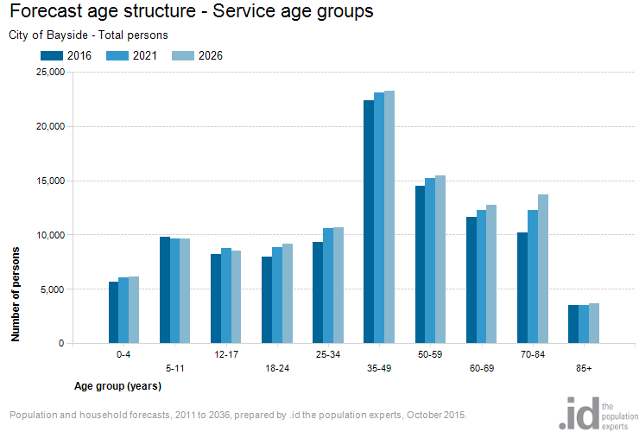

Source: id consulting, City of Bayside Population Forecasts, 2015

The most significant demographic change over the 2016 to 2026 period is going to be the growth in the population of seniors aged 70-84 years (refer to Figure 2b). The population of seniors will increase by nearly 3,500 in ten years, a growth of 35%.

Figure 2b: Change in Service age population, City of Bayside, 2016 to 2026

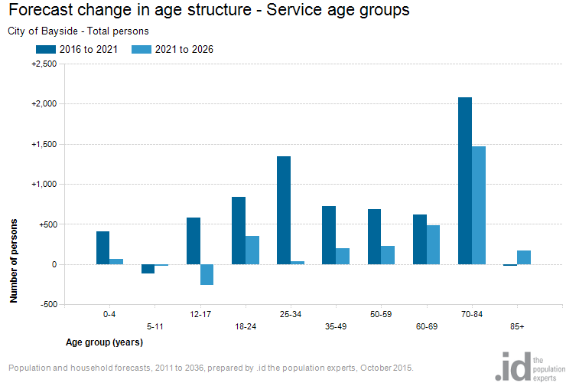

Source: id consulting, City of Bayside Population Forecasts, 2015

The ageing population of Bayside (as shown in Figure 2a and Figure 2b) will put pressure on the provision of community and recreational services and facilities commensurate with that age group. The University of Western Sydney Urban Research Centre prepared a report in March 2011 titled *Local Government and Ageing* using information provided by twenty Council’s across New South Wales. The report concludes that “ageing of the population impacts on almost all aspects of local government”, and that “the largest financial impact appeared to be in the area of providing appropriate infrastructure.”[4]

## 3.2 Identifying Future Demand Factors

Community expectations of the services provided by Council’s recreation and open spaces are increasing. Significant changes with respect to legislation, technology, and the environment are also anticipated. It is in this context that Council must plan for the upgrading of existing and the construction of new recreation and open space assets to meet these requirements.

### 3.2.1 Legislative Change

Legislative and regulatory change can significantly affect Council’s ability to meet minimum levels of service and may require improvements to recreation and open space assets. This can result from factors such as changing environmental standards, community safety standards, and OH&S, all of which potentially adding to the cost of maintaining and operating Council assets which must be accounted for in the annual budget process.

An example of such an impact is the changes to disability access and equal opportunity legislation on access to sporting facilities and foreshore areas.

### 3.2.2 Technological Change

Technology changes that relate to recreation and open space assets will allow alternative materials to be considered during maintenance and renewal works in the future. These changes will also allow improvements to the maintenance and management of existing assets. Some examples include:

* Lighting: Use of LED and more sustainable lighting options.
* New approaches in Herbicides / weed control.

There will also be changes to asset management technology, in particular in monitoring and data collection activities. Such upgrades in technology may require modifications to the published service levels to be considered as and when appropriate.

### 3.2.3 Environmental Issues/Climate Change

Council adopted the Bayside Climate Change Strategy[5] in May 2012 that sets Council’s direction in terms of environmental sustainability and adaptation to the inevitable consequences of climate change. Several ‘extreme’ risks were identified for 2030 in the preparation of this strategy regarding recreation and open space assets including:

* damage of recreation and open space assets, by flooding and extreme heat.
* loss of biodiversity in foreshore and inland reserves.
* erosion of foreshore cliffs under extreme rainfall, wind and loss of vegetation.
* vulnerability to sea level rise.

A report “Infrastructure and Climate Change Risk Assessment for Victoria” was prepared by the CSIRO for the Victorian Government in 2007. The report raises issues relating to infrastructure that may well be at risk due to climate change.

Increased frequency and intensity of extreme rainfall, wind and lightning events is likely to cause significant damage to public facilities. Accelerated degradation of materials, structures and facilities may occur through increased ground movement and changes in groundwater.

Increased temperature and solar radiation could reduce the life of structural assets due to temperature expansion and material breakdown. This accelerated degradation of materials may reduce the life expectancy of recreation and open space assets, increasing maintenance costs and leading to potential structural failure during extreme events.

From a Council infrastructure perspective, where alterations, upgrading, renewal, replacement or construction of new assets are proposed, a preliminary risk assessment needs to be undertaken as to the potential impact of climate change.

To enable Council to give consideration to elements of its recreation and open space asset stock that may be at risk, Appendix 3 is a checklist to be used to undertake this preliminary risk assessment.

If a risk of concern is identified, a more detailed risk assessment is required. Where any recreation and open space asset is at risk, suitable response or remedial measures need to be investigated and implemented.

## 3.3 Asset Upgrade Strategies

Bayside City Council recognises that each of the various classes of recreation and open space assets have different requirements and provide different services to the community. To this end, Asset Upgrade Strategies are required for asset categories and asset upgrades need to be linked to the service need as described in the service strategy. The strategies provide a service-driven assessment of asset performance, levels of service and future needs. Each strategy will be a reference document to the R&OS-AMP and a driver for funding referenced in later sections of the R&OS-AMP.

Strategic Service Management Plans are required for specific asset types. Each subclass of open space asset need to be managed in a way that reflects the specific nature of the open space and the needs of the users and the broader community and that they conform with any regulatory changes. For example, the Coastal Management Plan may be very different from the Playground Improvement Plan or Tree Strategy. In some instances site specific plans e.g. master plans will guide the management of specific areas

Figure 3 Relationships with Asset Upgrade Strategies

Asset Upgrade Strategies, such as the Coastal Management Plan, provide for broad future planning and guide key funding decisions concerning:

* Renewal
* Upgrade
* A New Asset
* Rationalisation

The general principles to be used in the development of Asset Upgrade Strategies are:

1. Each strategy is linked to Council’s Long Term Financial Plan (LTFP) and Asset Management Policy and Strategy,
2. Each asset will be maintained and renewed to ensure that it adheres to the required standard;
3. Strategic planning and asset review processes will examine opportunities for consolidation and rationalisation;
4. Any major changes/upgrade to recreation and open space assets would be considered as part of Council’s Capital Works evaluation process;
5. A whole of Council approach will be taken to ongoing management of recreation and open spaces assets. This recognises that the maintenance and renewal of assets will be at a consistent level. Additionally, it will be incumbent on all of the service areas involved in the elements of the management to ensure that overall upkeep is consistent;
6. Strategic planning and asset review processes will seek to minimise net loss of open space;
7. The funding strategy process is about identifying each structure’s renewal and/or upgrade requirements and providing the appropriate funds, in a timely manner to meet service needs. Securing external funding should be explored where appropriate;
8. Initial estimates within the strategy will be broad and based on aggregated information;

The Asset Upgrade Strategies which provide guidance to the R&OS-AMP are listed in Table 3 below. Several of these strategies are still in draft, or are yet to commence. The status of scheduling development of these plans is illustrated in the following table together with a list of other plans and strategies that may influence service planning. As discussed earlier, the meeting of community need at the neighbourhood level needs to be understood through the development of place-based strategies so that services can be consolidated, asset use is optimised and cost savings realised. Such place-based strategies need to be cross referenced with Asset Upgrade Strategies when available.

**Table 3: Status of Development of Strategic Service Management Plans[6]**

|  |  |  |
| --- | --- | --- |
| **Asset Category** | **Strategic Plans** | **Status** |
| General | Open Space Strategy (2012)  Active by the Bay Recreation Strategy (2013-2022)  Wellbeing for All Ages and Abilities (2013-2017)  Aging Well in Bayside Strategy | Completed 2012  Completed 2013  Completed 2013 |
| Parks | Cheltenham Park Master Plan  Hurlingham Park Master Plan Bayside City Council (2013)  Elsternwick Park Master Plan  Dendy Park Master Plan | Completed 2012  Completed 2013  Due 2016  Completed 2014 |
| Foreshore | Bayside Coastal Management Plan (2013)  Sandringham Foreshore Coastal Management Plan (2010)  Sandringham (Precinct 6) Foreshore Masterplan (2015)  Black Rock (Precinct 9) Foreshore Masterplan  Sandringham (Precinct 7) Foreshore Masterplan  Brighton (Precinct 5) Foreshore Masterplan  Foreshore Management Plans remaining precincts | Completed 2012  Completed 2010  Completed 2015  Due 2016  Due 2016  Due 2016  Due 2025 |
| Trees | Bayside Tree Strategy  Street and Park Tree Management Policy | Completed 2011  Due 2016 |
| Playgrounds | Playground Improvement Plan | Completed 2015 |
| Other | Dendy Street Beach Master Plan  Bayside Council Integrated Water Management Plan | Completed 2013  Completed 2016 |

Other planned Asset Upgrade Strategies to be included in a future revision of this document will be the Tennis Strategy (due 2017), including a regional tennis centre feasibility study and long term planning for netball and basketball facilities (due 2016).

## 3.4 Demand Management Strategies

Demand management strategies provide alternatives to the creation of new assets through managing customer demand for the service in question. A key long term approach in this R&OS-AMP is to manage demand so that future services can be provided at a reasonable cost without a negative impact on service. It is expected that effective demand management strategies will allow efficient management of the recreation and open space assets.

The objective of demand management is to actively seek to manage customer demands for services in order to:

* Optimise the efficiency, utilisation and performance of existing assets;
* Reduce or defer the need for new assets;
* Meet the organisation's strategic objectives;
* Deliver a more sustainable service; and
* Respond to customer needs.

Demand factors are to be analysed comprehensively, and their impact quantified in terms of the following:

* The effect of the growth of the recreation and open space asset stock;
* Any possible future need to increase or decrease assets; and
* The effectiveness of non-asset solutions.

In addition to the factors mentioned above, risk affects demand for services and consequently the following must be taken into account:

* The methodology and accuracy of forecasts;
* The currency of forecasts;
* The uncertainty of forecasts; and
* Any unforeseen natural factors.

Development of the Asset Improvement Strategies (refer to Section 2.4 Levels of Service) will include consideration of specific demands on that recreation and open space asset category.

Opportunities for funding new assets are generally limited to income from Government Grants and from Council rates. Although it may be possible to afford a new asset, especially if the subject of a Government grant, what must also be considered as part of the equation is the ongoing commitment to operations and maintenance.

Plans to introduce demand management measures are based on effective community engagement to ensure the resulting level of service meets user/community expectations. Such plans are based on the following hierarchy of options to meeting community needs with infrastructure:

1. Influence user behaviour (manage demand)
2. Maximising use from existing assets
3. Expanding or constructing new assets.

# 4.0 Lifecycle Management Plan

Lifecycle management details how Council plans to manage and operate its recreation and open space assets at the agreed levels of service, while optimising the life cycle costs. This section outlines strategies to ensure sustainability. Based on predictive modelling, testing of assumptions, risk identification and sample testing, a determination has been made as to the necessary level of operations, maintenance and renewal funding to ensure desired levels of service are achieved on a whole of life basis. The figure below provides a graphical representation of the stages in the asset lifecycle.

**Figure 4: Asset Lifecycle[7]**

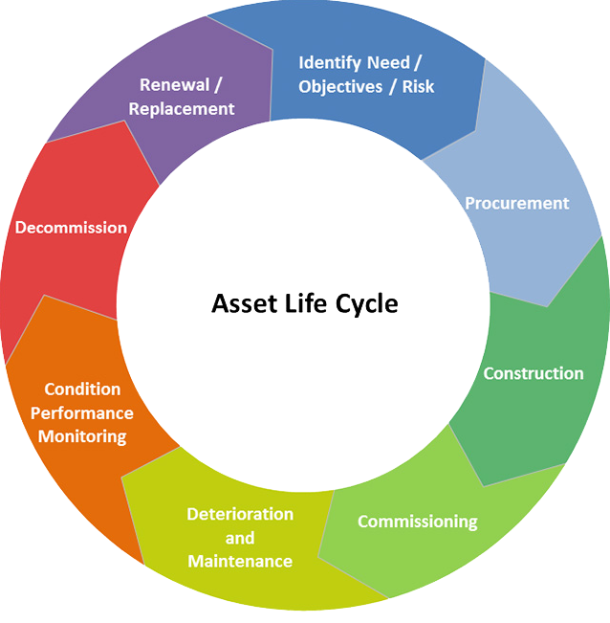

As custodian of the community’s infrastructure, Council’s function is to provide a range of services through the management of its recreation and open space assets. The cost imposition to Council involves the following aspects:

* Identifying the need and planning for the infrastructure
* Procurement and construction
* Operations, maintenance and condition monitoring
* Decommissioning or renewal/replacement (end of the useful service life of the asset).

## 4.1 Asset Description and Quantity

### 4.1.1 Asset Quantities

This R&OS-AMP covers approximately 450 hectares of reserves and parkland under Bayside City Council’s management responsibility together with their associated infrastructure assets and all street based tree planting and landscaping. In total, Bayside’s recreation and open space assets have a current replacement value (excluding unimproved land value) of $98.5 million the most significant functional class being ‘Sportsgrounds’.

The scope of the assets for which Bayside City Council is responsible are summarised in Table 4 below.

**Table 4: Categories for Recreation and Open Space Assets**

|  |  |  |  |  |  |
| --- | --- | --- | --- | --- | --- |
| Asset Type | Quantity | Area (ha) or Length (km) | Replacement Value | Useful Life | Average Annual Renewal Value |
| Playgrounds | 66 |  | $3,500,000 | 25 | $140,000 |
| Skate parks | 3 | $240,000 | 25 | $9,600 |
| Basketball Practice Courts | 19 | $380,000 | 25 | $15,200 |
| Sportsgrounds (26 locations) | 36 | 58.2 | $21,664,260 | 50 | $433,285 |
| Athletic Tracks | 2 |  | $1,000,000 | 40 | $25,000 |
| Sportsground Irrigation Systems | 29 | 43.4 | $2,900,000 | 40 | $72,500 |
| Goals (Football/Soccer) | 52 |  | $371,000 | 15 | $24,733 |
| Cricket Pitches - Concrete/Synthetic | 29 |  | $290,000 | 25 | $11,600 |
| Cricket Practice Nets | 56 |  | $1,960,000 | 20 | $98,000 |
| Sportsground Floodlights | 91 |  | $910,000 | 30 | $30,333 |
| Tennis/Netball/Bowling  Courts/Surfaces | 9 |  | $3,000,000 | 50 | $60,000 |
| Golf Courses | 3 | 141.43 | N/A | 50 |  |
| BBQs | 30 |  | $240,000 | 10 | $24,000 |
| Bins | 413 |  | $330,400 | 10 | $33,040 |
| Bollards | 6011 |  | $751,375 | 10 | $75,138 |
| Drinking Fountains | 91 |  | $227,500 | 15 | $15,167 |
| Fences (km) | 550 | 7.78 | $2,696,000 | 15 | $179,733 |
| Gates | 336 |  | $252,000 | 15 | $16,800 |
| Picnic settings | 188 |  | $470,000 | 15 | $31,333 |
| Seats | 871 |  | $871,000 | 15 | $58,067 |
| Signs | 1353 |  | $676,500 | 15 | $45,100 |
| Tree Guards | 19 |  | $9,500 | 15 | $633 |
| Irrigation systems - Other | 35 | 48.1 | $1,050 | 40 | $26 |
| Edging & Kerbing (km) | 364 | 45.7 | $2,160 | 40 | $54 |
| Park Lights |  |  | $728,000 | 15 | $48,533 |
| Paths (km) | NA |  | $3,164,040 | 35 | $90,401 |
| Ticket Machines(Car Parks) | 42 | 54.9 | $420,000 | 15 | $28,000 |
| Steps, Retaining Walls, Other Park Structures & Equipment | NA |  | $5,000,000 | 50 | 100,000 |
| Social Family Recreation Parks | 18 | 43.35 | NA | NA | - |
| Relaxation Parks | 40 | 13.53 | NA | NA | - |
| Formal Gardens | 8 | 16.05 | NA | NA | - |
| Conservation Reserves | 29 |  | NA | NA | - |
| Inland Bushland Reserves |  | 98.9 | NA | NA | - |
| Foreshore Reserves | 10 | NA | NA | NA | - |
| Park Trees |  | 12541 | $10,283,620 | 50 | $205,672 |
| Significant Park Trees | 22 | $18,040 | 80 | $226 |
| Street Trees | 42049 | $34,480,180 | 50 | $689,604 |
| Significant Street Trees | 2012 | $1,649,840 | 80 | $20,623 |
| **Total** |  |  | **$98,486,465** |  | **$2,582,402** |

Some inconsistencies have been identified between recent asset audit information in Authority and historic data in the Finance Register, which will be reviewed as an improvement action (refer Section 7.3). In 2015, a preliminary review was carried out on Council’s playing field asset inventory. The review identified a number of gaps in the inventory listed above. Desk based valuations were prepared for these assets. It was recommended to conduct a comprehensive review of the open space asset data including condition assessment and revaluation.

To enable the recreation and open space asset stock to be prioritised in order of importance, a functional hierarchy classification criterion has been established in this plan and all recreation and open spaces have been classified into the hierarchy. Appendices 1 and 2 outline the recommended hierarchy.

## 4.2 Asset Age and Useful Lives

### 4.2.1 Asset Useful lives

A key component of asset performance is asset life. A key aspect of asset management is achieving optimum life for lowest lifecycle cost. The useful lives of each recreation and open space element/component utilised in the financial modelling undertaken in developing the R&OS-AMP are shown in Table 4 above.

Given the number of different types of assets in many of the above categories there is in reality a range of useful lives in each category. The adopted useful lives above are the average life of the majority of assets in that category.

Establishing meaningful useful lives for soft landscaping is challenging. With regard to Parks and Conservation Reserves, the nature of these assets is that with regular maintenance and replanting, they will maintain their integrity without having to renew the whole asset on a periodic basis.

The useful lives of street trees depend on a number of factors including species, location of planting, vicinity of overhead power lines and maintenance requirements. A particular tree may well be healthy with considerable growing life remaining, but reaches an inappropriate size for its location and/or too expensive or impractical to maintain shape and clearances. Of particular note is that around 60% of all street trees are impacted by overhead powerlines and most will potentially impact on footpaths. Adopted tree lives reflect the average “useful life” of street trees rather than total life expectancy.

Parks trees have similar issues to street trees, however their location is often less restrictive on growth and size patterns. These trees will often not be replaced until their health deteriorates or they become too maintenance intensive.

An assessment of remaining useful life of trees has been undertaken, with over 90% of all trees being assessed individually. This assessment categorised all trees within four life expectancy categories and indicated that 78% of Council trees had a life expectancy of 10 to 20 years. It does not however identify where the majority of trees sit within this 10 year period which (if they were all at the upper or lower end) could skew predicted renewal requirements significantly. Given this generates uncertainty when life expectancy is used in the model, the replacement of trees was not included in this generation of the R&OS-AMP and remains a planning task that is required in the Improvement Plan.

Asset lives for each asset group will be further examined in each Strategic Service Management Plan to ascertain what is relevant to that group of recreation and open space assets.

### 4.2.2 Age Profile

The age profile for Council’s recreation and open space facilities is varied due to the range of assets included in this asset class, and also the quality of the data Council holds on these assets. In 2015, Council undertook an activity to investigate sporting facilities and playing fields on Council controlled land. As part of this activity, Council officers were consulted to review the available data on the year of construction and the remaining lives of the assets. Figure 5 below presents information collected. The average remaining life for each of these assets is approximately 56%. The remaining useful lives of associated infrastructure has yet to be determined and is a task captured in the Improvement Plan.

**Figure 5. Playing Fields & Facilities - Remaining useful asset life**

*\*All assets on Council controlled land – Council is not responsilble for all of the assets listed here.*

## 4.3 Asset Condition

### 4.3.1 Lifecycle Condition Audit

The maintenance contractor conducts a two-yearly Life Cycle Costing (LCC) audit on all recreation and open space assets[8], assigning assets a condition rating and remaining life estimate. This audit also includes an evaluation of asset compliance with current regulations. LCC audit results are used for long-term financial modelling purposes and in the development of Strategic Service Management Plans.

### 4.3.2 Asset Condition Rating

Appendix 4 provides the Condition Rating Scale used for open space assets. This is a 10 point scale where condition 0 represents a new asset while 10 is an asset with no remaining life. The 0-10 condition rating is applied to the key elements and this audit information is loaded into the AIM system and/or used to model and produce capital renewal programs.

### 4.3.3 Asset Condition

The condition of recreation and open space data is presented in Figure 5 below in a 5 point scale from excellent to "past intervention point". Past intervention is defined as condition 8 and above, or beyond RICL described in Section 5.2 below. Figure 6 represents the recreation and open space asset condition data as presented in the Moloney model.

The foreshore, open space and recreation categories are the three primary asset groups. Ancillary assets are those used to provide access to these spaces and include ramps, stairs and pathways.

**Figure 6. Recreation and Open Space Condition Data[9]**

As shown in Figure 5 over 80% of Ancillary, Recreation and Open Space assets are in average to excellent condition. For the Foreshore assets approximately 60% of assets are from average to good condition. Only a very small number of assets in any category are past intervention point and addressed with annual renewal works.

## 4.4 Risk Identification

Council’s Risk Management Process is an integral part of best practice asset management. The application of sound risk management allows for continual improvement in decision making and processes and is an essential consideration in determining appropriate levels of service.

Key risk issues for open space and recreation Assets include:

* Hazardous or defective trees;
* Unsafe sports facility surfaces;
* Defective infrastructure in parks and reserves;
* Uneven or damaged surfaces where walking, running or cycling use is likely (includes formed pathways and other natural surfaces;
* Defective playground equipment and/or softfall; and
* Fire risk in conservation and foreshore reserves;

It is not possible for Council to address all defects and eliminate all risks, however they are being minimised by undertaking inspections to identify risks.

## 4.5 Asset Data Storage Systems

Bayside City Council uses Civica SAM as the asset register for recreation and open space asset data. This database stores a range of asset attribute data. Recreation and open space asset data is also stored in the CVR and GIS. There is currently a project underway to align the asset data in these systems as per the Improvement Plan in Section 7.1.

The Moloney Modelling System is currently being utilised to determine the future funding levels for renewal of Council assets. Ongoing analysis and predictive modelling is required to define the assumptions and forecasts provided in this plan.

## 4.6 Operations and Maintenance

### 4.6.1 Maintenance Arrangements

Effective maintenance strategies are essential to ensure that an asset performs at the desired service level on a day to day basis. Typical maintenance activities undertaken in relation to recreation and open space assets include:

|  |  |
| --- | --- |
| * Turf management | * Garden bed maintenance |
| * Turf wicket maintenance | * Tree pruning including power line clearance |
| * Nursery Services | * Tree removal and planting |
| * Playground maintenance | * Sign inspection and cleaning |
| * Safety inspections and audits | * Beach cleaning |
| * Furniture cleaning and maintenance | * Litter Collection |

Council has entered into two contracts for its recreation and open space maintenance services.

The Management and Maintenance of Open Space and Trees Contract commenced in July 2009, ending in 2019. The Contract specification comprises the maintenance, management and coordination of works under this contract which are associated with Council’s recreation and open spaces and other assets. Ad hoc minor capital works are also required to be delivered. The Contractor is also required to provide assistance in the implementation of the strategies resolved by Council during the Contract Period for the operation and enhancement of those assets.

The Amenities, Bins and Beach Cleaning Services Contract commenced in January 2009 and also ends in 2019.

The following Table shows the responsibility split between Council and Contractor and also the objectives of the contracts.

**Table 5: Responsibility Arrangements – Council versus Contractor**

|  |  |
| --- | --- |
| **Contractor Responsibility** | **Council Responsibility** |
| Maintenance of Council’s assets on a day to day basis as directed. | Strategic planning |
| Monitoring and maintaining Council assets throughout the Municipality | Capital development and improvement for recreation and open space assets |
| Customer service and complaints management as they relate to services performed. | Management and supervision of contracted services |
| Ensuring the implementation of existing and future management plans, strategies and programs | Enforcement of Regulations for recreation and open space assets |

### 4.6.2 Inspections

A key level of service is the regular inspection of the recreation and open space assets. Inspections are essential for safe and efficient management of the assets. Inspection frequencies’ are set out in the Management and Operation Infrastructure Maintenance Services Contract and are monitored via the Maintenance Management System.

Maintenance inspections identify, record and report defects that are causing, or have the potential to cause:

* Disruption to service provision;
* Degradation of asset performance and/or condition including cleanliness;
* A public health or safety risk;
* Inconvenience to staff and/or the public;
* Breach of regulations or legislation;
* A financial risk; and
* Property damage

The Recreation and Open Space Maintenance Contracts requires two levels of programmed inspections:

* Maintenance Condition Audits - annually
* Life Cycle Costing Audits (Asset condition / remaining life) - every two (2) years

Data is provided on a monthly reporting cycle. The aim is for Council to build accurate life cycle costs and maintenance information that Council will use to improve recreation and open spaces management. All reports, correspondence or other documents are saved in the TRIM system.

## 4.7 Renewal, Upgrade and Disposal Plan

### 4.7.1 Renewal Strategy Prioritisation Process

Planned and reactive renewal works are prioritised in accordance with the consequence of failure rating for the asset in question.

This Renewal Section relates specifically to the need to renew assets to address condition problems rather than for capacity or performance reasons. Recreation and open space assets that are not fit for purpose or not performing adequately will be prioritised for upgrades based on the relevant Asset Upgrade Strategy.

### 4.7.2 Renewal Strategy

The justification to renew recreation and open space assets is based on the following criteria:

* Risk: The risk of failure and associated financial and social impact justifies action (e.g. impact and extent of resulting inability to be able to use the asset, probable extent of damage to business, and any health risk arising from use of the asset).
* Asset performance: The failure of an asset to meet the required level of service. Non-performing assets are identified by the monitoring of asset reliability, capacity and efficiency during inspections and operational activity.
* Economics: It is no longer economically prudent to continue repairing the asset (i.e. the annual cost of repairs exceeds the annualised cost of renewal.

In addition to criticality rating, prioritisation will be rated on urgency of work in accordance with the functional hierarchy and asset category.

### 4.7.3 New and Upgraded Asset Requirements

New and upgraded asset requirements include works required to cater for growth in or higher levels of service (performance). This may include the creation of a new asset or an upgrade to increase the capacity of an existing asset. New assets are constructed to meet new services or higher levels of service. An upgrade to a recreation or open space asset is an enhancement to meet the demand for an increased level of service or to render the building to be fit for purpose.

Funding of new and upgrade works fall into the following categories depending upon the extent and type of works:

* Council funded, or
* Externally funded (commercial, private, Government or non-profit organisation), or
* Shared contribution to the cost by Council and an outside interest.

A significant issue that affects demand for new recreation and open space asset or upgrades to existing assets is whether existing assets are fit for purpose in supporting the services that are provided to the community. In some cases, legislative and regulatory changes will drive such works. In other cases, it will be feedback from asset users. The ongoing development of Service Strategies for each service will guide Council’s investment in new and upgraded recreation and open space assets.

When Council considers discretionary capital expenditures for new or upgraded assets, it is essential to establish the consequential recurring operational and maintenance costs that will occur once the new or upgraded assets become operational. Understanding life cycle costs is part of being fully informed of future liabilities. As new projects are brought forward for consideration in annual budget deliberations, they will have to include an assessment of these ongoing operational (recurrent) costs to be presented to Council as part of the overall cost projections.

### 4.7.4 Asset Upgrade Strategies

The role of Asset Upgrade Strategies is to identify the need for new recreation and open space assets or upgrades to existing assets based on service performance or fit-for-purpose requirements. The critical principle behind Asset Upgrade Strategies is the recognition that some assets will require refurbishment to ensure that they continue to meet service needs for the community. The Strategies also enable ‘early’ renewal works to be considered together with other planned renewals based on poor asset condition. There is then a more strategically driven and systematic approach to the long term management of Council’s recreation and open space assets.

The general focus for recreation and open space assets has been on working towards developing a long term approach to identifying and programming the renewal and upgrade of assets. This work is ongoing as Council develops Strategic Service Management Plans for each asset category.

The following sections are summaries of Asset Upgrade Strategies that have been adopted by Council or are in draft form:

Bayside Open Space Strategy 2012

The Bayside Open Space Strategy (OSS), is a 20 year planning document for the period 2012-2032. It provides policy and strategy to enable Council to make decisions about how open space is used, developed and managed and maintained across the municipality. Both the Rec&OS-AMP and OSS inform Council’s Long Term Financial Plan to guide long term decision making to sustain and enhance the Bayside open space system and provide a link between strategic planning and the practical, operational delivery and management of Council managed parks, trails and reserves.

As well as setting out the classifications and functional hierarchy, the strategy establishes a vision Bayside Council Open Spaces: *To cherish open space, to work together to build the open space network in ways that celebrate our strengths, support biodiversity, improve health and wellbeing and community connections, for future and current generations*.

The strategy also sets out the following six principals:

1. Accessibility: Availability of open space experiences.
2. Appropriateness: Ability to get the most out of each open space as well as network as a whole.
3. Affordability: Management that is sustainable within Council’s resources.
4. Environmental sustainability: Practices which contribute positively to environment.
5. Connections: Physical and visual links between spaces.
6. Communications: Develop, manage and use open space network through sharing of information.

The key actions arising from the plan are:

* Adequate reporting to ensure no net loss of open space
* Development of management plans for each individual open space
* Rezoning inappropriately zoned land
* Investigating spaces which may warrant rezoning
* Develop policy for dogs in open space
* Develop policy for commercial advertising in open spaces
* Review fees charges and lease arrangements
* Review service levels and operational funding of open spaces
* Development of design standards for open space infrastructure
* Development of community gardens.
* Development of trail strategy
* Encourage awareness and multiuse of facilities.

As these actions are completed further understanding of the costs of upgrading existing or constructing new assets will be available for future versions of this document.

Recreation Strategy (2013-2022)

The Active by the Bay recreation strategy guides the planning, management and provision of recreation facilities and services in the City of Bayside for 2013-2022. The strategy is aimed at a demographic analysis of the City of Bayside, comprehensive analysis of relevant Council and external strategy and policy documents, research into recreation trends and best practice at local, state and national levels and extensive engagement with the community including residents and recreation and sporting groups.

The strategy identified and ranked a range of infrastructure works for Bayside. The works identified include the renewal and upgrades to cricket nets, floodlighting and sportsground surfaces.

Of these works recommended, the cricket net upgrades will be completed in 2015/16. Sportsground lighting upgrades will be completed in 2017/18. A sportsground improvement plan which sets Council’s spending plan for the next 10 years has been developed. Each of these elements have been incorporated into the LTFP.

**Table 6: Sportsground improvement 10 Year Costs**

|  |  |  |  |  |  |  |  |  |  |
| --- | --- | --- | --- | --- | --- | --- | --- | --- | --- |
| **2015/16** | **2016/17** | **2017/18** | **2018/19** | **2019/20** | **2020/21** | **2021/22** | **2022/23** | **2023/24** | **2024/25** |
| $2,205,000 | $2,439,000 | $3,781,000 | $4,630,000 | $2,458,000 | $2,557,000 | $2,661,000 | $2,769,000 | $2,881,000 | $2,205,000 |

Playground Improvement Plan 2015-2025

The Playground Improvement Plan sets out Council’s approach to the upgrading of its 61 playgrounds. While acknowledging that children play in a range of open space environments (including local parks, the beach, or beside a lake) the report focuses on built playgrounds. It develops a number of policy statements to assist Council in making decisions about future provision. The plan estimates that $10.5 million is require to fund playground renewal and upgrades, this is set out in Table 7 below.

**Table 7: Playground Improvement Plan 10 Year Costs**

|  |  |  |  |  |  |  |  |  |  |
| --- | --- | --- | --- | --- | --- | --- | --- | --- | --- |
| **2015/16** | **2016/17** | **2017/18** | **2018/19** | **2019/20** | **2020/21** | **2021/22** | **2022/23** | **2023/24** | **2024/25** |
| $1,205,000 | $965,000 | $1,020,000 | $1,040,000 | $1,000,000 | $1,215,000 | $1,010,000 | $1,065,000 | $1,325,000 | $650,000 |

Cheltenham Park Master Plan

Cheltenham Park is a mixed use sporting and recreational reserve, particularly noted for indigenous flora and as a habitat for fauna. The Cheltenham Park Master Plan was adopted in August 2013 and identified high priority activities including the ongoing maintenance of indigenous vegetation and revegetation, the improvement of pathways and carparks surfaces, and upgrading park furniture and signage. The Master Plan is to be carried out with a budget of $500,000[10], of which $182,287 will be allocated to recreation and open spaces assets.

**Table 8: Cheltenham Park Master Plan 10 Year Costs**

|  |  |  |  |  |  |  |  |  |  |
| --- | --- | --- | --- | --- | --- | --- | --- | --- | --- |
| **2015/16** | **2016/17** | **2017/18** | **2018/19** | **2019/20** | **2020/21** | **2021/22** | **2022/23** | **2023/24** | **2024/25** |
| $97,287 | $85,000 | - | - | - | - | - | - | - | - |

Dendy Park Master Plan

Dendy Park is a large sporting complex providing a range of recreation and sporting facilities, in addition to native vegetation. The Dendy Park Master Plan identified a number of opportunities including improvement of sporting and support facilities, paths and internal roads, lighting and signage, and vegetation protection.

**Table 9: Dendy Park Master Plan 10 Year Costs**

|  |  |  |  |  |  |  |  |  |  |
| --- | --- | --- | --- | --- | --- | --- | --- | --- | --- |
| **2015/16** | **2016/17** | **2017/18** | **2018/19** | **2019/20** | **2020/21** | **2021/22** | **2022/23** | **2023/24** | **2024/25** |
| $1,834,913.00 | $2,657,596.00 | $1,155,456.00 | $2,052,000.00 | - | - | - | - | - | - |

Hurlingham Park Master Plan Bayside City Council (2013)

Hurlingham Park is a 6 hectare mixed use facility zoned as Public Park and Recreation Zone. The Master Plan is designed to guide the future use of the facility renewal and upgrade works to ensure harmonious use of the space between all user groups. Works proposed at the site include an upgrade of the sports pavilion. Work on recreation and open space assets include renewal and upgrade of footpaths, carparks, drainage, playing surface, rain gardens, furniture and lighting.

**Table 10: Hurlingham Park Master Plan 10 Year Costs**

|  |  |  |  |  |  |  |  |  |  |
| --- | --- | --- | --- | --- | --- | --- | --- | --- | --- |
| **2015/16** | **2016/17** | **2017/18** | **2018/19** | **2019/20** | **2020/21** | **2021/22** | **2022/23** | **2023/24** | **2024/25** |
| $608,280 | $808,940 | $94,600 | - | - | - | - | - | - | - |

Elsternwick Park Master Plan

In March 2016 the Victorian Government committed $3 million towards the $6 million upgrade of No.1 Oval precinct at Elsternwick Park. The funds add to contributions of $1.2 million from Council, $1.05 million from the Victorian Amateur Football Association and $250,000 each from AFL, AFL Victoria and Old Melbournians Football Club.

The improvement to the Park include an upgrade to the pavilion as well as reshaping the sportsground and installation of drought tolerant couch grass as well as an upgrade to the sportsground lighting.

Consultation on the future use of the residential northern section of Elsternwick Park is currently underway in 2016.

Bayside Coastal Management Plan (2013)

The Coastal Management Plan provides strategic direction and policy on coastal use, management and development for the foreshore area. The strategy aims to provide long term strategic vision for the Bayside foreshore. The strategy aims formalises the 11 foreshore precinct areas features and opportunities. A detailed action plan will be prepared for each of the 11 foreshore precincts. Several plans have already been prepared, and a number are being prepared for completion in 2016 as follows:

* Sandringham Foreshore Coastal Management Plan (2010)
* Sandringham (Precinct 6) Foreshore Master plan (2015)
* Blackrock (Precinct 9) Foreshore Master plan (scheduled for 2016)
* Sandringham (Precinct 7) Foreshore Master plan (scheduled for 2016)
* Brighton (Precinct 5) Foreshore Master plan (scheduled for 2016)

As these plans are completed, further understanding of the costs associated with upgrading existing or constructing new assets will be available for future versions of this document.

Bushland Strategy 2002

Council’s bushland strategy acknowledges the contribution that bushlands have to the visual identity of Bayside. These belts provide refuge and habitat for indigenous fauna and service as "island sanctuaries' within an increasingly urban environment. This strategy will be incorporated into an overarching Biodiversity Action Plan in 2016/17.

Bayside Tree Strategy 2011 and Street and Park Tree Management Policy 2016

These documents provide a framework of actions to ensure that the future public and private spaces within Bayside are leafy. Every two years an audit of all trees takes place to determine which trees are missing or have reached the end of their useful life. Replacement and maintenance programs are then structured for this work to be carried out in an efficient manner based on allocated funding.

Funding for tree replacement is normally provided in the operating budget and is not considered part of the Capital Works program unless it is part of a project to upgrade a park or park infrastructure. This will be addressed in the Improvement Plan.

Other planned Asset Upgrade Strategies to be included in a future revision of this document will be the Tennis Strategy, including a regional tennis centre feasibility study and planning for Netball and Basketball facilities.

### 4.7.5 Strategic Service Reviews

To ensure its services demonstrate best value to the Bayside community, Council commenced a rolling program of Strategic Service Reviews (SSRs) in 2014 and currently aims to complete four SSRs per annum. The six SSRs completed to date include:

* Home and Community Aged Care
* Statutory Planning
* Arts and Culture
* Youth Services
* Maternal and Child Health

### 4.7.6 Asset Disposal Plan

The strategy for the development of a recreation and open space asset disposal plan is to first identify those recreation and open spaces or parts thereof that are either:

* Surplus to requirements;
* Technologically obsolete;
* No-longer meeting community needs; or
* Have reached the end of their useful life and there is no demand for renewal or replacement.

Where appropriate, such assets should also be considered for consolidation and rationalisation based on service needs and community benefit prior to being placed in the Disposal Plan.

When disposal does occur, recognition needs to be made in the recurrent/operating budget of the reduction of associated operating or maintenance costs of the decommissioned assets, as well as any disposal costs. Costs associated with the sale, demolition or relocation of decommissioned assets and any associated works are to be included as part of the Disposal Plan. Associated works could include any necessary site remediation or rehabilitation. This is a risk management issue. Failure by Council to undertake relevant site remediation may result in future litigation. An example of remediation work is on the site of old Council works depots where fuel and hazardous materials may have been stored, especially those stored in underground tanks.

Disposal of recreation and open spaces within Bayside City Council is very infrequent and no planning or policy has been developed. As Council progresses through the development of Strategic Service Management Plans for recreation and open space category it will be an opportunity to identify those assets that are underperforming in some way and make decisions accordingly.

## 4.8 Recreation and Open Space Ownership Obligations

### 4.8.1 Council Owned Recreation and Open Space

Council is responsible for the ownership and upkeep of recreation and open space assets. These assets must be appropriately maintained and operated to ensure that they are available for the use of residents and visitors to the municipality. Responsibility for health and safety and damage to property reside with Council where a reasonable level of service has not been provided.

### 4.8.2 Government Recreation and Open Space Managed by Council

Council may occupy Crown land as a Committee of Management under the *Crown Land (Reserves) Act* 1978. Council occupies not by virtue of any lease or licence but because it has Committee of Management status.

Although the precise relationship between the State Government and Council will turn on the Committee of Management appointment and any arrangements which complement it, practically Council comes to resemble both owner and occupier. That is, although Council does not own the land, it assumes obligations and incurs risks not dissimilar to those referable to an owner-occupier.

Ultimately, Council may be able to gain protection from the State Government through arrangements worked out with the Department of Environment Land Water Planning (which administers the *Crown Land (Reserves) Act*).

### 4.8.3 Commercially leased or licensed for use by a Community Group

In this scenario, ownership rests with Council and occupation rests with another (e.g. golf course lessee or sporting club).

As owner of the recreation and open space, Council will be subject to a number of obligations even though they are not directly involved in the day to day activities at the site.

In cases where Council has leased the land to another, it cannot wholly escape liability in negligence to an injured entrant. This means that not only the occupier but Council (in its capacity as lessor or landlord) can be directly liable to an injured entrant. In other words, the liability can, in this lease context, be a shared one.

Council can protect itself by:

* insuring against any liability by effecting and maintaining a Public Liability Policy of Insurance;
* insisting upon the lessee or tenant holding a current Public Liability Policy of Insurance; and extracting an indemnity from the lessee or tenant, meaning that if Council becomes legally liable to the injured entrant then the lessee or tenant must meet any damages paid and costs incurred by Council.

### 4.8.4 Community Usage Agreements

Formalised facility usage agreements/leases/licences need to be developed and executed between Council and community groups/facility users and/or Committees of Management for the ongoing use of specific Council recreation and open spaces & facilities. This will include Memoranda of Understanding between Council and the Committees of Management. The arrangements in these agreements will cover the actual usage, maintenance and housekeeping responsibilities.

# 5.0 Strategic Financial Management

## 5.1 Current Financial Position

Council’s current expenditure for 2015/16 on recreation and open space assets totals $19.3 million, representing approximately 30% of Council’s total budget[11]. The breakdown between capital works and maintenance is presented in Table 11.

**Table 11: Recreation and Open Space Service Budget Allocations 2015/16**

|  |  |
| --- | --- |
| Budget Component | 2015/16 Allocation |
| Capital (New, Renewal, Upgrade) | $8,794,000 |
| Operations and Maintenance | $10,543,000 |
| **TOTAL** | **$19,337,000** |

### 5.1.1 Maintenance Expenditure

Maintenance expenditure refers to all costs incurred to ensure that asset remains operational, such as repairs to playground equipment. Maintenance does not include actions which affect the remaining useful life of the asset (as this is defined as renewal).

Approximately 63% of Council annual expenditure on recreation and open space assets is on maintenance activities and the current budget is considered to be in line with annual requirements to achieve the adopted level of service standards. Table 12 below provides a breakdown of the annual costs of maintaining Council’s recreation and open space assets.

**Table 12: Recreation and open space asset maintenance allocations 2015/16**

|  |  |
| --- | --- |
| Maintenance Activity | Budget (Proposed 2015/16) |
| Open Space Management | $1,633,495 |
| Bushland and Foreshore | $947,996 |
| Amenities and Beach Cleaning (receives DSE Subsidy $175,000 pa) | $1,315,266 |
| Horticulture | $1,158,302 |
| Environmental Sustainability | $445,753 |
| Infrastructure | $1,020,842 |
| Sports grounds/Turf | $1,607,023 |
| Nursery(after sales cost) | $96,834 |
| Trees (street/park) | $1,842,635 |
| Tree Planting | $475,728 |
| **TOTAL** | **$10,543,874** |

It is noted that a Council resolution was made in 2015 to allocate an additional $150,000 a year to the provision of new approaches to Herbicides / weed control.

While designed to achieve the adopted service levels in the R&OS-AMP, these programs continue to be tested and their effectiveness monitored and measured over time to allow for a future review of the service.

Table 13 below shows the predicted increase in maintenance costs over the next 10 years due to annual cost escalation and the additional maintenance requirements of new assets created over this period.

**Table 13: 10-year Maintenance Cost Projects**

|  |  |  |  |  |  |
| --- | --- | --- | --- | --- | --- |
| Maintenance Activity | 2015/16 | 2016/17 | 2017/18 | 2018/19 | 2019/20 |
| Open Space Management | $1,633,495 | $1,682,500 | $1,732,975 | $1,784,964 | $1,838,513 |
| Bushland and Foreshore | $947,996 | $976,436 | $1,005,729 | $1,035,901 | $1,066,978 |
| Amenities and Beach Cleaning | $1,315,266 | $1,354,724 | $1,395,366 | $1,437,227 | $1,480,343 |
| Horticulture | $1,158,302 | $1,193,051 | $1,228,843 | $1,265,708 | $1,303,679 |
| Environmental Sustainability | $445,753 | $459,126 | $472,899 | $487,086 | $501,699 |
| Infrastructure | $1,020,842 | $1,051,467 | $1,083,011 | $1,115,502 | $1,148,967 |
| Sports grounds/Turf | $1,607,023 | $1,655,234 | $1,704,891 | $1,756,037 | $1,808,719 |
| Nursery(after sales cost) | $96,834 | $99,739 | $102,731 | $105,813 | $108,988 |
| Trees (street/park) | $1,842,635 | $1,897,914 | $1,954,851 | $2,013,497 | $2,073,902 |
| Tree Planting | $475,728 | $490,000 | $504,700 | $519,841 | $535,436 |
| New approaches weed control |  | $154,500 | $159,135 | $163,909 | $168,826 |
| **TOTAL** | **$10,543,874** | **$11,014,690** | **$11,345,131** | **$11,685,485** | **$12,036,049** |
|  |  |
|  |  |
|  |  |  |  |  |  |
| Maintenance Activity | 2020/21 | 2021/22 | 2022/23 | 2023/24 | 2024/25 |
| Open Space Management | $1,893,668.40 | $1,950,478.46 | $2,008,992.81 | $2,069,262.59 | $2,131,340.47 |
| Bushland and Foreshore | $1,098,987.19 | $1,131,956.80 | $1,165,915.50 | $1,200,892.97 | $1,236,919.76 |
| Amenities and Beach Cleaning | $1,524,753.77 | $1,570,496.39 | $1,617,611.28 | $1,666,139.62 | $1,716,123.81 |
| Horticulture | $1,342,789.48 | $1,383,073.16 | $1,424,565.36 | $1,467,302.32 | $1,511,321.39 |
| Environmental Sustainability | $516,749.90 | $532,252.39 | $548,219.97 | $564,666.56 | $581,606.56 |
| Infrastructure | $1,183,435.66 | $1,218,938.73 | $1,255,506.90 | $1,293,172.10 | $1,331,967.27 |
| Sports grounds/Turf | $1,862,980.10 | $1,918,869.50 | $1,976,435.59 | $2,035,728.66 | $2,096,800.52 |
| Nursery(after sales cost) | $112,257.15 | $115,624.86 | $119,093.61 | $122,666.41 | $126,346.41 |
| Trees (street/park) | $2,136,118.98 | $2,200,202.55 | $2,266,208.63 | $2,334,194.89 | $2,404,220.74 |
| Tree Planting | $551,499.14 | $568,044.11 | $585,085.43 | $602,638.00 | $620,717.14 |
| New approaches weed control | $173,891.11 | $179,107.84 | $184,481.08 | $190,015.51 | $195,715.98 |
| **TOTAL** | **$12,397,131** | **$12,769,045** | **$13,152,116** | **$13,546,680** | **$13,953,080** |

### 5.1.2 Capital Expenditure

Capital expenditure covers renewals, upgrades and new assets and increases the value and extends the useful service life of an asset.

However it needs to be recognised that all upgrade works on recreation and open space assets will normally include some renewal works and in many instances renewal works may also include an upgrade component to meet current service requirements. In some instances the upgrade may require the bringing forward of renewal works that were originally scheduled for the future.

To provide a more accurate picture of the impact of these works on future renewal needs, each financial year an assessment is undertaken on a project by project basis as to the forecast expenditure split by expenditure category.

Table 14 and Table 15 shows the 10 year forecast for capital works for recreation and open space assets, respectively for renewal and new assets.

**Table 14. Recreation and Open Space Capital Works Budgets 2015/16-2024/25 (renewal)**

|  |  |  |  |  |  |  |  |  |  |  |
| --- | --- | --- | --- | --- | --- | --- | --- | --- | --- | --- |
| **Renewal** | **2015/16** | **2016/17** | **2017/18** | **2018/19** | **2019/20** | **2020/21** | **2021/22** | **2022/23** | **2023/24** | **2024/25** |
| Foreshore and conservation | $2,758,000 | $2,205,000 | $2,439,000 | $3,781,000 | $4,630,000 | $3,559,000 | $3,705,000 | $3,775,000 | $3,809,000 | $3,842,000 |
| Parks and recreation | $1,416,000 | $725,000 | $270,000 | $281,000 | $292,000 | $867,000 | $903,000 | $916,000 | $913,000 | $900,000 |
| **Total** | **$4,174,000** | **$2,930,000** | **$2,709,000** | **$4,062,000** | **$4,922,000** | **$4,426,000** | **$4,608,000** | **$4,691,000** | **$4,722,000** | **$4,742,000** |

**Table 15. Recreation and Open Space Capital Works Budgets 2015/16-2024/25 (new)**

|  |  |  |  |  |  |  |  |  |  |  |
| --- | --- | --- | --- | --- | --- | --- | --- | --- | --- | --- |
| **New** | **2015/16** | **2016/17** | **2017/18** | **2018/19** | **2019/20** | **2020/21** | **2021/22** | **2022/23** | **2023/24** | **2024/25** |
| Foreshore and conservation | $2,125,000 | $269,000 | $588,000 | $611,000 | $636,000 | $909,000 | $945,000 | $983,000 | $1,022,000 | $1,063,000 |
| Parks and recreation | $2,495,000 | $3,584,000 | $3,370,000 | $2,816,000 | $7,144,000 | $2,370,000 | $2,844,000 | $3,945,000 | $4,103,000 | $4,267,000 |
| **Total** | **$4,620,000** | **$3,853,000** | **$3,958,000** | **$3,427,000** | **$7,780,000** | **$3,279,000** | **$3,789,000** | **$4,928,000** | **$5,125,000** | **$5,330,000** |

### 5.1.3 Funding Sources

Open Space funding is drawn from a number of sources. In addition to direct funding from rates, improvements to the open space network are also funded through the sources outlined below.

Recreation and Open Spaces Income

Property management is a significant source of non-rate revenue for Council through the collection of rentals and other income. These range from Commercial leases (e.g. golf courses) to sports facility allocations (e.g. ovals) that usually also involve use of buildings or other facilities on the site.

There are a wide range of user charges and fees applied to different infrastructure, services and enforcement activities provided by Council. Income from recreation and open space assets was $77,226 in 2014/15. [12]

Leasing and use of Council recreation and open spaces is undertaken in accordance with Council’s Leasing Policy and other use of community facilities policies. In some instances, in addition to the rental charges, the tenant is also required to undertake maintenance and/or upgrade of the recreation and open space as part of the leasing arrangement.

While commercial leases are intended to make an overall return to Council many of the community based arrangements only contribute in part to the cost of Council owning the facility.

At this stage the full impact of rental received, tenant maintenance obligations and Council funded responsibilities has not been fully assessed with respect to the asset management of these recreation and open spaces. It is proposed to review this situation as part of the Improvement Plan.

Developer Contributions and Other Funding Sources

Council has a range of mechanisms available to fund the management and development of the open space network including: State and Federal Government grants; and

Contributions, levies and special rates Council is entitled to collect including:

* Development Contributions under Part 3B of the Planning and Environment Act 1987
* Open Space Contribution under Section 18 of the Subdivision Act 1988
* Special Rate or Charge under Section 163 of the Local Government Act 1989

Whilst development contributions can be used to fund improvements to the open space network this requires a detailed identification of projects sought and compliance with the provisions of the Act in preparing a Development Contributions Plan.

Each of these sources of funding does, or has the potential to; contribute to the ongoing maintenance, renewal and development of the Bayside Open Space Network. The potential for other funding mechanisms also needs to be considered.

A draft Capital Contributions towards Community Sport and Recreation Facilities Policy has been developed, although this id yet tonto be adopted by Council. The objective of this policy is to guide Council decisions with regard to assessing and prioritising the level and type of capital investment. As part of the draft 2016/17 budget Council proposes to further draw down on the Open Space reserve from $1 to $2 million a year. $1.5m will be directed to open space funding while $0.5 million will be directed to funding the Playground Strategy.

## 5.2 Renewal Forecasts – Moloney Model Results

The Moloney Model is a financial modelling tool used to predict future asset renewal expenditure requirements based on asset condition (or age) profiles and using generic asset deterioration curves, the model estimates degradation / consumption of the asset. Two modelling outcomes are available within the software:

* Given a fixed – or predetermined expenditure level, the model predicts the overall average asset condition rating at a future date and plots a bar graph of asset condition versus asset amount; or
* A desired minimum asset condition level is established and the model determines the required annual expenditure to achieve the predetermined asset condition level.

In the Moloney Renewal Model, the intervention point is known as the Retreatment Intervention Condition Level (RICL). The RICL is the point at which the asset has deteriorated to such a condition that it is economically prudent to initiate restoration works to bring the condition of that component back to the new condition rating of zero (0).

**Figure 7: Default degradation profile used for Moloney Modelling**



The RICL range in the Moloney model is 0 to 10. An initial RICL has been used for the various recreation and open space components for the purposes of financial modelling within this Plan:

**Table 12: Intervention Level Used in the Financial Modelling**

|  |  |
| --- | --- |
| **Component** | **RICL** |
| Playgrounds | 8 |
| Sports Fields | 8 |
| Sports Facility Infrastructure | 8 |
| Park Furniture | 8 |
| Other Infrastructure and Equipment | 8 |
| Parks | Not Modelled |
| Conservation Reserves | Not Modelled |

Key Assumptions in Moloney Modelling Expenditure Forecasts are detailed in Appendix 5.

Figures 7 and 8 demonstrate the Retreatment Intervention Condition Level (RICL) renewal funding requirements for the retention of selected asset components for the next 20 years. The average annual renewal demand over 20 years for both Recreation and Open Space asset (trees excluded) is $1.11M/annum with the current peak, as modelled, being in 2018/19 at $2.84M.

**Figure 8: Predicted Renewal Split by Major Component of the Recreation Assets Group[13]**

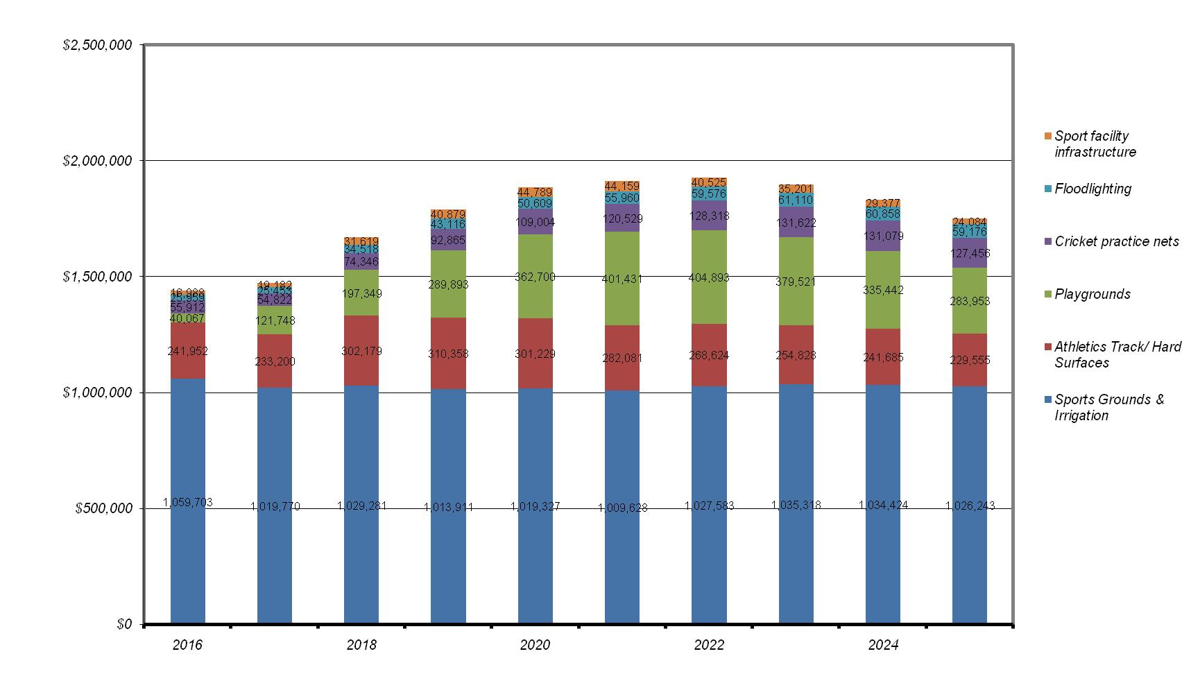

**Figure 9: Predicted Renewal Split by Major Component of the Open Spaces Assets Group**

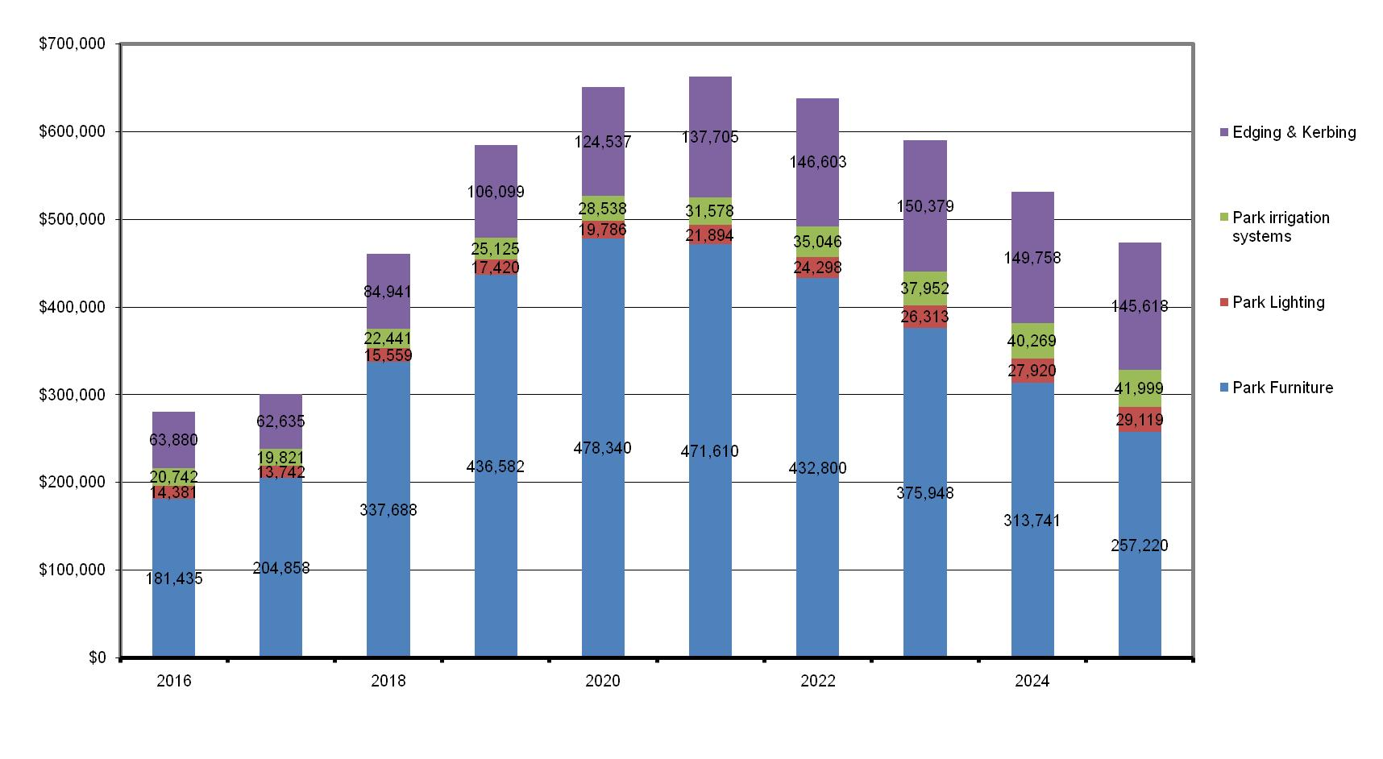

Figures 9 and 10 compare the predicted annual renewal requirement against the proposed expenditure (i.e. the current level of expenditure projected across 2015 – 2025). It should be noted that while proposed expenditure over the next 2 years is above that predicted by the model, after 2014/15 proposed renewal expenditure falls short of the predicted requirement.

**Figure 10: Predicted Renewal Requirement v Current Proposed Renewal Expenditure – All Recreation Assets Group[14]**

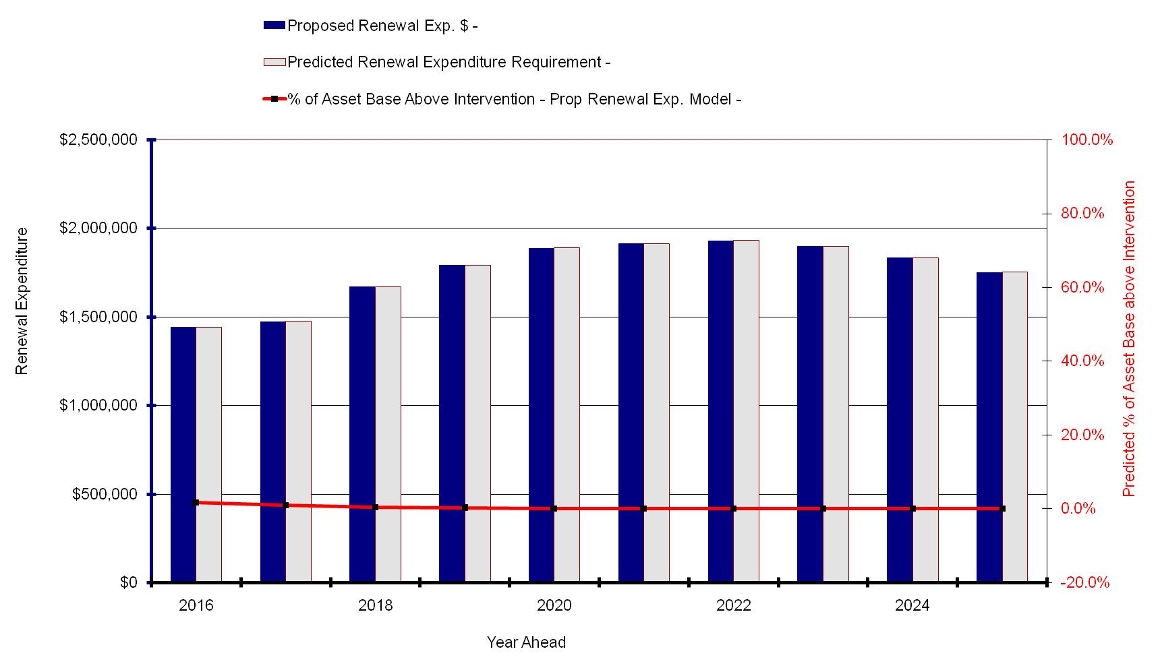

**Figure 11: Predicted Renewal Requirement v Current Proposed Renewal Expenditure – All Open Spaces Assets Group (Data source is file: Asset Graphs, Open Space Group, Graph 4)[15]**

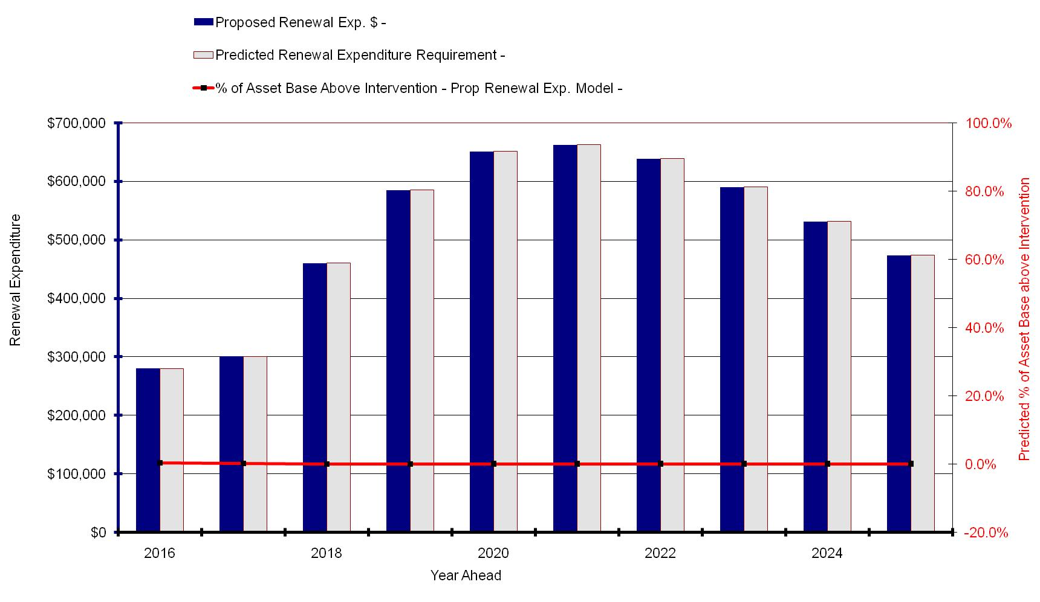

# 6.0 Inputs to the Recreation and Open Space Financial Forecast

## 6.1 Overview

The financial requirements resulting from the information presented in preceding sections of the R&OS-AMP are summarised below. These financial projections will continue to improve in accuracy as further information becomes available on the expectations of levels of service from the community and on current and projected asset performance.

These projections will need to be reviewed annually to reflect the actual funding allocated and the scope of the works achieved. For example, if only a fraction of the required renewal budget is allocated or a fraction of the renewal work can be completed within the allocated budget, the result will be a significant impact on the future funding needs and overall asset performance targets being met.

## 6.2 Service Financial Forecasts

The figures presented below in Table 15 summarise the funding requirements for recreation and open space assets over the next 10 years.

**Table 15: Recreation and Open Space Asset Services Projected Funding Requirements**

|  |  |  |  |
| --- | --- | --- | --- |
| Year | Capital Expenditure | | Operations and Maintenance Expenditure |
| Renewals | New Assets & Upgrades |

|  |  |  |  |
| --- | --- | --- | --- |
| 2015/16 | $1,721,022 | $4,620,000 | $10,693,874 |
| 2016/17 | $1,775,233 | $3,853,000 | $11,014,690 |
| 2017/18 | $2,129,922 | $3,958,000 | $11,345,131 |
| 2018/19 | $2,376,248 | $3,427,000 | $11,685,485 |
| 2019/20 | $2,538,859 | $7,780,000 | $12,036,049 |
| 2020/21 | $2,576,575 | $3,279,000 | $12,397,131 |
| 2021/22 | $2,568,265 | $3,789,000 | $12,769,045 |
| 2022/23 | $2,488,192 | $4,928,000 | $13,152,116 |
| 2023/24 | $2,364,553 | $5,125,000 | $13,546,680 |
| 2024/25 | $2,224,423 | $5,330,000 | $13,953,080 |
| **Totals** | **$22,763,292** | **$46,089,000** | **$122,593,281** |

## 6.3 Key Assumptions

The financial forecasts are subject to and limited by the following assumptions:

* The renewal costs are based on the asset data register (AIM) as at 30 June 2015.
* Modelled outcomes are derived using the Moloney Model and are therefore subject to the limitations of that model and data is used in it., which includes the assumed performance of the asset types and trigger intervention levels.
* Useful Service Lives derived from the asset register are assumed to be a reasonable estimate of the life of the assets.
* Asset quantities within the asset register are assumed to be correct.

# 7.0 Asset Management Improvements

An active and effective asset management strategy should include continuous review and improvement of the system, data and processes used to manage the assets. Table 16 below identifies areas for potential improvement to facilitate better asset management planning and practice.

## 7.1 Improvement Plan

**Table 16: AM Improvement Plan Action List**

|  |  |  |  |  |
| --- | --- | --- | --- | --- |
| **No.** | **Improvement** | **Responsibility** | **Priority** | **Target** |
|  | Continue to work towards integration of CVR, SAM and GIS.  Update CVR & align with Authority (AIM) and Moloney.  Develop role and responsibility matrix. Detail individual positions and work groups and their function. Update Asset Database classify all assets into areas of responsibility. | Coordinator Asset Management | Medium | Ongoing |
|  | Identify assets not addressed within the scope of this R&OS-AMP based on a criticality assessment. | Coordinator Asset Management | High | 16/17 |
|  | Determine a program and propose a renewal allocation in the Capital Works Program for trees | Manager Environment Sustainability and Open Space | High | 16/17 |
|  | Continue to develop and cross reference Asset Upgrade Strategies, Place-based Strategies, Service Strategies and undertake Strategic Service Reviews that document the future service needs for recreation and open space infrastructure.  Previously completed SSRs that did not consider asset requirements need to be revisited and long term asset requirements determined. | Service-driven Asset Management COG | High | ongoing |
|  | Risk Criteria needs to be developed for key recreation and open spaces to assist work programming and capital works prioritisation | Coordinator Asset Management | Medium | 16/17 |
| 4. | Clarify and review the maintenance and renewal arrangements for all lease and other tenancy agreements (e.g. golf courses, sports facilities) relating to Council owned recreation and open spaces and assess their impact on Moloney Modelling and the R&OS-AMP. | Coordinator Asset Management | High | 16/17 |
| 5. | Continue to clarify and review maintenance and renewal arrangements for all lease and other tenancy agreements and assess their impact on Moloney Modelling and the R&OS-AMP. | Recreation and Events Coordinator  Coordinator Asset Management | High | 16/17 |
| 6. | In preparation for the development of a Strategic Service Management Plan for Trees, review:  Improved estimating remaining life and replacement modelling;  Footpath planting protocols; and  Future planting programs and funding, including current backlog | Coordinator Asset Management | Medium | 17/18 |
| 7. | Identify areas and develop a strategy for the rejuvenation or renewal of garden beds and turf in Parks that are not meeting expected level of service requirements. | ESOS  Coordinator Asset Management | Medium | 17/18 |
| 8. | Undertake an audit and condition assessment of structural infrastructure such as sea wall etc. along foreshore reserves and review lifecycle renewal implications | Coordinator Asset Management | High | 16/17 |
| 9. | Develop and document a condition assessment methodology for recreation and open space assets to ensure accuracy and repeatability of condition scoring | Coordinator Asset Management | Medium | 16/17 |
| 10. | Review recreation and open spaces contract specification and update to include any outstanding asset management issues at least six months prior to tendering. | Coordinator Asset Management | Medium | 16/17 |
| 11 | Determine the replacement of trees within renewal model of R&OS-AMP | Coordinator Asset Management | Medium | 17/18 |
| 12 | The remaining useful lives of all infrastructure associated with various types of open spaces is to be determined and documented in this plan | Coordinator Asset Management | Medium | 17/18 for critical assets (ongoing) |

# 8.0 Standards, Manuals, Guidelines & Reports

Key standards, manuals, guidelines & reports include:

1. International Infrastructure Management Manual, Version 3.0 - 2006 - Institute of Public Works Engineering Australia (IPWEA)
2. Australian Infrastructure Financial Management Guidelines, Edition 1.0 - 2009 - IPWEA
3. Developing Levels of Service Performance Measures (Creating Customer Value from Community Assets) – Version 2.0, NAMS (NZ) 2007
4. Sustaining Local Assets – Policy Statement 2003, DVC
5. Accounting for Infrastructure Assets – Guidelines 2003, DVC
6. Australian Accounting Standard AAS27
7. MAV Asset Management Improvement STEP Program – Asset Management Plan Framework 2004.
8. Asset Management Procedure Manual – Department of Infrastructure, Government of Victoria, May 1999.
9. City of Bayside, 2011, Council Community Engagement Policy 11 October 2011
10. Pruning of Amenity Trees, AS 4373-2007, Australian Standards
11. Protection of Trees on Development Sites, AS 4970-2009, Australian Standards
12. Tree Stock for Landscape Use, AS 2303-2015, Australian Standards
13. The Electricity Safety Act 1998, Victorian Government
14. Electricity Safety (Electric Line Clearance) Regulations 2015, Victorian Government
15. Code of Practice, VicRoads

# 9.0 Reference Documents

1. Bayside Asset Management Procedures Manual 2011

# 10.0 Appendices

Appendix 1 – Functional Recreation and Open Space Hierarchy Criteria

Appendix 2 – Functional Facility Hierarchy Classification

Appendix 3 - Response Times - Request for Service

Appendix 4 - General Service Levels

Appendix 5 – Condition rating scale

Appendix 6 – Key Assumptions in Moloney Modelling Expenditure Forecasts

## Appendix 1 – Functional Recreation and Open Space Hierarchy Criteria

|  |  |  |  |  |  |
| --- | --- | --- | --- | --- | --- |
| **Functional Activity**  **Criterion** | **State or National Significance** | **Regional Significance** | **District Significance** | **Local Area Significance** | **Neighbourhood Significance** |
| **\* Essential Criteria** | Must be the primary facility of this nature within the State | Must be the Primary facility of this nature within the Region | Must be the Primary facility of this nature within the Municipal district * | Must be the Primary facility of this nature within the Local Area/Town/Suburb. | A facility servicing the properties within a block or two (400m) – easy walking distance. |
| **1 Predominant Activity** | Major facility that provides the primary service/purpose for that facility within the State or Nation | A facility that provides a service/function to a wider catchment of people than just those that live within the municipal district in which the facility is located. | A facility where the primary service/function is directed toward the residents of the municipality district in which the facility is located. | A facility where the primary service/function is directed toward a subset, e.g. a town or suburb, of the municipal district in which the facility is located | A facility where the primary service/function is directed toward the local neighbourhood (as described above). |
| **2 Historic Significance** | Listed on the Register of the National Estate or the National Heritage List or Listed on the State Heritage or Interim State Heritage inventory detailing significance to the State or Nation | State Heritage Inventory or Interim State Heritage Inventory Listing detailing significance to the Region | Listed on the Council’s Municipal Heritage Inventory | No Heritage Listing | No Heritage Listing |
| **3 Social/Cultural Value or Economic Benefit** | Of social and/or cultural significance or provides an economic benefit to the state | Of social and/or cultural significance or provides an economic benefit to the region | Of social and/or cultural significance or provides an economic benefit to the municipality. | Of social and/or cultural significance or provides an economic benefit to the local area | Of social and/or cultural significance or provides an economic benefit to the neighbourhood |
| **4 Part of a Network** | Forms part of a network of similar facilities between States | Forms part of a network of similar facilities across a State or land division or region of the State | Forms part of a network of similar facilities between municipalities. | Forms part of a network of similar facilities across the municipal area. | Is not necessarily part of a network of similar facilities |

***\* Municipal district*** means the district under the local government of a Council (LG Act 1989, Victoria)

## Appendix 2 – Functional Facility Hierarchy Classification

The recommended Bayside Functional Recreation and Open Space Hierarchy is categorised in **Appendix 1** and further description is as follows:

Category 1 – National/State Significance: Public facilities utilised to deliver services of significance to the State or Nation. Generally only one facility of this nature would exist in the state.

Category 2 – Regional Significance: These types of facilities provide for functions that are of regional significance, i.e. a large proportion of users come from outside of the district. Generally only one facility of this nature would exist within the region. A facility of this nature would have a high usage rate and could be expected to be multi-purpose or single purpose.

Category 3 – District Significance: These types of facilities provide for functions that are of significance to the district. They are used mainly by people living within the municipal district and from across municipal boundaries. Examples would be foreshore reserves, major open space reserves, sports ovals or skate-park. Facilities of this nature would have high frequency of use and could be multipurpose or single purpose.

Category 4 – Local Area Significance: These types of facilities provide for functions that are of local significance. They are used mainly by people living within a suburb, town, ward or local area. Examples would be a local park or a well-equipped children’s playground.

Category 5 – Neighbourhood Significance: These types of facilities provide for functions that are of immediate neighbourhood significance. They are mainly used by people within a block or two of where they live such as a small local children’s playground.

Ideally, when considering facility networks, every facility would need to meet all of the criteria of one Functional Facility Hierarchy type. However, many facilities meet some of the criteria appropriate to several different hierarchal types and are designated by determining the majority of criteria that apply. All must meet at least one ‘AA’ Essential Criteria.

Criterion 1- Predominant Activity

The main service or purpose that a facility provides

Criterion 2- Historical Significance

The heritage value the facility has to the community as defined by national, state and local heritage registers. Significant State tourist destinations may require a higher standard than will usually apply because of tourist recognition and iconic status

Criterion 3- Social/Cultural Value or Economic Benefit

The importance the community places on having the facility, or the level of economic benefit the facility either provides directly or indirectly by assisting in service delivery

Criterion 4- Network

Whether the facility forms part of a network of similar facilities across a given area  
i.e. the impact the facility has on the network if it is removed from service.

## Appendix 3 Response Times - Request for Service

|  |  |  |  |  |
| --- | --- | --- | --- | --- |
| **The Contractor shall respond to any complaints or requests for maintenance service within the times below.** | | | | |
| **Level** | **Intervention Type** | **Description** | **Response Time**  **Inspection On-site** | **Completion Time** |
| **1** | **Emergency Response (including call outs)** | Includes after hours call-outs. Works required to render safe any potentially dangerous situations that may be life threatening or detrimental to public health or safety or there has been a breach of asset security.  Action: Attend on-site & make safe | All recreation and open spaces  30 minutes | 30 minutes |
| **2** | **Urgent Response** | This applies to all situations where a hazardous or unsafe condition exists and requires urgent action. Action: Attend on-site & make safe | 2 hours | 2 hours |
| **3** | **Important Response** | This level applies to situations where it is considered potentially hazardous to asset users or significantly affects service, but is not considered urgent. Action: Attend on-site & make safe | 2 days | 2 days |
| **4** | **Written response to correspondence (letter)** | As per the Bayside Customer Service Charter | N/A | 10 working days |
| **Written response to correspondence (email)** | As per the Bayside Customer Service Charter | N/A | 1 working day |
| **Written response to complaint** | As per contract | N/A | 10 working days |
| **5** | **All Other Requests** | Action: Complete request | N/A | 10 working days |

## Appendix 4 - General Service Levels

|  |  |  |  |  |  |  |
| --- | --- | --- | --- | --- | --- | --- |
| **Performance Indicator** | **Level of Service** | **Performance Measurement Process** | **Target Performance** | **Current Performance** | **Actions to meet Performance Target** | **Resources Required** |
| **Legislative Compliance** | Compliance with all legislation, regulations and standards. | Audits as required | 100% compliance | 100% |  |  |
| **Safety** | To ensure all users, staff and contractors have personal safety with minimal health risk. | Hazards identified by audits or customer request to be made safe and appropriately dealt with. | No injuries due to recreation and open space defects or condition. | Hazards are being identified and dealt with through Council’s Service Providers. Service Providers have response times as set by contract and currently meeting these requirements. | An assessment required of condition and recreation and open spaces then brought up to appropriate level. | 1. Consultants required for assessments.  2. Internal resources.  3. Funding to bring condition to required standard.  4. Service Providers |
| **Condition** | All recreation and open spaces will meet condition standards as defined by category. | Regular condition audits to monitor progress. | 60% of recreation and open spaces assessed as good, better or average condition (see Figure 6. | Defects audited annually, then prioritised and works carried out if resources allow. | 1. Condition audits every 3-5 years  2. Audit results to be used for future planning.  3. Ensure maintenance and renewal is funded to required level. | 1. Possibly external consultants or internal staff trained to carry out audits.  2. Maintenance and renewal funding |
| **Utilisation** | Recreation and open spaces used to their full potential | Annual assessment of usage levels.  Recreation and open spaces used within capacity. | Bayside’s recreation and outdoor assets are heavily utilised. | More information is required upon expected utilisation. This is to be determined in Strategic Service Review. | 1. Establish usage rates with internal staff and users.  2. Establish capacity of recreation and open spaces.  3. Establish possible hours open, actual hours open and hours used. | Internal Resources |
| **Customer Satisfaction**  **(Internal & External)** | User satisfaction with  Appearance  Fitness for use  Comfort  Availability  Communication | Biennial customer survey | Bayside’s performance for recreation and open space assets was benchmarked against the State average. For recreation assets, the Statewide was 74, and for ‘public areas’ the average was 72. | Recreational assets received a score of 71 and a score of 74 for open space (public areas).[16] | 1. An initial assessment of users to established what will satisfy needs in regards to:  Appearance  Fitness for use  Comfort  Availability  Communication | Internal Resources |
| **Environment** | A commitment to continually improve environmental efficiencies. | Using sound environmental practices. | 100% of all new recreation and open spaces and upgrades to existing recreation and open spaces to be designed to minimise environmental impacts.   Reduce energy & water consumption   Use buy recycle products where possible | Not yet assessed | 1. Develop policy and procedures to minimise energy use.  2. Staff and service provider training.  3. Identify recycled products that can be used in the maintenance, renewal or upgrade of recreation and open spaces. | Internal Resources |
| **Cost effectiveness** | To provide the required services in the most cost effective manner | Review recreation and open space life cycle costs and identify areas for improvement.  Audit of maintenance and capital works for costs and standard of works. | To provide the required services in the most cost effective manner | Council manages maintenance and capital works well currently.  Life cycle cost reviews not currently being done. | 1. Supervision of service providers.  2. Capture and assess all life cycle costs per recreation and open space. | Internal Resources  Service Providers |

## Appendix 5 - Condition Rating Scale

|  |  |
| --- | --- |
| **Rating** | **Condition Rating Description** |
| **0** | A new asset or an asset recently rehabilitated back to new condition. |
| **1** | A near new asset with no visible signs of deterioration often moved to condition 1 based upon the time since construction rather than observed condition decline. |
| **2** | An asset in excellent overall condition. There would be only very slight condition decline but it would be obvious that the asset was no longer in new condition. |
| **3** | An asset in very good overall condition but with some early stages of deterioration evident, but the deterioration still minor in nature and causing no serviceability problems. |
| **4** | An asset in good overall condition but with some obvious deterioration evident, serviceability would be impaired very slightly. |
| **5** | An asset in fair overall condition deterioration in condition would be obvious and there would be some serviceability loss. |
| **6** | An asset in Fair to poor overall condition. The condition deterioration would be quite obvious. Asset serviceability would now be affected and maintenance cost would be rising. |
| **7** | An asset in poor overall condition deterioration would be quite severe and would be starting to limit the serviceability of the asset. Maintenance cost would be high |
| **8** | An asset in very poor overall condition with serviceability now being heavily impacted upon by the poor condition. Maintenance cost would be very high and the asset would at a point where it needed to be rehabilitated. |
| **9** | An asset in extremely poor condition with severe serviceability problems and needing rehabilitation immediately. Could also be a risk to remain in service |
| **10** | An asset that has failed is no longer serviceable and should not remain in service. There would be an extreme risk in leaving the asset in service. |

# 

## Appendix 6 – Key Assumptions in Moloney Modelling Expenditure Forecasts

Section 10.3 of Council’s Long Term Financial Plan 2016/17 – 2025/26 sets out the major financial assumptions applicable to the financial options considered by Council prior to community input.

The following are general assumptions relating to the asset group that have been made in preparing the group’s 10-year expenditure forecasts:

* Recreation and open space assets will remain in Council ownership throughout the planning period.
* There no allowance for CPI as the continuing revaluation and condition inspection process will make adjustments for current rates.
* All expenditure is stated in current dollar values with no allowance made for inflation or other escalations over this period.
* Capital renewal program has funding allocated as set out in Council’s Long Term Financial Plan (LTFP).
* The basis for renewals is the Moloney Renewal Financial Model which is used for the LTFP for all asset groups.
* Maintenance costs are based largely on historical industry expenditure and assume there is no significant change in contract rates (above the rate of inflation).
* The condition and size of the network as stated at 30 June 2015
* No growth in the asset base.
* Continued use of current construction techniques and materials.
* Maintenance and isolated failure replacement is generally “like for like”.
* Capitalisation threshold applied to minimum expenditure for maintenance within a single segment as per Council’s Asset Capitalisation Threshold Policy.
* Other equipment and furniture of less than $5,000 in value is to be a service provider’s operational cost.
* Operational Administration overheads and other non-asset maintenance costs such as cleaning are not included in the modelling; these will require separate budget consideration via other accounts.
* Depreciation is in accordance with Council Policy.
* Renewal works will be prioritised according to condition reaching RICL stated.
* Risk management mitigation works will be subject to the Capitalisation threshold.

1. http://www.bayside.vic.gov.au/living_in_bayside/6590.htm
2. Strategic Service Review Framework, 21 October 2014, FOL/13/33581
3. Deloitte, Service Driven Asset Management, July 2012, DOC/12/84970
4. University of Western Sydney Urban Research Centre, 2011, Local Government and Ageing, page 4
5. DOC/12/55184 & DOC/12/55185
6. http://www.bayside.vic.gov.au/about_the_Council/plans_policies_and_budgets.htm
7. Source: http://www.dsidsc.com/images/ph-me-asset-management-life-cycle.png
8. DOC/12/56629
9. Data from Moloney Model (DOC/16/53719)
10. http://www.bayside.vic.gov.au/about_the_Council/500k_upgrades_at_Cheltenham_Park.htm
11. Figures from Power Budget Report DOC/16/12952, 2014-15 Actuals & 2015/16 Adjusted Budget - Capital & Operating - Info for Asset Management. Does not include ESOS budget.
12. Bayside financial records
13. Data source is file: Asset Graphs, Recreation Group, DOC/16/53719
14. Data source is file: Asset Graphs, Recreation Group, Graph 4 DOC/16/53719
15. Data source is file: Asset Graphs, Open Space Group, DOC/16/53719
16. Local Government Community Satisfaction Survey 2015 (Bayside), DOC/15/91073