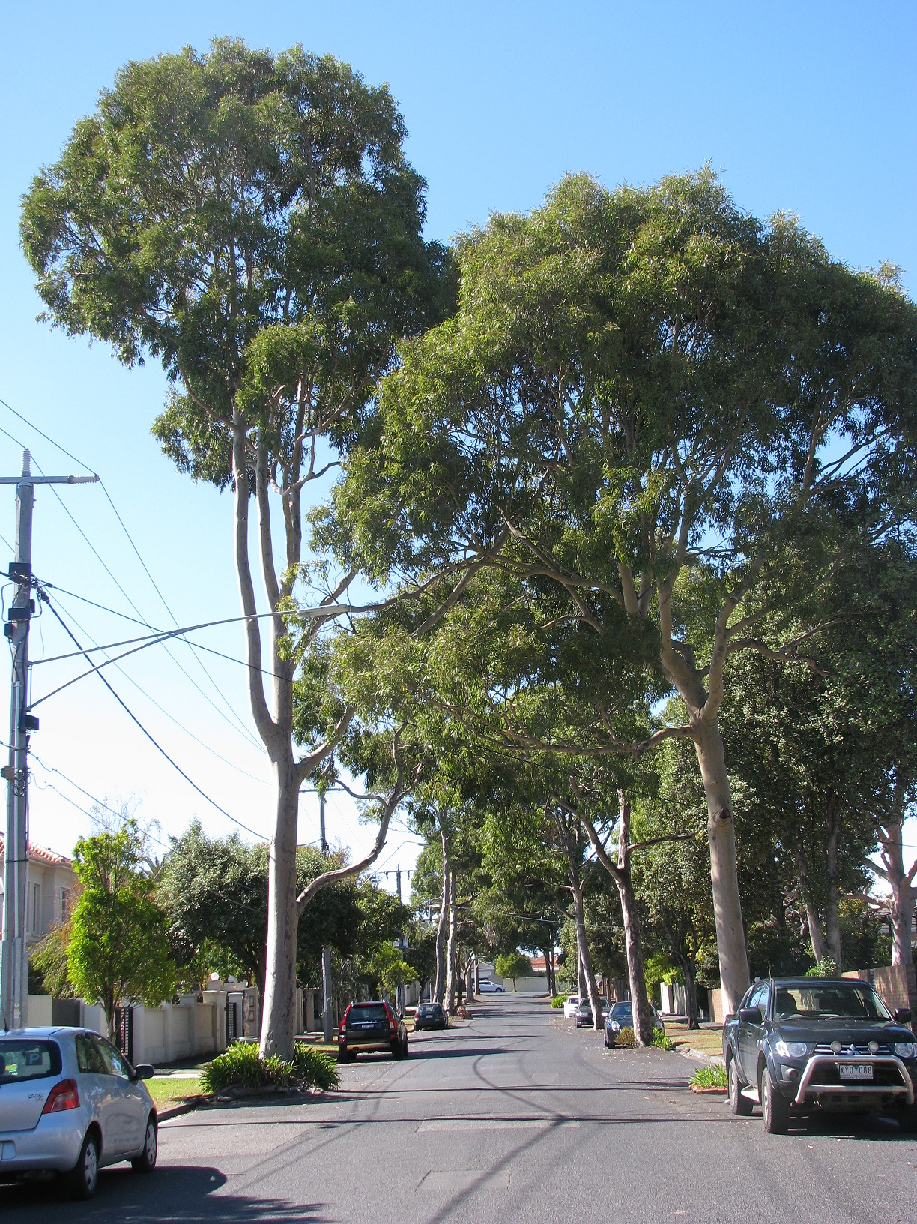

Preamble

Bayside City Council is known for its picturesque setting, parks and tree lined streets. These qualities contribute significantly to the liveability of the municipality.
Successful street and park tree plantings require planning and management to ensure they make a positive contribution to the landscape. Street trees must be tolerant of harsh environmental conditions e.g. soil compaction and competition for nutrients and water. They must also be tolerant of potential root disturbance from construction and utility maintenance or repair works and over their lifespan should have minimal impact on surrounding infrastructure.
Bayside’s Street and Park Tree Selection Guide 2015 will streamline the selection process by providing a list of species that are suitable for each nature strip type, based on the existing conditions, constraints and landscape character, with the aim of maximising the benefits of the trees over the longest possible period.
This guide highlights the complexities involved in street and park tree selection.
Park tree selection will be based upon the existing character of the park and the precinct it sits within.
Street tree selection will be based upon the existing character of the precinct and the constraints of the nature strip.

Contents

Preamble 1
Introduction 6
The benefits of trees 6
The importance of the urban forest 7
Landscape character of Bayside 8
Current Management 9
Understorey 9
Species diversity 10
Diversity in Bayside’s street tree population 10
Precincts 13
Brighton/Brighton North 14
North Road 15
Brighton East 16
Hampton 17
Sandringham 17
Highett / Hampton East 18
Cheltenham 18
Beaumaris and Black Rock 19
Existing street trees 21
Nature strip type 21
Soil type 22
Salt tolerance 23
Power lines 23
Planting styles 24
Cut outs 25
Roundabouts 25
Boulevards 26
Adding new tree species to the selection list 26
Street tree selection summary 26
APPENDIX 1: Species selection process for street trees 27
APPENDIX 2: Selection criteria for street trees 28
APPENDIX 3: Species selection for park trees 29
APPENDIX 4: Selection criteria for park trees 30
APPENDIX 5: Species list 29

Introduction

The benefits of trees

Trees in cities provide the following benefits:
Environmental
- Providing habitat and attracting fauna.
- Improving air quality by removing pollutants.
- Reducing stormwater run-off by intercepting rainfall.
- Sequestering carbon, and contributing to reduction of carbon in the atmosphere.
Social
- Improving local amenity through aesthetic value.
- Increased enjoyment of outdoor space; increased sense of safety and reduced crime rates.
- Health benefits, including wellbeing and reduction in UV exposure by shading footpaths/parks.
- Reducing the urban heat island effect by shading, transpiring and reducing wind speeds. Through aiding in the reduction of extreme summer heat, adverse health effects are decreased.
Economic
- Lowering road maintenance costs, as the shading of bitumen extends its life compared with bitumen in full sun.
- Reducing energy costs, as the cooling provided by trees reduces the need for air conditioning.
- Increasing property values, as it has been shown that street trees provide a positive impact on residential values.
- Increasing tourism as people are attracted to areas with more vegetation.

The importance of the urban forest
There is strong evidence demonstrating that the benefits of urban trees greatly outweigh the costs of their establishment and maintenance. Trees can increase the monetary value of a property by up to 30 per cent and provide improved health benefits in the urban environment. The importance of street and park trees, an explanation of our current tree selection and management practices are outlined below.
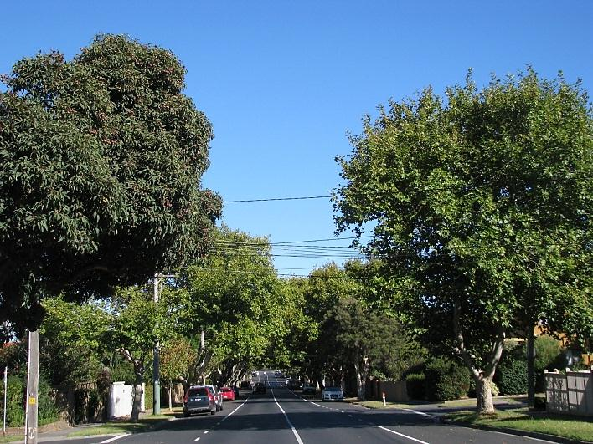
Large mature street trees.

All trees and other vegetation in cities make up what is termed an “urban forest”. Trees on public and private land provide the canopy cover for the urban forest. Local Councils and other authorities are responsible for the management of public trees along roadways and in public parks and reserves.
Local Councils such as Bayside have a history of successful street and park tree planting programs. Nature strips and median strips in road reserves provide valuable opportunities for planting street trees. Local Councils are setting targets to increase the amount of canopy cover in these zones. However, subdivision of properties can impact on Council’s ability to increase canopy cover due to reduced available public and private planting sites. In the long term, the success of these tree plantings is reliant on species selection.
Although larger trees provide the greatest benefits, a healthy urban forest has a diverse range of tree sizes and contains trees of different ages. Trees of different sizes are required for sites with various physical constraints. By having trees of different ages, the higher costs of planting and establishment can be spread over many years.
A resilient urban forest has a diverse range of species. A limited list of successful species may provide good results in the short term, but may result in a vulnerable tree population. In the long term, pests or diseases that attack one or more of those species have the potential to significantly reduce the street tree population over a short period. An example of this is Sudden Oak Death in the United States, or the recent introduction of Myrtle Rust into the east coast of Australia, which has prompted a large-scale response from authorities to understand and manage this disease.
A single pathogen has the potential to not only affect a species or genus, but an entire family of plants. Therefore diversity is required at the species level, the genus level and the family level.

Landscape character of Bayside
Several landscape character types have been identified in the City of Bayside. Features that contribute to this character include architecture types, property sizes, garden character, location, proximity to the bay, land use (e.g. commercial, retail or residential), road widths and predominant vegetation types (e.g. native, indigenous or exotic). Street trees form a significant element of each character type; good species selection further enhances local neighbourhood character.
At present there are over 300 different street tree species within Bayside. While many of these were planted as a result of careful planning and selection, others are a result of ad hoc plantings, resident plantings, and self-sown trees. Therefore the list of recommended species is shorter than what currently exists in the landscape. In some cases, trees which are no longer recommended for a nature strip type have been planted into streets. Where this planting has occurred it is intended that these trees will remain, until such time as they do not meet the criteria within the Street and Park Tree Management Policy. Infill planting will continue to occur in existing avenues of matures trees, even if the species is not listed in this guideline.

Current Management
The Street and Park Tree Management Policy states that Council aims to have 100% of suitable sites planted with a tree.
Bayside has an active management program for maintenance of its trees. Every public tree in the municipality is inspected at a minimum on a two year cycle. Tree selection for replacements and identified new sites are determined by this guide. Maintenance of existing character has been the single most important determinant in species selection.
There are several documents that are currently used to inform tree planting in Bayside.
- Street and Park Tree Management Policy (2016)
- Street and Park Tree Selection Guide (2016)
- Bayside Street Trees: An Evaluation (1997 Landscape Victoria)
- Urban Character Report 1999 (Ratio Consultants)
- Bayside Vegetation Character Assessment (2000 John Patrick)
- Bayside Neighbourhood Character Review (2008 Planisphere)
A Streetscape Assessment conducted in 1997 provided a large amount of information on the infrastructure found in each street and identified 14 somewhat distinctive landscape character precincts. Subsequent documents such as the Bayside Vegetation Character Assessment (2000) provide further information that assists in refining tree species selection for streets. The general nature of the precinct character descriptions has guided the landscape contribution requirements for street tree selection.
Bayside City Council has a tree database that keeps a record of every Bayside street, park or carpark tree planted, inspected and works undertaken. This database can be used to identify poorly performing species and to direct future planting choices.

Understorey
Understorey planting in parks is not the primary focus of this document. However, in general terms the default position is to plant indigenous or native species unless otherwise stated by a Park Masterplan or is the existing character of a Park or Public garden. Understorey planting within Vegetation Protection Overlay 3 are indigenous species, however, some exceptions are formal gardens i.e. Black Rock House.

Species diversity
The majority of Bayside’s street and park trees belong to 15 botanical families, with approximately 58% in the family Myrtaceae. This leaves the tree population somewhat vulnerable to severe impacts from pests and diseases, such as the threat posed by Myrtle Rust. Increasing diversity across the street tree population will make the urban forest more resilient. This can be achieved by including tree species from many different botanical families in the planting list.

Diversity in Bayside’s street tree population
As a general guide, no more than 30% of trees should belong to any one plant family, no more than 20% of trees should belong to a single genus, and no species should account for more than 10% of the tree population. Trees such as Eucalyptus, Angophora, Lophostemon, Melaleuca are some of the species that belong to the Myrtaceae family.
Bayside City Council currently manages over 45,000 street trees with a low level of species diversity.

Species diversity within the 2014 Bayside street tree population.

Bayside City Council currently manages over 12,700 park trees, excluding bushland reserves and the foreshore. A low level of diversity exists within this network.

Park tree species diversity within the 2014 Bayside park tree population

The graphs overleaf demonstrate Bayside’s low level of diversity between plant families. This lack of diversity exposes Bayside’s tree population to attack by pest or disease.
Targets will be developed to ensure the tree population remains diverse and resilient in future. Increased diversity at the species level will also increase resilience. This can be achieved by including more species in the planting list.

Commonly occurring street trees (>1% of total) in Bayside, 2014.

Precincts
Nine Streetscape precincts have been identified within the Bayside municipality. Each precinct has its own landscape character. Features that contribute to this character include architecture types, property sizes, private garden character, location, proximity to the bay, land use (e.g. commercial, retail or residential), road widths and predominant vegetation types (e.g. native, indigenous or exotic).
While there are exceptions to each identified character type within each precinct, the precinct descriptions provide a useful guide to the existing character to be considered when choosing street trees.
The precincts are shown below:
- Brighton/Brighton North
- North Road
- Brighton East
- Hampton
- Sandringham
- Highett/Hampton East
- Cheltenham
- Beaumaris
- Black Rock

Brighton/Brighton North
The Brighton landscape is dominated by mature exotic and native trees. A mixture of exotic and native trees will continue to be recommended for planting as street trees and in public parks.

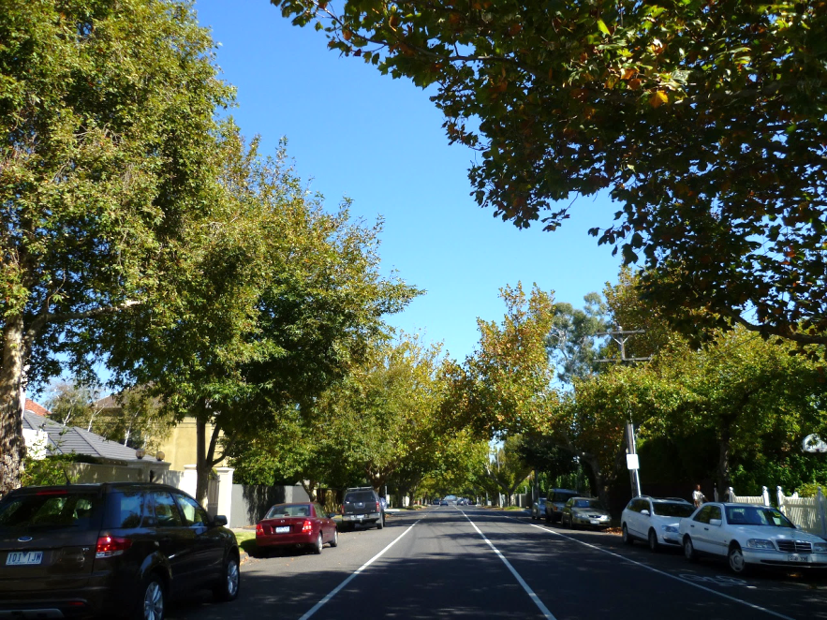
Martin Street, Brighton.
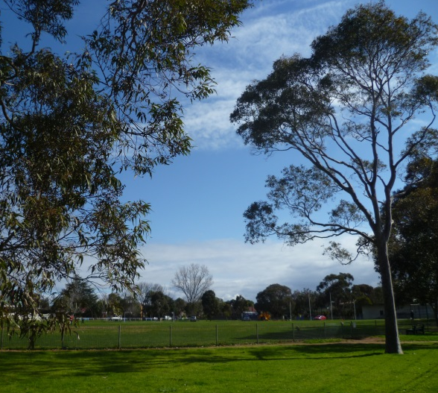
William Street Reserve Brighton

North Road

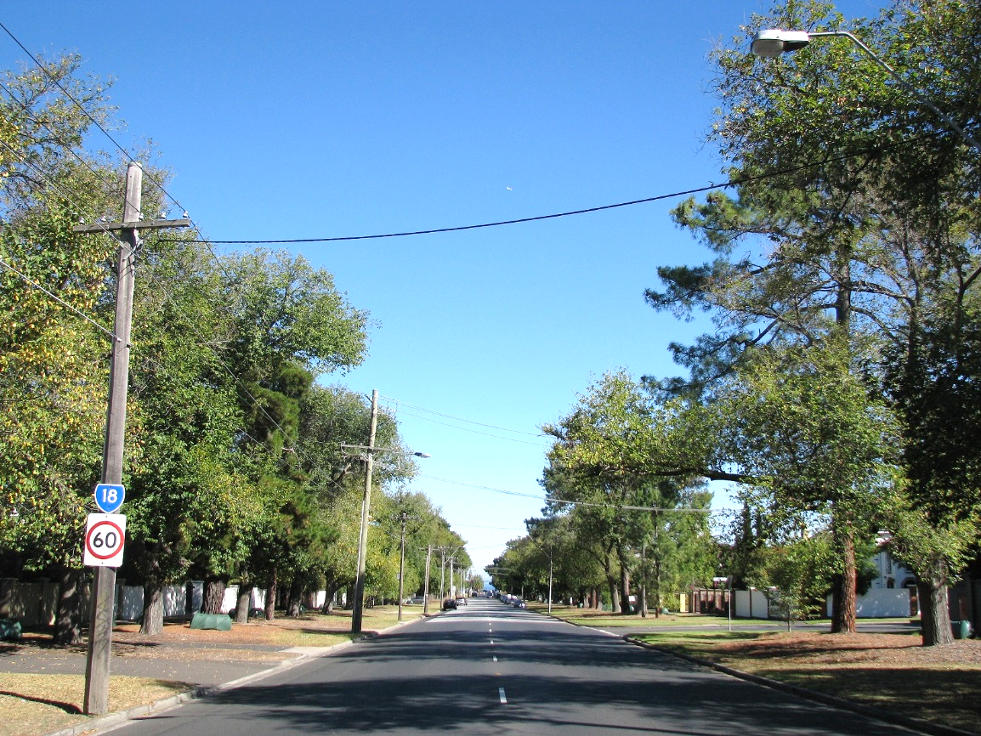
North Road.

The avenue of trees on North Road, Brighton is a significant local landmark. The area between the foreshore and the railway line is protected by a Heritage Overlay in the Bayside Planning Scheme. The mature tree avenue is a dominant feature contributing to this heritage. Predominant species are Elms and Pines, although subsequent ad hoc plantings have occurred. Original plantings included Dutch Elms and Canary Island Pines. Dutch Elm Disease has decimated whole populations of Elm trees elsewhere in the world but to date this disease has not been found in Australia. Canary Island Pines and Elm trees resistant to Dutch Elm Disease will be planted as replacement trees.

Brighton East
East Brighton has a mix of mature native and exotic trees as street trees. A mixture of native and exotic trees will continue to be recommended for future street and park tree planting.
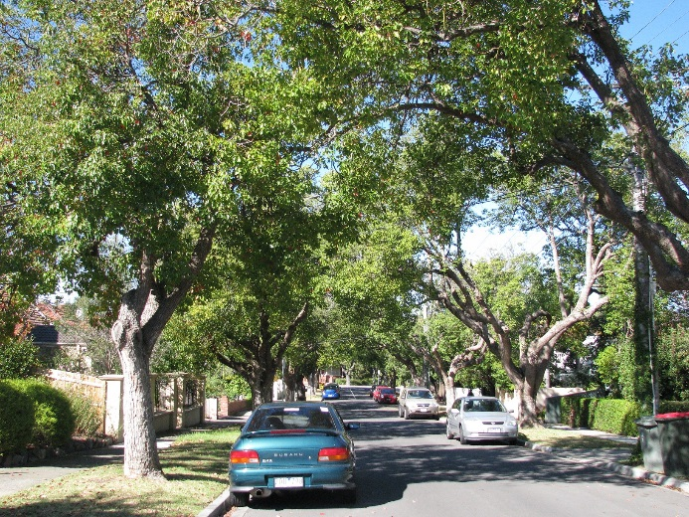
Davies Street, East Brighton.
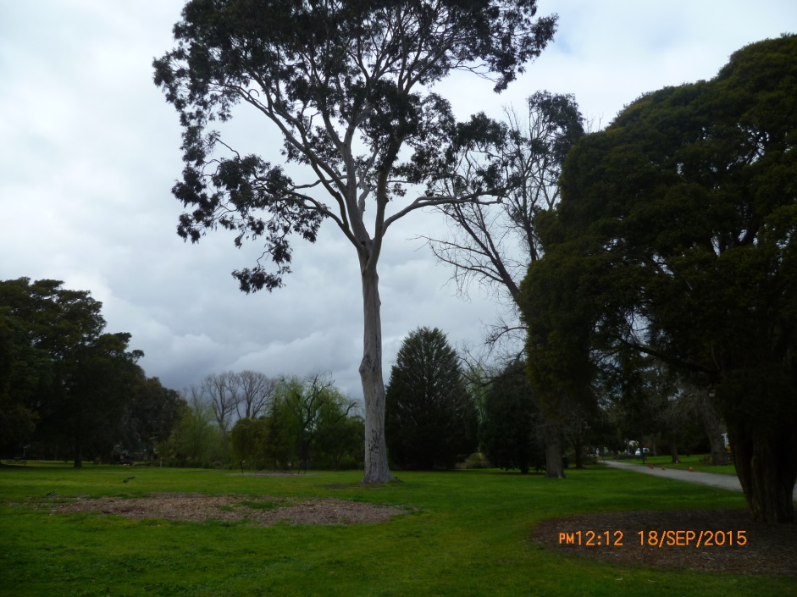
Landcox Park Brighton East

Hampton
Hampton has a mix of native and exotic trees, although native species are dominant. However it is appropriate to continue both native and exotic species. Native and exotic trees will continue to be recommended for future street and park tree planting.
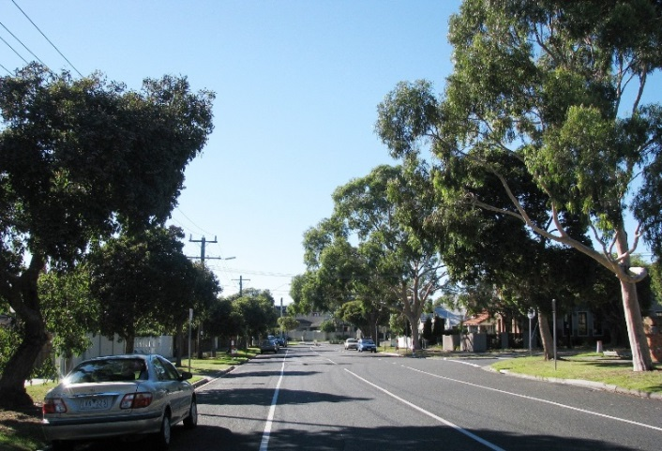Bridge Street, Hampton | 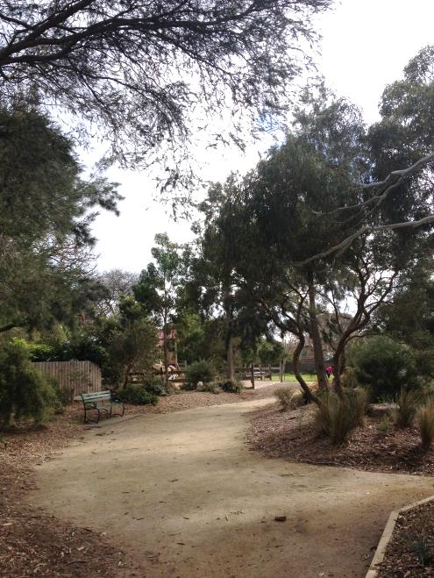  Alexander Park Hampton

Sandringham
Sandringham has a mix of mature native and exotic trees. A mixture of native and exotic trees will continue to be recommended for future street and park tree planting.
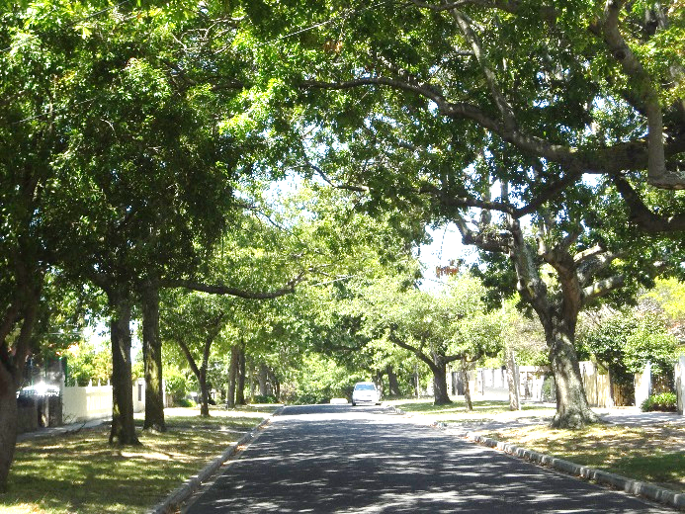  Vincent Street, Sandringham. | 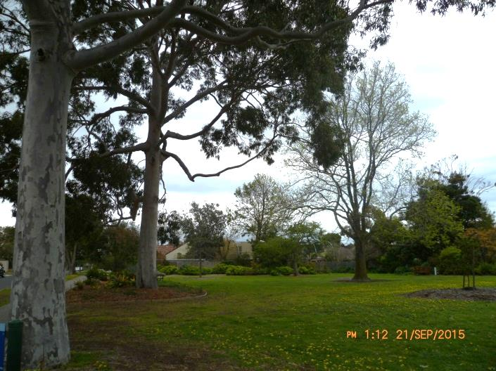  John Batman Park Sandringham

Highett / Hampton East
With relatively lower levels of canopy cover, Highett and Hampton East will benefit from strategic plantings. Native and exotic trees will continue to be recommended for future street and park tree planting.
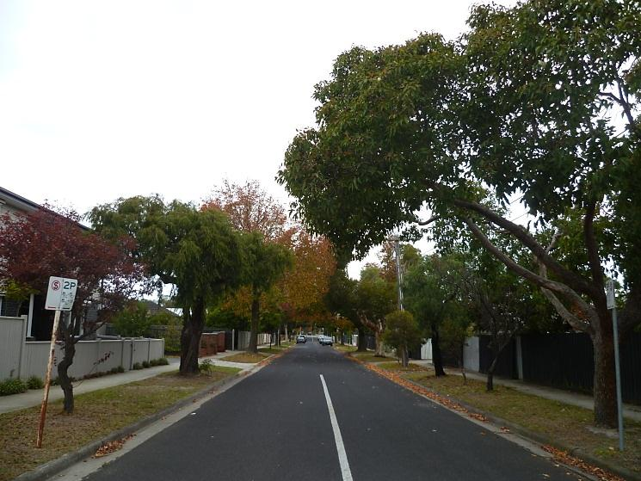  Sydenham St, Highett | 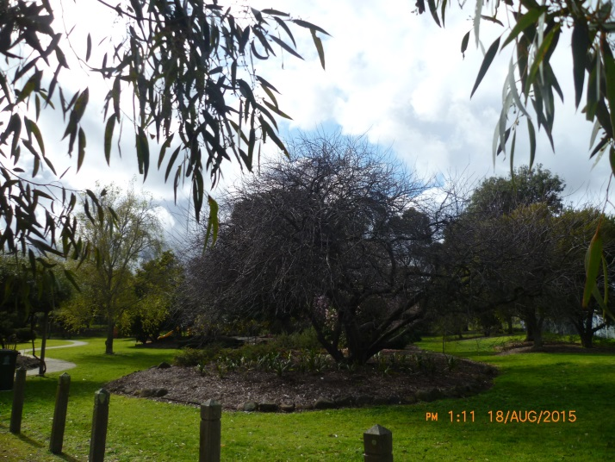  Lyle Anderson Park Highett

Cheltenham
Cheltenham includes many light industrial areas. Some exotic trees are present but natives are dominant. Future plantings will primarily be native except where significant areas of exotic trees already exist. Sections of Cheltenham which are in the VPO3 area to be planted with a minimum of 80% indigenous trees.
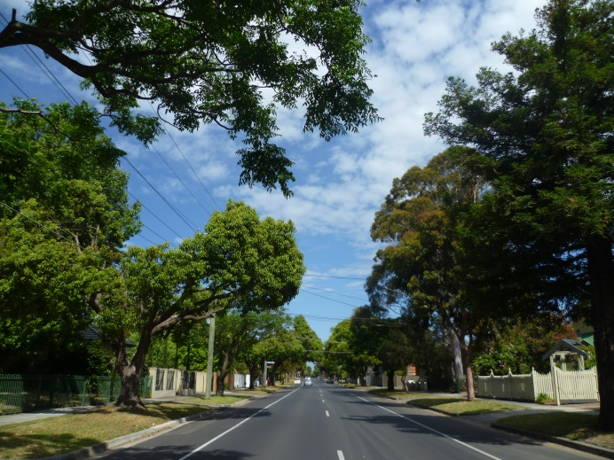  Weatherall Road, Cheltenham. | 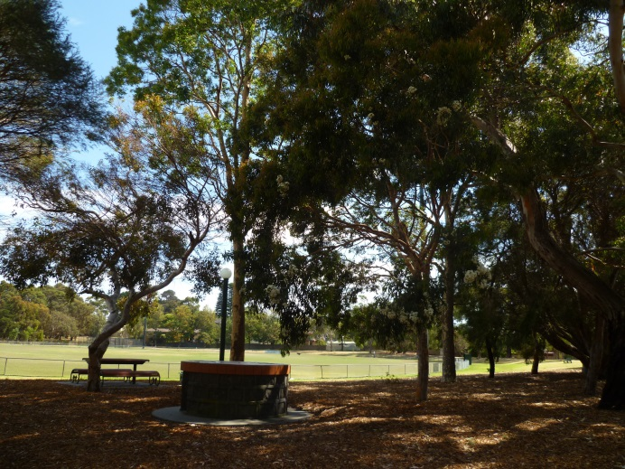  Cheltenham Recreation Reserve Cheltenham.

Beaumaris and Black Rock
Beaumaris and Black Rock both have a distinctive character dominated by natives, local indigenous species. Future plantings should focus on increasing the presence of indigenous species. Black Rock and Beaumaris are in the VPO3 planning overlay area and are to be planted with a minimum of 80% indigenous trees. Native trees may be planted as infill for mature rows of consistent plantings.
Beaumaris  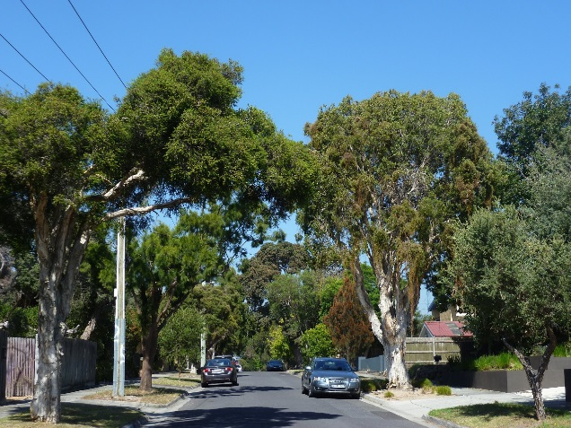  Coreen Avenue, Beaumaris. | Black Rock  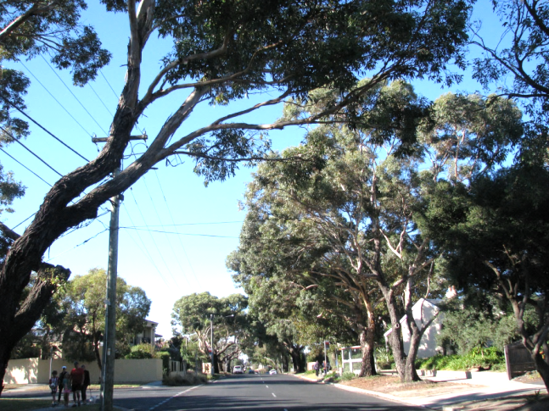Ebden Avenue, Black Rock.
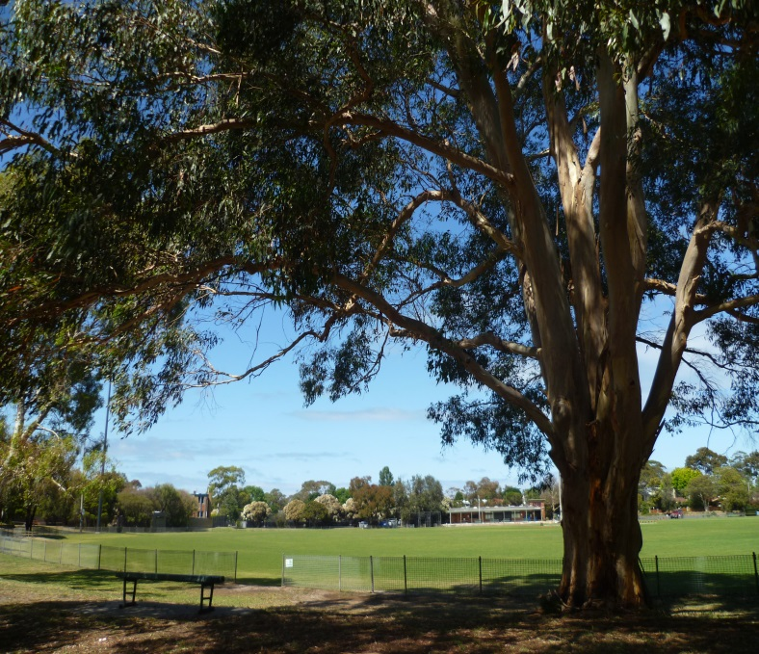  Banksia Reserve Beaumaris | 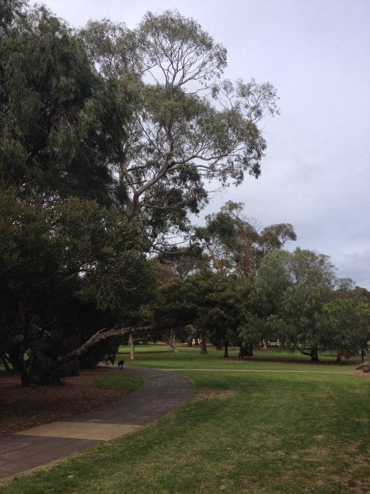  Tricks Reserve Black Rock

Future planting
Bayside is committed to increasing the extent of the street and park tree canopy by planting a tree into every suitable vacant site. Vacant sites become available as trees senesce, are removed for construction purposes, or are damaged during construction works or through vandalism. All streets will be considered for street tree planting.
Future challenges are likely to include:
- Climate change – predicted to alter the frequency, intensity, duration and timing of drought and storm events, which will in turn have an effect on insect and pathogen outbreaks;
- Pressures from increased development and increasing population density;
- Budgetary constraints;
- Challenges of establishing new trees in high-use areas
Selection of tree species can help address these challenges by increasing species diversity and survival rates.
Many of the constraints that are applicable to street tree selection do not apply to the selection of park trees. Therefore, the selection of park trees will be based on;
- Maintaining the existing character of the park
- Consistency with a parks Masterplan (larger parks)
- Maintenance of the overall landscape character of the precinct.
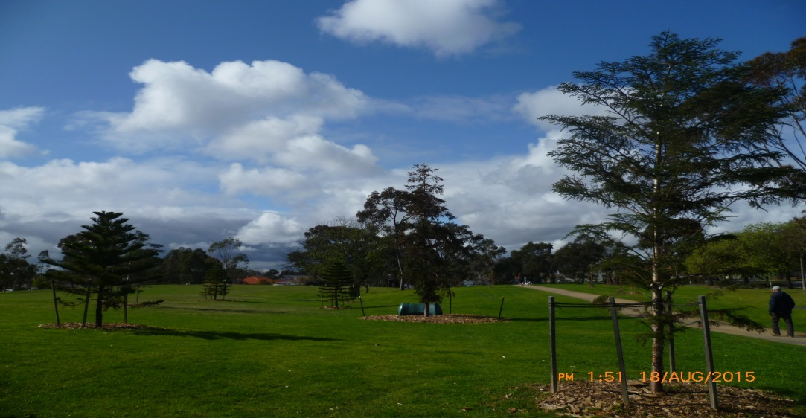
Tree planting at Elsternwick Park alongside a recently constructed perimeter walking path
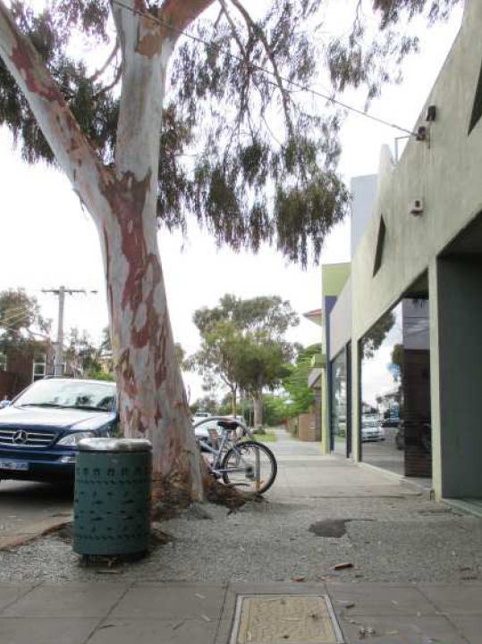  Existing established street tree lifting footpath | 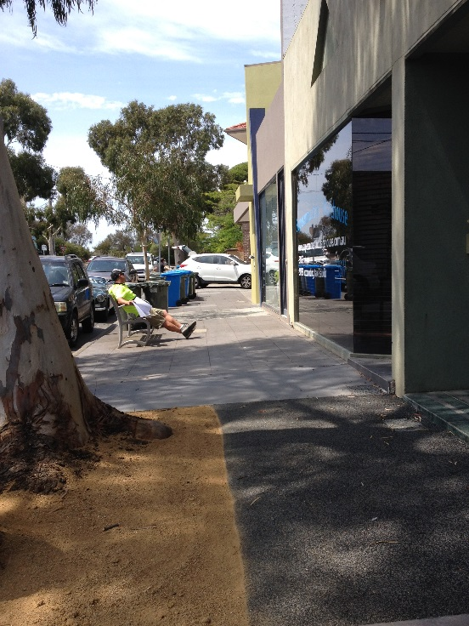  Street tree retained by using flexible footpath surface and increasing planting space for street tree
The factors that are used to determine suitable sites are outlined below.

Existing street trees
All new street plantings will consider existing trees in a street. Existing trees may not match the species recommended for a nature strip size. Established trees will be retained wherever possible and tree removal will only occur in accordance with the Street and Park Tree Management Policy. The Policy identifies circumstances where existing trees will be removed.

Nature strip type
Perhaps the most limiting constraint in selecting street tree species is the size of nature strips. The size of the nature strip dictates the volume of soil that is available for tree root growth which can have a direct impact on tree vigor. This is particularly relevant in the low nutrient sandy soils that predominate in Bayside.
It is important to note that as trees reach maturity surrounding infrastructure such as kerb and channel and footpaths can be impacted.
To reduce the impact on infrastructure and encourage a healthy tree population the size of the nature strip is used as a determining factor for species selection.
Nature strip type | Nature strip width
Very small | 0.3 m to 0.5 m
Cut outs | Located in Roads or footpaths
Small | >0.5 m to 1.0 m
Medium | >1 m to 2 m
Large | >2 m to 3 m
Very Large | >3 m

Table 1 Nature Strip Type

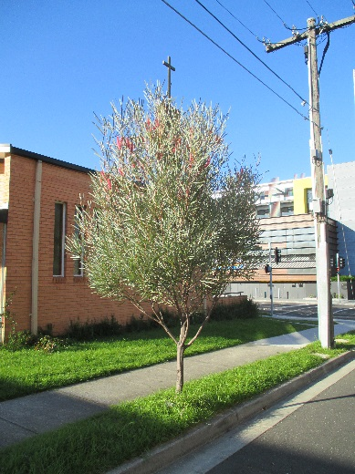  Small nature strip. | 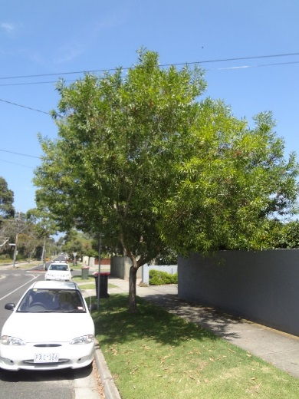  Medium nature strip. | 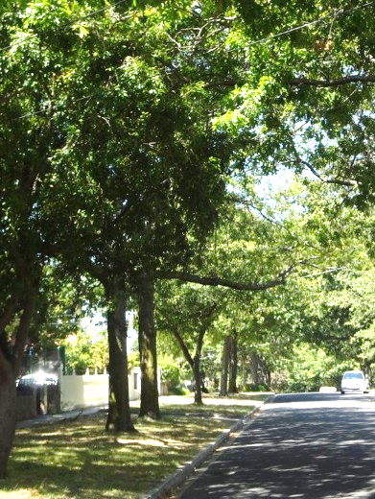  Large nature strip.

Soil type
Bayside soils are Sand and Clay Plains from the Cainozoic period.
Most of Bayside consists of deep sandy soils that drain well but are low in nutrients. For tree planting this may require frequent establishment watering. High water tables are present in some areas.
At the eastern and southern extremities of the municipality a dark grey sand is more likely to be found. Drainage may sometimes be impeded by a clay subsoil or perched water table.
The soil types described above have been considered when recommending species for each nature strip type. However, urban soils are generally highly disturbed, often highly compacted and the soil profile at any particular site may differ significantly from an adjacent site.

Salt tolerance
Trees planted in streets close to Port Phillip Bay must be tolerant, to some extent, of salt spray and salinity.

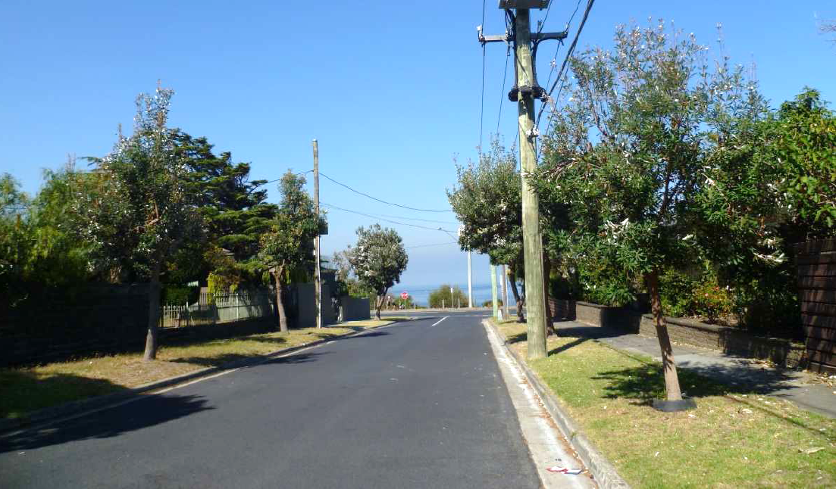
Street trees near Port Phillip Bay
.

Power lines
Street and park tree selection for trees growing under power lines will consider the species’ tolerance for pruning. For example, a tree that has a natural branching habit and a good wound response to mechanical damage would be considered an appropriate tree for growing under power lines. In streets that have small or very small nature strips a smaller growing tree will be considered for the power line side of the street. In those circumstances, the trees on both sides of the street should have similar foliage and form to provide a consistent theme for the street.

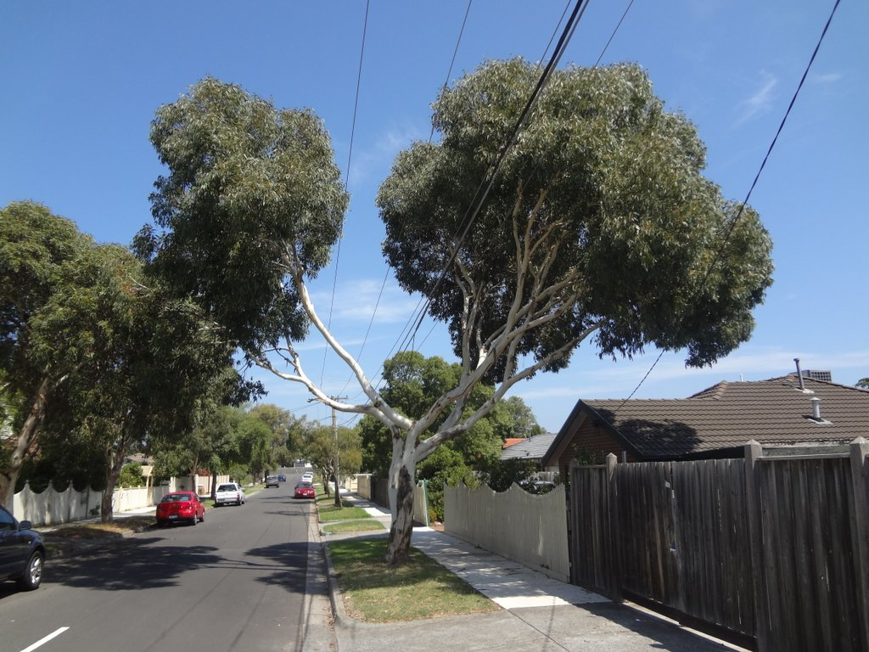
Tree pruned around power lines

Planting styles
Selection of sites is a complicated process and must consider a range of factors. Every opportunity must be taken to choose as many sites for street tree planting as is possible. The greatest visual impact is often created by planting a single species on both sides of the street and, where possible, this should be done. Where a nature strip is narrower on one side of the street, a smaller species may be planted on one side and a larger on the other.
At present street trees are planted into nature strips in the following themes:
- Consistent rows of a single species along both sides of the street
- One species on one side and a different species on the other
- Interplanted patterns, alternating between species along the street
- Mixed plantings with little or no pattern
Additional planting styles that exist in Bayside’s streets include:
- Trees planted in median strips
- Trees planted in cut-outs in the road or in a concrete or asphalt footpath
- Trees planted in roundabouts
- Trees planted in council carparks

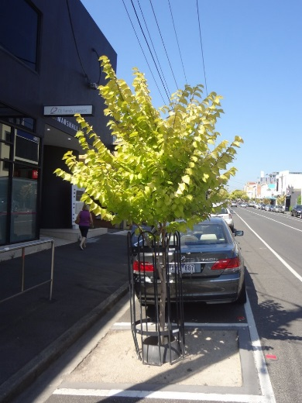  Cut-out in road. | 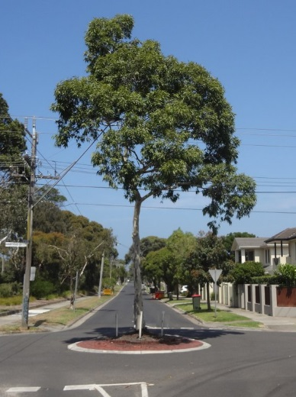  Roundabout.

Planting styles are described in more detail below.

Cut outs
Planting in cut-outs in the road or footpaths provides a useful alternative where there may be insufficient space on the nature strip. Suitability for planting in the road or footpath will depend on road/footpath width and other factors such as traffic volume and impact to on-street parking.

Roundabouts
Planting in roundabouts can add to the character of the area. Sight lines may be affected by roundabout planting therefore a Road Safety Audit may be required prior to preparation of planting design.
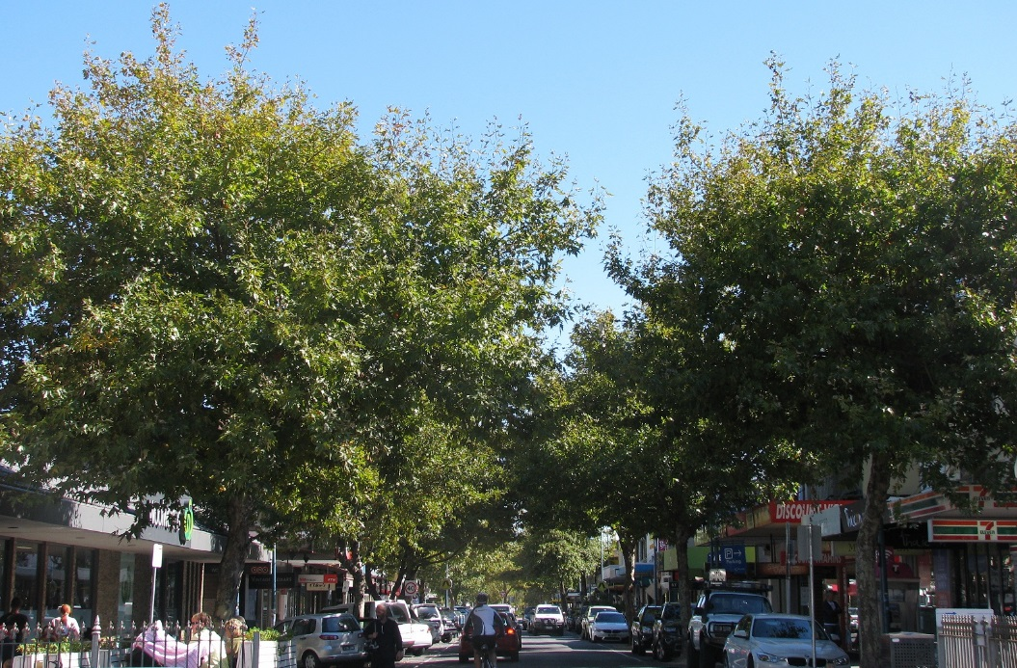
Street trees in Brighton’s Church Street shopping strip.

Boulevards
To recognise and improve streets that can be identified as existing or potential tree lined boulevards, Plan Melbourne is working with local councils and VicRoads to prepare a long term boulevard strategy. Where possible the philosophy of establishing boulevards should extend to local streets.

Adding new tree species to the selection list
The list of recommended species in the Street and Park Tree Selection Guide 2015 is not definitive. To continue meeting diversity targets, and to respond to any changes in environmental conditions, new tree cultivars suitable for local conditions will occasionally be added to Bayside’s list of street trees.
Tree species that have not previously been grown in Bayside may be included in the Street and Park Tree Selection Guide, or may be added in future. They may be classed as trial species and initially planted in limited numbers to assess their performance and suitability.

Street tree selection summary
Appendices 1 and 2 summarise the method for tree selection for streets and Appendices 3 and 4 summarise the method for tree selection in parks.
Appendix 5 contains all species to be used by the Open Space Arborist for the selection process.

APPENDIX 1: Species selection process for street trees

Some streets, especially longer ones, have changes along their length. They may change in their character or nature strip width; power lines might be present on one side of the street before changing to the other side. Therefore some streets are broken up into sections. Where large scale tree removal is required consultation will be undertaken to determine the most suitable species for that street in accordance with Policy.
1. Selection of street (or street section) using database (Appendix 5) by Open Space Arborist

2. This will generate a list of several potentially suitable species (see Table 1, p20)

3. Consider the following: (outlined in Appendix 2)
- Relationship with local landscape character
- Locations
- Ability to tolerate and thrive in a site’s environmental conditions
- Possible future damage to infrastructure

4. Select species using species database (Appendix 5)

APPENDIX 2: Selection criteria for street trees

The following factors will be considered for selection of suitable street tree species.
- Relationship with local landscape character
  - Garden character
  - Surrounding streetscapes
  - Vegetation Protection Overlays (VPO2, VPO3)
  - Heritage values
  - Maintain existing landscape character by selection of low fruiting cultivars where possible
  - Replacing difficult to replace existing species with species demonstrating similar characteristics e.g. growth habit, foliage colour and size

- Locations
  - Nature strip
  - Median strips
  - In-road cut-outs

- Ability to tolerate and thrive in a site’s environmental conditions
  - Species that have or can adapt to local conditions
    - Climate
    - Soil
    - Tolerances (e.g. coastal and salt)
    - Pests and diseases

- Possible future damage to infrastructure as assessed against identified current issues with
  - Footpaths
  - Kerb and channel
  - Roadways
  - Private infrastructure
  - Power lines

APPENDIX 3: Species selection for park trees

The steps involved in park tree selection will be based on the precinct landscape character and any relevant master plan for a specific park.

1. Identify Park

3. Consider the following: (Outlined in Appendix 4)
- Relationship with local landscape character
- Ability to tolerate and thrive in a site’s environmental conditions
- Possible future damage to infrastructure
- Specific considerations

2. Examine relevant master plan

4. Select species

APPENDIX 4: Selection criteria for park trees

The following factors will be considered for selection of suitable street tree species.
- Relationship with local landscape character
  - Surrounding streetscapes
  - Vegetation Protection Overlays (VPO2, VPO3)
  - Heritage values

- Ability to tolerate and thrive in a site’s environmental conditions
  - Species that have or can adapt to local conditions
    - Climate
    - Soil
    - Tolerances (e.g. coastal and salt)
    - Pests and diseases

- Possible future damage to infrastructure
  - Playgrounds
  - Pathways
  - Private infrastructure
  - Public infrastructure

- Specific considerations
  - Development of significant landscapes
  - Existing park landscape character
  - Relevant masterplan

APPENDIX 5: Street tree species list
Species to be planted in nature strips are listed below by suitable nature strip size (see p.21). Species selection will also take into consideration local landscape character, species diversity targets, power lines and salt spray.
SPECIES BY NATURE STRIP SIZE | COMMON NAME | North Road | North Brighton | Brighton | East Brighton | Hampton | Sandringham | Highett | Cheltenham | Beaumaris | Black Rock
CUTOUTS & VERY SMALL (= or <0.5M)
Acer buergerianum | Trident Maple |  | ☑ | ☑ | ☑ | ☑ | ☑ | ☑
Acer campestre | Field Maple |  | ☑ | ☑ | ☑ | ☑
Acer monspessulanum | Montpelier Maple |  | ☑ | ☑ | ☑ | ☑
Arbutus unedo | Strawberry Tree |  | ☑ | ☑ | ☑ | ☑ | ☑ | ☑ | ☑
Brachychiton 'Jasper Bells' | Jasper Bells |  | ☑ | ☑ | ☑ | ☑ | ☑ | ☑ | ☑ | ☑ | ☑
Bursaris spinosa | Sweet Bursaria
Callistemon viminalis | Weeping Bottlebrush |  |  |  |  | ☑ | ☑ | ☑ | ☑ | ☑ | ☑
Camellia sasanqua 'Pure Silk' | Camellia |  | ☑ | ☑ | ☑ | ☑ | ☑ | ☑ | ☑
x Chitalpa tashkentensis 'Pink Dawn' | Pink Dawn |  | ☑ | ☑ | ☑ | ☑ | ☑ | ☑ | ☑
Dias Cotinifolia | Pompom Tree
Eucalyptus macrocarpa 'Nullarbor Lime' | Nullarbor Lime
Eucalyptus macrocarpa 'Nullarbor Rose' | Nullarbor Rose
Hakea bucculenta | Red Pokers
Hakea francisiana | Bottlebrush Hakea
CUTOUTS & VERY SMALL (= or <0.5M) … continued
Hakea saligna | Willow Leafed Hakea
Hymenosporum flavum | Native Frangipani
Hibiscus syriacus 'Blue Bird' | Rose-of-Sharon |  | ☑ | ☑ | ☑ | ☑ | ☑ | ☑ | ☑ | ☑ | ☑
Lagerstroemia indica x fauiei 'Natchez' | Crepe Myrtle 'Natchez' |  |  |  |  |  |  |  |  | ☑ | ☑
Lagerstroemia indica x fauiei 'Zuma', 'Tuscarora' & 'Zuni' | Crepe Myrtle hybrid cultivar |  | ☑ | ☑ | ☑ | ☑ | ☑ | ☑ | ☑ | ☑ | ☑
Pyrus calleryana | Ornamental Pear cultivars |  | ☑ | ☑ | ☑ | ☑ | ☑ | ☑ | ☑ | ☑ | ☑
Pyrus calleryana 'Capital' | 'Capital' Pear |  | ☑ | ☑ | ☑ | ☑ | ☑ | ☑ | ☑ | ☑ | ☑
Pyrus calleryana 'Chanticleer' | 'Chanticleer' Pear |  | ☑ | ☑ | ☑ | ☑ | ☑ | ☑ | ☑ | ☑ | ☑
Pyrus ussuriensis | Manchurian Pear |  | ☑ | ☑ | ☑ | ☑ | ☑ | ☑ | ☑ | ☑ | ☑
Prunus cerasifera | Cherry Plum |  | ☑ | ☑ | ☑ | ☑ | ☑ | ☑ | ☑
Malus ioensis 'Plena' | Double-flowering Crab Apple |  | ☑ | ☑ | ☑ | ☑ | ☑ | ☑
Malus spectabilis 'Plena' | Double-flowering Chinese Crab Apple |  | ☑ | ☑ | ☑ | ☑ | ☑ | ☑
Melaleuca ericifolia | Swamp Paperbark |  |  |  |  | ☑ | ☑ | ☑ | ☑ | ☑ | ☑
Notelaea venosa | Mock-Olive |  |  |  |  | ☑ | ☑ | ☑ | ☑ | ☑ | ☑
Pittosporum crassifolium | Karo |  | ☑ | ☑ | ☑ | ☑ | ☑ | ☑ | ☑
Prunus xblireana | Double-rose Cherry-plum |  | ☑ | ☑ | ☑ | ☑ | ☑ | ☑ | ☑ | ☑ | ☑
Tristaniopsis laurina 'Luscious' | Kanooka 'Luscious'
SMALL (>0.5 metre -1 metre)
Banksia marginata | Silver Banksia |  |  |  |  |  |  |  |  | ☑ | ☑
Brachychiton 'Jasper Bells' | Jasper Bells |  | ☑ | ☑ | ☑ | ☑ | ☑ | ☑ | ☑ | ☑ | ☑
Callistemon citrinus | Crimson Bottlebrush |  | ☑ | ☑ | ☑ | ☑ | ☑ | ☑ | ☑
Callistemon hybrids | Bottlebrush cultivar |  |  |  |  | ☑ | ☑ | ☑ | ☑
Callistemon pallidus | Lemon Bottlebrush |  |  |  |  | ☑ | ☑ | ☑ | ☑
Callistemon viminalis | Weeping Bottlebrush |  |  |  |  | ☑ | ☑ | ☑ | ☑ | ☑ | ☑
Callitris columellaris | Richmond Cypress Pine |  |  |  |  | ☑ | ☑ | ☑ | ☑ | ☑ | ☑
Carpinus betulus 'Fastigiata' | Hornbeam |  | ☑ | ☑ | ☑ | ☑ | ☑ | ☑
Celtis australis | North American Hackberry |  | ☑ | ☑ | ☑ | ☑ | ☑ | ☑ | ☑ | ☑ | ☑
Elaeocarpus reticulatus | Blueberry Ash |  | ☑ | ☑ | ☑ | ☑ | ☑ | ☑ | ☑ | ☑ | ☑
Eucalyptus cosmophylla | Cup Gum |  | ☑ | ☑ | ☑ | ☑ | ☑ | ☑ | ☑ | ☑ | ☑
Eucalyptus gregsoniana | Wolgan Snow Gum |  | ☑ | ☑ | ☑ | ☑ | ☑ | ☑ | ☑ | ☑ | ☑
Eucalyptus kitsoniana | Bog Gum |  | ☑ | ☑ | ☑ | ☑ | ☑ | ☑ | ☑
Eucalyptus lehmannii | Small Yate |  | ☑ | ☑ | ☑ | ☑ | ☑ | ☑ | ☑
Eucalyptus pauciflora ssp. pauciflora | Snow Gum |  |  |  |  | ☑ | ☑ | ☑ | ☑ | ☑ | ☑
Eucalyptus pulchella | White Peppermint |  | ☑ | ☑ | ☑ | ☑ | ☑ | ☑ | ☑ | ☑ | ☑
Eucalyptus risdonii | Risdon Peppermint |  | ☑ | ☑ | ☑ | ☑ | ☑ | ☑ | ☑
Flindersia australis | Crow's Ash |  | ☑ | ☑ | ☑ | ☑ | ☑ | ☑ | ☑ | ☑ | ☑
SMALL (> 0.5 metre -1 metre)… continued
Flindersia maculosa | Leopardwood |  |  |  |  |  | ☑ | ☑ | ☑ | ☑ | ☑
Fraxinus griffithii | Evergreen Ash |  | ☑ | ☑ | ☑ | ☑ | ☑ | ☑ | ☑
Fraxinus ornus | Manna Ash |  | ☑ | ☑ | ☑ | ☑ | ☑ | ☑ | ☑
Geijera parviflora | Wilga |  |  |  |  | ☑ | ☑ | ☑ | ☑ | ☑ | ☑
Hakea laurina | Pincushion Hakea |  |  |  |  |  | ☑ | ☑ | ☑ | ☑ | ☑
Jacaranda mimosifolia | Jacaranda |  | ☑ | ☑ | ☑
Koelreuteria paniculata | Golden Rain Tree |  | ☑ | ☑ | ☑
Lagunaria patersonia | Norfolk Island Hibiscus |  | ☑ | ☑ | ☑ | ☑ | ☑ | ☑ | ☑ | ☑ | ☑
Leptospermum petersonii | Lemon-scented Myrtle |  | ☑ | ☑ | ☑ | ☑ | ☑ | ☑ | ☑ | ☑ | ☑
Melaleuca bracteata | Black Tea-tree |  | ☑ | ☑ | ☑ | ☑ | ☑ | ☑ | ☑
Melia azedarach | White Cedar |  | ☑ | ☑ | ☑ | ☑ | ☑ | ☑ | ☑ | ☑ | ☑
Melia azedarach 'Elite' | White Cedar 'Elite' |  | ☑ | ☑ | ☑ | ☑ | ☑ | ☑ | ☑ | ☑ | ☑
Metrosideros excelsa | New Zealand Christmas Tree |  | ☑ | ☑ | ☑ | ☑ | ☑ | ☑ | ☑ | ☑ | ☑
Myrsine howittiana | Muttonwood |  |  |  |  |  |  | ☑ | ☑
Olea europaea ‘Tolleys’, ‘Swan Hill’ | Fruitless Olive |  |  |  |  | ☑ | ☑ | ☑ | ☑
Photinia serratifolia | Chinese Photinia |  | ☑ | ☑ | ☑ | ☑ | ☑ | ☑ | ☑
Pistacia chinensis | Chinese Pistachio |  | ☑ | ☑ | ☑ | ☑ | ☑ | ☑ | ☑
Prunus lusitanica | Portugal Laurel |  | ☑ | ☑ | ☑ | ☑ | ☑ | ☑ | ☑
SMALL (> 0.5 metre -1 metre) … continued
Prunus sargentii | Sargent's Cherry |  | ☑ | ☑ | ☑ | ☑ | ☑ | ☑ | ☑
Pyrus calleryana | Ornamental Pear cultivars |  | ☑ | ☑ | ☑ | ☑ | ☑ | ☑ | ☑ | ☑ | ☑
Pyrus calleryana 'Capital' | 'Capital' Pear |  | ☑ | ☑ | ☑ | ☑ | ☑ | ☑ |  | ☑ | ☑
Pyrus calleryana 'Chanticleer' | 'Chanticleer' Pear |  | ☑ | ☑ | ☑ | ☑ | ☑ | ☑ |  | ☑ | ☑
Pyrus ussuriensis | Manchurian Pear |  | ☑ | ☑ | ☑ | ☑ | ☑ | ☑ |  | ☑ | ☑
Triadica sebifera | Chinese Tallow Tree |  | ☑ | ☑ | ☑
MEDIUM (>1 metre to 2 metre)
Acacia implexa | Lightwood |  |  |  |  | ☑ | ☑ | ☑ | ☑ | ☑ | ☑
Acacia pendula | Weeping Myall |  |  |  |  | ☑ | ☑ | ☑ | ☑ | ☑ | ☑
Acer negundo | Box Elder |  | ☑ | ☑ | ☑ |  |  | ☑
Acer negundo 'Aurea', 'Sensation' & 'Variegatum' | Box Elder cultivar |  | ☑ | ☑ | ☑ |  |  | ☑
Acer rubrum | Red Maple |  | ☑ | ☑ | ☑
Acer truncatum x A. platanoides 'Norwegian Sunset' | Hybrid Shuntang Maple |  | ☑ | ☑ | ☑
Acer x freemanii 'Jeffersred' | Autumn Blaze® Maple |  | ☑ | ☑ | ☑
Afrocarpus falcata | Yellow-wood |  |  |  |  | ☑ | ☑ | ☑ | ☑
Allocasuarina littoralis | Black She-oak |  |  |  |  |  |  |  |  | ☑ | ☑
Allocasuarina torulosa | Forest Oak |  |  |  |  |  |  |  |  | ☑ | ☑
MEDIUM (>1 metre to 2 metre) … continued
Allocasuarina verticillata | Drooping She-Oak |  |  |  |  | ☑ | ☑ | ☑ | ☑ | ☑ | ☑
Angophora hispida | Dwarf Apple |  |  |  |  | ☑ | ☑ | ☑ | ☑ | ☑ | ☑
Arbutus unedo | Strawberry Tree |  | ☑ | ☑ | ☑ | ☑ | ☑ | ☑ | ☑
Banksia serrata | Saw Banksia |  |  |  |  |  | ☑ |  |  | ☑ | ☑
Brachychiton populneus | Kurrajong |  | ☑ | ☑ | ☑ | ☑ | ☑ | ☑ | ☑ | ☑ | ☑
Brachychiton rupestris | Queensland Bottle Tree |  |  |  |  | ☑ | ☑ | ☑ | ☑ | ☑ | ☑
Callistemon salignus | Willow Bottlebrush |  | ☑ | ☑ | ☑ | ☑ | ☑ | ☑ | ☑ | ☑ | ☑
Calodendrum capense | Cape Chestnut |  | ☑ | ☑ | ☑ | ☑ | ☑ | ☑ | ☑
Ceratonia siliqua | Carob Tree |  |  |  |  | ☑ | ☑ | ☑ | ☑
Cercis siliquastrum | Judas Tree |  | ☑ | ☑ | ☑ | ☑ | ☑ | ☑ | ☑
Corymbia calophylla | Tuart |  |  |  |  | ☑ | ☑ | ☑ | ☑ | ☑ | ☑
Corymbia eximia 'Nana' | Yellow Bloodwood |  |  |  |  | ☑ | ☑ | ☑ | ☑ | ☑ | ☑
Corymbia ficifolia | Flowering Gum |  | ☑ | ☑ | ☑ | ☑ | ☑ | ☑ | ☑ | ☑ | ☑
Cupaniopsis anacardioides | Tuckeroo |  | ☑ | ☑ | ☑ | ☑ | ☑ | ☑ | ☑ | ☑ | ☑
Eucalyptus crenulata | Silver Gum (Buxton Gum) |  |  |  |  | ☑ | ☑ | ☑ | ☑ | ☑ | ☑
Eucalyptus leucoxylon | Yellow Gum cultivar |  | ☑ | ☑ | ☑ | ☑ | ☑ | ☑ | ☑ | ☑ | ☑
Eucalyptus leucoxylon ssp. megalocarpa | Large-fruited Yellow Gum |  |  |  |  | ☑ | ☑ | ☑ | ☑ | ☑ | ☑
Eucalyptus leucoxylon ssp. rosea | Red-flowering Gum |  |  |  |  | ☑ | ☑ | ☑ | ☑ | ☑ | ☑
MEDIUM (>1 metre to 2 metre) … continued
Eucalyptus mannifera 'Little Spotty' | Brittle Gum |  |  |  |  | ☑ | ☑ | ☑ | ☑ | ☑ | ☑
Eucalyptus nicholii | Nicholls Gum |  | ☑ |  | ☑ | ☑ | ☑ | ☑ | ☑ | ☑ | ☑
Eucalyptus scoparia | Wallangarra White Gum |  |  |  |  | ☑ | ☑ | ☑ | ☑ | ☑ | ☑
Eucalyptus sideroxylon | Iron Bark |  |  |  | ☑ | ☑ | ☑ | ☑ | ☑ | ☑ | ☑
Fraxinus excelsior 'Aurea' | European Golden Ash |  | ☑ | ☑ | ☑ |  | ☑ | ☑ | ☑
Fraxinus pennsylvanica | Green Ash |  | ☑ | ☑ | ☑ | ☑ | ☑ | ☑ | ☑
Ginkgo biloba | Maidenhair Tree |  | ☑ | ☑ | ☑ | ☑ | ☑ | ☑ | ☑
Gleditsia triacanthos var. inermis 'Shademaster' | Shademaster Honey Locust |  | ☑ | ☑ | ☑ | ☑ | ☑ | ☑ | ☑
Leptospermum laevigatum | Coast Tea-tree |  |  |  |  |  |  | ☑ | ☑ | ☑ | ☑
Liquidambar formosana | Formosan Evergreen Liquidamber |  | ☑ | ☑ | ☑ | ☑ | ☑ | ☑ | ☑ | ☑ | ☑
Liquidambar styraciflua | Liquidamber cultivar |  | ☑ | ☑ | ☑ | ☑ | ☑ | ☑ | ☑ | ☑ | ☑
Lophostemon confertus | Brushbox |  | ☑ | ☑ | ☑ | ☑ | ☑ | ☑ | ☑ | ☑ | ☑
Maclura pomifera ‘Wichita’ | Wichita Osage Orange |  | ☑ | ☑ | ☑ | ☑ | ☑ | ☑
Melaleuca lanceolata | Moonah |  | ☑ | ☑ | ☑ | ☑ | ☑ | ☑ | ☑ | ☑ | ☑
Melaleuca linariifolia | Snow-in-Summer |  | ☑ | ☑ | ☑ | ☑ | ☑ | ☑ | ☑ | ☑ | ☑
Melaleuca quinquenervia | Broad-leaved Paperbark |  | ☑ | ☑ | ☑ | ☑ | ☑ | ☑ | ☑ | ☑ | ☑
Platanus orientalis 'Digitata' | Oriental Plane cultivar |  | ☑ | ☑ | ☑ | ☑ | ☑ | ☑ | ☑
Platanus orientalis var. insularis 'Autumn Glory' | Autumn Glory Plane |  | ☑ | ☑ | ☑ | ☑ | ☑ | ☑ | ☑
MEDIUM (>1 metre to 2 metre) … continued
Platanus xacerifolia | London Plane |  | ☑ | ☑ | ☑ | ☑ | ☑ | ☑ | ☑
Quercus cerris | Turkey Oak |  | ☑ | ☑ | ☑ | ☑ | ☑ | ☑ | ☑
Quercus ilex | Holm Oak |  | ☑ | ☑ | ☑ | ☑ | ☑ | ☑ | ☑
Siphonodon australis | Ivorywood |  |  |  |  |  |  | ☑ | ☑
Syzygium floribundum | Weeping Lilly Pilly |  |  |  |  | ☑ | ☑ | ☑ | ☑ | ☑ | ☑
Syzygium paniculatum | Magenta Cherry |  |  |  |  | ☑ | ☑ | ☑ | ☑ | ☑ | ☑
Syzygium smithii | Lilly Pilly |  | ☑ | ☑ | ☑ | ☑ | ☑ | ☑ | ☑ | ☑ | ☑
Tamarix aphylla | Athel Tree |  |  |  |  |  |  | ☑ | ☑
Tilia cordata | Small-leaved Linden |  | ☑ | ☑ | ☑ | ☑ | ☑ | ☑ | ☑
Tristaniopsis laurina | Kanooka (Water Gum) |  |  |  | ☑ | ☑ | ☑ | ☑ | ☑
Tristaniopsis laurina 'Luscious' | Kanooka 'Luscious' |  | ☑ | ☑ | ☑ | ☑ | ☑ | ☑ | ☑
Ulmus parvifolia | Chinese Elm |  | ☑ | ☑ | ☑ | ☑ | ☑ | ☑ | ☑
Ulmus parvifolia 'Murray's Form' | Murray's Form Chinese Elm |  | ☑ | ☑ | ☑ | ☑ | ☑ | ☑ | ☑
Vitex lucens | Puriri |  | ☑ | ☑ | ☑ | ☑ | ☑ | ☑ | ☑ | ☑ | ☑
Zelkova serrata 'Green Vase' | Green Vase Japanese Zelkova |  | ☑ | ☑ | ☑ | ☑ | ☑ | ☑ | ☑
LARGE (>2 metres to 3 metres)
Acacia maidenii | Maiden's Wattle |  |  |  |  | ☑ | ☑ | ☑ | ☑
Acacia mearnsii | Black Wattle |  |  |  |  | ☑ | ☑ | ☑ | ☑ | ☑ | ☑
Acacia melanoxylon | Blackwood |  |  |  |  | ☑ | ☑ | ☑ | ☑ | ☑ | ☑
Agonis flexuosa | Willow Myrtle |  | ☑ | ☑ | ☑ | ☑ | ☑ | ☑ | ☑ | ☑ | ☑
Angophora costata | Smooth-barked Apple |  | ☑ | ☑ | ☑ | ☑ | ☑ | ☑ | ☑ | ☑ | ☑
Banksia integrifolia | Coast Banksia |  |  |  |  | ☑ | ☑ | ☑ | ☑ | ☑ | ☑
Brachychiton acerifolius | Illawarra Flame Tree |  |  |  |  | ☑ | ☑ | ☑ | ☑ | ☑ | ☑
Cinnamomum camphora | Camphor Laurel |  | ☑ | ☑ | ☑ | ☑ | ☑ | ☑ | ☑ | ☑ | ☑
Corymbia citriodora 'Scentuous' | Lemon-scented Gum 'Scentuous' |  | ☑ | ☑ | ☑ | ☑ | ☑ | ☑ | ☑ | ☑ | ☑
Cupressus cashmeriana | Kashmir Cypress |  |  |  |  | ☑ | ☑ | ☑ | ☑
Eucalyptus camaldulensis | River Red Gum |  |  |  |  |  |  |  |  | ☑ | ☑
Eucalyptus cornuta | Yate |  |  |  |  | ☑ | ☑ | ☑ | ☑ | ☑ | ☑
Eucalyptus melliodora | Yellow Gum |  |  |  |  |  |  |  |  | ☑ | ☑
Eucalyptus ovata | Swamp Gum |  | ☑ | ☑ | ☑ | ☑ | ☑ | ☑ | ☑ | ☑ | ☑
Eucalyptus polyanthemos | Red Box |  |  |  |  |  | ☑ | ☑ | ☑ | ☑ | ☑
Eucalyptus pryoriana | Gippsland Manna Gum |  |  |  |  |  |  |  | ☑ | ☑ | ☑
Eucalyptus radiata | Narrow-leaved Peppermint |  |  |  |  |  |  |  |  | ☑ | ☑
Liquidambar styraciflua | Liquidamber |  | ☑ | ☑ | ☑ | ☑ | ☑ | ☑ | ☑ | ☑ | ☑
Podocarpus elatus | Plum Pine |  | ☑ | ☑ | ☑ | ☑ | ☑ | ☑ | ☑ | ☑ | ☑
Quercus canariensis | Algerian Oak |  | ☑ | ☑ | ☑ | ☑ | ☑ | ☑ | ☑
Quercus palustris | Pin Oak |  | ☑ | ☑ | ☑ | ☑ | ☑ | ☑ | ☑
LARGE (>2 metres to 3 metres) … continued
Quercus robur | English Oak |  | ☑ | ☑ | ☑ | ☑ | ☑ | ☑ | ☑
Quercus rubra | Red Oak |  | ☑ | ☑ | ☑ | ☑ | ☑ | ☑ | ☑
Quercus suber | Cork Oak |  | ☑ | ☑ | ☑ | ☑ | ☑ | ☑ | ☑
Schinus areira | Peppercorn Tree |  | ☑ | ☑ | ☑ | ☑ | ☑ | ☑ | ☑
Stenocarpus sinuatus | Firewheel Tree |  |  |  |  | ☑ | ☑ | ☑ | ☑ | ☑ | ☑
Ulmus glabra 'Lutescens' | Golden Elm |  | ☑ | ☑ | ☑ | ☑ | ☑ | ☑ | ☑
Ulmus procera | English Elm | ☑ | ☑ | ☑ | ☑ | ☑ | ☑ | ☑ | ☑
Ulmus 'Sapporo Autumn Gold' | Sapporo autumn Gold Elm | ☑ | ☑ | ☑ | ☑ | ☑ | ☑ | ☑
Ulmus xhollandica | Dutch Elm | ☑ | ☑ | ☑ | ☑ | ☑ | ☑ | ☑ | ☑
VERY LARGE (> 3 metres) including any trees from large nature strip
Araucaria heterophylla | Norfolk Island Pine |  | ☑ | ☑ | ☑ | ☑ | ☑ | ☑ | ☑ | ☑ | ☑
Corymbia citriodora | Lemon-scented Gum |  | ☑ | ☑ | ☑ | ☑ | ☑ | ☑ | ☑ | ☑ | ☑
Corymbia maculata | Spotted Gum |  | ☑ | ☑ | ☑ | ☑ | ☑ | ☑ | ☑ | ☑ | ☑
Pinus canariensis | Canary Island Pine | ☑
Pinus pinaster | Maritime Pine | ☑
Quercus coccinea | Scarlet Oak |  | ☑ | ☑ | ☑ | ☑ | ☑ | ☑

