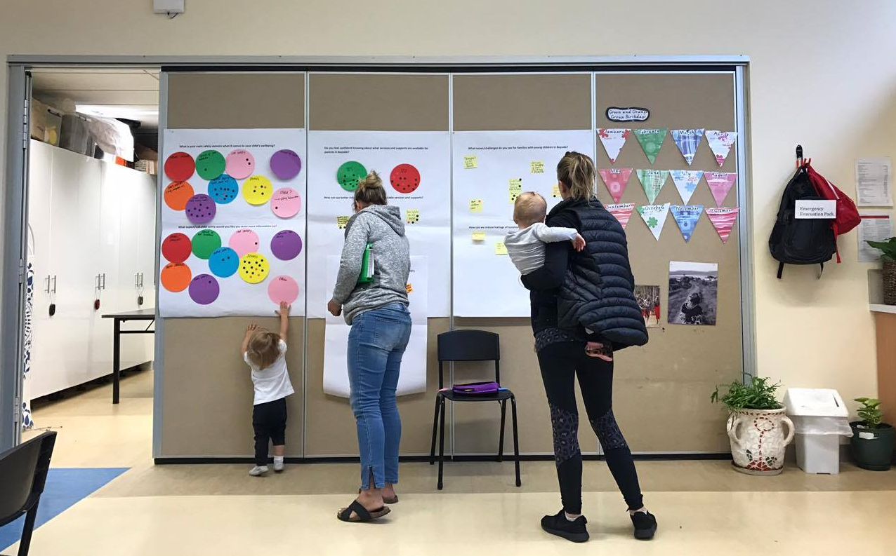
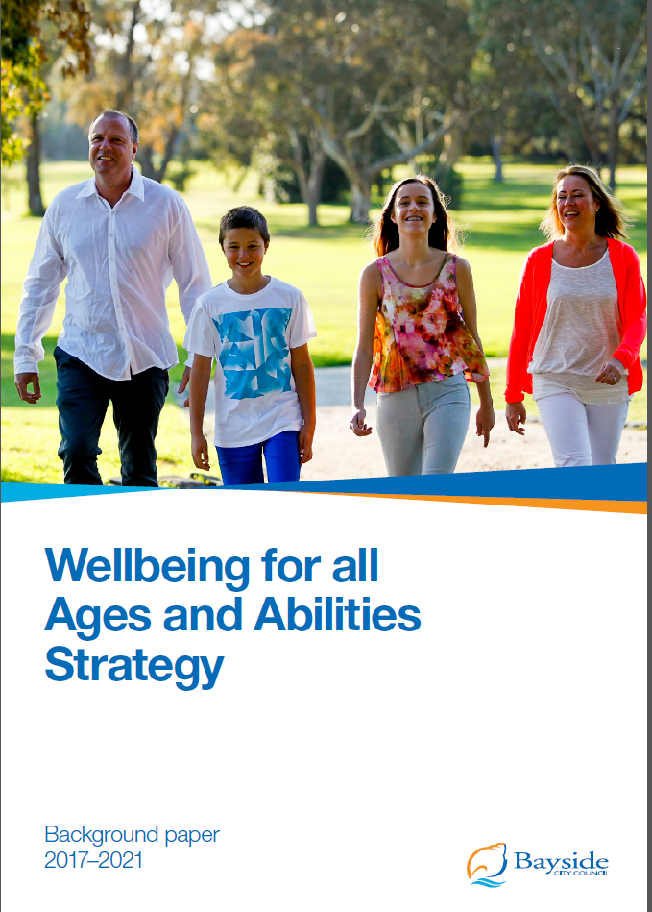

Wellbeing for All Ages and Abilities Strategy

Community Engagement Report:

An exploration of health and wellbeing priorities identified by the Bayside community
January – March 2017

Contents
1. Introduction 3
2. Methodology 4
2.1 Aim and objectives 4
2.2 Consultation approach 4
2.3 Engagement tools 5
2.4 Participants 6
3. Results and findings 7
3.1 One – An engaged and supportive community 7
3.1.1 Overview 7
3.1.2 What did the community say? 8
3.2 Two – A healthy and active community 14
3.2.1 Overview of theme 14
3.2.2. What did the community say? 15
3.3 Three – Safe and healthy environments 19
3.3.1 Overview of theme 19
3.3.2 What did the community say? 20
4. Next steps 24
Appendix 1 - Images of engagement activities held at ‘pop up’ events across Bayside. 25
Appendix 2 – City of Bayside Health and Wellbeing Profile: Summary of key findings 26

Introduction
The purpose of this report is to provide an overview of community consultation activities undertaken between January and March 2017 to inform the development of the Wellbeing for All Ages and Abilities Strategy 2017-2021.

Methodology

2.1 Aim and objectives
The main aim was to deliver a targeted consultation approach to explore the health and wellbeing priorities previously identified in the Health Profile across key life stages.
Key objectives include:
- Enable the community to have a say about what influences their health and wellbeing and what would make a difference.
- Ensure the community has a voice when it comes to planning for improved health and wellbeing.
- Create awareness of current health and wellbeing issues experienced by Bayside residents.
- Engage targeted community members (early years, young people, disability, older adults) to provide direction on planning for key life stages.

2.2 Consultation approach
A new approach to consultation was adopted for the Wellbeing for All Ages and Abilities Strategy. This approach involved attending already organised Council and non-Council events, workshops and information sessions occurring during early 2017. This enabled a greater reach into the community, engaging with community members from all ages and abilities who may not usually be involved in planned health forums. In addition, community reference groups and community centres were also engaged and an online forum was available through Have Your Say and Survey Monkey.
This consultation builds on information collected from the door to door survey undertaken in November 2016 and will be followed by the release of a Discussion Paper in June 2017.
A list of events, pre-organised meetings, workshops and information sessions attended between January and March 2017:
- Accessible beach day
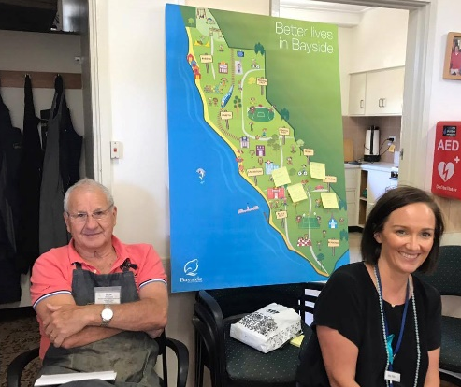
- Bayley House
- Bayside Art and Design Graduates Exhibition
- Bayside Healthy Aging Reference Group
- Bayside Youth Ambassadors meeting – February and March
- Elsternwick Estate Library session
- Freeza – Peterson Youth Centre
- First time mums groups – Highett and Sandringham
- Hang out session – Peterson Youth Centre
- Highett Neighbourhood House activities
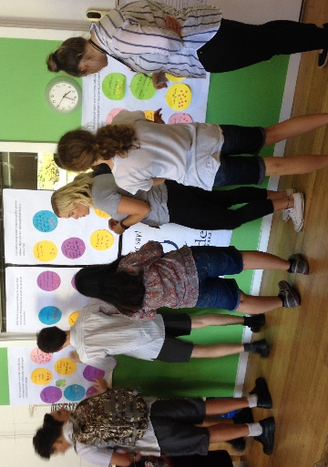
- Immunisation sessions – Brighton and Highett
- Keith street playgroup
- Kindergarten readiness information session
- Maternal and Child Health Nurses monthly meeting
- Men’s Shed
- Public Housing Estate Bluff Road Estate community BBQ
- Sandy Beach Community Centre disability program
- Senior citizen meetings
    - Beaumaris seniors
    - Brighton seniors
    - Hampton seniors
    - Highett seniors
    - Japanese seniors
- Sustainable housing workshop
- University of the third age annual general meeting
- Volunteers - Aged and Disability volunteers (delivered meals, social support and volunteer transport)
- Youth workers and counsellors monthly meeting
Please refer to Appendix 1 for phots taken during the consultation process.

2.3 Engagement tools
A range of engagement tools were used during the consultation process. Engagement tools were tailored depending on the individual audience. Table 1 provides an overview of the engagement tools used during the consultation period.
Table 1. Engagement tools
Engagement tool | Description
35’s | A group activity to identify and then prioritise issues, concerns or ideas. Individuals develop issues, concerns or ideas which are then circulated 5 times and ranked on a scale of 1-7 to prioritise.
Brainstorm posters | Community members share ideas, issues or concerns by writing them down and sticking them onto large A1 posters.
Dotmocracy | Voting on a series of options through placing a dot on the desired idea or concern.
Focus group | A small group discussion hosted by a facilitator about a focused topic. Designed to allow for an open discussion that is guided by a series of questions but which may follow the flow of participant’s discussion.
Interactive visual map | A large scale map of the municipality was available and community members were invited to pin a message to the map, about aspects they liked and aspects they would like to change about Bayside.
Surveys | A series of questions provided in an online or hard copy format.
Workshop | A structured method to explore specific, complex issues and where participants work in small groups.

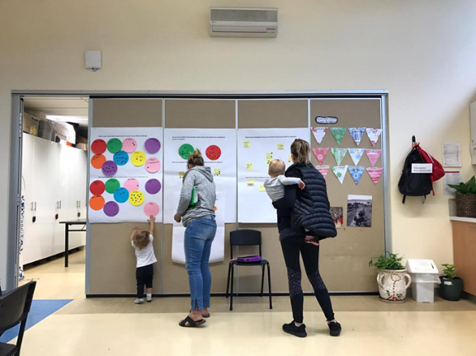
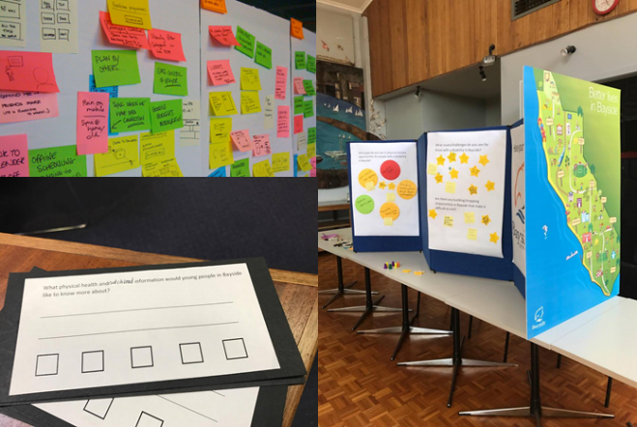

Brainstorm poster and Interactive visual map Dotmocracy

2.4 Participants
A total of 532 residents from Bayside participated in the consultation process between January and March 2017. A key objective was to engage targeted community members (early years, young people, those with a disability or long term illness, older adults and vulnerable people) to provide a clear direction on planning for key life stages. Table 2 provides a breakdown of participants based on key life stages. It is important to note that ‘older adults’ included those with mobility issues over the age of 55 years and ‘people with a disability’ represents those under 55 years with a disability or long term illness.
Table 2. Breakdown of participants based on life stage or target group.
Life stage /Target group | No.
Early years | 109
Young people | 66
Older adults | 238
People with a disability *(under the age of 55) | 30
Vulnerable groups | 49
General community (no target group specified) | 40
The Discussion Paper which will be published in June 2017 will take a broader consultation approach and opens the discussion to the wider community, external agencies and other stakeholders.

Results and findings
Results from the consultation activities are categorised by three key themes:
• An engaged and supportive community
• A healthy and active community
• Safe and healthy environments
These themes were identified based on a wide range of inputs and information which include: direction from the 2017 health and wellbeing profile, health priorities identified in the door-to-door survey, a policy review and an internal staff workshop. These themes provide a structure for analysis and suggested actions for the Wellbeing for All Ages and Abilities Strategy 2017-2021.

3.1 One – An engaged and supportive community

3.1.1 Overview
An engaged and supportive community allows people from all ages and abilities access to services and resources that enhance their wellbeing and enable them to live fulfilling lives. At one level it represents the degree to which individuals feel connected with their community, however more broadly it is the strength and resilience within communities that sustains positive mental health. Social connectedness and social inclusion have also been identified as key contributing factors to ensuring an engaged and healthy community.
Data from 2017 Health and Wellbeing Profile provides key insight into areas of focus for the Bayside community. This includes:
- An ageing population.
- An increase in the number of lone person households in Bayside.
- Low scores amongst those over 75 years and those with a disability for sense of community connections.
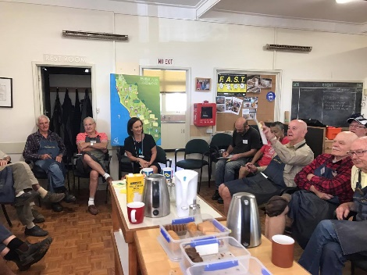
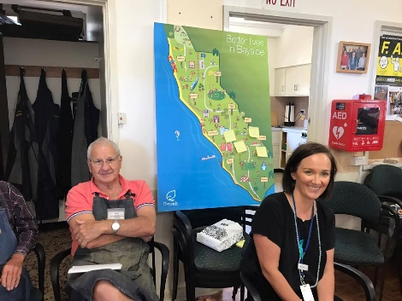
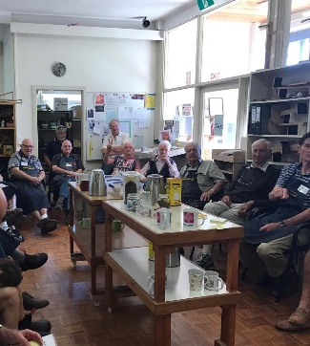
- Young people losing sleep through worry, not feeling good about themselves and not getting 8 hours sleep.

3.1.2 What did the community say?
The community provided a wide range of comments about this theme. Ideas were identified by each target group or life stage. These ideas provide a guide to potential solutions to making Bayside a more engaged and supportive community.
- Address social isolation and improve community engagement
Group | Ideas
Early years | - Second time parents group targeted at parents who are feeling isolated with their second child. Currently there is only organised parent groups for first time parents.  - Support for parents trying to visit a playground with a child who has a disability.  - More support for new families to the area (those moving from other suburbs, states and countries). How do I find out about playgrounds, kindergartens and early year services?  - Support group for dads.
Young people | - Support and information on how to build meaningful relationships.  - Reduce or subsidise cost of extracurricular activities.
Older adults | - Need to improve public transport options.  - Support for men, especially post retirement.  - Support for older adults who can’t drive. How to get around when I can’t drive- will I be isolated?  - Parking issue surrounding senior centres and neighbourhood houses- can we have a pass? Or senior sticker which allows parking for 4 hours? Double the allocated time? This is restricting individuals from attending activities.  - The development of community gardens.  - Peer led or intergeneration activities/classes (ideas include iPad classes, community garden)  - Community Bus and outings.  - Improved assistance, case management for isolated older adults (washing clothes, making appointments, cleaning home).  - Provide a service whereby volunteers visit on a regular basis (similar to the Do Care Service).  - Provide a 1300 call centre where people can call and just talk to other people.
People with a disability | - More accessible community events.
Vulnerable groups | - Reduce or subsidise cost of extracurricular activities.  - Public housing estate residents feeling disconnected and isolated from the community  - Infrastructure at public housing estates – Ensuring there is a central community area at all estates.  - Advocate to ensure there will be a community room in the new build at the estate. (Elsternwick estate).  - Helping mums to get back into the workforce - cheaper training courses e.g. in Admin. Are refresher courses available at community centres? What courses are available for mums trying to return back to work?  - More free playgroups for disadvantage families (similar to that of Keith Street).  - Advocacy and partnership work with other organisations such as FamilyLife and Community Health.

- Promotion of services, supports and activities available to residents
Group | Ideas
Early years | - Increase confidence of parents by providing more information on what services and supports are available to them.  - Develop map of services and supports for young families including map of kindergartens.  - Improve promotion of services and supports available to parents e.g. improved websites, brochures about services, emails sent to parents depending on age of child.  - Develop a flyer introducing support services and where to find them.  - Review green book and add more services and supports to it like a directory.
Older adults | - We need to get more information out to people about the services/activities that are available. The Leader and let’s talk Bayside should feature sections on the different social groups and activities on offer.  - No knowledge about neighbourhood house. People who live in Highett don’t know what is on offer. Need to improve this.  - More information required around clubs, etc. available in community.  - Libraries now serve as community hubs, can they be used more to advertise about activities.  - Find out about activities/services/supports through local newspaper, community notice boards and library. More promotion needed here in the future.  - Invest in promotion of activities, supports and services.  - Referral pathways and partnership work.  - Up to date register of community groups and promote this.  - BBQ event so people can learn more about what Council does and offers.  - Transport to get to these opportunities. More information about them, probably in a hard copy format.  - It’s important to inform both the clients and their families as many family members are not aware of what services are available to assist their parents.
People with a disability | - Use local newspaper to promote support and services on offer.
Vulnerable groups | - Most not accessing or aware of services available. Let’s improve this.  - Library service is great! Make sure this is available for all estates in Bayside.  - Training for MCH nurses on how to support disadvantaged parents/families (what supports are available).  - Referral services and promotion of free services or low cost lows for families.
General community (no target group specified) | - Overwhelming response for promoting services, supports and activities in local newspaper and Let’s Talk Bayside.

- Strengthen volunteering and opportunities to volunteer across all ages and abilities in Bayside
Group | Ideas
Young people | - Want to give back through global issues.  - Council needs to invest time into making the volunteer portal attractive for young people, need to promote the volunteer website, get schools on board, volunteering tends to die off in upper years this should be a target year 10 onwards.  - Develop a mentor program university students mentor high school students.  - Would like to see more internships available.
Older adults | - More opportunity to volunteer in the community. We didn’t know about the website.  - Community gardens.  - Senior groups linking in with schools, kindergartens.  - Extend the season & opening hours of the Community Nursery in Reserve Rd.
People with a disability | - Opportunity to volunteer in the community.  - Promote the volunteer website to disability organisations and have opportunities for those with a disability.
General community (no target group specified) | - Volunteering and opportunities to volunteer across all ages and abilities in Bayside.  - Promote the friends of Bayside group.

- Improve resilience and mental health
Group | Ideas
Early years | - More support through MCH nurse on where to go if experiencing mental health issues.  - Breastfeeding pressures and support to keep going/feel comfortable.
Young people | - Reduce the stigma around mental health so people feel more comfortable to talk about it and seek help.  - There is stigma associated with using mental health services, youth don’t like using counselling at school as they have privacy concerns, would prefer to use mental health services outside school where they can remain private (no sees them on there and no one knows them there).  - Face to face bullying is still occurring. A big focus on cyber bullying but need to still focus on face to face in the school yard.  - Poor body image and self-worth - may come from using social media at a younger age.  - Young people spoke about fear of missing out, social pressures (need to constantly check phone), family pressures and academic pressures as main reasons for worry.  - Education on the link between worry/restless sleep and phone using after 10pm.
Vulnerable groups | - Young parents support group (under 25).  - Support for grandparents who have custody of children.

- Social inclusion
Group | Ideas
Early years | - Ensure housing for young families is affordable.  - Ensure Bayside is accessible for prams.  - Accessible environment for prams (pram parking/permit)  - More baby changing facilities in public areas.
Older adults | - Accessibility of buses is an issue.  - Public transport needs to be improved.  - Ensure Bayside is accessible for all older people.
People with a disability | - Building/shopping strips/centres in Bayside that are difficult to visit  -Dendy street beach is not accessible at all.  - When Road and footpath are very steep cannot take wheelchair over.  - Normanby road Brighton.  - Dislike push button public toilets - feels insecure.  - Church street problem disability parking.  - Permanent beach matting - ensuring beaches are made accessible.  - Reduce discrimination for those with a disability and make bayside environment more inclusive.
Vulnerable groups | - Reduce cost of extracurricular activities.  - Ensure Bayside is accessible for those with low financial means.  - Lack of opportunity for low income families to provide experiences for kids.  - More free playgroups for disadvantage families.  - Have a case worker on the ground at the estates providing direction on services and supports.  - Funding for more recreational opportunities (e.g. pool access/mums and bubs $$$$).

3.2 Two – A healthy and active community

3.2.1 Overview of theme
Eating well and being physically active is important to maintain and protect the longevity of good health and wellbeing. There is now strong evidence that regular physical activity provides people of all ages and abilities substantial physical, social and mental health gains and that good nutrition benefits people across all age groups to help the body function at optimal efficiency and maintain healthy weight.
Data from 2017 Health and Wellbeing Profile provides key insight into areas of focus for the Bayside community. This includes:
- An increase in the number of residents sitting for 7 hours or more per day.
- Those aged 75 years and over were more likely to report not doing any exercise.
- Nearly half of all residents in Bayside were considered overweight (pre obese) or obese.
- Breastfeeding rates decrease after 6 months.
- An increase in chronic disease such as diabetes and cardiovascular disease.
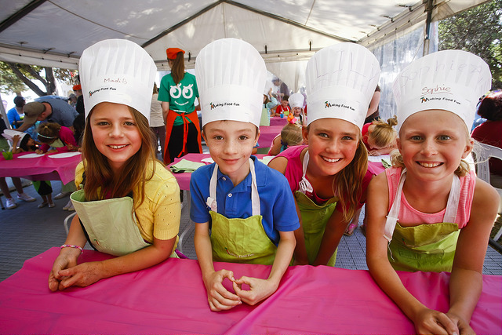

3.2.2. What did the community say?
The community provided a wide range of comments about this theme. Ideas were identified by each target group or life stage. These ideas provide a guide to potential solutions to making Bayside a healthy and active community.
- Increase physical activity opportunities for all ages and abilities.
Group | Ideas
Early years | - Develop a map of all playgrounds in Bayside. With information on what type of facilities are available.  - Ensure all playgrounds are age appropriate.  - Funding for more recreational opportunities for families with low income (e.g. pool access/mums and bubs).
Young people | - More skate parks.  - Cheaper sports and recreational activities.  - Outdoor gym stations (this is a free way to exercise and enjoy foreshore).  - Low cost gym membership.  - Sport events in Bayside e.g. Young person’s fun run or triathlon.  - Free introductory classes.  - Don’t know how to join a club.  - More open days and come and try at clubs.  - Group exercise classes for youth.  - Beach activities.  - Development of new swimming complex like WAVES or GSAC.  - Scooter hire.  - Music DJ's in park.
Older adults | - Hydrotherapy  - We need to provide more emphasis on sporting /recreation groups for older people. Both inside and outside groups.  - Improved car parking at senior centres and neighbourhood houses.  - Foreshore gym station.  - Promotion of strength training, tai-chi, hydro therapy classes that are cheap.  - Better advertising of what is available.  - More activities across different days.  - Focus on senior’s day across the year.  - More public toilets (in particular along foreshore) however make them less touch.  - Exercise classes on the beach.  - Bikes should be off paths.  - Good walking trails (no bikes) where feasible away from main roads.  - Public toilets strategically placed on key walking paths.  - Charging points for electric bikes (at coffee shops).  - Better bikes paths and connecting them to others. Make it easier to ride around.  - More dog bins and dog bags at leash free beaches.  - More cycling could be encouraged by improving cyclist safety in main roads. Cut speed limited to 40kmph.  - Apart from U3A I am not aware that council does anything for physical activity.  - Community spaces (buildings) and larger library (mental health) in Hampton area particularly.  - More elderly parking spaces near train stations & shopping centres if one is ineligible for disabled sticker.  - Extend the season & opening hours of the Community Nursery in Reserve Rd.  - More yoga, Pilates, etc. specifically for older people (these always book out and have waiting lists at the Bayside U3A).  - Not enough affordable activities - as in yoga, Pilates, low impact exercise.  - Transport to get to these opportunities. More information about them, probably in a hard copy format.  - We need a heated public swimming pool. the one on east boundary road is too far away  Yoga/ Pilates classes.  - 10,000 step initiative.  - Linking in with Youth services to connect with older adult groups.  - Opportunities through grant funding.  - Senior groups linking in with schools, kindergartens.  - Annual 3km walk (65+) in Bayside City Council.
People with a disability | - Beach matting as permanent structure at Bayside beaches, enabling people with a disability permanent access to the beach.  - Educate sporting groups/recreational groups about equal opportunity and inclusiveness.  - Accessible toilets and change rooms at beach and across Bayside. Even hoists.  - Pools in Bayside we need them.  - More ten pin bowling opportunities in Bayside.
Vulnerable groups | - Provide increase opportunity for low income families to provide experiences for kids.  - Funding for more recreational opportunities (e.g. pool access/mums and bubs).  - Older kids – recreation opportunities, engagement with Youth Services, sporting clubs, programs at HNCH.  - Parents – promotion of playgrounds nearby, mothers groups, explore funding for a new playground (young vs older kids).
General community (no target group specified) | - Bay trail shared paths conflict.  - Community gardens.  - Bike stands at shopping centres.  - More cycling infrastructure.  - More medium strips on busy roads e.g. bluff road.  - Promotion of friends of bayside groups.  - Park running tracks.  - Cycling infrastructure to get in and out of Bayside (e.g. cycling network).

- Increase healthy eating practices through skill development and information provision.
Group | Ideas
Early years | - More support and education around breastfeeding after 6 months.  - More support groups.  - Education for parents (many agree).  - Explain how much easier it gets after 6 months.  - How to ready your boobs anti natal classes.  - Social awareness and acceptance of breastfeeding in public.  - Breastfeeding consultant available with MCH mothers sessions.  - Promote a positive experience not a negative/forced experience.  - Women returning to work who want to still breastfeed.
Young people | - Cooking skills/meal preparation information. For teenagers and those at university.  - Education and workshops on:  - Information on food what’s healthy and what’s not.  - When diets can be helpful or harmful.  - Which food taste good and are healthy.  - What can you substitute with meat?  - Debunking myths about foods/habits e.g. certain foods being healthy or unhealthy).  - How much sugar is in claimed 'healthy food’?  - Learn about vegan and vegetarian diets and options.
Older adults | - Community garden
People with a disability | - Continue the community vegetable garden at council. Would like to use the food harvested. from the garden to provide catering for some events at council.  - Increase opportunities for more community gardens not just at council.

3.3 Three – Safe and healthy environments

3.3.1 Overview of theme
A safe environment where people can live, work and play has a direct impact on members of the community’s physical, social and emotional wellbeing. Whilst Bayside is one of the safest municipalities in Victoria, issues relating to crime, road safety, family violence, safety in the home and in public places do occur and can have an impact on individuals, families and the community.
Extreme weather events relating to climate change may also impact on the safety of the community, specifically vulnerable groups such as older adults and disadvantaged residents. Health impacts of increasing temperatures may include; increases in heat stress and dehydration and changes in fresh food and productions and consumption.
Data from 2017 Health and Wellbeing Profile provides key insight into areas of focus for the Bayside community. This includes:
- A slight increase in the number of reported family violence cases.
- Perception of safety if relatively high, however women and older people are less likely to feel safe.
- Two out of five residents are at risk of short term harm from alcohol. This is higher than the Victorian average.
- Over half of all young people in bayside are texting between 10pm-6am.

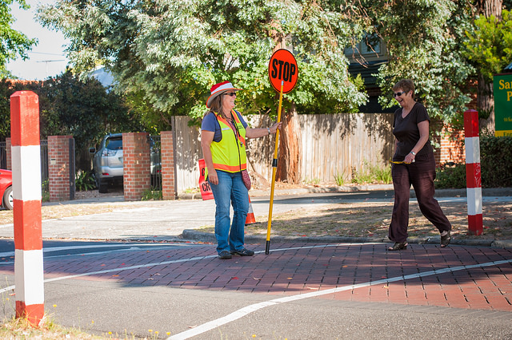
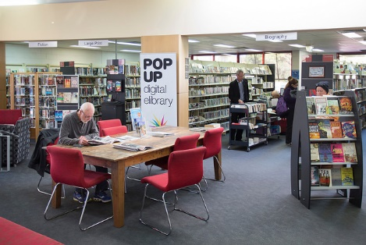
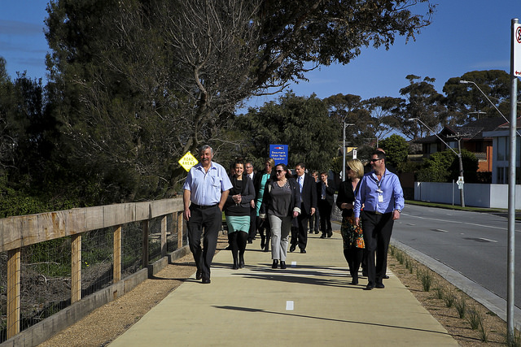
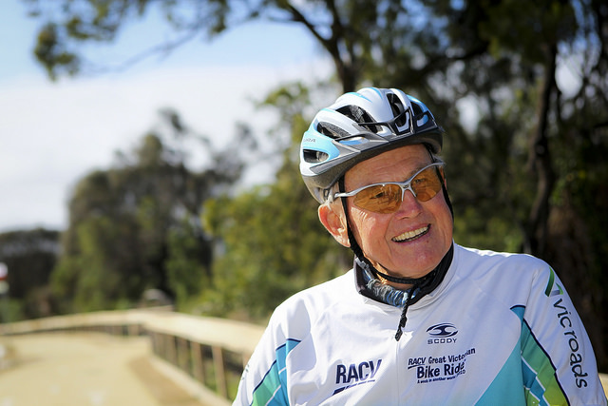

3.3.2 What did the community say?
The community provided a wide range of comments about this theme. Ideas were identified by each target group or life stage. These ideas provide a guide to potential solutions to making Bayside a safer and sustainable environment.
- Increase safety in public areas
Group | Ideas
Older adults | - Increase respect for older people.  - Lack of response by local police.  - Encourage community watch.  - Let’s get neighbourhood watch up and going again across Bayside.  - Free alarms for older households.  - Increase PSO presence at train stations.
People with a disability | - More police and PSO officers to make us feel safe.
Vulnerable groups | - Fear of violence.  - Disputes with neighbours.  - Public housing make safer.
General community (no target group specified) | - Advocate to reduce alcohol promotion and sponsorship with sporting clubs in Bayside.  - Restrict shops sale of alcohol.  - Don’t provide alcohol in pubs without snacks.  - Cut down advertisement.  - Create awareness on harms.  - No advertising connected with sporting events and sponsorships.

- Safety education
Group | Ideas
Early years | - Would like more information on water safety, road safety, car safety and heat safety.  - Would like to know where they can access basic first aid training for parents. Some happy to pay $$ others would like to know about free classes or subsidised classes.
Young people | - Educate youth about the harms of alcohol and how you don’t need to have alcohol to have a good time. Many feel pressured into drinking alcohol at parties to be “cool” and fit in. There needs to be a change in culture.  - What like more information on how to support a friend/family with drug or alcohol problem?  - Increased focus in schools on family violence awareness and LGBTI awareness.
Older adults | - Some concerns about using online banking.  - Elder abuse regarding financial situations.  - Can councils make digital scams known?  - More concerns with phone scams than internet scams.  - I want to use an iPad but classes are expensive $$$$ ( a free peer led class would be good).  - Know how to block rubbish from inbox.  - Promotion of places to go when hot e.g. libraries used as a hub when it is extreme weather.
People with a disability | - Like to use computer but need help/support.  - Would like internet safety education.  - Have been involved in courses at the library for online safety.  - Education on needles on beaches and in public areas what to do.
Vulnerable groups | - Promotion of places to go when hot e.g. libraries used as a hub when it is extreme weather.

- Invest in Infrastructure
Group | Ideas
Early years | - Pram parking at main shopping hubs and community locations. Parking with prams and small parking spots makes it hard to get the baby and pram out.  - Footpath and road connection steep (makes it hard to cross roads).  - Ensure there are “off ramps” at all shopping strips from the footpath to the road for crossing safely.  - Improve the amount of clean public changing facilities for parents with young children.
Older adults | - Good walking trails (no bikes) where feasible away from main roads.  - More public seating.  - Improve footpaths. Uneven footpaths – trip hazards. Tree roots causing problems, particularly with low light.  - Low lighting in Bay Road makes walking later at night scary.  - Hampton Senior Citizens Centre lighting not bright enough needs improving.  - Fix trees breaking through sidewalk.  - Develop a list of suitable private trees for residents. Recommended trees that won’t cause problem.  - Shelter at bus stops.  - Improve lighting in areas where people feel unsafe at night such as near public transport and shopping/restaurant strips.
People with a disability | - Ensure all footpaths and pedestrian access are clear with construction work is being completed. New large construction sites making it hard to walk around the community.  - More lighting to make it feel safer at dark.
General community (no target group specified) | - Drink fountains near public transport (train station, bus stop).  - Drink fountains outdoor shopping strips.  - More shade at bus stop.

- Improve Council and community capacity to respond to extreme weather
Group | Ideas
Older adults | - Promotion of places to go when hot e.g. libraries used as a hub when it is extreme weather.  - Southland is full of older people when the temperature is high. Or the local library.  - Maybe provide information re where to go. Will need to have public transport. Are there places where people can go in higher temperatures?  - Can we start a register to help people who might need assistance? Concerns regarding keeping them up to date.  - Hydration – people over 75 can find it difficult to regulate. Can they register with Council?  - Can meals list be used from those receiving home support to keep an idea on vulnerable people?
People with a disability | - Can we do something about the risk of bushfires in nature reserves?
General community (no target group specified) | - Green zones more trees  - More information on where to go when it’s hot  - Stop new developments covering 99% of site!  - Drink fountains outdoor shopping strips.  - Drink fountains near public transport (train station, bus stop).  - More shade at bus stop.  - Plant more trees.  - Use integrated waste and water management.  - Sensitive urban design in parks and carparks.

Next steps
The information contained in this report will be used to inform the Wellbeing for All Ages and Abilities 2017-2021 Strategy as well as the development of a Discussion Paper which will be available for public comment in June 2017. The Discussion Paper will be used to consult with the wider community, local health service providers, agencies and external partners on key health topics identified.

Appendix 1 - Images of engagement activities held at ‘pop up’ events across Bayside.
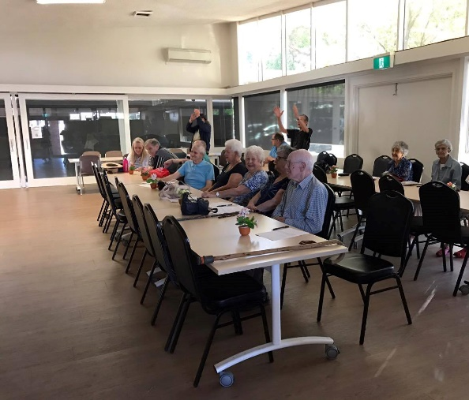
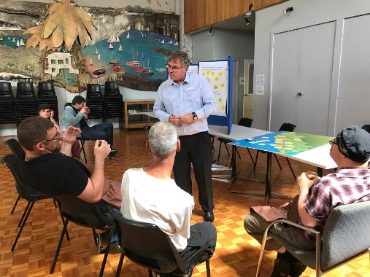
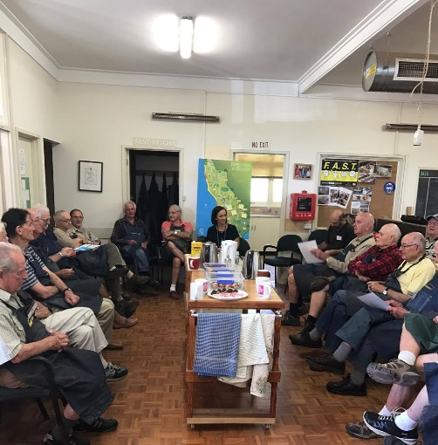
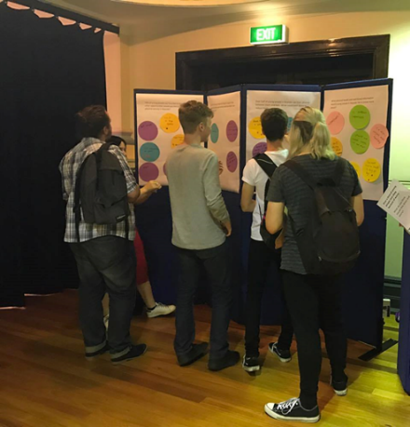
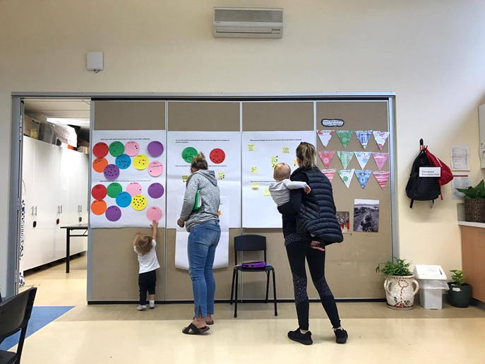
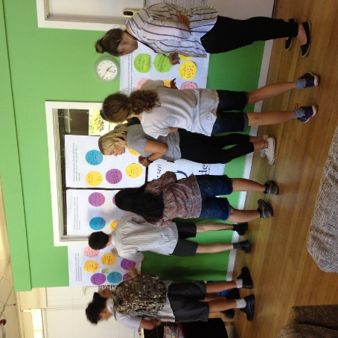

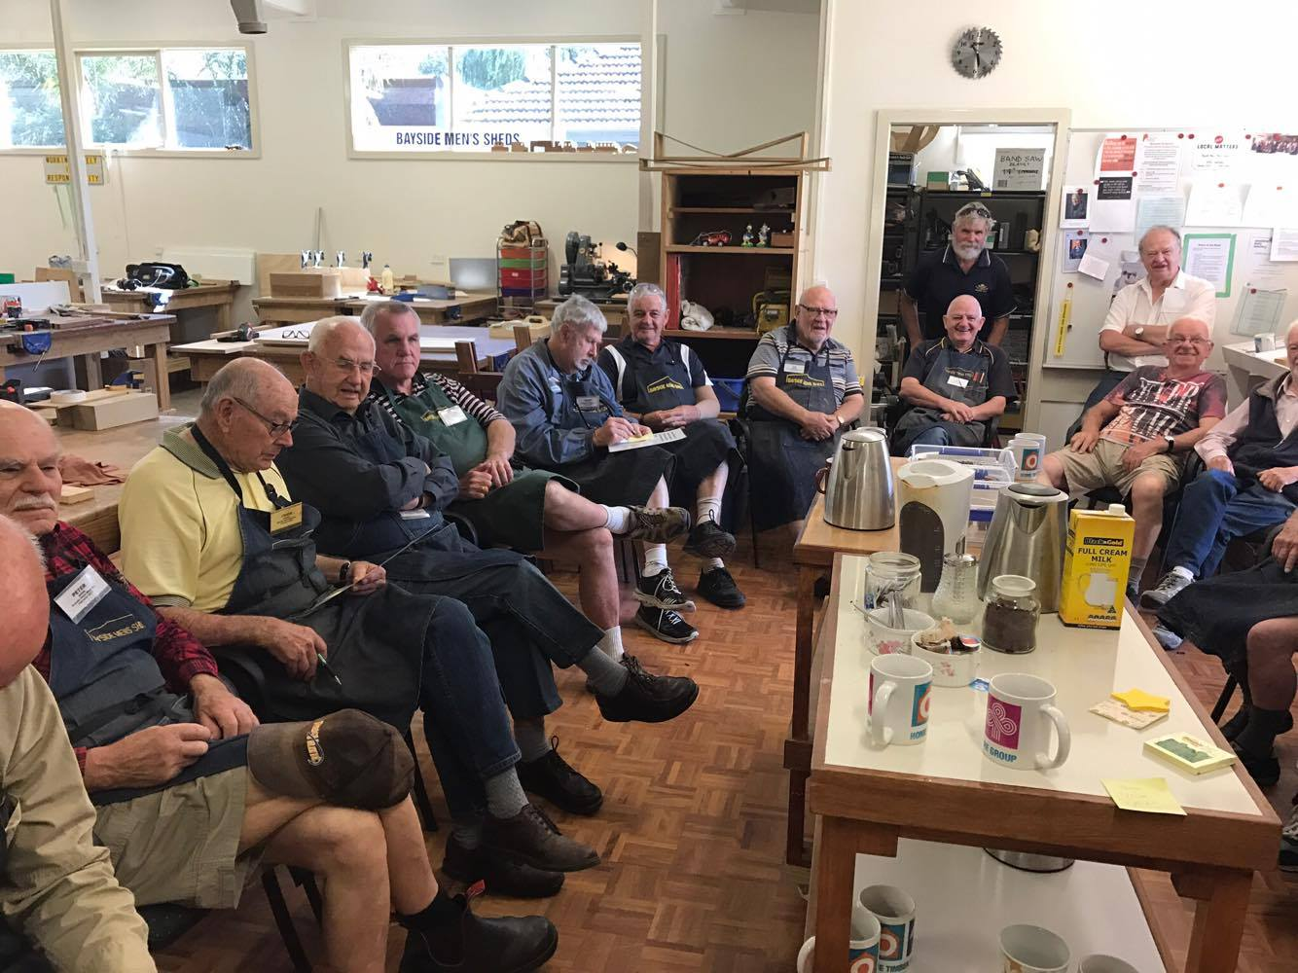
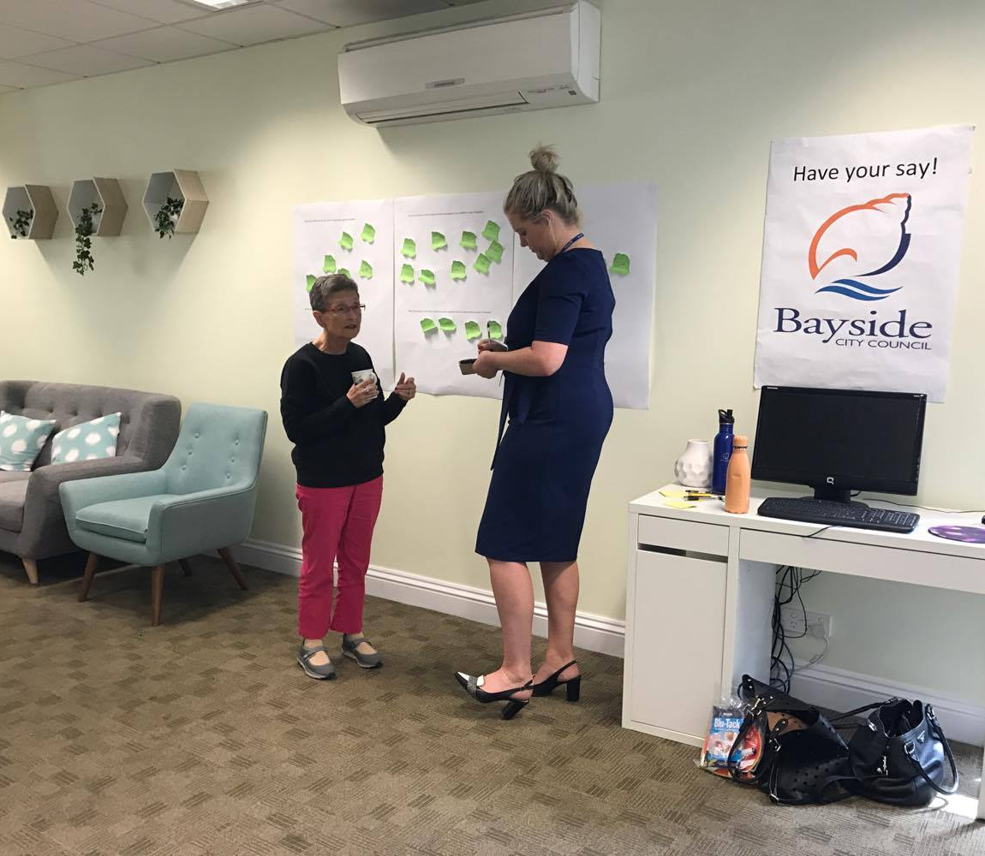

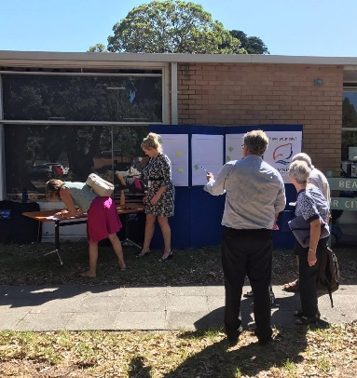
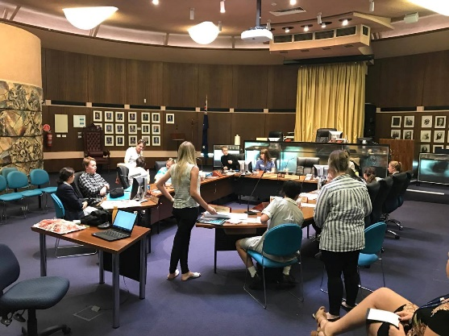
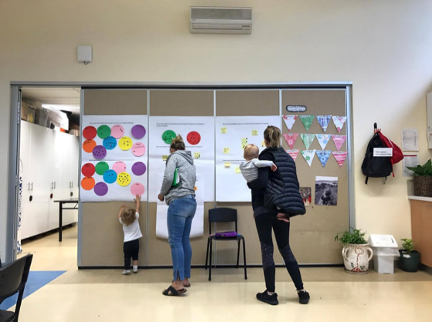

Appendix 2 – City of Bayside Health and Wellbeing Profile: Summary of key findings
Bayside population characteristics
Bayside predominantly consists of families and lone older persons, with the majority of residents Australian born. The municipality is characterised by high income earners and tertiary qualified residents.
- 101,321 estimated population 2015.
- 38% of residents aged 40-59 years.
- Aging population with a high percentage of frail aged persons.

- Most common household type; couples with children (36%), followed by couples without children (24%) and lone persons (23%).

- Majority of Australian-born residents (71%) however 12% of residents born in a non-English speaking country. Greek, Italian and Russian are the main non-English languages spoken, and a small but growing number of Mandarin speakers.

- High income earners with 25% of the population earning $1,500 or more per week.
- 46% of residents have tertiary qualification.
Vulnerable populations
There are areas of disadvantage in Bayside which include public housing estates, low income earners and residents who hold pension concession cards. There are also many people who are have a disability and need assistance in their day-to-day lives.
- 3.2% of dwellings are public housing.
- 5.7% of Bayside households experiencing housing stress.
- 5,557 (18.7%) households are low income households earning nil to $32,449 annually.
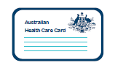
- 2,905 residents have healthcare cards.
- 10,547 residents are holders of pension concession cards.

- 3.2% unemployment rate.
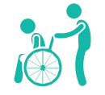
- Over 16,600 people have a disability and 3,635 people need assistance in their day-to-day lives because of a disability, long-term health condition or old age.

Health status
The overall health status of residents in Bayside is very good with high life expectancy, high self-reported mental health status in adults and lower than average chronic disease rates. However obesity, diabetes and mental health in young people are areas of concern.

- Life expectancy above Victorian average; 84 years male – 87 years female.
- Bayside residents reported an average wellbeing score of 78.4 out of 100. This was higher than the Victorian average of 77.3.

- 76% of Bayside respondents rated their mental health as either ‘very good’ or ‘excellent’. However residents from non-English speaking backgrounds were more likely to rate their mental health as ‘fair’ or ‘poor’.

- Young people in Bayside reported that they felt safe and secure at home (91%), have a good adult role model (86%), have a healthy attitude towards violence (80%), think it’s important to help others (93%) and keep physically fit (79%).

- Areas of concern for Bayside youth include: losing sleep through worry (31%), feeling constantly under strain (33%) and feelings of lack of purpose (34%), not getting 8 hours sleep (31%), texting between 10pm and 6am (49%) and eating disorders (6.6%).
- Asthma and respiratory system disease rates are higher in Bayside compared to Victoria and metropolitan Melbourne.

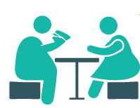
- Bayside has slightly higher rates of high blood cholesterol compared to Victoria and metropolitan Melbourne.
- A total of 42.3% of residents in Bayside were considered overweight or obese.

- Type 1 diabetes makes up 14.4% of those living with diabetes and is higher than the national average (9%). Type 2 diabetes makes up 82.7% of those living with diabetes and is slightly below the national average.
- Low crime rate compared to metropolitan Melbourne.
- Slight increase (1.2%) in family violence cases in 2015-16.

Health behaviours
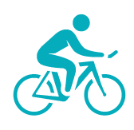
Bayside residents are generally active and engage in in high levels of weekly physical activity. However sedentary behaviour across the municipality is a concern. Bayside residents are also at risk of short term harm from alcohol consumption and have low rates of smoking.

- 49.4% engage in physical activity four or more days per week. This is higher than the Victorian average of 41.3%.

- 39.8% of residents sit for at least 7 hours per day. This is higher than the Victorian average.

- Fruit consumption 1.7 serves per day, similar to Victorian average of 1.6.
- Vegetable consumption 2.5 serves per day, higher than the Victorian average of 2.2.

- 40.2%, two out of five residents are at risk of short-term harm from alcohol. This was significantly higher than the Victorian estimate of 29.4%.

- Low smoking rates amongst males and females - 15.4% males and 10.3% females.

- 62% of babies 6 months old were breastfed. Fourth highest rate in southern metro region.

- High screening rates for breast cancer, cervical cancer and bowel cancer.

- Non-English speaking households, residents with a disability or long-term illness and those aged over 75 years had lower satisfaction with their community connections.

Service access
Majority of Bayside residents had private health insurance and access to health services when needed with wait times much lower than Victorian average. However GP attendance was below the Victorian average.

- 70.9% of residents have private health insurance.
- 1.8 GP’s servicing Bayside per 1,000 people. Higher than Victorian average of 1.2.
- GP attendance below the Victorian average for both females and males.
- 61% of services are bulk billed.
- The top four causes for Emergency Department Presentations were: Injury, Digestive system illness, Circulatory system illness and Respiratory system illness.

