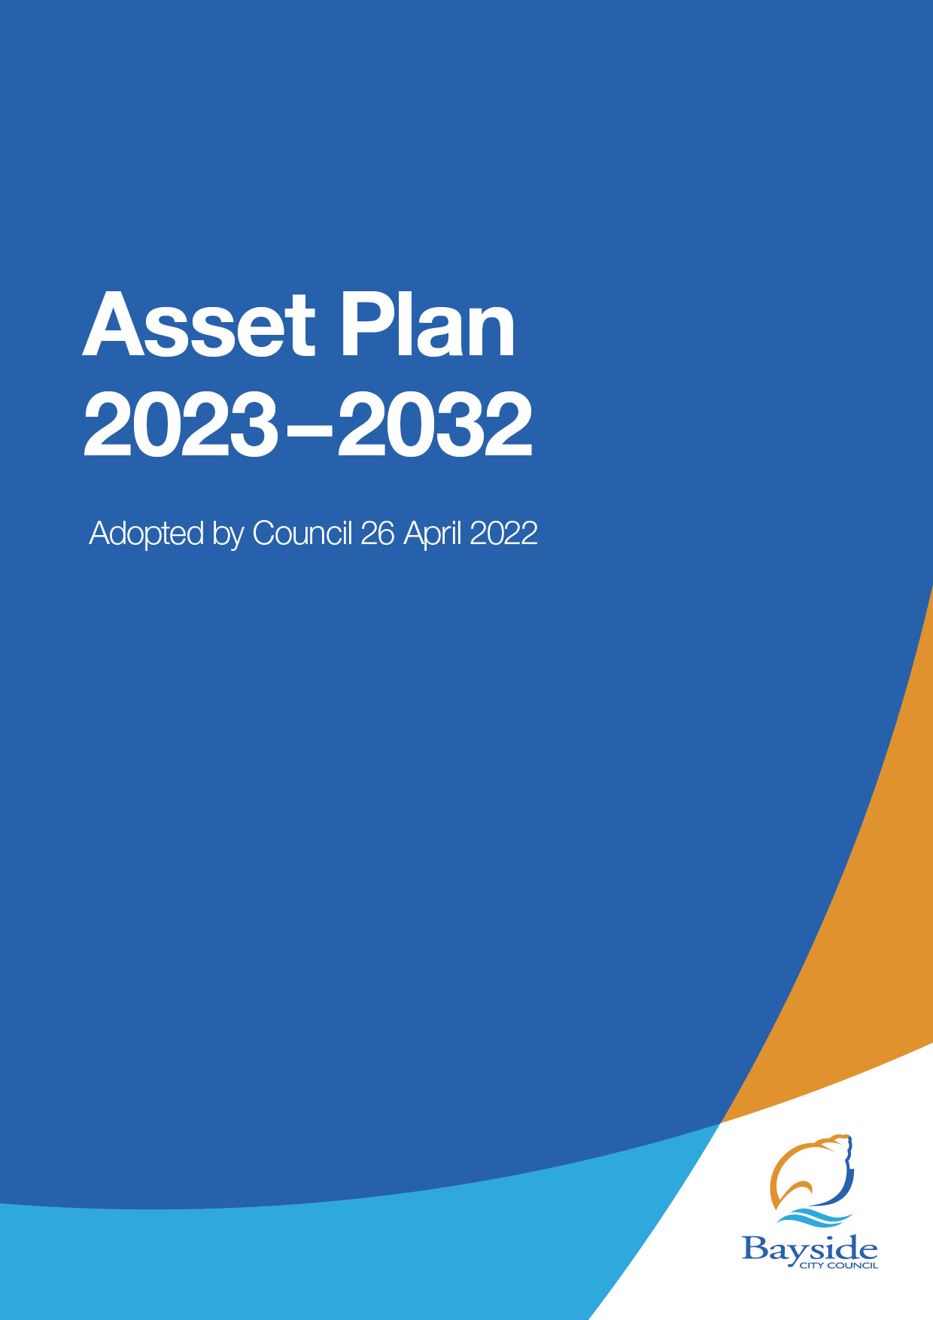

Bayside City Council proudly acknowledges the Bunurong People of the Kulin Nation as the Traditional Owners and Custodians of this land, and we pay our respects to their Elders, past, present and emerging.
Council acknowledges the Bunurong’s continuing relationship to the land and waterways and respects that their connection and spiritual identity is maintained through ancient ceremonies, songlines, dance, art and living culture.
Council pays tribute to the invaluable contributions of the Bunurong and other Aboriginal and Torres Strait Island elders who have guided and continue to guide the work we do.

Table of contents
1. Introduction 4
1.1. The Purpose of this Asset Plan 4
1.2. The scope of this Asset Plan 4
1.3. Not included in this Asset Plan 5
1.4. Asset Plan continuous improvement 5
2. Strategic Alignment 6
2.1. Community Vision and Council Plan 6
3. Asset Plan overview 8
4. Asset Service Levels 10
4.1. Asset Service Level Standards 11
4.2. The Role of Community Engagement Policy 2021 12
5. Renewal 14
5.1. State of the assets 14
5.2. Renewal Plan 14
5.3. Renewal Modelling 14
5.4. Renewal Improvements 15
6. Acquisition 16
7. Disposal & Decommission 17
7.1. Infrastructure Assets 17
7.2. Land Assets 17
8. 10 Year Planned Expenditure Forecast ($m) 18
8.1. Maintenance and Operations Expenditure ($m) 19
8.2. Renewal Expenditure (As projected by modelling software, $000) 20
8.3. Renewal Expenditure (actual Capital program, in $000) 21
8.4. New Expenditure ($000) 22
8.5. Upgrade & Expansion Expenditure ($000) 23
9. Improvement Plan 24
10. Appendix 1 Infrastructure Asset Performance 25
10.1. Condition Monitoring 25
10.2. Calculating asset condition 25
10.3. Calculating Function and Capacity/Utilisation scores for an asset 25
11. Appendix 2 Service levels (Indicative) 27
11.1. Scheduled inspections 27
11.2. Reactive Maintenance 27

- Introduction
  - The Purpose of this Asset Plan
This Asset Plan has been developed to guide and demonstrate Bayside Council’s (Council) responsible and sustainable management of its infrastructure assets, comply with the Victorian Local Government Act 2020, and model the funding required to meet the future service needs of the community.
The Victorian Local Government Act 2020 states that an Asset Plan must:
- Include information about maintenance, renewal, acquisition, expansion, upgrade, disposal, and decommissioning in relation to each class of infrastructure asset under the control of the Council and any other matters prescribed by the regulations, and

- be developed, adopted, and kept in force in accordance with the Council's deliberative engagement practices.

- Councils are expected to complete their Asset Plans by 30 June 2022 although deliberative engagement is not required for the first iteration of the Asset Plan.

  - The scope of this Asset Plan
Council’s Property, Infrastructure, Plant & Equipment, Intangible Assets, and Right of Use Assets have a total value projected at June 2021 of $3.42 billion of which includes $2.8 billion of land. The assets subject to renewal have a written down value of $734 million. Bayside City Council’s total asset portfolio consisting of property, plant and equipment and infrastructure assets comprising the following asset quantities:
Asset Inventory:
176 parks, reserves, gardens, foreshore precincts, and grounds | 357 kilometres of local roads
66 playgrounds | 20 kilometres of laneways
36 sports grounds on ovals | 121 car parks
5 playing fields | 672 kilometres of kerb and channel
3 golf courses | 781 kilometres of civil and open space pathways
4 skate parks | 15,500+ drainage pits
14 park shelters | 415 kilometres of drainage pipes
13,600+ park and Street furniture assets including BBQs, seats, fences, irrigation, sports appurtenances (i.e. nets/goals), horticulture assets. | three major stormwater harvesting systems
63,000+ street and park trees + | 34 major buildings & 147 minor buildings

These assets are critical in supporting a variety of community services and must be effectively managed to ensure quality and reliable service delivery into the future.
  - Not included in this Asset Plan
This first iteration of Council’s Asset Plan is written to articulate Council’s current service level standards and the resulting costs to Council in delivering to those standards.
This Asset Plan does not provide details such as:
- outcomes of deliberative engagement on service standards (although some Council strategies that underpin this document do)
- maintenance procedures;
- operational procedures; or
- engineering design standards.
This Asset Plan also does not include:
- Non-council assets, such as highways and arterial roads maintained by the Department of Transport
- Land, parks, and reserves maintained by the Department of Land, Water and Planning;
- Council assets that Council chooses not to maintain or renew; and
- Assets not capitalised in accordance with Council’s Asset Capitalisation Policy.
This Asset Plan is a separate document to Council’s Road Management Plan 2021, the latter being a requirement for Council to comply with its specific responsibilities and obligations under the Road Management Act 2004.
  - Asset Plan continuous improvement
The Asset Plan is a new requirement under the Local Government Act 2020 and requires realignment of Council priorities, data, processes, and community consultation. Therefore, this first plan meets the most immediate needs of LGA 2020 and will be subject to an ongoing process of prioritised improvement. Any assumptions are documented throughout this plan, and the improvement plan is documented in section 10.

- Strategic Alignment
  - Community Vision and Council Plan
This Asset Plan is a key element of medium- and long-term planning and delivery of Council’s services to our community represented in our integrated strategic planning framework
The Community Vision drives the Council Plan, and this Asset plan subsequently links to relevant sections of the Council plan.
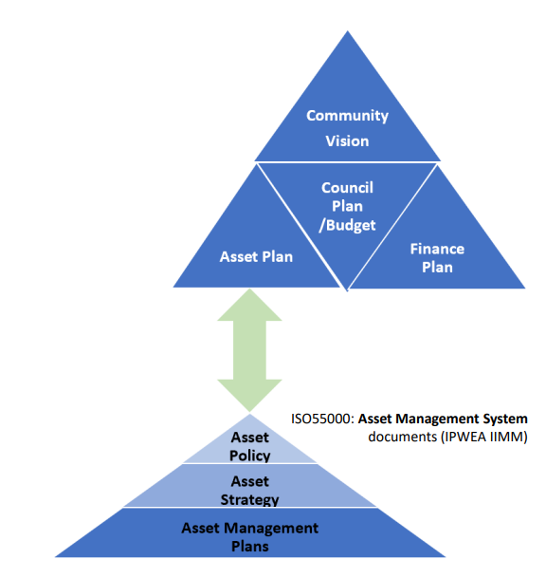
The Asset Plan then is a key component of the Asset Management Framework which includes a Policy, Strategy, underlying Asset Management Plans for specific classes of infrastructure. Supporting these documents are Asset Management Information Systems, processes and integrations. A key deliverable from the framework is inputs to the Long-Term Financial Plan.

The Asset Plan supports delivery of the Community Vision and Council Plan as below:
Community Vision | Council Plan | Asset Plan
Theme 1  The living environment/natural environment | Goal 1 Our Planet | Asset Service Level Standards (ASLSs) ensure that Community expectations in the living and natural environment are integral to decisions on Capital and operational expenditure.
Theme 2  Increase & enhance open space | Goal 1 Our Planet  Goal 3 Our Place | Asset Planning is based on an understanding of how our facilities are valued and used by the Community. Enhancement to those assets is based on a shared understanding of the need to be improved for sustainable long-term use.
Theme 3  Transport, Walkability and Rideability | Goal 3 Our Place | Plan for and implement effective stewardship of all  Council assets to ensure our infrastructure is safe, activated, accessible, adaptable and environmentally sustainable.
Theme 4  Community Feel and Direction. | Goal 2 Our People | Partner with community, agencies and other levels of government to deliver the right mix of assets to ensure that services are fit-for-purpose so the community can feel safe and live healthy, resilient, active lives at all ages and stages of life.
Theme 5  Nurturing creativity. | Goal 2 Our People | Ensure accessibility and inclusion needs are explicitly captured during community consultation and included in asset design considerations
Theme 6 Promoting innovation | Goal 1 Our Planet  Goal 4 Our Promise | Support foreshore, open space and urban forest initiatives with better service level tools and data for more informed decisions and planning.
Theme 7  Council Operations and Accountability | Goal 4 Our Promise | Ensure the Asset Plan is increasingly open and transparent.
Theme 8  Access and Inclusion | Goal 2 Our People | Access and inclusion are a key theme in ASLSs.
Theme 9  Built Environment | Goal 3 Our Place | Plan for and implement effective stewardship of all  Council assets to ensure our infrastructure is safe, activated, accessible, adaptable and environmentally sustainable.
Theme 10  Tourism, Commercial and Economic Opportunities | Goal 2 Our People | Ensure ASLSs recognise the unique needs of Activity Centres and the foreshore to maximise Tourism, Commercial and Economic Opportunities
- Asset Plan overview
How the Asset Plan informs the Long-Term Financial Plan
The Asset Plan informs the long term, as a 10-year picture of capital expenditure across all asset classes. It captures the full financial impact of combining asset renewal and maintenance, to meet the needs of users with new, upgraded, expanded or disposed assets.
The classes of assets and expenditure categories align with Councils Asset Accounting Policy 2021
Asset classes
Bayside City Council uses the following classifications of non-current assets (that are relevant to this Asset Plan):
Land & Buildings
- Buildings – specialised
- Buildings – non specialised
- Heritage buildings
Plant and equipment
- Fixtures, fittings and furniture
- Art and culture collection
Infrastructure
- Roads
- Bridges
- Footpaths and cycleways
- Laneways
- Drainage
- Parks, open space and streetscapes
- Foreshore and conservation
- Off street car parks
- Road management, traffic signals and street furniture
Types of capital expenditure
Extracting optimal life from existing assets via
- Renewal
- Maintenance
Meeting the needs of users or legislation/regulation via
- Upgrade
- Expansion
- Acquisition
- Disposal

Asset Planning Framework
The asset renewal and maintenance programs arise from stewardship of an asset inventory and condition data. Assets need to be kept to a condition that balances the increasing maintenance cost as assets age with the renewal cost, extracting the optimum service potential.
Collection, storage and analysis of condition data for all asset classes is coordinated by Council’s Asset Management team.
Asset upgrades, expansion, acquisitions and decommissioning are identified when assessing the needs of all users. Council directorates such as Community Services and Recreation Services use significant assets to deliver services, requiring significant community input and consultation into understanding needs. Asset service level demands arise from this consultation which in turn may require capital investment, often long before renewal is required. Changing Community preferences, demographics and legislation are common causes of service level change.
Asset service levels are assessed by the service manager using Asset Service Level Standards (ASLSs) as the basis for scoring the Function and Capacity of each asset.
The resulting matrix of condition, function and capacity scoring across assets forms the basis of analysis and asset planning.
Asset Plan 2022
Asset data
Asset Intensive Council Services
- Condition scoring
- Asset inventory
- Valuation
- Intervention Levels

- Function and Capacity scoring (Service Levels) based.
- Community engagement on Asset Service Level Standards and Maintenance Service Levels
- Strategic Plans
Upgrade, expansion, Acquisition, Disposal Program
Non-asset solutions
Renewals and Maintenance Program
- Long Term Financial Plan
- Asset Management Plans
- Capital Planning
- Analysis

- Asset Service Levels
Two types of service levels are used in this plan: maintenance service levels and asset service levels. A goal of The Victorian Local Government Act 2020 is to ensure that that Councils increasingly utilise deliberative engagement with the Community to develop these service levels.
Maintenance service levels include resolution times to reactive maintenance requests, intervention levels and proactive inspection and maintenance frequencies. Higher service level requirements lead to higher maintenance costs. Some indicative service levels are shown in appendix 2.
The remainder of this section considers asset service levels.
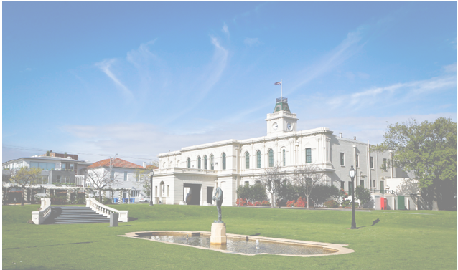

Brighton Town Hall exemplifies the challenge of managing asset service levels. This heritage listed building delivers a variety of Council services to the Community; an Art Gallery, a Community Arts Group and the Brighton Historical Society. It also provides space for events such as weddings, performances, community events and fundraising. Its heritage status, mixed usage and required response to climate change place complex and sometimes conflicting demands on how the building is funded, maintained and operated. Understanding, mapping and responding to the complex array of shifting requirements across all of Council’s asset classes (not just public buildings but open space, roads, sports pavilions and clusters of assets in activity centres) is the key challenge, which is met by capturing and mapping the service level requirements of each service that use the building.
The service levels developed by Council for its infrastructure assets relate to both community and technical service aspects which are categorised as condition, capacity and functionality.
The asset service levels, as defined in this Asset Plan, include the following key performance indicators:
Service level category | Description | Who assesses the assets? | How are assessments done?
Condition | The physical condition of an asset based on a score of 1 – 5. The score represents the assets Remaining Useful Life (RUL). | Asset Management | Periodic inspections (internal or external resource)
Functionality | The ability of the physical infrastructure to meet program delivery needs, or design objectives. | Service Manager | Against ASLS criteria as continuously improved under engagement policy
Capacity /utilisation | The ability of the asset to meet intended service demand. An indicator of value for money from community investments

Having up to date information on an asset’s Condition, Functionality and Capacity/Utilisation gives asset and service managers an evidence base for targeted investment proposals. The evidence can support multiple perspectives; an asset may be in good physical condition, but score poorly against functionality or capacity, indicating that the asset is not fit for purpose. In such a case the asset is a strong candidate for upgrade or expansion.
Functionality and Capacity/Utilisation criteria will be developed and reviewed based on Council’s Community Engagement Policy 2021, with service level demand codified and published through Asset Service Level Standards (ASLS). ASLSs therefore form the basis of and justification for capital investment in New, Upgrade, Expansion and Decommission categories.
These scores can also drive the acquisition of new assets if the ASLS dictates (for example) a spatial provision or distribution based on population or hierarchy. For example, a Council might decide that no resident needs to travel more than 20 minutes to access a library between the hours of 8am and 8pm.

Further detail on Infrastructure Asset performance is discussed in detail in the Appendix.
  - Asset Service Level Standards
Engage Victoria: Local Government Act 2020, Integrated Strategic Planning and Reporting Framework:

“Effective stewardship of assets assumes that assets exist to support the delivery of service outcomes to the community. Therefore, as a core part of its Asset Plan, Council should develop and adopt functional service level standards across all classes of assets. The Asset Plan should define these functional performance standards for each asset class/type, as well as the necessary investments that will be required to achieve this (i.e. maintenance, renewals, new investment).”

Bayside’s Response:

For the most asset intensive services, our Asset Service Level Standards (ASLSs) will become the key ‘contract’ between the community, the service managers and Council’s Capital works program.

• As an integral part of the asset planning framework AND service planning, Council will develop and continuously improve a suite of Asset Service Level Standards (ASLSs) to align service delivery, and community expectations with future Capital investments.
- These ASLS documents will be available on Council’s website.
• They will align Service areas with Council’s ASLSs, Strategies, Engagement and Capital works program and be used to support capital investment proposals.

Covering the bulk of the asset inventory, current ASLS documents exist in draft form for the following asset groups and will be subject to future community engagement:
Asset Class | A single ASLS for each Service Area
Buildings | Families and Children (Immunisation and Kindergartens)  Library Services  Arts and Cultural Services  Youth Services  Pavilions  Senior Citizens  Public Toilets
Roads | Asset Management
Open Space | Playgrounds  Playing Surfaces and surrounds

In many cases, true levels of service (i.e. kindergartens) are more complex than what can be codified in an ASLS. In those cases the ASLS will hold an entry point only to further detail in other documents.
Demand Impact

ASLSs also capture future demand as driven by economic, social demand, technology and environmental factors.

  - The Role of Community Engagement Policy 2021
As part of developing reviewing asset and maintenance service levels, Council will call for different levels of engagement based on the significance, complexity, and anticipated level of impact on what is being proposed and the stakeholders to be targeted.
Care is taken to adhere to the engagement principles, set clear engagement objectives and consider statutory processes, community interest, opportunities for co-designing engagement projects, political sensitivity, time, resources, and budget constraints.
Table 2.2.1 below illustrates Council’s use of the IAP2 spectrum of public participation to guide the range and extent of engagement when defining service levels.
 | Inform | Consult | Involve | Collaborate | Empower
Goal | Provide the public with balanced and objective information to assist them in understanding the problems, alternatives, opportunities, and or/solutions. | To obtain public feedback on analysis, alternatives and/ or decision. | To work directly with the public throughout the process to ensure that the concerns and aspirations are consistently understood and considered. | To partner with the public in each aspect of the decision including the development of alternatives and the identification of the preferred solution. | To place the final decision making in the hands of the public.
Bayside’s promise | We will keep you informed. | We will keep you informed, listen to and acknowledge concerns and aspirations, and provide feedback on how public input influenced the decision. | We will work with you to ensure that your concerns and aspirations are directly reflected in the alternatives developed and provide feedback on how public input influenced the decision. | We will work together with you to formulate solutions and incorporate your  advice and recommendations into the decisions to the maximum extent possible. | We will implement what you decide
Table 2.2.1 – IAP2 Spectrum of public participation

The Community engagement outlined above will be used when engaging the community during service and infrastructure strategy development. Groups will be deliberatively engaged in discussions around the content of relevant Asset Service level Standards, intervention levels (the condition at which an asset should be considered for renewal) and cost implications.

Currently when engaging on infrastructure provision, this is done through the engagement process of the policy/strategy development, overseen by the relevant service manager.

- Renewal
Renewal or replacement of an existing asset represents the complete or partial refurbishment or replacement, which extends the functional use of an existing asset. It returns the service potential or the life of the asset to that which it had originally. Examples include the replacement of an internal wall in a building (Bayside Draft Asset Accounting Policy, 2021).
As it reinstates existing service potential, it has no impact on revenue, and may reduce future operating and maintenance expenditure if completed at the optimum time. Council undertakes annual renewal programs such as road re-sealing, road re-sheeting, footpath and kerb & channel renewal.
  - State of the assets
The infrastructure assets supporting Council services are overall well maintained and operate at a high standard.

Condition 1= Excellent, 2 = Good, 3 = Fair, 4 = Poor, 5 = Failed
The bulk of Councils assets are in excellent, good or fair condition, with 12% (by combined Replacement Cost) approaching the point of renewal. Note: a good part of the 12% are drainage assets whose condition is estimated based on age, not observation. These assets typically last well beyond their expected life, so the 12% figure is actually substantively less.
  - Renewal Plan
Assets for which the condition score is above or approaching the intervention level are considered for closer onsite assessment and inclusion in the long-term capital renewal program.
Condition inspection programs are scheduled every 3 years for roads, footpaths, open spaces, and buildings. Stormwater inspection program is carried out as a rolling program on an annual basis, targeting high risk areas.
Renewal works may also be identified from adhoc inspections and customer requests.
  - Renewal Modelling
Renewal modelling uses asset condition data and modelling software to predict the investment required to ensure the overall asset base stays in a condition that is acceptable to the Community.
The graph below shows an overall renewal investment requirement of $14m (in 2023) increasing to $18.4m (by 2032). The red line indicates that an increasing percentage of the asset base will require intervention, suggesting that slightly higher levels of renewal funding may be required to ensure that only 3% of the asset base stays under intervention levels (i.e. in good or better condition). Confidence in the modelling varies by asset class.
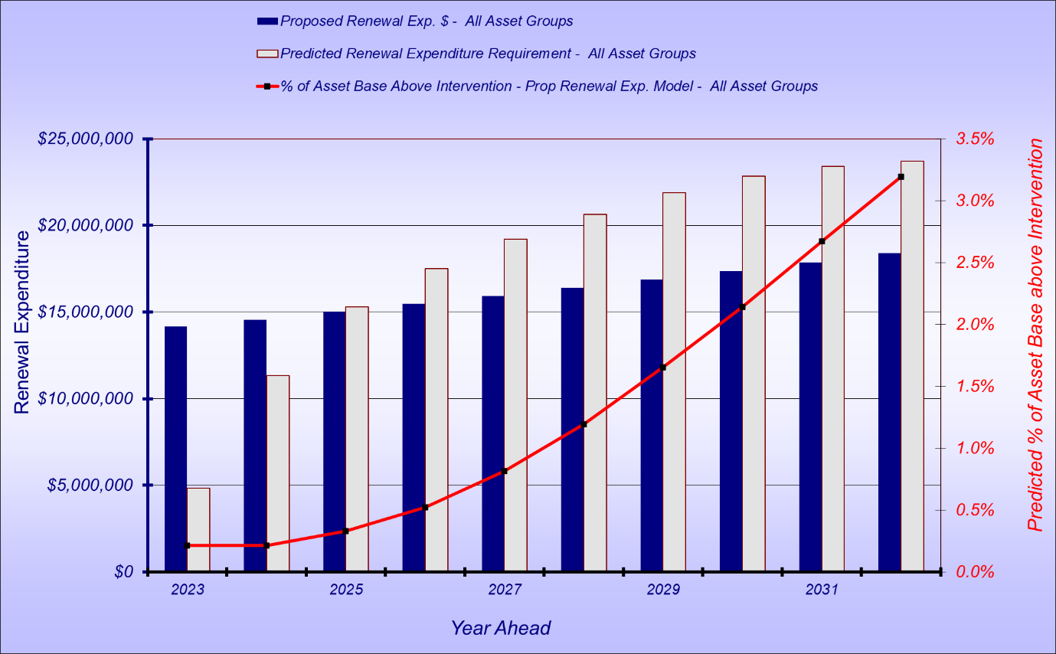

  - Renewal Improvements
Council has committed through the Asset Management Policy to providing a sufficient level of annual funding to meet ongoing asset renewal needs. Without this commitment a ‘renewal gap’ develops and overall asset condition declines.
A renewal gap, and renewal requirements are monitored using modelling tools and data inputs (inventory, condition, valuation and intervention levels). The quality of the input data has a significant impact on quality of the modelling, therefore all inputs to the modelling are under continuous improvement and scrutiny (a key improvement task under this asset plan). For example, in 2019/20 Council undertook a major review of how it calculates asset replacement cost.
- Acquisition
Expenditure that creates a new asset that provides a service that does not
currently exist. Acquisition or creation includes actions taken to produce new assets. Examples
include building a new stand-alone building, a new road or new drainage (Bayside Draft Asset Accounting Policy, 2021).

New assets may be gifted, constructed, acquired, or purchased by Council in the following circumstances:

Gifted Assets
Gifted assets provided by developers constructing infrastructure for various subdivisions and civil works. State/Federal Government projects may also result in assets gifted to Council.

Construction, Acquisition or Purchase of New Assets
There may be an identified need to construct, acquire or purchase a new asset for municipal purposes. This need may be identified as part of a Study / Strategy / Policy / Master Plan / or Council Report that has been endorsed by Council resolution.

The identified need may relate to the acquisition of land for purposes associated with any of the following:

- public car parking.
- public open space including biodiversity and habitat connectivity.
- widening, realigning up-grade or linking / connection of roads.
- municipal infrastructure.
- municipal facility.
- meeting of any strategic objective to facilitate service provision.
- meeting objectives identified in the Council Plan.
- reasons that may be determined by Council resolution from time to time.
- Upgrade & Expansion
Asset expansion expenditure that extends the capacity of an existing asset to provide benefits to new users at the same standard as is provided to existing beneficiaries (Bayside Draft Asset Accounting Policy, 2021).

Expansion is discretional expenditure, which increases future operating and maintenance costs because it increases council’s asset base e.g., extending a drainage or road network, the provision of an oval or park in a new suburb for new residents.

Capital upgrade is expenditure that: (a) Enhances an existing asset to provide a higher level of service, or (b) Increases the life of the asset to beyond its original life. Upgrade expenditure is discretionary and aimed at improving community satisfaction. It often does not result in additional revenue unless direct user charges apply. It will increase operating and maintenance expenditure in the future because of the increase in the Council’s asset base. Examples include adding a shade sail to a playground, replacing a pipe with a larger diameter pipe, adding a lane to an existing road, extending a drainage or road network, or replacing a gravel path surface with an asphalt path.

Upgrade will increase future operating and maintenance expenditure.

- Disposal & Decommission
  - Infrastructure Assets
Closure and disposal of assets may occur when there is insufficient use of the asset, continued existence of the asset is not justified, or the service has been discontinued or significantly modified.
The disposal or decommissioning of Council assets will draw on relevant information and expertise around social, economic, and environmental considerations to ensure alignment to whole of Council priorities.
  - Land Assets
Council owns land for a variety of public purposes, including for health, education, community services, sports, and recreation. Council also owns land to protect its natural environment or heritage value in the form of parks or reserves.
The need for Council to own land changes over time, in response to demand for public services, population change or new policy priorities. As a result, from time to time there may be some land that become surplus to Council needs.
All Council land is to be retained unless all the following criteria applies:
- The land is no longer used or intended to be used for a purpose associated with service provision by Council.
- The land is not being used for its originally intended purpose.
- The land has a net realisable value for another purpose which is significantly greater than the cost of re-establishing the service on another site.
- The land does not contribute to the achievement of a current Council objective.
- The land has no strategic significance to Council on a long-term basis.

- 10 Year Planned Expenditure Forecast ($m)
The graph shows Council’s planned investment on property and infrastructure assets between 2023 and 2031.
The higher levels of Renewal and Upgrade/Expansion in 2023 are mainly for building projects that carry an element of renewal, such as Black Rock Lifesaving Club, Brighton beach SLSC, Brighton Recreation Centre, Boss James Reserve Pavilion, Sillitoe Reserve Pavilion, Fern St Children’s Centre and Nth Brighton Children’s Centre. Southern Basketball Association Building is mostly New expenditure (i.e. $5.7m), as are new car parks planned for 2024 and 2025.
Upgrade/expansion is considered early renewal and reduces renewal requirements in the longer term (outside the 10-year horizon in most cases).
Capital Exp Class | 2023 | 2024 | 2025 | 2026 | 2027 | 2028 | 2029 | 2030 | 2031 | 2032
Maintenance & Operations | 18.32 | 18.59 | 18.87 | 19.16 | 19.44 | 19.74 | 20.03 | 20.33 | 20.64 | 20.95
Renewal | 27.70 | 17.02 | 15.28 | 18.42 | 16.28 | 16.85 | 17.44 | 18.05 | 18.69 | 19.34
Acquisition (New) | 9.54 | 15.91 | 16.53 | 16.64 | 5.15 | 4.48 | 4.48 | 4.23 | 4.23 | 4.23
Upgrade/Expand | 30.53 | 17.53 | 12.58 | 6.79 | 5.15 | 4.48 | 4.48 | 4.23 | 4.23 | 4.23
Extra Maintenance from acquisition and upgrade/expansion (accum @1.5%) | 0.60 | 1.10 | 1.50 | 1.90 | 2.00 | 2.18 | 2.31 | 2.45 | 2.56 | 2.70

  - Maintenance and Operations Expenditure ($m)
The following table provides an estimate of future expenditure for the maintenance of existing and future assets over a 10-year period. Current service levels are outlined in maintenance contracts. Higher service levels (i.e more frequent inspections, or improved intervention levels and response times) will require reprioritisation or may incur higher maintenance costs. Council ensures the best value for maintenance costs by tendering out its maintenance services.
 | 2023 | 2024 | 2025 | 2026 | 2027 | 2028 | 2029 | 2030 | 2031 | 2032
General | 4.22 | 4.28 | 4.35 | 4.41 | 4.48 | 4.55 | 4.61 | 4.68 | 4.75 | 4.83
Infrastructure | 4.69 | 4.76 | 4.83 | 4.90 | 4.98 | 5.05 | 5.13 | 5.21 | 5.28 | 5.36
Open Space | 4.56 | 4.63 | 4.70 | 4.77 | 4.84 | 4.91 | 4.99 | 5.06 | 5.14 | 5.21
Shopping Centres | 0.46 | 0.47 | 0.47 | 0.48 | 0.49 | 0.50 | 0.50 | 0.51 | 0.52 | 0.53
Street Cleaning | 0.92 | 0.93 | 0.95 | 0.96 | 0.98 | 0.99 | 1.01 | 1.02 | 1.04 | 1.05
Tree Services | 2.31 | 2.34 | 2.38 | 2.42 | 2.45 | 2.49 | 2.53 | 2.56 | 2.60 | 2.64
Buildings | 1.16 | 1.18 | 1.20 | 1.21 | 1.23 | 1.25 | 1.27 | 1.29 | 1.31 | 1.33
Total | 18.32 | 18.59 | 18.87 | 19.16 | 19.44 | 19.74 | 20.03 | 20.33 | 20.64 | 20.95
Projected increase from acquisitions | 0.60 | 1.10 | 1.50 | 1.90 | 2.00 | 2.18 | 2.31 | 2.45 | 2.56 | 2.70

Maintenance will vary in response to:
- Council acquisition of new assets triggers a variance to the maintenance cost based on an agreed schedule of rates.
- The CPI rate varies – maintenance costs will increase in line with CPI with some modifications. If CPI < 2%, variance is 50% of CPI. If CPI > 2% variance is 1% less than CPI. If CPI is 0, variance is 0 (for this forecast a nominal CPI of 1.5% is used).
- Nominally it is expected that maintenance investment should be 1.5% of the asset cost when considering a typical Local Government mix of Assets in varying condition (Shown as projected increase from acquisitions and upgrade/expansion).

  - Renewal Expenditure (As projected by modelling software, $000)
The following table provides an estimate of future expenditure ($000) for renewing existing assets over a 10-year period. It represents a minimum recommended renewal investment, and will change as underlying data and processes are improved.
Renewal Data from Moloney Model | FY2023 | FY 2024 | FY 2025 | FY 2026 | FY 2027 | FY 2028 | FY 2029 | FY 2030 | FY 2031 | FY 2032
Buildings* | 4,953 | 5,126 | 5,306 | 5,491 | 5,684 | 5,883 | 6,088 | 6,302 | 6,522 | 6,750
Roads | 2,251 | 2,330 | 2,412 | 2,496 | 2,583 | 2,674 | 2,767 | 2,864 | 2,965 | 3,068
Bridges | 30 | 31 | 32 | 33 | 34 | 35 | 36 | 38 | 39 | 40
Kerbs and Channels | 1,012 | 1,048 | 1,084 | 1,122 | 1,162 | 1,202 | 1,244 | 1,288 | 1,333 | 1,380
Footpaths & cycleways | 2,231 | 2,309 | 2,390 | 2,473 | 2,560 | 2,649 | 2,742 | 2,838 | 2,937 | 3,040
Drainage | 2,021 | 2,091 | 2,165 | 2,240 | 2,319 | 2,400 | 2,484 | 2,571 | 2,661 | 2,754
Parks, Open Space and Streetscapes** | 1,477 | 1,529 | 1,583 | 1,638 | 1,695 | 1,755 | 1,816 | 1,880 | 1,946 | 2,014
Off Street Car Parks | 215 | 222 | 230 | 238 | 246 | 255 | 264 | 273 | 282 | 292
Total | 14,190 | 14,686 | 15,202 | 15,731 | 16,283 | 16,853 | 17,441 | 18,054 | 18,685 | 19,338

  - Renewal Expenditure (actual Capital program, in $000)
Any renewal amount that is above and beyond the projected requirement is early renewal where buildings are upgraded or expanded due to a gap in the assets service levels i.e. sporting pavilions upgraded to accommodate women’s AFL might include a % of Renewal. The total capital investment in the project is apportioned between Renewal, Upgrade and Expansion and New.
Asset Group | FY2023 | FY2024 | FY2025 | FY2026 | FY2027 | FY2028 | FY2029 | FY2030 | FY2031 | FY2032
Buildings* | 15,225 | 6,970 | 5,225 | 8,086 | 5,684 | 5,883 | 6,088 | 6,302 | 6,522 | 6,750
Roads** | 4,613 | 2,157 | 2,943 | 3,012 | 2,583 | 2,674 | 2,767 | 2,864 | 2,965 | 3,068
Bridges | 0 | 0 | 0 | 0 | 34 | 35 | 36 | 38 | 39 | 40
Kerbs and Channels | 1,041 | 1,114 | 1,169 | 1,229 | 1,162 | 1,202 | 1,244 | 1,288 | 1,333 | 1,380
Footpaths & cycleways | 2,086 | 2,019 | 1,803 | 1,804 | 2,560 | 2,649 | 2,742 | 2,838 | 2,937 | 3,040
Drainage | 1,516 | 1,119 | 1,081 | 1,580 | 2,319 | 2,400 | 2,484 | 2,571 | 2,661 | 2,754
Parks, Open Space and Streetscapes*** | 2,993 | 2,828 | 2,493 | 2,273 | 1,695 | 1,755 | 1,816 | 1,880 | 1,946 | 2,014
Off Street Car Parks | 221 | 815 | 565 | 432 | 246 | 255 | 264 | 273 | 282 | 292
 | 27,695 | 17,022 | 15,279 | 18,416 | 16,283 | 16,853 | 17,441 | 18,054 | 18,685 | 19,338

Buildings* = Buildings and Building Improvements
Roads** = Roads and Road Management (signals etc)
Parks, Open Space and Streetscapes*** = Activity Centres, Foreshore and Conservation, Parks and Recreation and Street furniture
Applies to all tables below

Source: Capital program as at 3/4/2022 (Each item in the 4 Year Capital program is assigned a percentage of Renewal, New, Upgrade/Expansion).
  - New Expenditure ($000)
The following table provides an estimate of future expenditure for new assets over a 10-year period.
Newly acquired assets create new maintenance cost and a future renewal liability. (These are not factored into current maintenance costs in table 10.1)
Asset Group | FY2023 | FY 2024 | FY 2025 | FY 2026 | FY 2027 | FY 2028 | FY 2029 | FY 2030 | FY 2031 | FY 2032
Buildings | 4,970 | 4,915 | 6,944 | 13,878 | 2,825 | 2,150 | 2,150 | 1,900 | 1,900 | 1,900
Roads | 395 | 507 | 0 | 0 | 127 | 127 | 127 | 127 | 127 | 127
Bridges | 0 | 0 | 0 | 0 | 0 | 0 | 0 | 0 | 0 | 0
Kerbs and Channels | 0 | 0 | 0 | 1,139 | 0 | 0 | 0 | 0 | 0 | 0
Footpaths & cycleways | 133 | 310 | 432 | 96 | 154 | 154 | 154 | 154 | 154 | 154
Drainage | 884 | 593 | 163 | 191 | 375 | 375 | 375 | 375 | 375 | 375
Parks, Open Space and Streetscapes | 2,631 | 3,278 | 2,338 | 1,332 | 1,650 | 1,650 | 1,650 | 1,650 | 1,650 | 1,650
Off Street Car Parks | 527 | 6,305 | 6,655 | 0 | 20 | 20 | 20 | 20 | 20 | 20
Total | 9,540 | 15,908 | 16,532 | 16,636 | 5,151 | 4,476 | 4,476 | 4,226 | 4,226 | 4,226
Additional Maintenance | 143 | 239 | 248 | 250 | 77 | 67 | 67 | 63 | 63 | 63

Commentary on table (Limitations, assumptions):
Years 2026/27 to 2031/32 come from Finance Capital Assumptions, equally split between (a) New and (b) Upgrade and Expansion

  - Upgrade & Expansion Expenditure ($000)
The following table provides an estimate of future expenditure for the upgrade and expansion of existing assets over a 10-year period.
Asset Group | FY 2023 | FY 2024 | FY 2025 | FY 2026 | FY 2027 | FY 2028 | FY 2029 | FY 2030 | FY 2031 | FY 2032
Buildings | 23,452 | 6,947 | 3,008 | 2,335 | 2,825 | 2,150 | 2,150 | 1,900 | 1,900 | 1,900
Roads | 277 | 2,095 | 523 | 539 | 127 | 127 | 127 | 127 | 127 | 127
Bridges | 0 | 0 | 0 | 0 | 0 | 0 | 0 | 0 | 0 | 0
Kerbs and Channels | 0 | 0 | 0 | 0 | 0 | 0 | 0 | 0 | 0 | 0
Footpaths & cycleways | 546 | 1,140 | 2,644 | 344 | 154 | 154 | 154 | 154 | 154 | 154
Drainage | 2,363 | 1,657 | 847 | 1,367 | 375 | 375 | 375 | 375 | 375 | 375
Parks, Open Space and Streetscapes | 3,889 | 5,667 | 5,502 | 2,206 | 1,650 | 1,650 | 1,650 | 1,650 | 1,650 | 1,650
Off Street Car Parks | 0 | 23 | 60 | 0 | 20 | 20 | 20 | 20 | 20 | 20
Total | 30,527 | 17,529 | 12,584 | 6,791 | 5,151 | 4,476 | 4,476 | 4,226 | 4,226 | 4,226
Additional Maintenance | 458 | 263 | 189 | 102 | 77 | 67 | 67 | 63 | 63 | 63

- Improvement Plan

Theme | Steps/Action | Year | Scale
Document format | For 2023/23 document update adopt the IPWEA format for Asset Plan update | 2023 | Moderate
Engagement | Plan to engage community on relevant Asset Service Level Standards and publish agreed ASLS documents on Council Website as public documents. | 2023 | Moderate
Infrastructure Strategy | Utilise relevant ASLS in future development of Infrastructure Strategies | 2023+ | Moderate
Asset Data/Process | Continuous improvement of tools, data, processes, and use of modelling software to improve confidence of all modelling and better communicate options to stakeholders.  Compilation of Condition, Function and Capacity/Utilisation scores against the significant assets to enhance planning. | 2023+ | Major
Asset Disposal Plan | Review internal stakeholder requirements for asset disposal (Finance, Maintenance, technology). Capture disposal implications early in project definition. | tba | Minor
Alignment | Improve alignment between service areas, Capital Delivery, Asset management and Finance in linking strategic plans to assets, and Capital projects. Improved alignment of reporting categories and aggregation.  Review roles and responsibilities and workflows. | 2023+ | Major
Condition assessment | Consider a heightened inspection regime for assets approaching end of life (esp. drainage). Assess impact on relevant maintenance contracts. | 2023+ | Moderate

- Appendix 1 Infrastructure Asset Performance
  - Condition Monitoring
Council’s asset condition monitoring objective is to:
- Identify those assets which are in a condition that is below the acceptable level or approaching such a level;
- Predict when asset failure to deliver the agreed level of service is likely to occur;
- Ascertain the reasons for performance deficiencies;
- Determine what corrective action is required and when it will be required;
- Develop long term financial plans to provide sustainable asset management practices and funding plans.
Frequency of condition assessment
Asset Class | Maximum Inspection Interval | Assessment mode
Roads & Footpaths | 4 years | Roads – electronic  Footpaths – visual
Open Space | 3 years | Visual
Facilities | 3 years | Visual
Stormwater | Rolling Program | Visual

  - Calculating asset condition
The condition of most assets is assessed on a 1 to 5 basis where the score is intended to represent the useful remaining life (URL) of an asset.

Asset condition is assessed by maintenance contractors, coordinated by the Asset Management department.

Condition Grade | Description | Indicative (URL) Factor | Action required
1 | Excellent. Asset is as new. | > 0.90 | Only planned maintenance required
2 | Good. Asset is functional and displays superficial defects only. | 0.60 ≤ 0.90 | Minor maintenance required.
3 | Fair. Asset is functional but shows signs of wear and tear. | 0.30 ≤ 0.60 | Significant maintenance required.
4 | Poor. Asset has significant defects affecting major components. | 0.10 ≤ 0.30 | Significant renewal / rehabilitation required.
5 | Failed. Asset is no longer functional. | < 0.10 | Asset requires to be decommissioned or replaced.

  - Calculating Function and Capacity/Utilisation scores for an asset

As future strategies are being developed, the Community will be consulted on the content of the relevant Asset Service Level Standard (i,e Buildings, Playgrounds, etc). The next iteration of this process will be the upcoming development of Bayside’s public toilet strategy (2024-28). The resulting ASLS will then be used as the basis for assessing each individual public toilet to inform the strategy.

Assets are assessed against the relevant ASLS by the relevant service area and used to develop Function and Capacity/utilisation scores as below.

Function Grade | Description
1 | Excellent. Meets service delivery needs in a fully efficient and effective manner.
2 | Good. Asset meets service delivery needs in an acceptable manner.
3 | Fair. Asset meets most service delivery needs and some inefficiencies and ineffectiveness present.
4 | Poor. Limited ability to meet service delivery needs.
5 | Failed. Is critically deficient, does not meet service delivery and is neither efficient nor effective.

Capacity / Utilisation Grade | Description
1 | Excellent. Usage corresponds well with design capacity and no operational problems experienced.
2 | Good. Usage is within design capacity and occasional operational problems experienced.
3 | Fair. Usage is approaching design capacity and/or operational problems occur frequently.
4 | Poor. Usage exceeds or is well below design capacity and/or significant operational problems are evident.
5 | Failed. Exceeds design capacity or is little used and/or operational problems are serious and ongoing.

These scores are then used to assess potential Capital investment to improve the asset function or capacity/utilisation. Typically, assets that don’t meet the capacity/utilisation service levels are candidates for upgrade or expansion.

These scores can also drive the acquisition of new assets if the ASLS dictates (for example) a spatial provision or distribution based on population or hierarchy. For example, a Council might decide that no resident needs to travel more than 20 minutes to access a library between the hours of 8am and 8pm.

- Appendix 2 Service levels (Indicative)
Some maintenance activities are required by Legislation. The Victorian Road Management Act requires Councils to publish and maintain a Road Management Plan (accessible on Council website) that identifies the standards to which roads will be managed, frequency of inspection and intervention levels for defects. Some of these activities are listed below as examples.

Other intervention levels and response times are documented within the service contracts for open space and civil maintenance and are to be discussed with relevant stakeholders in upcoming engagements.

  - Scheduled inspections
Scheduled inspections aim to identify maintenance needs that arise within relatively short periods, by usage and/or weather conditions. Dedicated staff are best placed to undertake planned inspection and identify/document any action required to address any issues found (such as reactive maintenance) and to report defects which are beyond treatment by routine maintenance for alternative action.
Item | Road assets | Maximum Inspection Interval (months)
1 | Activity Centre Areas – Pathways, car parks and pedestrian walkways within the  designated Shopping Centre Area as identified in Appendix | 6
2 | Pathways – Abutting high use facilities as identified in Appendix | 6
3 | Pathways – Shared path along Beach Road and the Esplanade | 6
4 | Roadside pathways other than those identified in item 2 and 3 | 12
5 | All municipal road surfaces and kerb and channel | 12
6 | Laneways | 36
7 | Road related signs, bollards, traffic signs and other street furniture | 12
8 | Bridges: Structure and abutments (Level 1 inspection) | 12
  - Reactive Maintenance
Reactive maintenance is triggered in response to a request from a member of the public or Council staff, or as identified during a scheduled inspection by contractors.

An appropriate response could include inspection, provision of warning signs, safety control action, remedial repairs, or permanent repairs.

The performance measure from the receipt of notification, for various asset classes, are provided in the following tables. The performance measure will be measured against the time when the issue was first reported. The shorter the performance target/time, the more costly the maintenance regime will become.

Service | Initial Response (Make Safe) | Performance Measure | Performance target
Roads – Edge Breaking | 7 | 30 wd | >95%
Roads – Line Marking (Reline) | 7 | 45 wd | >95%
Roads – Pothole (Exceeding 300mm diam and 25mm in depth) | 7 | 45wd | >95%
Footpaths – displacement or depressions exceeding 25mm | 7 | 60 wd | >95%
Kerb & Channel – holding stormwater for more than 3 days after rain | 7 | 45 wd | >95%

