MANAGEMENT OF TREE PROTECTION ON PRIVATE PROPERTY POLICY 2015

Council Policy

Council policy title: | Management of Tree Protection on Private Property Policy 2015
Council policy ref no: | C/POL/CPA/001
Council policy owner: | Director City Planning & Amenity
Adopted by: | Bayside City Council
Date adopted: | 22 September 2015
Scheduled review: | September 2019
Document reference no: | DOC/15/37434
(Council Policy is a public statement formally resolved by Council, which clearly states Council’s requirements in relation to a particular matter or issue. For Council policy approval process, refer Section 10 and Appendix 1 of the Policy Handbook.)
- Policy intent
Protecting and expanding the tree canopy of the entire municipality is an integral part of neighbourhood amenity, natural beauty and a sustainable environment and identified in Goal
4.1.4 Protecting and enhancing vegetation (increase indigenous plant usage) on private and public land.

The Bayside Planning Scheme Vegetation Protection Overlay (VPO) Neighbourhood Amenity Local Law 2021 assist Council to protect and expand the tree canopy of the entire municipality. Clause 21 in the Neighbourhood Amenity Local Law 2021 protects Significant and Protected Trees on private property.

This Policy is intended to provide guidance with regard to assessing Local Law permits for Protected Trees on private property in accordance with Neighbourhood Amenity Local Law 2021, Clause 21 – Tree Protection. A person, without a permit, must not destroy, damage or remove or allow to be destroyed, damaged or removed protected or significant trees on any private property.

A permit is not required:
- where pruning is carried out by a qualified Arborist in accordance with the relevant Australian Standard (4373:2007) who certifies his work, including photographs before and after work; or
- in an emergency, any part of a tree that is an immediate threat to life and or property may be removed.

- Purpose/Objective
The purpose of this Policy is to protect and enhance the urban character, by regulating tree removal and pruning of trees on private property. The replacement planting will be achieved

using species that are suitable to the local vegetation character of the area and site constraints.

Protected trees can be very long-lived and provide a sense of character and identity to an area. They also contribute significantly to modifying the impacts of living in an urban environment, including reducing runoff into drains, reducing air temperatures, capturing dust particles and pollutants in the canopy, increasing property values, providing natural protection from the sun, contributing to psychological well-being and providing habitat for local fauna.

An increasing density of urban development means that the number of large trees on private land is decreasing, therefore the health and sustainability of these trees is becoming increasingly important.

Decisions made in respect to tree removal permits need to consider the property owner’s needs, any risk or damage to persons or property and the impact of the tree removal on the environment and local amenity.

Objectives:
- to guide the decision making for tree removal permits for protected trees on private property;
- to guide the selection of replacement planting on private property where tree removal permits are granted, in order to enhance local amenity and urban character; and
- to encourage all tree pruning works to comply with the appropriate Australian Standards.

- Scope
This Policy is limited in its application to trees that are protected under Neighbourhood Amenity Local Law 2021.

A protected tree is a tree with a single, or combined trunk circumference greater than 155 centimetres measured at one metre above ground level, excluding species which are declared Noxious Weeds or an immediate hazard.

This Policy does not apply to exemptions and determinations made by the Responsible Authority regarding trees protected by the Bayside Planning Scheme. This includes, but is not limited to:
- Heritage Overlay;
- Significant Landscape Overlays;
- Native vegetation (Clause 52.17 Planning Scheme);
- Vegetation Protection Overlay;
- Significant Trees on Council’s Significant Tree Register (refer instead Significant Trees Management Policy 2013); and
- Vegetation on land owned or managed by Council (refer instead Street and Park Tree Management Policy 2011).

- Roles & Responsibilities
Role | Responsibility
Policy Development | Manager Amenity Protection
Policy Implementation | Coordinator Investigations
Policy Evaluation | Manager Amenity Protection
Policy Review | Manager Amenity Protection with Coordinator Investigations
Decision Making – Tree pruning and removal permits | As per section 7.5
Tree replacement | As per section 8

- Monitoring, evaluation & review
The effectiveness of the Local Law Tree Permit Policy will be reviewed by the Amenity Protection Department and will consider input from community stakeholders. Information on applications and decisions will be maintained in Council’s record management system.

- Policy statement
Bayside City Council has committed to providing high-quality living environments for residents, ratepayers and visitors.

Bayside’s vegetation makes an important contribution to local amenity, sense of place, neighbourhood character, landscape values and cultural heritage. It enhances local climatic conditions by providing shade, wind protection and relief from the urban heat island effect. In some locations, vegetation also contributes to native fauna habitat and local biodiversity.

Bayside City Council is committed to protecting and enhancing vegetation cover because it is regarded as integral to municipal identity and underlying land values. Recent research has confirmed that the tree canopy is gradually being eroded. Large trees are being lost due to land development, risk aversion, infrastructure and property maintenance, climate variability, natural attrition, pests and disease.

A proactive approach to protecting and enhancing vegetation cover is required in order to maintain the high levels of amenity and distinctive character of Bayside’s suburbs.

Council applies a range of regulatory and operational measures aimed at protecting vegetation on both private and public land. In relation to private land, two legal instruments facilitate vegetation protection and replacement:
- Neighbourhood Amenity Local Law 2021 (Clause 21 – Tree Protection)
- Bayside Planning Scheme (under provisions listed in Section 3 of this policy and through the use of planning permit conditions).

- Tree removal permit
A Permit is required to remove a tree described in Clause 21 of the Local Law.
Applications are made in writing using a standard template and must be adequately supported with the nominated information.

Tree removal applications need to include a plan for planting suitable replacement canopy tree or trees (information in section 8). Approved replacement trees may be subject to inspection by Council Officers after planting and failure to plant or removal shall be considered a breach of permit.

  - Assessment
The preliminary assessment includes inspection of the tree’s health and structure to determine if the tree is dead or structurally unstable. Permits are granted to remove dead or hazardous trees. Refer to Attachment A, Preliminary Assessment.

For trees not identified as structurally unstable or dead, a full tree removal assessment is undertaken. Refer to Attachment B, Tree Removal Assessment.

A Quantified Tree Risk Assessment (QTRA) is only completed to assess a tree’s risk where it is identified on the application form that the tree removal is required as it is poses a danger to people or surrounding infrastructure. When a tree is assessed using the QTRA and an unacceptable risk of harm is identified, a Permit to remove the tree will be issued.

For a tree-failure hazard to exist there must be potential for failure of the tree and potential for injury or damage to result. The assessment will consider the likelihood of a combination of

tree failure, harm to people and property and the likely severity of the harm. Refer to Attachment C.

Other considerations:
Officers assessing applications are to take into consideration all relevant matters, and specifically, any evidence supplied in the form of:

- a report by a qualified Arborist where the report assesses the tree as posing an unacceptable risk;
- a report by a Structural Engineer where the report assesses that the tree is the primary cause of damage to the structure; and
- a landscaping proposal that includes suitable canopy tree replacements, for trees proposed to be removed.
When considering a) and b) above the report MUST contain verifiable information on which the conclusions are drawn.

  - Pruning trees on private property
Pruning should be carried out by a qualified Arborist in accordance with the relevant Australian standard (the current standard is Australian Standard 4373:2007 Pruning of Amenity Trees). This standard encourages pruning practices and procedures that reduce the potential for a tree hazard developing, branch failure, fungal infection or premature tree death. Local Law 2021 states that a permit is required for a tree described in clause 21 of that local law to be cut, trimmed, lopped or pruned. Applications should be in the standard form and be adequately supported with relevant information.

A permit is not required:
- where pruning is carried out by a qualified arborist in accordance with the relevant Australian Standard (4373:2007) who certifies his work, including photographs before and after work; or
- in an emergency, any part of a tree that is an immediate threat to life and or property may be removed.

Lopping, topping or flush cutting are not promoted practices as the indiscriminate removal of trunks or leaders at internodal points in the crown may lead to the development of poorly attached epicormic growth.

  - Tree pruning / removal in emergency circumstances
In an emergency, that part of a tree that is an immediate threat to life and or property may be removed without a permit.

  - Branches overhanging properties
Where a permit is required to cut, trim, lop or prune limbs that overhang a property boundary, the owner of the tree (if not the applicant) will be provided with a copy of any permit issued.

It is noted that a permit does not change any common law rights and obligations relating to overhanging branches.

  - Decision making for Tree Removal and Pruning Permits
Tree assessments are undertaken by Council’s arborist in accordance with section 7.1, 7.2,
7.3 and 7.4. The Coordinator Investigations will inform the applicant of the decision made by Council.

If an applicant is dissatisfied with the decision in relation to the application, the applicant may apply in writing for an internal review of the decision. The internal review will be conducted by the Manager Amenity Protection.

The applicant can appeal the decision made by the Manager Amenity Protection not to grant a tree removal permit to Council under the Local Law 2021 clause 88

7.6 Tree Assessment Definitions
The tree assessment definitions are provided in Attachment D and section 10 of this Policy.

- Replacement Planting
In order to enhance the overall tree canopy cover, Council aims to:
- achieve a net increase in the number of canopy trees on both private and public land; and
- encourage the planting of canopy trees of sufficient scale to contribute to the diversity of the canopy.

Preferred tree planting ratios and scale
Application type | Preferred number of canopy trees | Preferred scale of trees
1. Tree removal under Neighbourhood Amenity Local Law 2021 | A minimum of one canopy tree for every canopy tree removed. | Replace canopy trees with new trees expected to mature to achieve the heights specified below.

  - Tree Replacement Planting Height
- Where the existing tree is 20 metres or less, the existing tree will be replaced with a tree capable of achieving a minimum of 75% of the existing tree’s size; or
- Where the existing tree is 21 metres or greater, the existing tree will be replaced with one tree capable of achieving a minimum of 75% of the existing tree’s size, or with two trees, one of which is capable of reaching a minimum height of 15 metres at maturity.
Applications are assessed and consideration will be given to site constraints and available tree replacement planting zones (refer to information in section 8.2 and 8.3). Alternative canopy heights may be approved in exceptional circumstances, for example where there are existing medium to large trees (greater than eight metres) on the site or there is insufficient set back to accommodate the tree root zone of a larger canopy tree.

Replacement trees that have been approved by Council may be inspected. Failure to plant, or removal, of the approved replacement tree will be considered a breach of permit.

  - Site constraints
Canopy trees should be included on all Replacement Planting Plans unless evidence is provided by a suitably qualified professional to the satisfaction of Council, that:

- there is insufficient soil volume to support the long-term viability of a canopy tree suitable to the locality; and
- the planting of a tree in a particular location would likely cause damage to property or infrastructure services, a substantial nuisance to adjoining property owners, or a traffic hazard that cannot be avoided or mitigated without unreasonable expense.

  - Tree Planting Zone
New canopy trees need to be carefully located and managed in order to promote tree growth and vitality; and to reduce the likelihood of long-term damage to buildings and infrastructure.

In order to ensure optimal conditions a Tree Planting Zone must be identified around each proposed new canopy tree and around canopy trees that are to be retained. The size of the Tree Planting Zone is based on the tree canopy spread (width) at maturity.

Tree Planting Zones should be sited and designed in accordance with the following guidelines:
- trees should be planted in locations where they will have access to sunlight and water;
- trees should be centred within their Tree Protection Zones in order to encourage even growth;
- trees should be planted outside of easements and in accordance with service authority guidelines (e.g. near sewer and water mains and power lines);
- overlapping of Tree Protection Zones should be minimised;
- Tree Protection Zones should be clear of buildings, hard surfaces and clothes lines. Where buildings or hard surfaces do encroach, applicants must demonstrate how healthy tree growth will be promoted and structural damage avoided;
- paved surfaces should be constructed of water-permeable materials;
- mulching to a minimum depth of 50mm should be installed throughout the majority of Tree Protection Zones. Mulched areas may include understorey planting; and
- where tank water is available, the installation of automatic drip irrigation is encouraged.

  - Species selection
The structure and mass of a tree’s canopy is one of the most defining aspects of the character that it contributes to an area. Refer to Attachment E for a list of tree species.

Reports regarding vegetation character can be found at http://www.bayside.vic.gov.au/search_results.php?q=vegetation+character+assessment These reports identify significant vegetation characteristics that form a major element of a distinctive urban character in the municipality, particularly in Beaumaris and Black Rock. Replacement trees are to be approved by the Manager Amenity Protection.

- Related documents
Policies | Significant Tree Management Policy 2013
Legal | Bayside City Council, Neighbourhood Amenity Local Law 2021 Victorian Human Rights Charter
Procedures
Guidelines | Customer Focus Guideline

- Definitions & Abbreviations
Term | Meaning
Protected Tree | A Protected Tree is a tree with a single trunk circumference or combined trunk circumference greater than 155 centimetres measured at one metre above ground level but excluding species which are declared Noxious Weeds.
Significant Tree | Are located on private property and public land or a tree listed on the Significant Tree Register.
Tree | Any perennial plant having one or more permanent, woody, self- supporting trunks and with branches forming a crown, and includes all parts of the plant whether above or below ground.
Canopy tree | A tree which has, or at maturity is likely to have, sufficient height and canopy characteristics to make a positive contribution to local amenity, sense of place, microclimate and/or biodiversity.  Minimum 8 x 4 metres.
Indigenous tree | Native species that were present in the original vegetation communities of the suburb, excluding cultivars and varieties thereof.
Native tree | Species that are endemic to Australia, may include indigenous (including cultivars and varieties of indigenous species).
Exotic tree | Species whose natural habitat is exclusively outside of Australia.
Weed species | Species identified as:  - a State prohibited weed;  - a regionally prohibited weed;  - a regionally controlled weed; or  - a restricted weed;  under State catchment and land protection regulations.

Please note: This policy is current as at the date of approval. Refer to Council’s website (www.bayside.vic.gov.au) or staff intranet to ensure this is the latest version.

Preliminary Assessment ATTACHMENT A

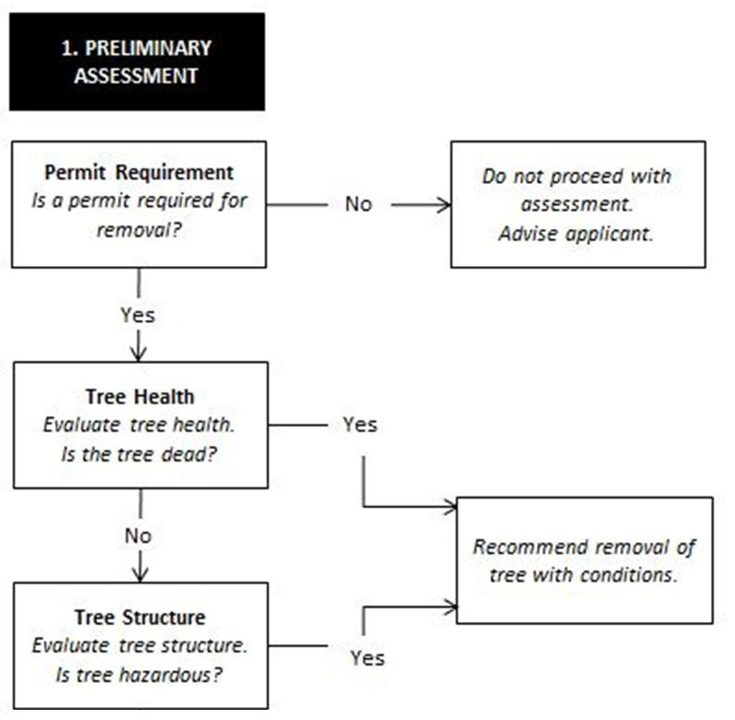

Tree Removal Assessment ATTACHMENT B
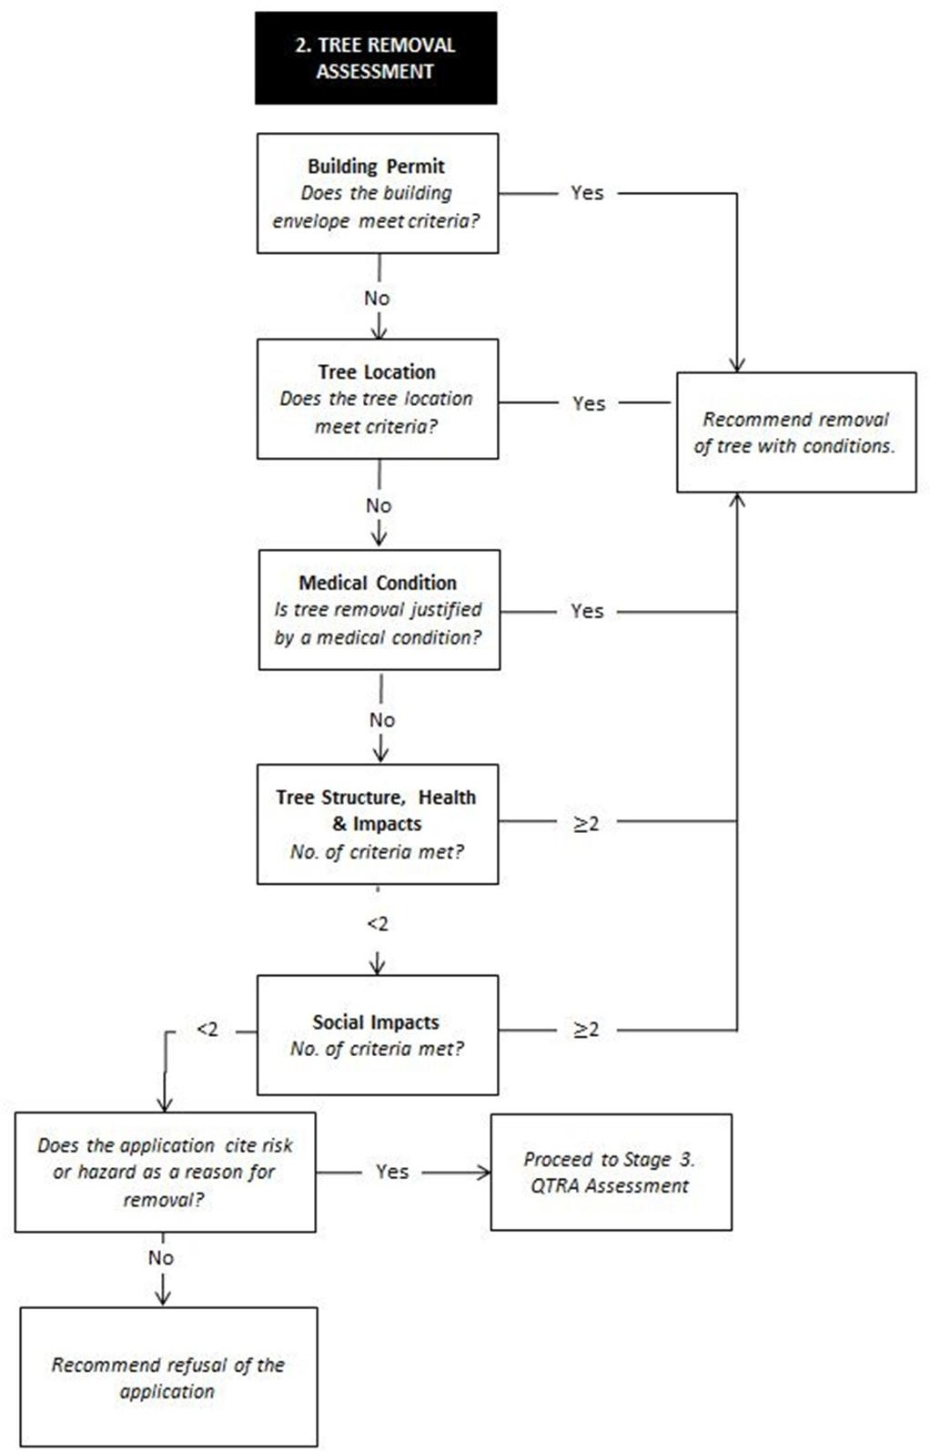

Additional Assessment Criteria for Tree Removal Permit Applications

- Building Permits
Where a building permit has been issued under the Building Control Act 1993 and the permitted building(s) and/or construction works:

- are located in such a position that the subject tree is within the envelope of the permitted buildings or works;
- encroach on the tree protection zone of an existing tree by more than 40%; or
- encroach on the structural root zone of an existing tree.

A permit will be issued to remove the affected trees with Conditions, which include a requirement for replacement tree/s.

Where a Building Permit has been issued under the Building Control Act 1993 and the above criteria do not apply the application must be assessed in accordance with Table 1.

Table 1. Assessment method for tree removal
Works proposed | Assessment | Recommendation
New dwelling, or alterations and additions to existing dwellings including extensions to the dwelling or garages built as part of the house. | The applicant can demonstrate to Council’s satisfaction that:  - the proposed works cannot be redesigned;  - appropriate arboricultural techniques as detailed in the submission of an arborist report cannot be employed in order to retain the tree; and  - compensatory replacement planting can be established on site. | Approval  Subject to a condition requiring replacement tree/s.
 | The applicant cannot satisfy the above requirement. | Refusal
Tennis courts, patios, decks, and carports. | The proposed works cannot incorporate retention of the subject tree. | Refusal  Where Building Permit not granted.

- Tree Location
A Permit will be issued where a report from a licensed and/or qualified person in their field provides evidence that the tree is causing structural damage to a building, services or infrastructure or is a risk to people or property, which can only be overcome by implementing a remedy that is unreasonable or greatly disproportionate to the value of the tree or the risk posed by the tree (assessed by QTRA).

Trees located in close proximity to dwellings, garages, intersections and crossovers must be assessed in accordance with the criteria outlined in Table 2. The recommendation to the Coordinator Investigations should be consistent with the Table, unless subsequent steps in the procedure warrant a different recommendation.

Table 2
Tree Location | Recommendation
Within two metres of a dwelling | Removal recommended if any part of the tree trunk is within two metres of an existing dwelling.
Within one metre of a garage or carport | Removal recommended if the tree will outgrow the location and/or is causing damage to an existing garage or carport.
Crossover | Removal recommended if a crossover is approved within the structural root zone of the tree.

Conditions will include a requirement for replacement tree/s.

- Medical condition
Where an application for tree removal:
- Where a medical certificate is provided from a doctor or specialist in the relevant field to certify that a specific tree is causing a specific allergenic problem for a resident that significantly diminishes the quality of life of that person and there is no other way of managing the problem.

A permit would be issued for removal under delegated authority, subject to referral to the relevant Manager Amenity Protection and the inclusion of appropriate conditions. Conditions will include a requirement for replacement tree/s.

- Tree health, structure and impacts
A tree removal permit will be granted where a referral report by Council’s Environmental Health, Assets, Traffic or other relevant Council Employee at Coordinator or Management level, or higher, confirms the tree has a detrimental impact on the surrounding environment/public health.

If any two of the tree health, structure and impacts criteria nominated below apply a recommendation for tree removal should be made to the Coordinator Investigations by the Arborist assessing the tree. Conditions for replacement tree/s would be included.

If none of the criteria apply, a recommendation for refusal of the application should be made to the Coordinator Investigations.

Criteria
Tree health, structure and impacts criteria:

- the health of the tree is classified as poor (definition included in Attachment D);
- the structure of the tree is classified as poor (definition included in Attachment D);
- the sustainable life expectancy of the tree is assessed at less than 5 years.

- Social considerations
If any two of the ‘Social considerations’ criteria apply a recommendation for tree removal should be made to the Manager Amenity Protection subject to conditions. Conditions should include a requirement for replacement tree/s.

If less than two of following criteria apply, a recommendation for refusal of the application should be made.

Criteria
Social considerations criteria:
- the amenity or character value of the tree is classified as moderate or low (definition included in Attachment D);
- there are at least two other trees on the property that:
  - require Council permission to remove;
  - are classified as having an amenity or character value of moderate or high;
  - have a sustainable life expectancy of more than10 years;
  - are not subject to a current removal permit application or existing permit;
- there are written letters supporting tree removal from property owners/tenants and adjacent to and opposite the property (at least four individual properties);
- demonstrate financial hardship and inability to undertake routine maintenance - the applicant has no source of income to pay for the maintenance and is receiving Centrelink benefits.

ATTACHMENT C

Tree Removal Assessment
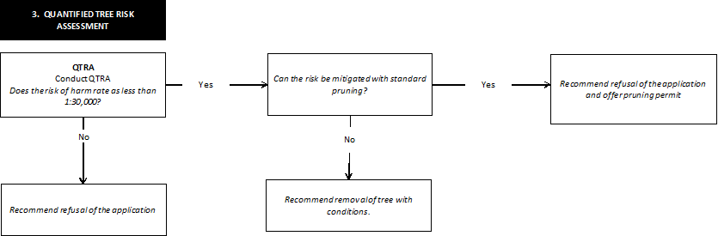

Quantified Risk Assessment
Tree safety management involves limiting the risk of harm from tree failure while maintaining the benefits conferred by trees.

The Quantified Tree Risk Assessment (QTRA) system quantifies the risk of significant harm from tree failure in a way that enables tree managers to balance safety with tree values and operate to predetermine limits of tolerable or acceptable risk. Council’s Arborist’s have a licence to undertake a QTRA.

By quantifying the risk from tree failure as a probability, Quantified Tree Risk Assessment (QTRA) enables a tree owner or manager to manage the risk in accordance with widely applied and internationally recognised levels of risk tolerance. It provides a risk level against which mitigation strategies can be balanced to determine appropriate actions

QTRA advisory risk thresholds
Threshold | Description | Action
1/1- 1/9,999 | Unacceptable (where imposed on others)  Risks will not ordinarily be tolerated | - Control the risk  - Review the risk
 | Tolerable  (by agreement)  Risks may be tolerated if those exposed to the risk accept it, or the tree has exceptional value | - Control the risk unless there is broad stakeholder agreement to tolerate it, or the tree has exceptional value  - Review the risk
1/10,000 – 1/999,999 | Tolerable  (where imposed on others)  Risks are tolerable if as low as reasonably practical (ALARP) | - Assess costs and benefits of risk control  - Control the risk only where a significant benefit might be achieved at reasonable cost  - Review the cost
1/1,000000 or less risk | Broadly Acceptable Risk is already ALARP | - No action currently required  - Review the risk

Tree assessment definitions
ATTACHMENT D

Origin

(I) Indigenous
The tree is endemic to the local area and has been naturally occurring since recordings of flora commenced.

(V) Victorian
The tree is endemic to the state of Victoria and has been naturally occurring since recordings of flora commenced.

(A) Australian
The tree is endemic to mainland Australia and has been naturally occurring since recordings of flora commenced.

(E) Exotic
The tree is not endemic to any part of mainland Australia.

Health
Tree health is based on vigour and vitality. In assessing health, observations are made of the following:
- foliage characteristics
- extension growth
- wound wood development
- extent of predation or disease
In many instances correct application of arboricultural management practices can revitalise a tree and extend its ability to provide a value to the community.

(G) Good
- Tree displays 71-100% live canopy mass
- Foliage exhibits near optimal foliage characteristics in size, colour and density
- Tree may have low levels of tip dieback
- Tree may exhibit low levels of pest/pathogen infestation that is not expected to have a
significant impact on the long term health of the tree

(F) Fair
- Tree displays 51-70% live canopy mass
- Foliage may be stunted or discoloured
- Tree exhibits less than optimal extension growth
- Tree has moderate pest/pathogen infestation which may be retarding growth and impacting on health levels, it is expected that the tree can recover with or without intervention

(P) Poor
- Tree displays <50% live canopy mass
- Tree exhibits low levels of extension growth
- Tree has extensive pest/pathogen infestation and is not expected to recover from such infestation even with intervention
- Tree may be senescent

(D) Dead
- Tree has no live vascular tissue

Structure
Structure refers to the physical integrity of the tree. Natural species form may not constitute poor structure.

Pest/pathogen damage is not directly a structural issue, however may contribute to structural issues/faults.
In assessing structure, observations are made of the following:
- Branch attachment and union formation
- Damage to trunk/roots/unions/branches
- Trunk/scaffold/tertiary branch taper
In many instances correct application of arboricultural management practices can reduce likelihood of failure to an acceptable level and extend a tree’s ability to provide a value to the community.

(G) Good
- Tree has good branch attachment and well-formed unions
- Tree has good trunk and scaffold branch taper
- Tree may have poor tertiary branch taper
- Tree may exhibit structural defects on tertiary branches and attachments
- Complete tree failure or major structural failure under normal environmental conditions is unlikely
- Remedial pruning works may improve the structural rating of the tree

(F) Fair
- Tree may have poor scaffold branch/stem taper
- Tree may have poor tertiary branch taper
- Tree may have minor structural root damage/severance
- Tree may exhibit structural defects to the trunk or scaffold branches
- Majority of structural defects may be managed through current recognised arboricultural practices

(P) Poor
- Tree may exhibit major structural defects to trunk and/or scaffold branch attachments
and/or roots

(H) Hazardous
- Complete or major structural failure is imminent

Amenity Value
The visual contribution the tree makes to the neighbourhood character.

Low
- Tree has poor health and/or
- Tree provides little visual contribution to the neighbourhood character

Moderate
- Tree has fair/good/excellent health and/or
- Tree is easily viewed from the street

(H) High
- Tree has fair/good/excellent health
- Tree is highly visible from the street
- Tree is visible from other streets in the area
(N/A) Not Applicable

Useful Life Expectancy
The period of time that the tree is expected to maintain a positive contribution to the neighbourhood character.

20 yrs +
Tree is likely a semi-mature or mature tree that is in good health and structure and is expected to maintain current levels of amenity for a minimum of 20 years.

10-19 yrs

Tree is likely a mature tree that is in good health and/or structure and is expected to maintain current levels of amenity for a minimum of 10 years.

4-9 yrs
Tree is likely a mature tree that is in fair health and/or structure and is likely declining. It is expected that the tree is not likely to maintain current levels of amenity for more than 9 years.

0-3 yrs
Tree is likely a mature tree that is in poor health and/or structure and is likely declining. It is expected that the tree is not likely to maintain current levels of amenity for more than 3 years.

Retention Value
The value of the tree when considering the tree as a whole. The health, structure, amenity value and life expectancy are considered when determining this factor. The tree location on the subject site or a development proposal is not a consideration for determining retention value.

(H) High
The tree is generally in good health and structure, provides high levels of amenity and is likely to do so for more than 20 years. Tree may have historic or cultural significance.

(M) Medium
The tree is generally in fair to good health and structure, provides high levels of amenity and is likely to do so for up to 20 years.

(L) Low
The tree is generally in fair health and structure, provides low levels of amenity and may do so for up to 10 years. The tree may be juvenile or otherwise small and easily replaced by advanced plantings or plantings that will provide similar amenity value in a reasonable timeframe.

None
The tree has no features that would promote retention for any reason, such as a dead tree or one that provides no amenity value.

Trees on other property
Any tree located outside the subject site is to be retained and protected.

ATTACHMENT E

REPLACEMENT TREES – COMMONLY ACCEPTED HEIGHTS AND WIDTHS AT MATURITY IN THE BAYSIDE REGION
The structure and mass of a tree’s canopy is one of the most defining aspects of the character that it contributes to an area.

The Vegetation Character Assessment (March 2000) report identifies significant vegetation characteristics that form a major element of a distinctive urban character in the municipality, particularly in Beaumaris and Black Rock. These should be considered when selecting appropriate species.

Indigenous
Botanic Name | Common Name | Height | Width | Evergreen/ Deciduous
Acacia implexa | Lightwood | 8 | 6 | E
Acacia mearnsii | Black Wattle | 8 | 6 | E
Acacia melanoxylon | Blackwood | 8 | 6 | E
Allocasuarina littoralis | Black She-oak | 8 | 6 | E
Allocasuarina verticillata | Drooping She-oak | 10 | 8 | E
Banksia integrifolia | Coast Banksia | 15 | 12 | E
Eucalyptus camaldulensis | River Red Gum | 15-25 | 12-18 | E
Eucalyptus melliodora | Yellow Box | 15-20 | 10-15 | E
Eucalyptus ovata | Swamp Gum | 15 | 12 | E
Eucalyptus pauciflora | Snow Gum | 10 | 8 | E
Eucalyptus viminalis subsp.  pryoriana | Rough-barked Manna Gum | 15 | 10-15 | E
Eucalyptus radiata | Narrow-leaved Peppermint | 15 | 10 | E
Native
Botanic Name | Common Name | Height | Width | Evergreen/ Deciduous
Acacia pendula | Weeping Myall | 8-10 | 6-7 | E
Agonis flexuosa | Weeping Willow Myrtle | 10-12 | 10-12 | E
Allocasurina torulosa | Rose She-oak | 10 | 7 | E
Angophora costata | Smooth-barked Apple | 15-20 | 10-15 | E
Angophora floribunda | Rough Barked Apple | 12-15 | 10-12 | E
Corymbia ficifolia | Red-flowering Gum | 10-15 | 10-15 | E
Corymbia exima | Yellow Bloodwood | 15 | 10-12 | E
Corymbia maculata | Spotted Gum | 18-22 | 12-15 | E
Elaeocarpus reticulatus | Blueberry Ash | 8 | 3-5 | E
Eucalyptus cephalocarpa | Silver-leaved Stringybark | 8-15 | 8-12 | E
Eucalyptus cinerea | Mealy Stringybark | 12 | 7-10 | E
Eucalyptus cornuta | Yate | 8-12 | 10 | E
Eucalyptus crenulata | Silver Gum | 8 | 6 | E
Eucalyptus largiflorens | Black Box | 10-15 | 8-12 | E

Eucalyptus leucoxylon subsp. connata | Yellow Gum | 12 | 10 | E
Eucalyptus mannifera | Red Spotted Gum | 12-15 | 8-12 | E
Eucalyptus microcarpa | Grey Box | 15 | 10 | E
Eucalyptus nicholii | Narrow-leaved Black Peppermint | 10-15 | 10 | E
Eucalyptus polyanthemos | Red Box | 15 | 8-12 | E
Eucalyptus pulchella | White Peppermint | 15 | 7 | E
Eucalyptus rubida | Candlebark Gum | 15 | 12 | E
Eucalyptus saligna | Sydney Blue Gum | 15-25 | 12-18 | E
Eucalyptus scoparia | Wallangarra White Gum | 8-12 | 5-10 | E
Eucalyptus sideroxylon | Red Ironbark | 12-18 | 10-15 | E
Eucalyptus tereticornis | Forest red gum | 15-20 | 12-15 | E
Lophostemon confertus | Brush Box | 10-15 | 8-12 | E
Melaleuca quinquenervia | Broad-leafed paperbark | 10-15 | 8-12 | E
Tristaniopsis laurina | Water Gum | 8 | 6 | E
Waterhousia floribunda | Weeping Lilly Pilly | 10-12 | 8-10 | E
Exotic
Botanic Name | Common Name | Height | Width | Evergreen/ Deciduous
Acer cultivars | Maple | 10-20 | 10-15 | D
Araucaria heterophylla | Norfolk Island Pine | 20-25 | 10-20 | E
Arbutus unedo | Irish Strawberry Tree | 8 | 8 | E
Catalpa bignonioides | Indian Bean Tree | 10-12 | 10-12 | D
Cedrus deodara | Deodar Cedar | 15-25 | 12-18 | E
Celtis occidentalis | Hackberry | 7-12 | 6-10 | D
Fraxinus ‘Raywood’ | Claret Ash | 12 | 9 | D
Fraxinus excelsior ‘Aurea’ | Golden Ash | 8-12 | 7 | D
Fraxinus pensylvanica | Green Ash | 10-15 | 8-12 | D
Gleditsia tricanthos | Honey Locust | 10-15 | 8-15 | D
Jacaranda mimosifolia | Jacaranda | 8-12 | 8 | D
Liquidambar styraciflua | American Sweetgum | 12-22 | 12-15 | D
Magnolia grandiflora | Bull Bay | 8-15 | 8-12 | E
Metrosideros excelsior | Pohutukawa | 8-10 | 8-10 | E
Platanus x acerifolia | London Plane | 14-22 | 12-18 | D
Pyrus cultivars | Flowering Pear | 8-12 | 4-8 | D
Quercus coccinea | Scarlet Oak | 12-15 | 12-15 | D
Quercus palustris | Pin Oak | 15-22 | 12-18 | D
Quercus rubra | Northern Red Oak | 12-20 | 12-20 | D
Schinus molle | American Pepper | 8-15 | 10-15 | E
Tilia cordata cultivars | Small-leaved Linden | 15-20 | 12-20 | D
Ulmus glabra ‘Lutescens’ | Golden Elm | 10-15 | 12-15 | D
Ulmus parvifolia | Lacebark | 12-15 | 10-15 | D
Ulmus procera | English Elm | 12-20 | 12-15 | D
Zelcova serrata | Japanese Zelkova | 15-20 | 12-15 | D

