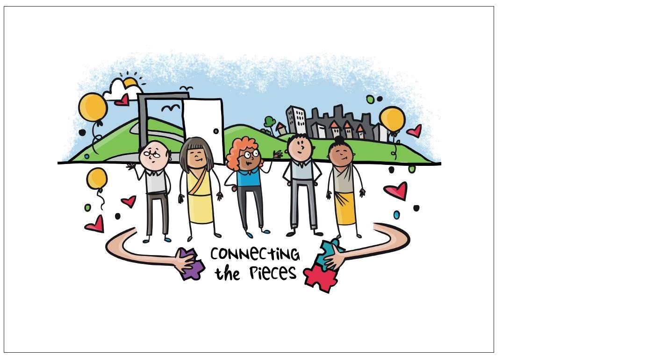

EMR Alliance
Connecting the Pieces

EMR Alliance
Connecting the Pieces

Introduction

As providers of Health and Community services, we all recognise the value in improving access to services for all people and delivering services that are responsive and centred on the needs of the person, their family and carers.

The Connecting the Pieces video (and accompanying Guide) articulates the unique aspects of diversity and person centred care and importantly, the relationship between these approaches, how they influence each other and the need for diversity and person centred care to be understood throughout the continuum of the client’s journey.

The video addresses three key questions:

Why are our experiences of health and community services different?

What is it that attracts us to one service provider over another? and

How can providers help people to get the most out of the services they use?

Content

Topic 1 Know our community

Topic 2 Removing the barriers to accessing services

Topic 3 Working with people

Topic 4 Putting the person at the centre of care

Topic 5 Celebrate not tolerate

Case Studies John, Jenny, Mai-Lee &

Kimiko

Topic 6 Diversity Jigsaw

Further Resources
Video Transcript

Who is this resource for?

The Connecting the Pieces video is suitable for all staff and volunteers involved in service delivery who want to improve their understanding about the interrelationship between diversity, inclusive access and person centred care to improve outcomes for clients.

This resource has been developed for members of the Eastern Metropolitan Region (EMR) Alliance, in recognition of their continued commitment and ongoing contribution to implementing inclusive person centred practice across the Eastern Metropolitan Region.

What’s included?

This resource includes:
Connecting the Pieces video (7 minutes)

Facilitator’s Guide comprising Discussion

Topics and reflective questions; Case Studies; and Resources to further discuss, explore and embed key messages from the Connecting the Pieces video.

Acknowledgements & Further Information

Art work and video produced by Think in Colour at http://www.think-in-colour.com.au

Connecting the Pieces is available to download via the EMR Alliance website: www.oepcp.com.au The video resource is available to view at the EMR Alliance YouTube channel

For further information about this resource please contact the EMR Sector Development team at: emr.alliance@each.com.au

The EMR Alliance is supported by the Victorian Government and supported by the Australian Government Department of Health. Visit the Department of Health website (http://www.health.gov.au/) for more information. Disclaimer: Although funding for this resource has been provided by the Australian Government, the material contained herein does

not necessarily represent the views or policies of the Australian Government. EMR Alliance Connecting the Pieces
How to use the resource

Orientation for new staff or refresher training for existing staff

Make the video available to new employees as part of an orientation program

Provide access to an internet enabled computer and quiet workspace or preview the video as a group

Embed link to the video in organisational orientation material via the EMR Alliance YouTube channel

Use the Discussion Topics and/or Case Studies to explain what the approach looks like on the ground and involve participants in discussions about how they might contribute to the approach

Follow up with regular individual or team discussions to understand how the approach is being implemented and to identify good practice and potential barriers

Team reflection

Show the video at a team meetings to engage and motivate staff and volunteers in training, reflective practice or use as part of a quality review process

Use the Discussion Topics and/or Case Studies to introduce new ideas and approaches or to reflect on current practice, identifying what’s working well and what’s not

Follow up with regular supervision to identify good practice, potential barriers and professional development needs

Using the Discussion Topics

The reflective questions in the Discussion Topics are included to prompt a conversation depending on your area of interest. Identify one or more of the reflective questions and build your conversation around these. Alternatively, you may want to address questions of your own.

Connecting

the Pieces

video

Connecting

the Pieces

Facilitator’s

Guide

 | Orientation for |  | Refresher training |  | Reflective practice
 | new staff |  | for existing staff

Learning objectives:

Articulate the way in which a client’s diversity informs the concept and practice of person centred services and how to remove barriers to accessing service

Understand the relationship between diversity and person centred services with a focus on the key elements that support the promotion of independence and wellness for clients and their carers.

Develop an understanding of the breadth of characteristics that create a person’s diversity and how these characteristics intersect.

Use the Guide to start a conversation, generate discussion and debate and identify good practice and improvement opportunities

Use the Guide as part of orientation, training or quality improvement activities

Support continuous quality improvement by re-engaging with the video and the accompanying Guide as your practice evolves and the people who use your service change

EMR Alliance
Connecting the Pieces

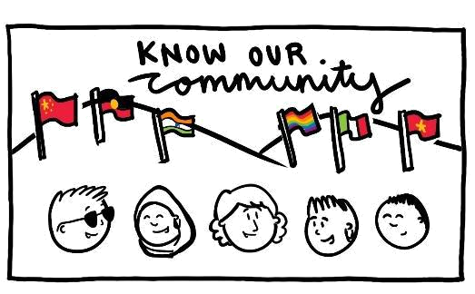

Discussion Topic 1

Know our community

Identifying the diversity of the people who live in the local area, understanding their

interests and needs and knowing who is and isn’t using our service. This links directly to diversity planning and practice and is essential if we are going to offer appropriate services. When discussing the Know our community topic the following questions may help generate discussion and debate.

Reflective questions

What does knowing our community mean to you/our organisation?

How would you describe the demographics/diversity of our local area?

What evidence do we use to learn about the demographics/diversity of our community?

What have we done to understand who lives in our local area and what their needs are?

What could we do to connect with our local community and hear what is important to them?

How representative are our clients of the wider community? What makes you say this?

What could we do to make our service more appealing to different community groups?

EMR Alliance
Connecting the Pieces

EMR Alliance
Connecting the Pieces

Discussion Topic 2

Removing the barriers to accessing services

If services are to be inclusive and responsive to the needs of the community it is important to understand who isn’t accessing services and why this is the case. A barrier may be real; the service does not offer what people want or need so people don’t use the service. Alternatively a barrier may be perceived, the service offers what people want or need, but people think it doesn’t and therefore do not use the service. These barriers would be addressed differently, but both need to be addressed because the outcome is the same – people won’t use the service.

When discussing barriers and how to remove them it is important to be aware of our own cultural norms and practices and see things from the perspective of the diverse community. The following may help with your discussion.

Reflective questions

What do you think could be some of the barriers people or communities face in accessing our service?

What barriers are real (they do exist) and what barriers are perceived (we don’t think they exist, but the community does)?

*Some prompts for the discussion could include affordability, cultural safety, unfriendly staff, services don’t fit interest/wants, people unaware what support is needed*

How have we tried to remove barriers to accessing services in the past?

*Prompt could include, fees policy, open days, working with community organisations, marketing or communication*

How do we find out why people are not using our service?

What steps can we take to remove or reduce the barriers people face in accessing our service?

EMR Alliance
Connecting the Pieces

EMR Alliance
Connecting the Pieces
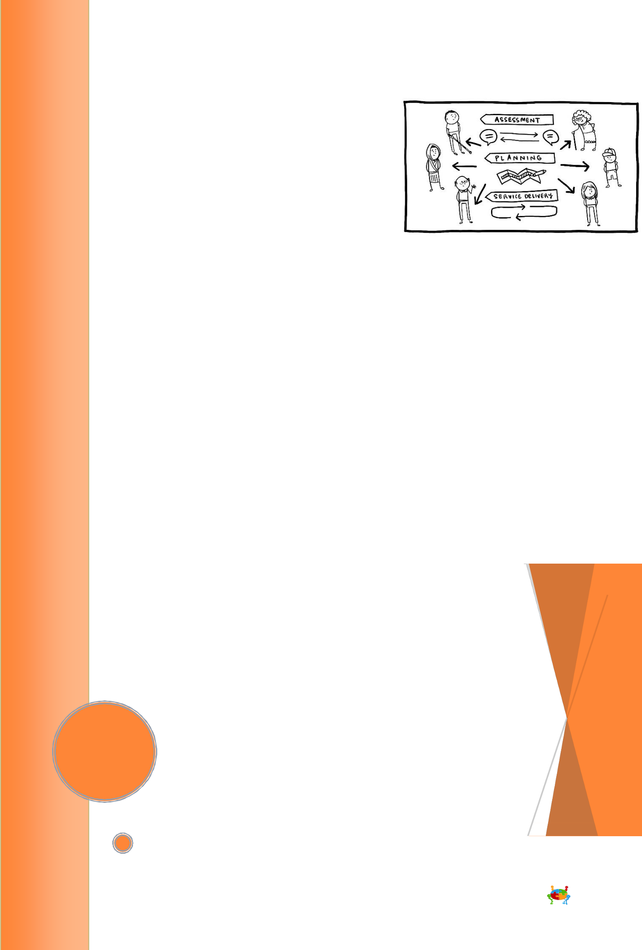
Discussion Topic 3

Working with people

Flexibility and responsiveness is fundamental to supporting independence and engaging people in activities and relationships that are important to them. So how do we support independence while maintaining a consistent approach to our service delivery model?

For most people independence is “the quality of life that a person can have, irrespective of

the support they need to achieve it”. Everyone’s definition of independence will be

different.

We need to create and nurture an organisational culture where independence is valued. We can do this by ensuring that our systems, processes and practices provide opportunities to empower staff and the people we work with. We need to build in ways to promote and model behaviours that enable choice, ensure shared responsibility for decision-making and
support the achievement of goals while optimising people’s ability to do things for

themselves. The questions below may help to reflect on the way our organisation works with people.

Reflective questions - assessment

What does independence mean to you?

What do you think it means for the clients you work with? What are some examples of strategies you have used to
find out what’s important to, and for the client?

What might be some of the barriers we create for people at assessment and how might we address these?

What do you think it means by “looking at the whole person”?

What are some of the ways we take into account people’s unique diverse characteristics at assessment? Can you share any specific examples?

Do our interactions and relationships with others (people and service providers) make the most of opportunities to reduce duplication? How could we improve this?

EMR Alliance
Connecting the Pieces

Reflective questions - planning

Do we engage clients in all aspects of planning? How could we enhance their involvement?

What approaches have worked well when engaging clients in the planning process?

What are some of the barriers to a client’s involvement in planning and how could we address these?

Thinking about a client; what was their (and your) experience of goal setting? What worked well, what didn’t?

How do we/could we measure outcomes for clients accessing or exiting our services? What do you think this information could tell us about the way we work with people?

Reflective questions - service delivery

Do we provide opportunities for people to participate as fully as they can at all levels of the service?

Do we make the best use of information obtained about the client to guide the way services are delivered?

Thinking about a client, what are some of the ways you have been able to support a person’s diversity and preferences within service delivery?

Can we identify any areas where people’s independence is being undermined? What could we do to redress the balance?

Does the physical, cultural and psychosocial environment of our service support person-centred care?

If we could change one aspect of our service delivery model what would it be and why?

How do we check in with the client and/or their carer to understand how they are progressing and whether their needs continue to be met?

How do we find out about people’s experience of our service? Why do you think this is important and how could the information add value to our program? Are there other ways we can collect this information?

EMR Alliance
Connecting the Pieces
Discussion Topic 4

Putting the person at the centre of their own care

Person centred care involves thinking and doing things in a way that puts people, their experiences, well-being, preferences and needs at the centre of the caring process. People are experts in their own lives and it is important to recognise and value each person as a unique individual, shaped by their personal characteristics, experiences, values and beliefs.

How we involve people in the caring process requires us to work with the person, providing choice and enabling them to be in control. Our approach should involve sharing power and responsibility, seeing people as partners in the planning, delivery and review of care and ensuring that people are at the centre of decisions that affect their care.

Reflective questions – choice/control/preferences

How do we balance duty of care and dignity of risk with the delivery of services?

Has there been a time when a person’s choices or preferences conflicted with your professional judgement? How did you approach this situation and what might you do differently next time?

When and how do we establish clear service expectations and how do we balance these with maximising a client’s control?

Do people have access to sufficient information to support them to make empowered choices and decisions? If not, what else is required?

Are there areas of our service model where we could increase people’s (clients and staff) involvement in decision-making? What are they and how might we make these changes?
What is our approach to working with people with cognitive or

communication difficulties and how do we engage them in decision-making processes?
Do we have the necessary skills to do this?

EMR Alliance
Connecting the Pieces

Reflective questions - building on a person’s strengths

What are your own strengths?

Why do you think it’s important to build on these rather than focus on the things you can’t do?

Thinking about a client that you have worked with, what is it that motivated them and how did this motivation affect the way they engaged with you/the service?

What strategies have you used with people who may only be focused on what they can’t do? What worked well, what didn’t?

How do we support and monitor the progress of a person’s strengths within the service delivery model?

Who is involved in the monitoring and do the right people have access to the right information to do this?

Reflective questions – working together

What are the key elements of a good partnership and how do we embed these as part of our service model?

Who are our partners (people and services) and how do they contribute to achieving successful outcomes for our clients?

Do our interactions and relationships with these people and service providers take into account each contributors area of expertise?

When do we engage with our partners (people and service providers) and do we need to increase their involvement in the caring process?

What strategies do we use to establish meaningful partnerships with people (clients or service providers)? How do we establish trust?

What processes do we have in place to monitor and review how our collaboration is tracking?

How do we encourage and support people to participate in the wider community?

EMR Alliance
Connecting the Pieces
Discussion Topic 5

Celebrate not tolerate

To create an inclusive environment it is important that people are comfortable to be themselves and know they are appreciated and respected. Therefore, it is important that organisations celebrate who people are. Tolerating people’s difference or their diversity isn’t being inclusive. Organisations and staff should not be tolerant or accepting, but instead be welcoming and embracing. To “tolerate” something or someone implies that they are less than you and while you will endure their difference it is not your preference or enjoyable. To “accept” someone does not promote inclusive behaviour. By “accepting them” you are highlighting their difference as a deficit and demonstrating a power imbalance between you (the mainstream/normal) and them who is different. Below are some questions to help the discussion.

Reflective questions

Why do you think the video says we should celebrate rather than tolerate diversity/difference?

How do we let people know that we welcome, support and celebrate who they are, their difference and diversity?

What else do we need to do to make it explicit that we welcome, celebrate and support different diversity groups?

*Prompt – discuss the different diversity groups and what you currently do and where you could improve. You may have good practice in working with Aboriginal clients, but have not focused on CALD communities or people living with dementia*

EMR Alliance
Connecting the Pieces

EMR Alliance
Connecting the Pieces
Case Studies

Meet John, Jenny, Mai-Lee and Kimiko

The Connecting the Pieces video introduces a number of people with different diversity characteristics. Their personal stories and diversity characteristics provide an opportunity to discuss who they are and what is important to them. It also provides the opportunity to discuss how service providers should/might approach, understand and respond to the diversity of each of the characters and the people you work with.
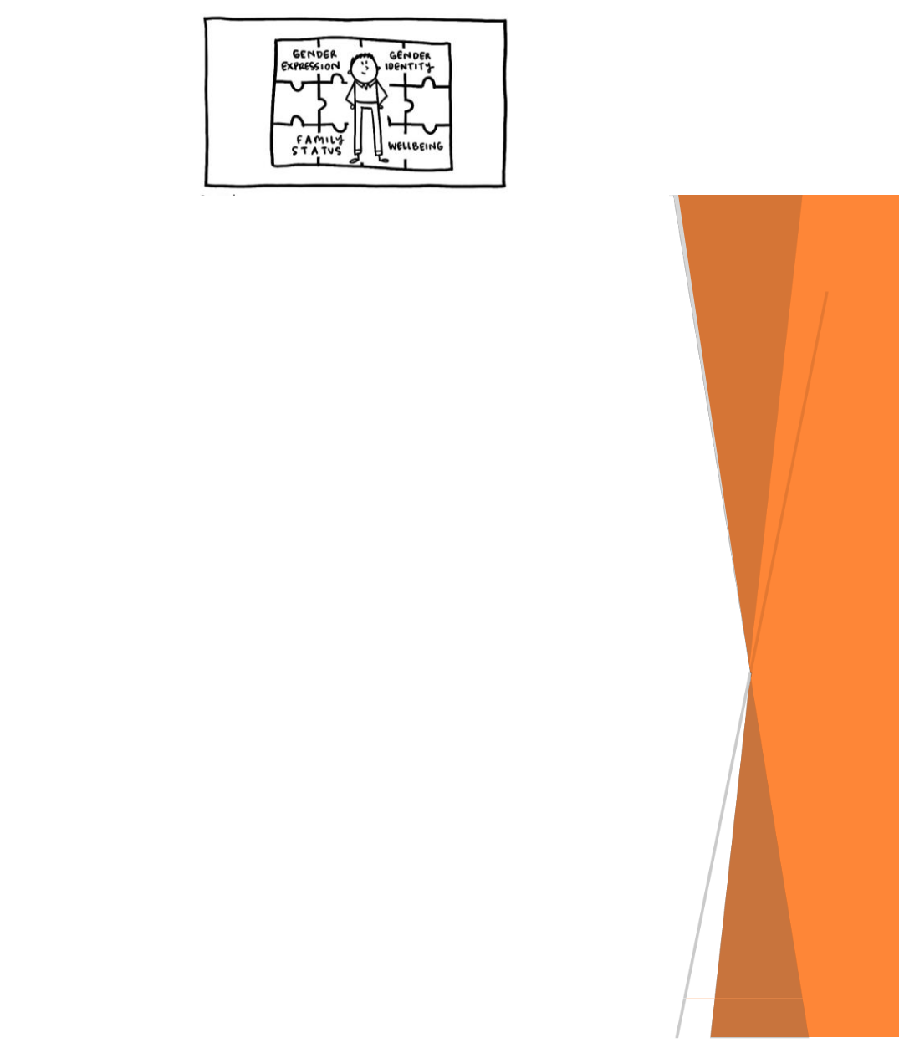

John

Remind the group of John from the video. He is referred to as a trans man and the video says that gender identity and gender expression are important to him.

The video describes John as a trans man, do you know what trans means?

Why do you think gender identity and gender expression would be important diversity pieces to John?

If John were to use our service are there any issues, problems or barriers he might face? (Either real or perceived) What are they and what could we do to remove those problems?

*Prompt - think about intake and assessment, the types of services, staff knowledge and attitudes, other clients, John may have previously had negative experience and fear the same will happen again.*

Information: Trans is short for Transgender. John was assigned female gender at birth and raised as a girl. However John’s gender identity is male, he lives his life as a man and therefore he is and should be always treated and referred to as a man. Gender Identity and Gender Expression may be important to John because for his early years he had people treating him as female, so being able to live in the correct gender and express himself (personality, clothes, body language, and interest) is an important part of his identity. Refer to the Diversity Jigsaw resource for further information on gender identity and gender expression and visit the EMR Alliance YouTube channel to hear the stories of trans people.

EMR Alliance
Connecting the Pieces

Jenny

We meet Jenny in the Connecting the Pieces video. Jenny is an older person who enjoys catching up with friends in the local walking group, is a long-term member of a senior’s choir and is a volunteer tutor at the neighbourhood house.

What are some of the stereotypical assumptions that promote ageism?

How do you think these assumptions might affect clients?

How do we avoid applying stereotypical assumptions, and our own values and beliefs when working with people?
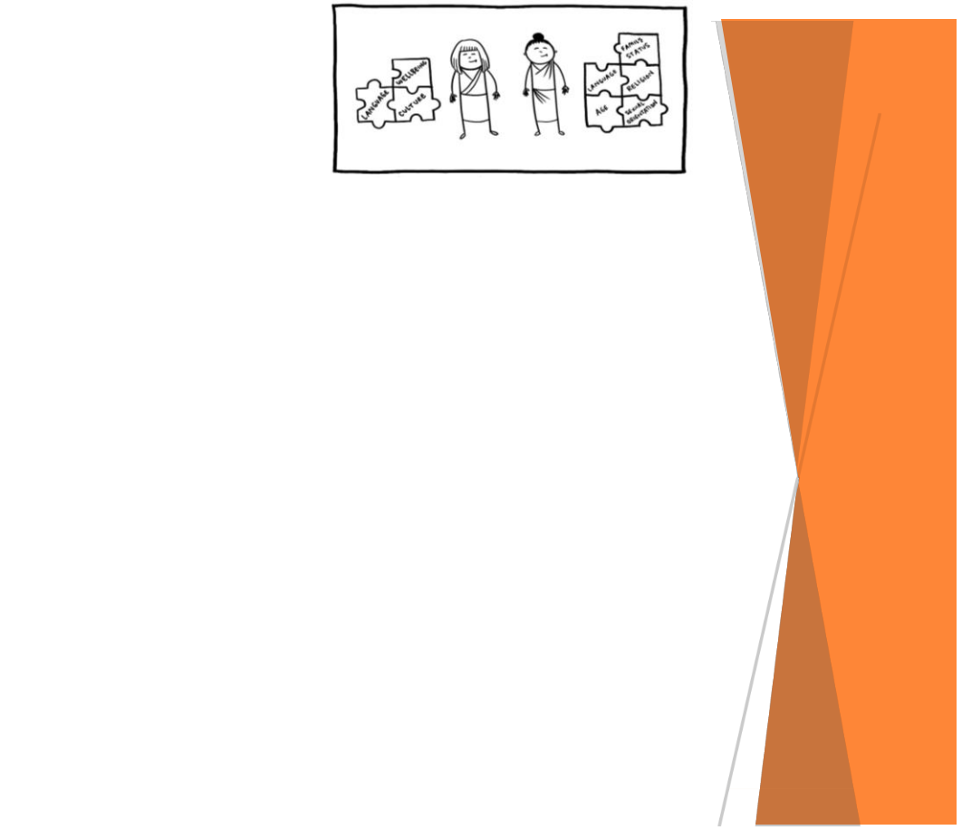

Mai-Lee and Kimiko

Remind the group of Mai-Lee and Kimiko from the video. They appear to be in a similar situation as they both have limited English, no family and like to be active. However they are interested in making social connections with different parts of their diversity, Mai-Lee with people of the same culture and language group whereas Kimiko wants to improve her language skills so she can meet people who share other interests.

What do you think are the take away messages from Mai-Lee’s and Kimiko’s story in the video?

What would we do or need to do, to ensure our service didn’t assume Mai-Lee and Kimiko had the same interests or motivations?

What could be the consequences if we treated Mai-Lee and

Kimiko the same and didn’t understand their interests or motivations?

EMR Alliance
Connecting the Pieces
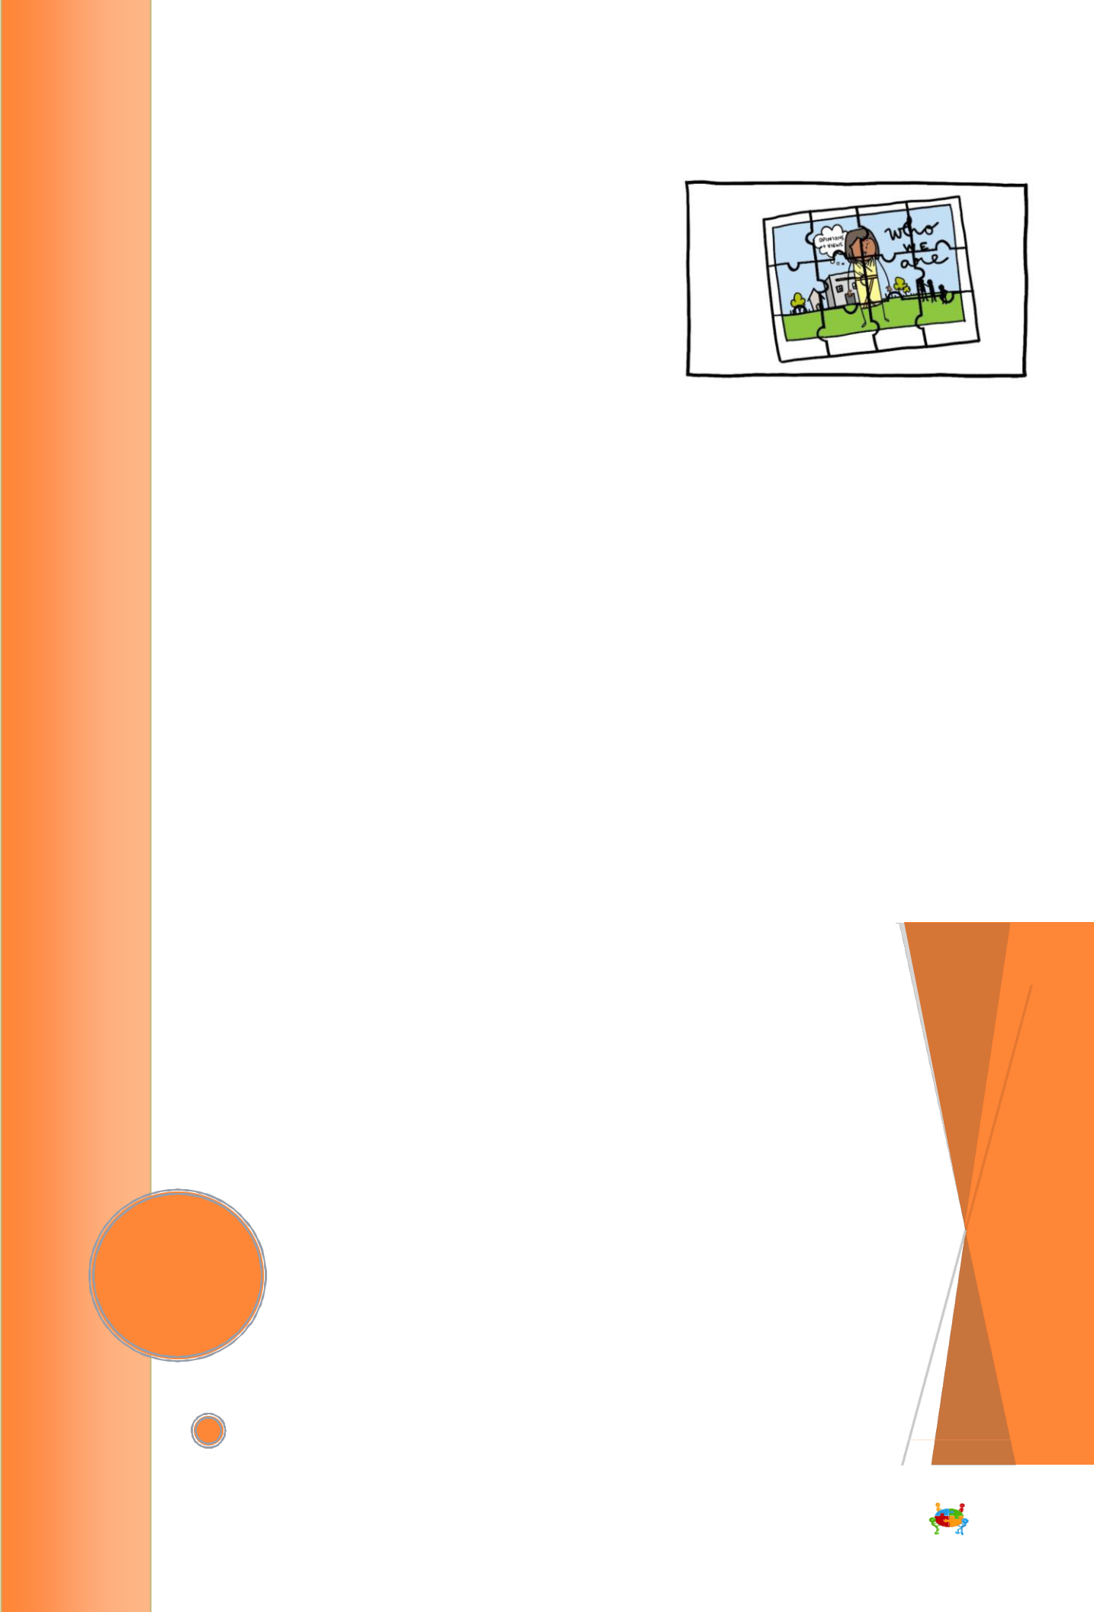
Discussion Topic 6

Diversity Jigsaw

Connecting the Pieces discusses the many diversity characteristics that connect together to create a picture of each person. Sitting below the video is a tool called the Diversity Jigsaw. The Diversity Jigsaw illustrates the range of characteristics that help shape each person and their identity. These diversity characteristics can provide a useful insight to someone’s preferences and interests. Important information lies within these characteristics, relating to a person’s strengths, capabilities and areas where they potentially need support. The Diversity Jigsaw encourages you to look beyond the visible or obvious diversity and emphasises the need to develop the trust and respect of the people you work with. This will allow you to learn more about who they are and what is important to them. See the supporting document for a description of the diversity jigsaw pieces and use the below questions as conversation starters.

It is important to remember that when talking and learning about clients and their diversity to always be respectful. Information should be freely given and shared, not forced or coerced. Over time people may share more information once you have gained their trust.

Reflective questions

How do we learn about our clients, who they are and their diversity?

What do we do to gain the trust of our clients?

Are they any examples where people have opened up over time? Why do you think this happened?

If we think about a current client, how much of a picture do we have of them?

Who they are? What they like?

What are their experiences? What’s important to them?

How might that missing information help you/the organisation offer better support?

EMR Alliance
Connecting the Pieces

Reflective questions

Using the Diversity Jigsaw choose 1 or more jigsaw pieces and have a discussion about that diversity characteristic.

How would you describe this diversity characteristic and what do you think it could tell you about a client?

What are we currently doing well? What do we need to do better to support people regarding this diversity piece?

How could we use the concepts discussed in the Diversity Jigsaw so we learn as much as we can about our clients?

How do we make the Diversity Jigsaw part of our everyday practice and make sure it continues to be relevant?

What do we do/what can we do to make sure we don’t just look for visible diversity?

What do we do/what can we do to make sure we don’t make assumptions about people based on part of their diversity?

How can we support each other to operate in this way?

EMR Alliance
Connecting the Pieces
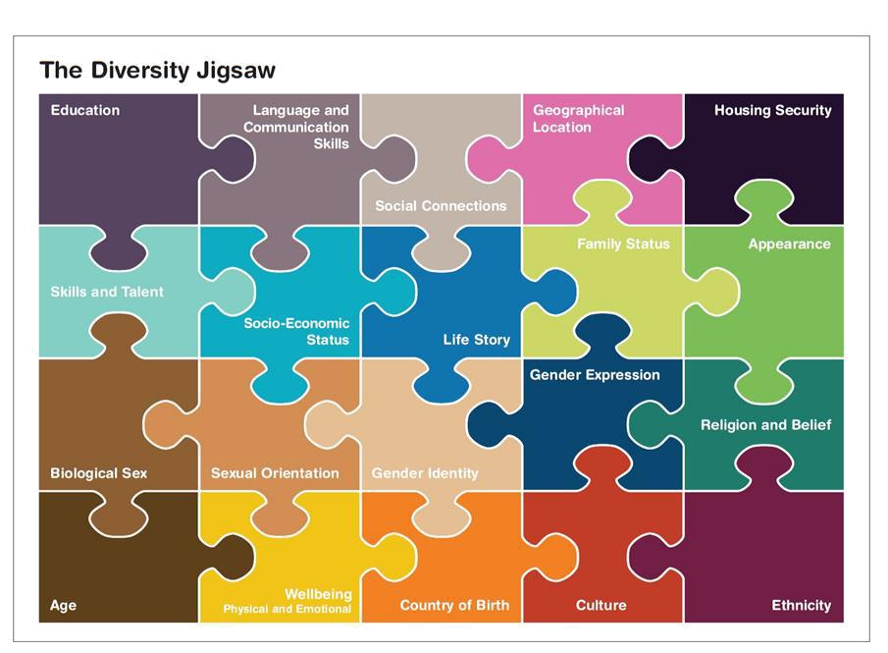

EMR Alliance
Connecting the Pieces

EMR Alliance
Connecting the Pieces
Understanding the Diversity Jigsaw

The Diversity Jigsaw illustrates the range of characteristics that help shape each person and their identity. These diversity characteristics can provide a useful insight to someone’s preferences and interests. Important information lies within these characteristics, relating to a person’s strengths, capabilities and potentially areas where they need support. The Diversity Jigsaw encourages you to look beyond the visible or obvious diversity and emphasises the need to develop the trust and respect of the people you work with. This will allow you to learn more about who they are and what is important to them.

To be effective the Diversity Jigsaw needs to be embedded within the thinking and ways of working for all staff across all disciplines and program areas. If you want to deliver services that are person centred and meaningful, staff must be attuned to the breadth of diversity characteristics and how they connect to provide important information about a person.

This resource provides some information about the Diversity Characteristics. These examples do not describe every person or possible situation. It is important to remember that everyone is different, we can’t make assumptions or generalisations. Clients may be reluctant to disclose information so gaining trust and explaining why and how information is used will be important. This tool has been designed to help you understand the breadth of diversity, but it should not be used by simply asking clients overt questions related to the different areas identified on the jigsaw. It is important that through your work with clients you obtain this information in a respectful and inclusive way, understanding that some topics may never be discussed. The aim of this tool is help you think broadly about the people you support, truly see them as individuals and develop ways to understand who they are and what is important to them.

Education

A person’s education may highlight areas of interest and what stimulates them. Understanding the type of education someone has had could help you develop meaningful goals and engage them in interesting activities. Their literacy and numeracy capabilities may also be revealed and show that there is extra support needed to understand information, documentation, care plans and payment processes.

Social Connections

Maintaining or developing meaningful relationships is an important aspect of a person’s wellbeing. Forming friendships and being connected to communities of interest or relevance can help improve overall health and wellbeing. Therefore it is important to learn from people which communities or groups they identify with and would like to be connected with into the future.

Language and Communication Skills

The ability to communicate and be understood is important for everyone. Communicating with people in a way that is clear and appropriate for them is essential. There are different cultural practices to consider when working with people from some CALD and Aboriginal communities including eye contact and physical contact, such as shaking hands. It is important to use interpreters for people who aren’t fluent in English or for anyone who requests one. This will enable you to gather the appropriate information, to help you assess, plan and deliver appropriate services. Registered interpreters need to be used as it is not appropriate or good practice to use family members.

It is important to consider how to work with and support people who may not use or have little

verbal communication. Visual and other communication aids are necessary tools to assist in these situations. Allowing people to communicate in a way that is comfortable for them will allow you to find out what is important to them and ensure you gather the most appropriate information.

EMR Alliance
Connecting the Pieces

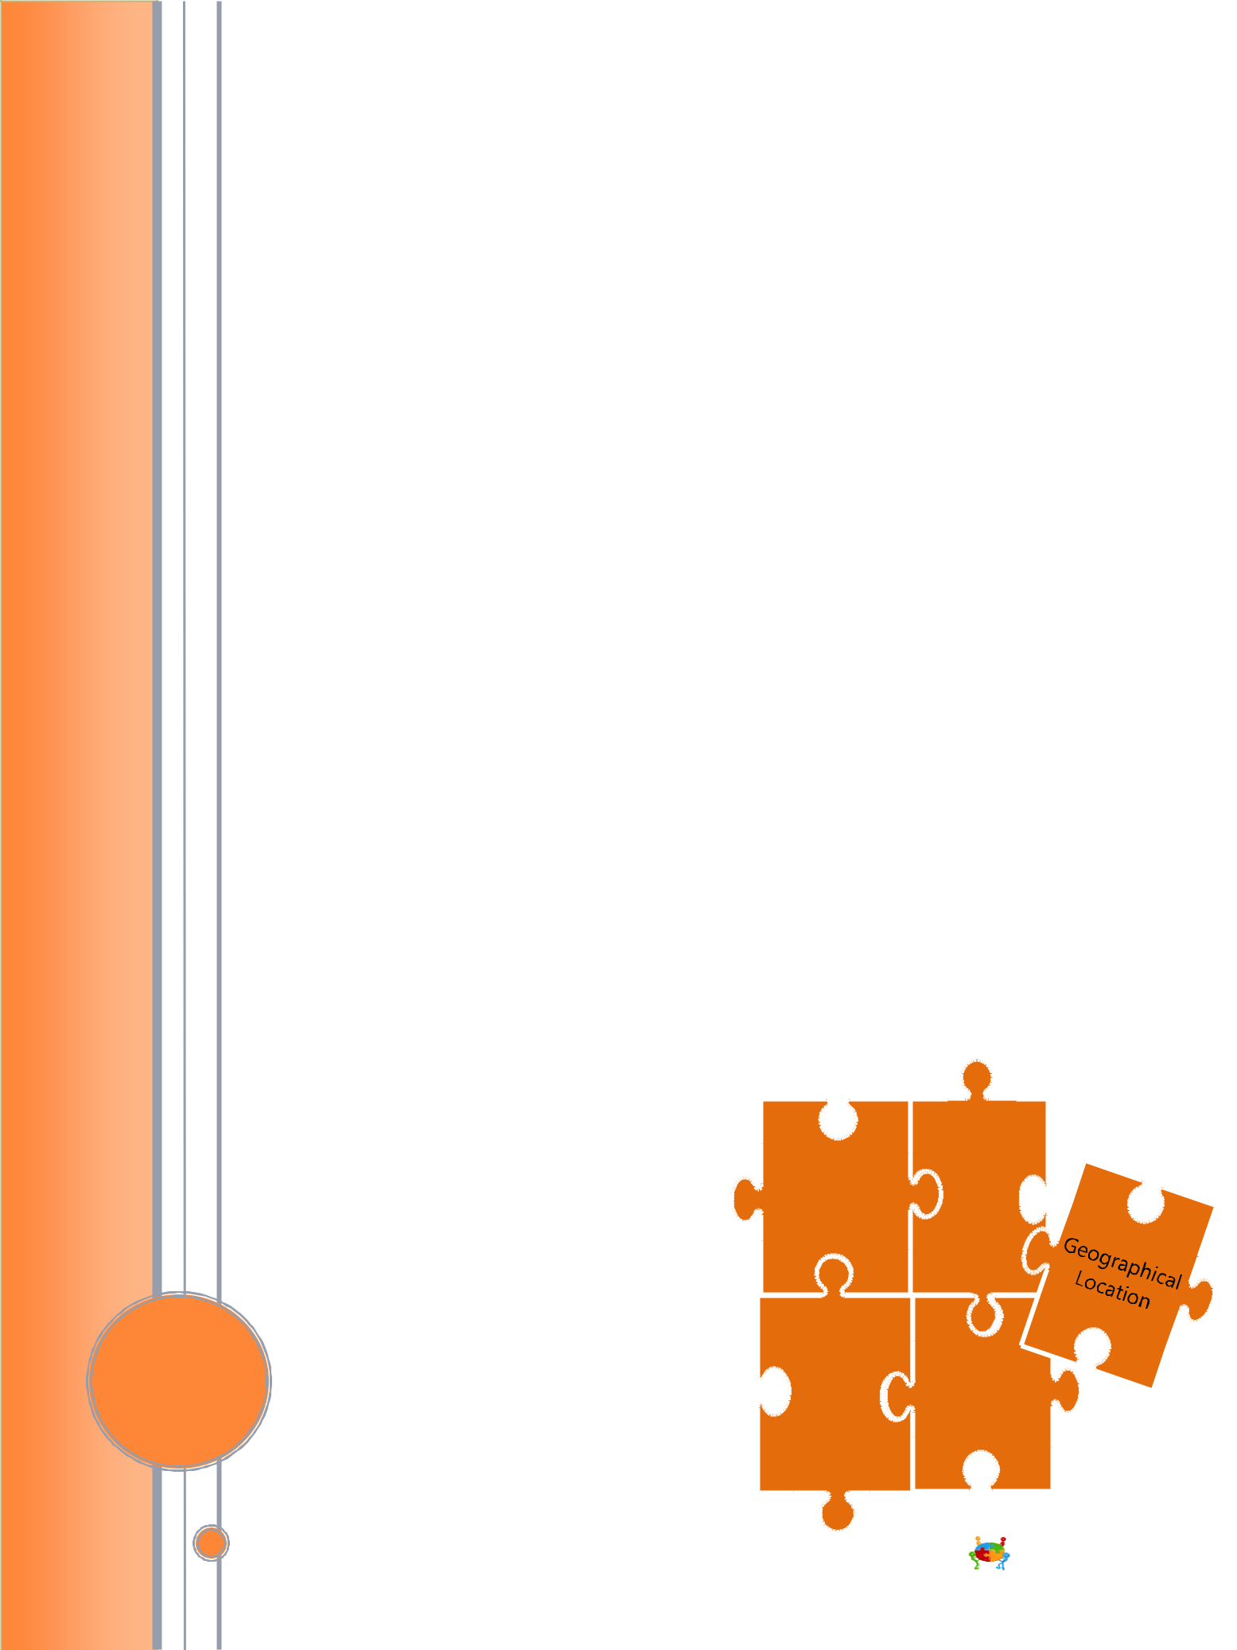
Geographical Location

Where someone lives could hold significant importance to them as they may have a strong connection to the local area. This could have specific value for Aboriginal people or others with a long family history. For some people it may be difficult to access services or they may be reluctant to do so because of their geographical location. There will be different needs and situations to consider for people living in rural or remote locations, but even people living in metropolitan areas could have access issues if they don’t drive or if there is limited public transport.

Housing Security

A person’s living arrangements can greatly impact their health, wellbeing and ability to engage with services. Their housing may be considered “insecure” if they are receiving a pension, have no access to other funds and living in a private rental. If their rent was to rise it may leave them unable to cover the costs and they could potentially become homeless. Clients living in supported residential services or boarding houses may also be considered at risk of homelessness and their living situation could impact their mental and physical wellbeing.

Skills and Talent

Learning about someone’s skills and achievements can help identify activities they may be interested in, build their self-confidence and allow you to better understand who they are and what’s important to them. It is important to look for the possibilities and capabilities in each person, rather than deficits, impairments or limitations.

Socio-Economic Status

A person’s financial position, level of education and employment history combine to give an insight into their socio-economic status. People from a low socio-economic background may experience higher incidents of poor health and wellbeing. This may also impact on their ability or willingness to engage with services. A history of disengagement from services may also impact on the value that they place in receiving or paying for such services. Whilst this might be true for some people it would be wrong to make assumptions about a person’s experiences, motivation or capabilities based on their socio-economic status.

Life Story

A person’s life story will include the experiences that have impacted them throughout their entire life. These events will be unique to each person. There may be a combination of positive experiences that give a client confidence, self-esteem and value, but may also include negative experiences such as trauma, rejection, loss and grief. Understanding the life events that have had a profound impact on a client will allow you to offer the best support and ensure you are mindful of any triggers of distress or unease that a client could experience. A person’s life story may also provide useful information about their resilience, motivation, and values.

Housing Skills &
Security Talent

Socio- | Life Story
Economic
Status

EMR Alliance
Connecting the Pieces
Family Status

The role and dynamics of families can vary greatly. Cultural norms and backgrounds can impact these differences, so it is important to understand a person’s family situation and relationships without judging from your own cultural perspectives.

Many people have broad family networks that include aunts, uncles, cousins and grandparents and they need to be considered when working with clients. This includes many Aboriginal and CALD families, so it is important to understand how the family structure works for each person. Aboriginal families that have lived through the Stolen Generation, forced removals or separation may experience long lasting negative impacts. Asking questions about family therefore must always be done in a culturally appropriate and sensitive way. There are also approximately 500 000 people known as Forgotten Australians who lived in government-run intuitions in the 20th Century. It is acknowledge that many of these children experienced neglect and abuse and had no connection or knowledge of their family. When working with Forgotten Australians it will be important to be aware of the long lasting impact that can result from these experiences and ensure questions or discussion about family are handled sensitively and appropriately.

People who identify as lesbian, gay, bisexual, transgender, intersex or queer (LGBTIQ) may have friends who they value and identify as their family. They may have lost connection with their biological family or experienced rejection because they are LGBTIQ. Often in these situations the family of choice replace the biological family and become just as important as a biological family could be. This cultural difference needs to be understood, respected and acknowledged.

.

Family
_{Status} Appearance

Biological
Sex

Appearance

People may be judged and treated unfairly because of their appearance. This can have long term negative impacts on their self-confidence and their health and wellbeing. This may result in people not seeking services because of fear of poor treatment or judgemental attitudes.

If you are working with someone and notice their appearance has changed dramatically (weight loss/gain, body odour, type of clothing), it could indicate that they need some support. It will be important to either discuss the situation with a manager, the client or other appropriate professionals. Appearance should not be used to assess a person’s ability, skills or interest. For example, people living with a physical disability are not defined by their disability and can be integrated into almost all activities. It is important to see the person and their strengths rather than focus on what you may perceive as deficits.

Biological Sex

The genetic, hormonal and physical characteristic of a person creates their biological sex. Biological sex is often described as being either strictly male or female, but there is diversity within biological sex, just as there is diversity within sexual orientation, gender identity and gender expression. People who are Intersex are born with physical sex characteristics that don’t fit medical norms for female or male bodies. This may include variations in chromosomes, hormones, reproductive organs or genitals. There are many variations of intersex, it is a spectrum, not a single category. Having an intersex body should not be considered a medical condition or a problem. People who identify as Intersex may have been raised male or female and could have undergone unnecessary medical procedures to align their bodies to be either more male or female. This intervention can negatively impact the person and their trust of health and other services. Whilst it is important to understand the diversity of biological sex, conversations on this topic should be led by a client if they feel it is important. For further information on Intersex please refer to https://oii.org.au/

EMR Alliance
Connecting the Pieces
Sexual Orientation

The combination of emotional and physical attraction, how someone self identifies and the sexual activity they participate in. It is important to treat everyone with respect and dignity regardless of their sexual orientation or relationship. It is important that we never make assumptions about anyone’s sexual orientation. Assuming someone is heterosexual or in a heterosexual relationship could unintentionally make the person feel uncomfortable or unsafe. If they aren’t heterosexual or are in a same-sex relationship they would need to decide if they were going to “out” themselves. This requires them to assess if it is safe to disclose this information. The fact that an assumption has been made, may be enough for that person to feel the environment isn’t safe or they may be unsure if it is safe to correct you.

Some people will not disclose their sexual orientation or identify with any particular label and their choice should always be respected. Others may share this information through initial conversations or reveal it once you have gained their trust. Everything should be taken at a speed that is comfortable for the client. It is vital that you understand the potential barriers, discrimination and abuse that same-sex attracted people may have experienced. If a client has experienced negative treatment in the past, they may be reluctant to allow people into their home or engage with mainstream services. Therefore it is important to demonstrate that the organisation, staff and volunteers are welcoming, inclusive and celebrate people for who they are.

Sexual Gender

Orientation Identity

Gender Identity

The way a person identifies or describes their gender. A person’s gender identity is a not fixed by their biological sex, the gender they were raised or what was written on their birth certificate. Trans or Transgender people identify with a different gender to what they were assigned at birth. E.g., their biological sex and birth certificate may have been female at birth, but they identify and live as male.

For some people their gender identity may be fluid and move between male and female. For others it may be more fixed as they identify as either male, female, intersex, non-identifying or another way that they feel accurately represents who they are. Gender identity is deeply personal and clients must always be treated and referred to as the gender they identify with.

Intersex people may identify as male or female, others will not and prefer to describe their gender as intersex. Intersex is not just about Gender Identity – refer to biological sex above.

Gender identity does not dictate someone’s sexual orientation or who they are attracted to. People can face discrimination and exclusion from services and society because of their gender identity. It is therefore important to understand the barriers they may experience and work with them supportively so they feel safe and secure within your service.

Women who identify as feminist may consider their gender identity to be an important aspect of who they and what is important to them.

Equally some men gain a strong sense of self from identifying as male. They may link their interests, activities and how they conduct themselves with a sense of what it is to be a “man/masculine”. If they can no longer be involved with these activities or their circumstances change it may conflict with their views of “what it is to be a man” and may have a negative impact on their health and wellbeing. This is important to consider as people experience financial difficulties, the breakdown of relationships or mental health issues or grow older.

EMR Alliance
Connecting the Pieces
Gender Expression

This describes how a person acts and expresses who they are. It may be through their body language, speech, appearance and interests which may be described as “traditionally” masculine/male, feminine/female or possibly androgynous or gender neutral. What is consider male/masculine and female/feminine is constructed by society and therefore may be different from community to community. People may have elements that are masculine, feminine and neutral in the way they express themselves.

The way someone expresses themselves can often lead people to make assumptions about other characteristics such as sexual orientation or gender identity. This is not always correct, so assumptions are not helpful. A person may identify as male, heterosexual but have some expressions or interests that are considered “traditionally feminine” or not “masculine” such as how they walk, talk, dress or the activities they are involved with. Every client should feel free to express themselves knowing that they will be welcomed and celebrated by staff and service providers. If organisations can communicate this to current and potential clients/customers it will allow people to feel more comfortable, welcomed and safe.

Gender
Expression

Age | Religion and
 | Spiritual Belief

Religion and Spiritual Belief

People’s faith, religion or spiritual belief can form important aspects of who they are and what is important to them. There are many different religions and spiritual beliefs and they may be interpreted differently from person to person. Therefore it is not enough to know that someone has a particular faith or belief. It is necessary to understand what that faith/belief means to them and how it informs their daily life. This includes learning about diet and food preparation, dress and clothing, engaging with people of opposite sex, important times of worship and many more. This information will be different for each client, so an individual approach is necessary. Adopting this approach will help assure clients that their religion, faith, beliefs and practices are respected and understood as being important to them.

Just as there are many people with a religion or spiritual belief, there are many others who do not follow a faith or are connected with a religion. Their views and perspectives need to be considered and respected. No-one should have views or values imposed on them by staff, volunteers or an organisation. Some people may have had negative experiences with a religion or faith-based organisation in the past and therefore be reluctant to engage with these service providers. As with other characteristics, people may be fearful about sharing their religion or beliefs. This topic needs to be approached with sensitivity and with a clear message that helps the person understand that you will use this information to better support and work with them.

Age

A person’s age may help to assess how their health and wellbeing is compared to others of the same/similar age. However, people age at varying rates and in different ways, cognitively and physically. Age should not be a barrier to participation or impact the value or importance an organisation places on someone. As people age, some may lose confidence in going out in the community or fear losing their independence. For services working with these people it is important to help build their confidence and demonstrate how services can help them remain independent.

EMR Alliance
Connecting the Pieces
Wellbeing

A person’s physical and emotional wellbeing is impacted by many aspects. Service providers need to support the overall wellbeing of their clients/customers and consider these areas. Physical wellbeing includes areas such as exercise and diet, health and medical conditions, mobility and impairments. A positive sense of emotional wellbeing enables people to function and engage with others and the wider community. It covers all aspects of positive mental health as well as mental health support that they could benefit from. Understanding their current and previous mental health issues or illness or the experiences they have gone through in their life can provide a good insight into their emotional wellbeing and what services or support may be appropriate. It is important to consider physical and emotional wellbeing jointly as they can impact the other positively and negatively. Whether a client has limited mobility, is living with dementia, depression or has a physical or intellectual disability it is important to look for their strengths, capabilities and what they can do, rather than focusing on what they can’t.

Country of Birth

A person’s accent, the language they speak, their cultural or ethnic group should not be used to assume where they were born. Learning about where a client was born and where they have lived can help to provide a deeper understanding of the communities they have lived with and any significant events throughout their life.
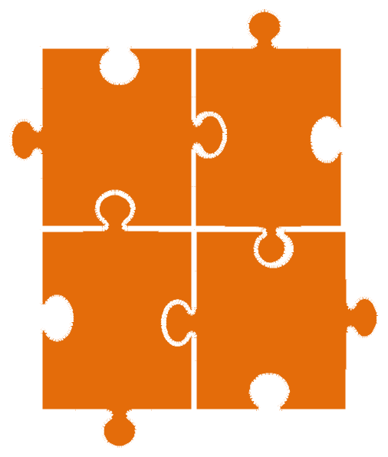

Wellbeing Culture

Country
of Ethnicity
Birth

Culture

The complex range of elements which may include knowledge, beliefs, customs, traditions, language, kinship and a way of life. It may be connected to people’s ethnic origin, country of birth, religion or other important aspect of their life or areas that have influenced and shaped their perspectives and what is important to them. Understanding what aspect of a person’s culture is important to them will help you build meaningful relationships, develop services that are appropriate and maximise people’s ability to improve their health and wellbeing. Different people who belong to the same culture will have similarities and differences in the way they live and experience that culture. Culture can be constantly evolving, people’s preferences, interests and values in relation to their culture need to be known and understood, rather than identifying they belong to a cultural group and assigning stereotypical values, beliefs, traditions or customs. It is important to understand that a person’s culture may inform their perspectives on a range of issues including, health, ageing, family, relationships and many others. Therefore it is important that your own cultural beliefs do not negatively impact how you work with and support others.

Ethnicity

Belonging to a social group that may have shared ancestral origins, language or national tradition. Ethnicity could be described in broad terms such as Aboriginal, Indian, Chinese and British or as narrowly as Wurundjeri, Punjabi, Han and Scottish. Ethnicity is an inherited identity that can inform a person’s culture, but people of the same ethnic background may belong to different cultural groups or speak different languages. People may have faced exclusion or discrimination in the past because of their race, ethnic origin or culture. Therefore, it is important to consider these possibilities if they are reluctant to use services and to proactively promote that your service is welcoming. It is important to engage with people respectfully and learn about different ways to deliver culturally appropriate services for people from different ethnicities, cultures and communities.

EMR Alliance
Connecting the Pieces
Video transcript

Many people use health and community services that are delivered in the home or in the community, but

Why are their experiences of these services different?

What is it that attracts us to one service provider over another / and

How can providers help people to get the most out of the services they use?

All services aim to be welcoming and create environments that make people feel comfortable and safe. This is important for services delivered in the home or the community. As service providers, staff or volunteers we can unintentionally create barriers for people, reinforcing their concerns that the service or staff maybe unwelcoming, unsafe or unable to help.

To overcome these barriers we need to “know our community”. This means, understanding the diversity of the people who live in the local area, which parts of the community aren’t accessing services and why. We need to develop ways to connect with local people and learn about what is important to them and then respond appropriately.

When people use our services we need to work with them, their families and carers to help them do as much as they can for themselves and to maintain their quality of life. We can do this through a model that includes:

Assessment Planning, and

Service Delivery
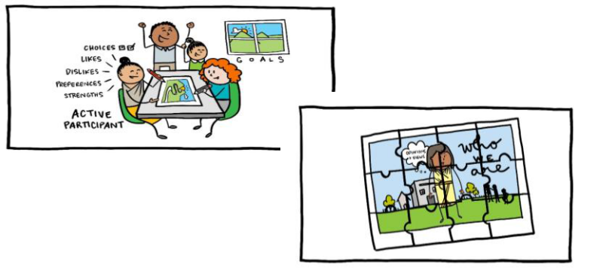

Assessment – a conversation that helps us to get to know the person, including their strengths and what motivates them. Planning – that is inclusive of the person (their family and carers) and is based on what is important to the person now and into the future and Service delivery – that is flexible and responsive to the individual needs of the person and includes regularly ‘checking in’ to find out how things are going

While it is important that the quality of support we offer through assessment, planning and service delivery is consistent for everyone, we must still be focused on providing a service that is individual and flexible to suit each person.

People are experts in their own lives and are therefore best placed to be involved in, and plan their own futures. As service providers it is our role to listen and learn, focusing on what is important to someone now and for the future. If we look at the whole person rather than viewing them as a series of needs we can provide services that enable a person’s sense of purpose and confidence - through meaningful social participation, connectedness and life enjoyment.

Part of looking at the whole person is understanding their diversity. We are all unique, shaped by a variety of areas:

personal characteristics – the things that are innate to who we are including our age, sexual orientation, gender identity, culture, ethnicity and many more

experiences - our personal story and situations such as our financial or living arrangements and how socially connected we are

values and beliefs – our opinions and views potentially informed by religion or faith, political ideology or our personal experiences.

EMR Alliance
Connecting the Pieces
We are all made up of many diversity pieces that connect together to create a picture of who we are. The value or significance of each diversity piece will vary from person to person.

For example:

Gender identity and gender expression may rate highly for John a trans man, but be less important for someone else. These diversity pieces are not the only things important to John. If we ignore part of someone’s diversity or only focus on one or two diversity pieces we will be overlooking their other characteristics and what else is important to them.

Jenny is an older person who enjoys catching up with friends in the local walking group, is a long term member of a senior’s choir and is a volunteer tutor at the neighbourhood house. While Jenny’s physical and cognitive capabilities are similar to many 20 year-olds some of her friends have experienced significant declines in physical and cognitive capabilities at a much younger age. There is no typical older person. As service providers we need to be responsive and create an inclusive environment where everyone feels welcomed. This means going beyond tolerating people’s difference and truly respecting, celebrating and embracing them for who they are.

Diversity pieces shouldn’t just be looked at individually, multiple pieces may connect to tell you something about a person and what is important to them. Mai-Lee was born outside of Australia, she speaks little English, has no family, but enjoys being active. To her it is important to remain active and form social connections with people who speak the same language and share a similar culture. However, Kimiko who appears to be in the same situation as Mai-Lee is interested in improving her language and communication skills so she can form social connections with people who have other diversity pieces in common, such as family status, religion, age or sexual orientation.

To see the entire person we need to connect the pieces they have shared with us, being sure that we never make assumptions about them, their diversity or their history, as no two people are the same.

Helping people maintain their independence and live the best life they can requires us to put the person at the centre of their own care. Mai-Lee and Kimiko’s journeys will be different, based on their diverse characteristics, preferences and strengths but we can help by really getting to know them as a person, and understanding what is important to them, where they are now, and where they want to be in the future. We need to support them to be an active participant in all aspects of their own care, enabling them to have control and make decisions about their care. Assisting them to decide on their goals and make a plan for their future, including what actions need to be taken to achieve their best possible outcome. Our services need to be adaptable to meet their own unique capabilities and strengths, but also be responsive to their changing needs and circumstance. The final way we can support Kimiko and Mai-Lee is by creating an environment where they, the people important to them and others involved in their care, work together to support their goals.

People’s journey through health and community services will differ. Individual experiences and preferences will influence the paths they take. As service providers, staff or volunteers we can support people to retain or regain their functional, emotional and social independence by

removing the barriers they face when trying to access services,

understanding their diversity, interests and needs; and

delivering appropriately tailored long or short term services

EMR Alliance
Connecting the Pieces
Further Information and useful resources

Diversity
The following websites include a range of resources and information relating to diversity areas:

Alzheimer’s Australia Victoria: https://vic.fightdementia.org.au/

Australian Bureau of Statistics: http://www.abs.gov.au/

Centre for Culture Ethnicity and Health: http://www.ceh.org.au/

Council to Homeless Person: http://chp.org.au/

Department of Veterans Affairs: http://www.dva.gov.au/

Eastern Elder Abuse Network: http://www.eclc.org.au/what-we-do/partnerships-and-projects/elder-abuse/

Ethnic Communities Council Victoria: http://eccv.org.au/

Gay and Lesbian Health Victoria: http://www.glhv.org.au/

Housing For The Aged Action Group: http://www.oldertenants.org.au/

Migrant Information Centre (Eastern Melbourne) : http://miceastmelb.com.au/

Open Place – Supporting forgotten Australians: http://www.openplace.org.au/

Organisation Intersex International Australia: https://oii.org.au/

Seniors Rights Victoria: https://seniorsrights.org.au/

Transgender Victoria: http://www.transgendervictoria.com/

Val’s Café: http://www.valscafe.org.au/

Victorian Aboriginal Community Controlled Health Organisation: http://www.vaccho.org.au/

Victorian Adoption Network for Information and Self Help: http://vanish.org.au/

EMR Alliance
Connecting the Pieces
Further Information and useful resources

Person centred care

The following websites include a range of resources about person centred approaches:

Helen Sanderson and Associates: www.helensandersonassociates.co.uk

The Picker Institute: http://cgp.pickerinstitute.org/?page_id=1319

The Learning Community for Person Centred Practices: http://www.learningcommunity.us/

Alzheimer’s Australia (2015) Valuing people: Why is person centred care important. Available at: http://valuingpeople.org.au/the-resource/what-is-person-centred-care

Other

Commonwealth Home Support Programme manual available at: https://agedcare.health.gov.au/ageing-and-aged-care-publications-and-articles-fact-sheets/commonwealth-home-support-programme-programme-manual-2015

Department of Health Living well: CHSP Good Practice Guide: https://agedcare.health.gov.au/programs-services/commonwealth-home-support-programme/living-well-at-home-chsp-good-practice-guide

Department of Health & Human Services Victorian Home and Community Care

Program Manual 2013: https://www2.health.vic.gov.au/about/publications/policiesandguidelines/hacc-program-manual-2013

EMR Alliance Connecting the Pieces: www.oepcp.com.au

EMR Alliance YouTube Channel: https://www.youtube.com/channel/UCNJNartUMt2N3odUaDBW6rA

EMR Alliance
Connecting the Pieces

