ConneCting
through inclusive communication practices
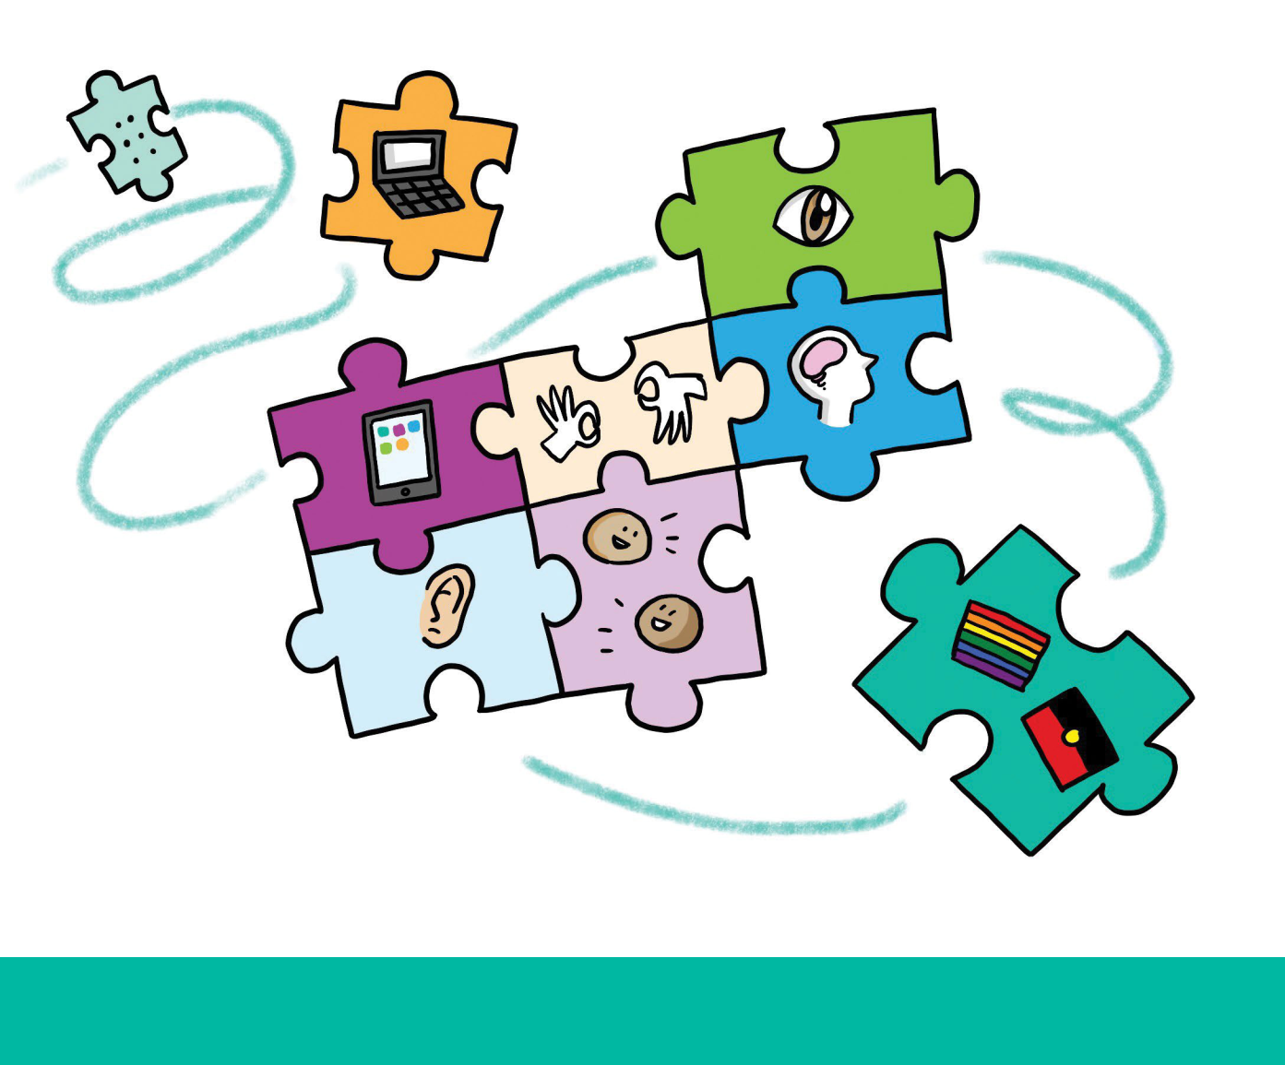

A resource for service providers
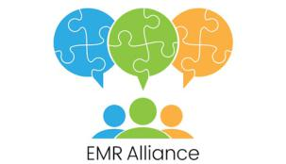

‘Working together to innovate good practice in aged, health & community services’

Acknowledgements

This resource is produced for members of the EMR Alliance, in recognition of their continued commitment and ongoing contribution to implementing inclusive, person centred practice across the Eastern Metropolitan Region (EMR) of Melbourne. The EMR Alliance celebrates the diversity of the EMR and actively supports our funded service providers to make their services inclusive and accessible for everyone. We acknowledge Aboriginal and Torres Strait Islander people as the traditional owners of country throughout Australia and pay respect to elders past and present.

We would particularly like to acknowledge the Outer East Health & Community Support Alliance (OEHCSA) & Inner East Primary Care Partnership (IEPCP) for their contribution on ‘Health Literacy Principles’. We would also like to thank the following service providers for sharing their communication material and/or allowing us to reference their material in the resource. The website links and links to resources were current at the time of publication.

Annecto

Bolton Clarke (formerly RSL Care & RDNS)

Bridges Connecting Communities

Inspiro

Interchange Outer East

Mountain District Learning Centre

Penumbra Centre

Uniting AgeWell

Uniting, Uniting Life Assist, Uniting East Burwood

If you wish to cite this resource please use the following notation:

EMR Alliance (2017), Connecting through inclusive communication practices, Melbourne, Victoria

© EMR Alliance 2017, Melbourne, Victoria

Hardcopy and electronic materials may be reproduced for non-commercial use only in accordance with the provisions of the Copyright Act 1968 (the Act). No part of this work may be reproduced or communicated for resale or commercial distribution.

This resource is available to download via the EMR Alliance website at www.emralliance.org

For further information about this resource, please contact the EMR Sector Development team at emr.alliance@each.com.au

The EMR Alliance is supported by the Victorian Government and supported by the Australian Government Department of Health. Visit the Department of Health website for more information (http://www.health.gov.au/). Disclaimer: Although funding for this resource has been provided by the Australian Government, the material contained herein does not necessarily represent the views or policies of the Australian Government.

2

Contents

Section 1: Introduction to Inclusive Communication, Language and Health Literacy 6
• Inclusive communication 7
• Inclusive language 8
• Plain language 8

• Health literacy principles 9

Section 2: Inclusive Communication in Action 11
• Having meaningful conversations 12

• Conversations with diverse communities 14

Section 3: Developing Inclusive Written Communication 21
• Language, content & style 22
• Design & format 24
• Diversity & inclusion 25

• Wellness & reablement 27

Section 4: Inclusive Communication and Language Guide 29
• Diagram – developing inclusive communication 30
• Template 31
• Checklist 32
• Phrase alternatives 37
• EMR alliance example 38

• Website examples 39
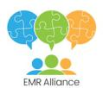

3

Background

Using appropriate language and communication approaches is critical to ensuring that people accessing your services feel welcomed, valued and understood. Staff and volunteers need to reflect on the language and communication approaches they use, so that they are accessible and appropriate for all, taking into account diverse experiences, preferences and characteristics. Training and ongoing development that covers the wide range of diversity characteristics is important for staff and volunteers and needs to be part of an organisation’s core business.

Findings from the 2016-17 Active Service Model (ASM)

- Diversity quality planning for the Eastern Metropolitan Region (EMR) Commonwealth Home Support Program (CHSP) and Home & Community Care Program for Younger People (HACC PYP), indicated that working on inclusive person centred communication was a priority for 41% of service providers. Further, 80% of service providers identified priorities relating to enhancing inclusive access and service delivery. This requires service providers to use appropriate communication practices to engage with and promote their services to people from diverse communities.

This resource has been developed by the EMR Alliance, to support the use of inclusive, person centred communication by CHSP and HACC PYP service providers.

The EMR Alliance provides a forum that promotes a strong partnership approach through effective information sharing and collaborative problem solving. It also supports the sharing of good practice that promotes inclusive access and person centred care.

How to use this resource

This resource includes information and tools that you can use with your staff and consumers to develop new communication material or when reviewing existing communication material.

It has useful information and links to resources which will support you to have meaningful conversations that are person centred and consider each person’s diversity.

This resource is not intended to provide comprehensive marketing support for service providers. Rather,

it focuses on the use of inclusive language and communication practices that are meaningful and relevant to potential and current consumers of your service.

The resource has been divided into sections. Sections 1-3 focus on an introduction to inclusive language, communication and health literacy, inclusive communication in action and considerations when developing inclusive written communication. Section 4 is the ‘Inclusive Communication & Language Guide’, which consists of a number of tools. It contains a template and checklist that you can use with your team to develop new material or to identify areas of improvement within existing communication material.

The sections are designed so that they can be downloaded individually for ease of use.

The resource is available on-line and can be downloaded at www.emralliance.org/resources.html.

4

Language is a powerful tool. The written and spoken words that we use and the images that we create reflect our attitudes, beliefs, and assumptions. Language shapes the way those around us speak and treat one another, and conveys the respect we have for others. It affects how we behave.

http://www.codsn.org/person-centered-language.html

Language is important. It not only defines how people see us but ultimately how we view ourselves. It allows us to communicate with others, and can impact stigma and discrimination.

It has the potential to promote and empower, enable and increase self-esteem, and encourage one’s ability to self-help and self-advocate. Or it can demean, devalue, disrespect and offend those we refer to.

Y. Gavriel Ansara (July 2013) Inclusive Language Guide: Respecting People of Intersex, Trans and Gender Diverse Experience Sydney. National LGBTI Health Alliance

5

Section 1

Introduction to Inclusive Communication, Language and Health Literacy

About this section

This section is an introduction to inclusive communication, language and health literacy. It provides background information on the importance of using inclusive communication and language and the key health literacy principles you need to consider when engaging with current or potential consumers

6

Inclusive communication

What is it?

We all understand and express ourselves in different ways according to our cultural, social, educational and personal experiences. For example, in some cultures, people will not make direct eye contact as a sign of respect, but this could be misinterpreted as the person being uninterested or disengaged. Inclusive communication both verbal and written, means developing and sharing information in ways that everybody can understand. How we communicate needs to be tailored to suit each person.

Why is it important?

People can experience barriers to health and community services when information is not written or explained in a clear and accessible format, available in their preferred language or staff are unable to adjust to the person’s needs and preferences.1 As service providers, we need to be aware of our clients’ preferred language and use words and examples that are appropriate and relevant to their language, cultural background, abilities and personal experiences. This will ensure people have the opportunity to receive information and express themselves in ways that are appropriate for them.

We want people to identify with the messages, images and the overall design of the materials we produce. The images and style of our communication need to reflect the principles and values of the organisation without being contrived or tokenistic.

When communicating with people in person, we need to be welcoming, positive and demonstrate culturally respectful verbal and body language. For example, if we have a client who does not shake hands or touch people of the opposite gender because of their religious or cultural beliefs, when greeting them we could make them feel at ease by placing our hand over our heart, nodding slightly and saying hello.2

The Connecting the Pieces resource http://www. emralliance.org/connecting-the-pieces.html explores the breadth of diversity through the diversity jigsaw and encourages people to operate within a framework that recognises respect and promotes all aspects of diversity. Working to these principles, enables you to consider how best to develop inclusive communication material that engages rather that alienates and excludes. It may be necessary to adapt your messages, images and language and produce different communication pieces for different communities or groups.

- http://www.eccv.org.au/library/An_Investment_Not_an_Expense_ECCV_Health_Literacy_Paper_FINAL.pdf

- https://thinkthink.wordpress.com/2009/04/23/guide-avoid-embarrassing-handshake-situations/
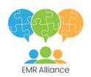

7

Inclusive Plain
Language Language

What is it?

Inclusive language demonstrates respect and has the ability to make people feel welcome and included. It positively reflects and promotes the abilities of individuals, acknowledges and embraces diversity and is free from demeaning, insulting and complex phrasing.3 Examples of inclusive language include: ‘we are committed to providing a welcoming and safe environment and delivering appropriate services for our entire community; we encourage people of all abilities, cultures and backgrounds to contact us to find out more about our services’.

Why is it important?

Using inclusive language allows us to focus on strengths and abilities rather than deficits or limitations.

Key principles of inclusive language

- Respects a person’s values (cultural, spiritual, emotional) and beliefs
- Demonstrates respect of how people describe who they are and what is important to them (relationships, gender, abilities, and identities)

- Focuses on a person’s strengths and assets and what they can do, not their limitations or deficits or what they can’t do.

What is it?

Plain language is communication that can be understood the first time it is read or heard. It allows people to find the information they need, understand the information they find and act appropriately on that information. It is an important tool for improving health literacy.4

Why is it important?

Plain language saves time and effort for everyone. Our messages become more meaningful when we say precisely what we mean and always speak with the intended audience in mind.5 It is recommended that clients are involved in developing and reviewing communication material for readability including plain language.

Key elements of plain language

- Organise information so that the most important points come first
- Break complex information into understandable portions
- Use examples to help explain the text

- Avoid jargon and technical terms – explain concepts/ideas in plain and straightforward way

- Use the active voice

- Further information: http://www.plainlanguage.gov/whatisPL/ definitions/Kimble.cfm

- https://www.uq.edu.au/equity/content/inclusive-language

- http://www.plainlanguage.gov/whatisPL/index.cfm

- https://publicsector.sa.gov.au/wp-content/uploads/20070101-Good-practice-guide-Plain-English.pdf

8

Health Literacy principles

‘Health literacy refers to the personal characteristics and social resources needed for individuals and communities to access, understand, appraise and use information and services to make decisions about health. Health literacy includes the capacity to communicate, assert and enact these decisions.’6

What is health literacy?

Health literacy is about how people understand information about health and health care, and how they apply that information to their lives, use it to make decisions and act on it.7

A person’s individual health literacy needs to be considered in the context of the demands that they will face when accessing and using our complex health system.

- Individual health literacy - the skills, knowledge, motivation and capacity of a person to access, understand, appraise and apply information to make effective decisions about health and health care and take appropriate action

- The health literacy environment - the infrastructure, policies, processes, materials, people and relationships that make up the health system and have an impact on the way in which people access, understand, appraise and apply health-related information and services8

Did you know?

Just over 1/3 of Victorians aged 15-74 have an adequate level of individual health literacy.9 This means that the majority of people do not have sufficient skills, knowledge, motivation and capacity to access, understand, appraise and apply information to make effective decisions about their health and take appropriate action.

Why is health literacy important?

Health literacy is important because it shapes people’s experience of the services and healthcare they receive and contributes to the safety and quality of their health care. A person’s ability to access, understand and use information about their condition will influence the action they take and the decisions they make about treatment and management.

Poor health literacy can have an impact on people’s health and wellbeing. These challenges affect the individual and the community more broadly. Research has found low health literacy to be associated with:

- Misdiagnosis and low rates of treatment compliance

- Higher incidence of chronic disease conditions and later engagement with the health system

- Poor management of chronic conditions and appropriate medication taking, and poorer knowledge about own diseases or conditions

- Poorer ability to interpret labels and health messages

- Less engagement in health-promoting behaviours and poorer overall health status

- Fragmented access to care and reduced use of preventive health services

- Increased hospitalisation and readmissions, greater use of emergency care and longer stays in hospital10

It can be difficult to clearly identify the causes of poor health literacy. We do know there are a number of factors that can impact individual health literacy, including educational attainment, culture and language, age, employment and socio-economic status.11, 12

Health literacy and communication

The Australian Commission on Safety & Quality of Health Care (ACSQHC) recommends health literacy be addressed in a coordinated way in both individual and environmental contexts. Collaborative action to improve health literacy is promoted across three key areas: embedding health literacy into systems, ensuring effective communication and integrating health literacy into education.

Effective communication includes:

- The provision of clear, focused and useable information about health and health care – the content and format of written and electronic health information needs to be easy to understand for those with low levels of individual health literacy

- Interpersonal communication – this includes how health information is communicated verbally and nonverbally between two or more people

9

Did you know?

While current policy places a large emphasis on increasing consumer participation in healthcare, poor health literacy can significantly impact an individual’s capacity to interact with health professionals and participate in their health care.

Consumer participation may therefore unintentionally increase inequalities in health by favouring certain population groups as a consequence of their higher health literacy.

Inclusive language and health literacy

It is common knowledge that health information that is not understandable or accessible creates a significant barrier for those with low health literacy, preventing active participation and action in health.13 Whether presented verbally, in written form or electronically, information needs to be clear, focused and useable. However, the role of inclusive language is often not discussed when considering ‘health literate’ communication.

The relationship between health literacy status and patient-centred communication has recently been explored. Individuals with limited health literacy are much less likely than those with adequate health literacy to report that their health care organisation ‘always’ provides patient-centred communication.14 Essentially, limited health literacy is associated with lower reported communication quality. Therefore, ensuring that language is simple, clear and inclusive will help your message reach as many people as possible.

This highlights the range of communication challenges facing patients with limited health literacy, and reinforces the importance of using:

- inclusive/person-centred language in combination with,

- clear, focused and useable written and electronic information, and effective verbal communication

Recommended resources

- https://health.gov/communication/literacy/

quickguide/factsbasic.htm

- http://www.ceh.org.au/training/browse/health-literacy-development/
- Matthew K. Wynia, and Chandra Y. Osborn Health Literacy and Communication Quality in Health Care Organizations

- Helen Osborne - Health Literacy Consulting When It’s Time to Choose: Thinking About the Right Words

Australian Commission on Safety and Quality in

Health Care (ACSQHC):

- Health Literacy: A summary for clinicians

- Health Literacy: A summary for clinicians (infographic)
- National Statement on Health Literacy

- https://www.safetyandquality.gov.au/wp-content/ uploads/2015/06/Standard-2-Tip-Sheet-5-Preparing-written-information-for-consumers-that-is-clear-understandable-and-easy-to-use.pdf

Online training:

- Centers for Disease Control and Prevention Free online health literacy training modules

Videos:

- Keep it simple for safety - Don’t Use Jargon Improving Americas Health Literacy

- S. Dodson, A. Beauchamp, R. Batterham and R. Osborne, “Information sheet 1: What is health literacy? In Ophelia Toolkit: A step-by-step guide for identifying and responding to health literacy needs

within local communities,” 2014. [Online]. Available: http://www.ophelia.net.au.

- ACSQHC, “Health Literacy: Taking action to improve safety and quality,” 2014. [Online]. Available: https://www.safetyandquality.gov.au/wp-content/uploads/2014/08/Health-Literacy-Taking-action-to-improve-safety-and-quality.pdf

- ACSQHC, “Health Literacy: Taking action to improve safety and quality,” 2014. [Online]. Available: https://www.safetyandquality.gov.au/wp-content/uploads/2014/08/Health-Literacy-Taking-action-to-improve-safety-and-quality.pdf

- ACSQHC, “Health Literacy: Taking action to improve safety and quality,” 2014. [Online]. Available: https://www.safetyandquality.gov.au/wp-content/uploads/2014/08/Health-Literacy-Taking-action-to-improve-safety-and-quality.pdf

- N. Berkman, S. Sheridan, K. Donahue, D. Halpern and K. Crotty, “Low health literacy and health outcomes: an updated systematic review,” Annals of Internal Medicine, pp. 97-107, 2011

- ACSQHC, “Health Literacy: Taking action to improve safety and quality,” 2014. [Online]. Available: https://www.safetyandquality.gov.au/wp-content/uploads/2014/08/Health-Literacy-Taking-action-to-improve-safety-and-quality.pdf

- ABS, “Health Literacy,” Australian Bureau of Statistics, Canberra, 2006

- ACSQHC, “Health Literacy: Taking action to improve safety and quality,” 2014. [Online]. Available: https://www.safetyandquality.gov.au/wp-content/uploads/2014/08/Health-Literacy-Taking-action-to-improve-safety-and-quality.pdf

- N. Berkman, S. Sheridan, K. Donahue, D. Halpern and K. Crotty, “Low health literacy and health outcomes: an updated systematic review,” Annals of Internal Medicine, pp. 97-107, 2011

10

Section 2

Inclusive Communication in action

About this section

This section describes inclusive communication in action. It provides information on the key communication approaches, the factors to consider when communicating with people face to face or over the phone and particular considerations for people from diverse communities.

11

Having meaningful conversations

What we say, and how we say it, is equally important. The following communication approaches are necessary when operating in an inclusive and person centred way.

Communication Approach | Description
Active Listening | • Active listening is communicating empathetically through reflective listening.
 | It describes the act of being present and attentive to what someone else is
 | saying. It involves viewing the world through the eyes of the person you are
 | communicating with and demonstrating that you understand their feelings and
 | views by repeating back to them what you have heard in your own words15
 | • The approach demonstrates an appreciation and understanding for the
 | perspective of a person without judging, criticising or blaming
 | • It builds on trust and minimises resistance and promotes self-confidence
 | • It clarifies, rather than assumes you know what is meant
 | • It allows or invites opportunity for feedback

Active listening involves some key steps to demonstrate you’re paying attention, engaged and listening:

- Use verbal and non-verbal communication (maintain eye contact, use open body language, mirror)
- Provide feedback by responding in an active way (nod, smile, say yes)

- Defer judgement and avoid interrupting

- Respond appropriately by summarising what the person has just said and ask them to confirm if you’ve heard it correctly
e.g. It sounds like you are concerned that you don’t get out of the house as often as you used to? Would this be correct? What would you like to be doing, or where would you like to be going?

Useful videos: https://www.youtube.com/watch?v=oWe_ogA5YCU https://www.youtube.com/watch?v=z_-rNd7h6z8

15. https://www.mindtools.com/CommSkll/ActiveListening.htm

12

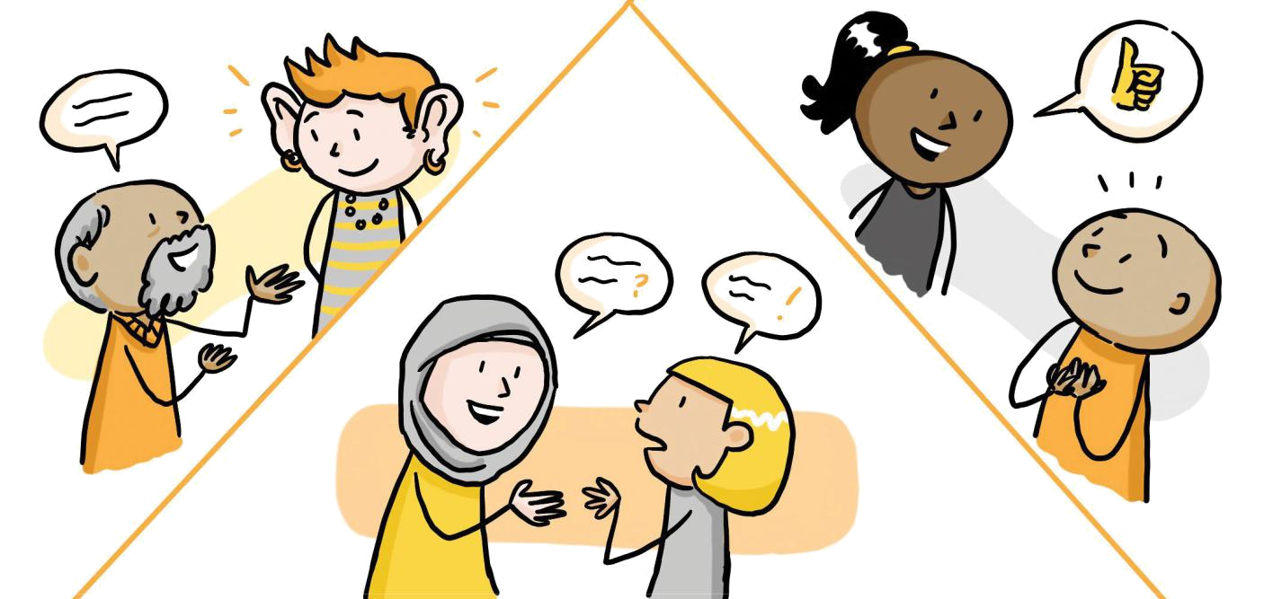

Communication Approach | Description
Using appropriate | • Good questioning techniques encourage people to share their own story
questioning | in their own words, describe what’s important to them, their strengths,
techniques | resources, motivation and interests
 | • Appropriate questioning empowers the person to make suggestions and
 | contribute their ideas about the support they would like

You can do this by:

- Framing questions in a positive way e.g. I understand that you are finding some tasks more difficult
- Asking open ended questions that require more than a yes or no answer e.g. What has brought you here today? or What’s makes you think it might be time to get some help around the house?

Using affirming language • Affirming language shows that you genuinely and respectfully affirm someone’s personal qualities, strengths, efforts, successes and intentions

- This approach supports independence, improves confidence, and demonstrates a recognition that people are experts in their own lives. e.g. It sounds like you are very creative

You can do this by:

- Listening and reflecting back what has been said in a positive way

- Acknowledging people’s strengths, successes and efforts to change e.g. It’s clear that you are really trying to change16

13

Conversations with diverse communities

There are additional communication considerations when interacting with people from diverse communities. The following are some of the recognised areas to consider when working with different communities. However, these are just a guide and it must be acknowledged that not all people from the same cultural or social group have the same beliefs, values, customs, experiences or expectations.

Not all of the diversity characteristics have been detailed in this guide. For further consideration refer to the diversity jigsaw, understanding the diversity jigsaw and the recommended resources after each section.

Aboriginal and Torres Strait Islander peoples

There are specific cultural and social practices that are important to understand when communicating with Aboriginal and Torres Strait Islander peoples. Aboriginal and Torres Strait Islander people have a history of sharing their traditions and passing on information orally through stories. Story telling is an important part of Aboriginal and Torres Strait Island culture, so taking the time to share things about ourselves and to learn about the person we are meeting will help to build trust and rapport in a cultural appropriate way.17 Having an informal conversation can help us to learn where a client is from, where their traditional country is and what else is important to them.

Whilst it is a sign of respect to refer to an Aboriginal person by their language or country, it is important to remember that due to past displacements and the Stolen Generations some people may not know their language or which country Aboriginal people are from. It is important to understand the role and value of family and community. The definition and makeup of family may be broader or different to a Western/Anglo family context.

For some people making eye contact can be considered inappropriate or a sign of disrespect. We need to be

aware of this and adapt our own eye contact and body language as appropriate. Personal space and touching people of the opposite sex may also be culturally inappropriate for Aboriginal and Torres Strait Islander peoples.

Extended periods of silence during conversations can be normal for Aboriginal and Torres Strait Islander people. Silent pauses may be used to demonstrate respect

or consensus.18 Before we start speaking, we should observe the silence and body language of those present and assess when it is appropriate to speak.

It may not be appropriate to assume someone is an elder and we should ask if they want to be called Aunty or Uncle. Similarly, if we are unsure what words or references are appropriate ask the person what they prefer, Aboriginal, Indigenous, Wurundjeri elder/man/woman.

Aboriginal and Torres Strait Islander people may use indirect language when communicating.19 This is considered a polite way to communicate, but it requires others to identify indirect language and respond appropriately to ensure the needs and preferences of the person are understood.20

Indirect question example | Direct question example | Indirect Response
‘Wow, isn’t it cold in here’ | ‘Can you close the window please?’ | ‘Would you like me to close the
 |  | window/put the heating on?’
‘Is it normal that your feet hurt when | ‘When I walk my feet hurt, is that | ‘That doesn’t seem right, does it
you walk?’ | normal?’ | hurt when you walk?’

- https://www.health.qld.gov.au/__data/assets/pdf_file/0021/151923/communicating.pdf

- https://www.health.qld.gov.au/__data/assets/pdf_file/0021/151923/communicating.pdf

- http://www.vaccho.org.au/assets/01-RESOURCES/TOPIC-AREA/CULTURAL/Koorified-Aboriginal-Communication-and-Well-Being.pdf

- Reference Silvia, A. Politeness in social interaction and indirect speech acts. Undated. https://www.academia.edu/2344547/Politeness_and_Indirect_Speech_Act

14

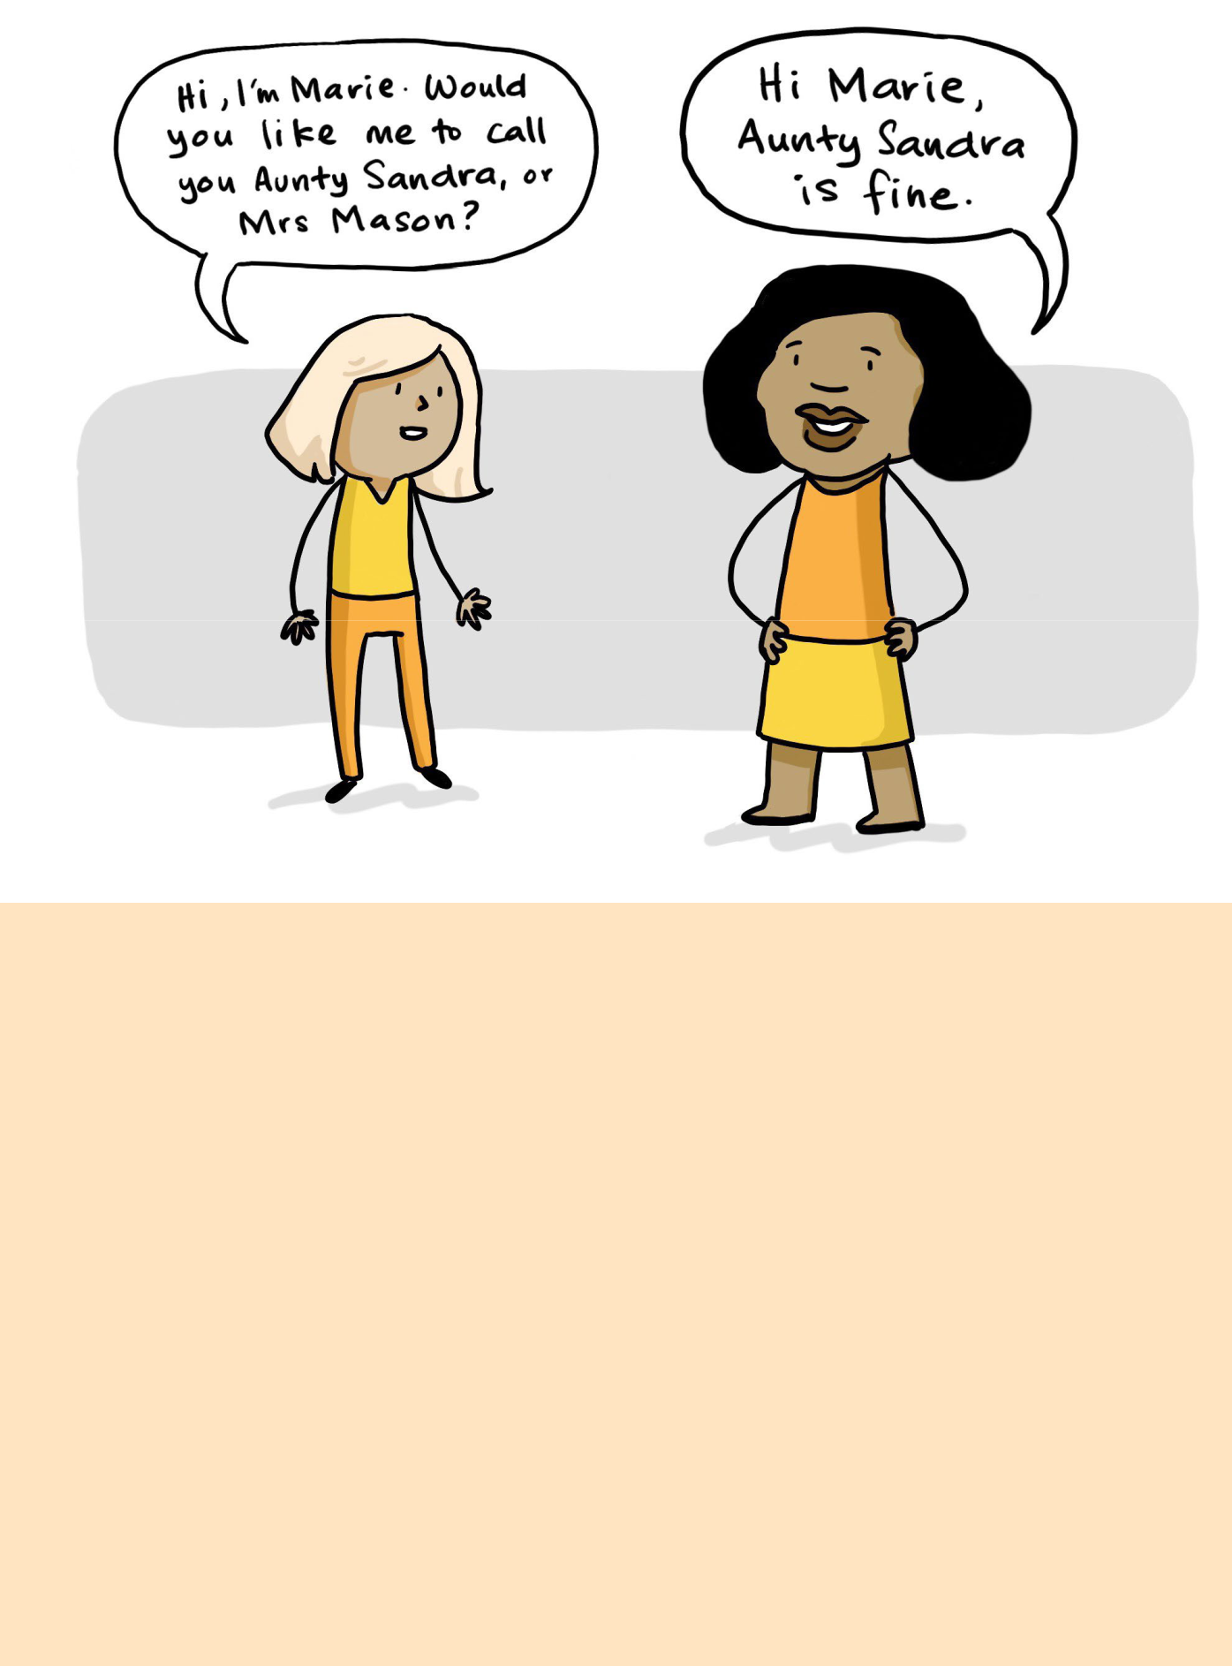

Recommended resources

- Alzheimer’s Australia https://www.fightdementia.org.au/about-dementia/resources/aboriginal-and-torres-strait-islander
- Queensland Health https://www.health.qld.gov.au/__data/assets/pdf_file/0021/151923/communicating.pdf

- VACCHO http://www.vaccho.org.au/assets/01-RESOURCES/TOPIC-AREA/CULTURAL/Koorified-Aboriginal-Communication-and-Well-Being.pdf

- Alliance for Forgotten Australians http://www.forgottenaustralians.org.au/assets/docs/Booklet/AFA_Booklet.pdf http://www.forgottenaustralians.org.au/

- Australian Department of Health https://agedcare.health.gov.au/support-services/people-from-diverse-backgrounds/care-leavers-resources
- Australian Human Rights Commission https://www.humanrights.gov.au/publications/bringing-them-home-report-1997
- Australians Together http://www.australianstogether.org.au/stories/detail/the-stolen-generations

- Child Migrants Trust https://www.childmigrantstrust.com/

- Open Place http://www.openplace.org.au/AboutForgottenAustralians

- Parliament of Australia

http://www.aph.gov.au/Parliamentary_Business/Committees/Senate/Community_Affairs/Completed_ inquiries/1999-02/child_migrat/report/index http://www.aph.gov.au/Parliamentary_Business/Committees/Senate/Community_Affairs/Completed_ inquiries/2004-07/inst_care/report/index

- VACCHO http://www.vaccho.org.au/about-us/ah/tsg/

- VANISH https://vanish.org.au/

15

People from Cultural and Linguistically Diverse (CALD) Communities

CALD communities are diverse and whilst there may be similarities between some, there are also significant differences. Respect is central to having inclusive face-to-face communication and building trust.

It is vital that we are aware of our own cultural practices and perspectives and do not try to impose these on others or judge people’s beliefs, traditions or experiences that are different to ours.21 We should avoid undue emphasis on differences between CALD communities and western cultures.22 We need to consider the language we use and avoid terms such as foreigner, migrant and immigrant as they have been used with negative connotations and can alienate or isolate people on the basis of their country of birth, identity or culture.

People who have come from countries experiencing war or oppression may be reluctant to trust government, health and community sector systems. Therefore, service providers and their staff become the bridge, linking individuals and the Australian healthcare system.

Developing relationships with community groups and learning about specific cultural norms, beliefs and practices can help staff build relationships with CALD clients.23 Formal and informal education about specific CALD communities or faith groups will help to build the capacity of the workforce to develop and deliver services in an inclusive way.

The role and dynamics of families can vary greatly across and within different cultural groups. It is important that we understand a person’s family situation and relationships

without judging from our own cultural perspectives.

Many people have broad family networks that include aunts, uncles, cousins and grandparents and we need to consider them when working with clients.

Shaking hands or other touching between people of the opposite sex will be considered culturally inappropriate for some people and could make the person feel uncomfortable if they need to point this out.

Some people from CALD communities will only access practitioners or interpreters of the same gender, but this will not be the case with all people; it is important to ask and not assume.24 It is vital that professionally qualified interpreters are used for:

- people who ask

- people not fluent in English

- people who cannot grasp or respond to questions in English

Interpreters should be used for assessments, explaining health information and delivering allied health services.25 Family members, friends and bi-lingual volunteers should not be used as interpreters in a formal setting. Clients may be unaware that they are entitled to an interpreter, so it is important we recognise when an interpreter is required.

The use of bi/multi-lingual volunteers in social support settings can help to integrate clients and build a welcoming and inclusive environment and should be actively resourced and promoted.

Recommended resources

  - Alzheimer’s Australia https://www.fightdementia.org.au/resources/culturally-and-linguistically-diverse

  - Banyule City Council https://www.banyule.vic.gov.au/Services/Diverse-Communities-and-Social-Inclusion

  - Centre for Cultural Diversity in Ageing http://www.culturaldiversity.com.au/resources

  - Centre for Culture Ethnicity and Health http://www.ceh.org.au/health-literacy-hub/ http://www.ceh.org.au/6-steps-effective-translation/

  - Dental Health Services Victoria https://www.dhsv.org.au/__data/assets/pdf_file/0013/3226/cald-kit.pdf

  - ECALD http://www.ecald.com/Portals/49/Docs/Toolkits/cald-older-people.pdf

  - Ethnic Communities Council of Victoria

http://www.eccv.org.au/library/An_Investment_Not_an_Expense_ECCV_Health_Literacy_Paper_FINAL.pdf

  - EMR Alliance http://www.emralliance.org/connecting-the-pieces.html http://www.emralliance.org/building-culturally-inclusive-social-support-groups.html

  - Migrant Information Center http://miceastmelb.com.au/resources/

- https://www.dhsv.org.au/__data/assets/pdf_file/0013/3226/cald-kit.pdf

- http://www.emralliance.org/building-culturally-inclusive-social-support-groups.html

- http://www.ecald.com/Portals/49/Docs/Toolkits/cald-older-people.pdf

- https://www.dhsv.org.au/__data/assets/pdf_file/0013/3226/cald-kit.pdf

- http://www.ceh.org.au/assessing-the-an-interpreter/

16

People living with Dementia

People living with dementia have varying abilities, skills and needs. It is important we understand these so that we can communicate appropriately and adjust our style and approach.

The physical environment is also very important. We should create a quiet space with minimal distractions and use large font signs on doors to indicate which room is behind each door. Distinct walkways will also help people to navigate the building.

Losing the ability to communicate can be frustrating for the person, carers and families. As the disease progresses the person with dementia will find it more difficult to express themselves.26 We need to be mindful of how we ask questions and provide information. Complex information and multiple questions can be overwhelming and confusing. Introduce one question at a time and check if the message has been understood.27 Wear name tags with a large font and use people’s names during conversations to assist people to follow the conversation.

There are a range of alternative communication approaches28 and strategies that can also be useful to support people who are living with dementia. These include:

- Validation Therapy

- Music Therapy

- Reminiscence

- Creating a ‘This is your Life’ book

It may be necessary to have separate meetings with the person’s support network to find out any additional information, listen to their experiences and assist them to access appropriate support. Working with a person’s support network is important, but the client must still be involved, listened to and respected.

Things to remember

- Losing the ability to communicate can be frustrating and difficult for people with dementia, their families and carers

- Positive communication can help a person with dementia maintain their dignity and self-esteem
- A caring attitude, use of appropriate body language and maintaining the right environment are all important aspects of communication

- Try alternative communication approaches

Recommended resources

- Alzheimer’s Australia http://livingwellwithdementia.org.au/ https://www.fightdementia.org.au/files/NATIONAL/documents/language-guidelines-full.pdf https://vic.fightdementia.org.au/about-dementia/resources/help-sheets#About-dementia https://vic.fightdementia.org.au/vic/about-dementia-and-memory-loss/resources-to-download https://vic.fightdementia.org.au/files/helpsheets/Helpsheet-CaringForSomeone01-Communication_english.pdf https://vic.fightdementia.org.au/files/helpsheets/Helpsheet-CaringForSomeone02-TherapiesAndCommunicat ionApproaches_english.pdf https://www.fightdementia.org.au/sites/default/files/20090901-NATSIDAG-FacilitatorsGuide_Sec-11_Ways_ of_Communicating.pdf

- Uniting Age Well Dementia Friendly Checklist http://www.unitingagewell.org/Pages/News/2015-Dementia-friendly-checklist.aspx
- Journal of Dementia Care http://journalofdementiacare.com/the-power-of-language/

- https://www.betterhealth.vic.gov.au/health/conditionsandtreatments/dementia-communication#lp-h-1

- https://www.betterhealth.vic.gov.au/health/conditionsandtreatments/dementia-communication#lp-h-1

- https://vic.fightdementia.org.au/files/helpsheets/Helpsheet-CaringForSomeone02-TherapiesAndCommunicationApproaches_english.pdf

17

People who identify as Lesbian, Gay, Bisexual, Transgender, Intersex and Queer (LGBTIQ)

LGBTIQ people have a history of exclusion, discrimination and invisibility within health and community services. Lesbian, Gay, Bisexual, Transgender, Intersex and Queer groups have their own distinct histories and experiences.29 It is important to understand that some issues around inclusive communication practices will be similar across the LGBTIQ groups, but there are also specific and unique histories, issues and preferences that need to

be understood. We need to invest in understanding the entire LGBTIQ group including transgender, bisexuality or intersex issues.

There is often an automatic assumption that everyone is heterosexual.30 For example, people are often asked about their marital status at intake and assessment. We may automatically ask a male client about their wife or a female client about their husband. These assumptions suggest the service is not inclusive and places same-sex attracted people in a difficult position where they must decide if they correct the staff and out themselves. The term partner

is inclusive and does not suggest gender. If someone mentions a partner, don’t use gendered pronouns (he/she) unless they have. Incorrectly assuming the gender of a

partner forces people to either correct you or ignore it, both of which can be difficult and exclusionary.

Misgendering happens when someone refers to a person as one gender (male/female) but they identify as another gender (female/male/non-binary, neither male nor female).31 It can be deeply upsetting and make people feel alienated and doubt the appropriateness of the service. Refer to the person as the gender they identify with and avoid making assumptions about a person’s gender identity based on their appearance or voice. Service intake forms are often ‘gendered’ and require people to select male or female. This is not inclusive and can place the person in an awkward, upsetting or frustrating position. If a person introduces themselves as Mary and uses she/her pronouns, we would echo Mary’s choice of pronouns and refer to her as Mary/she/her.

Working with LGBTIQ people in an inclusive way requires us to consider our systems, processes and communication styles from the perspective of a LGBTIQ person.32 We need to learn about the history of older LGBTIQ people in order to understand the potential barriers they have in accessing services.

Recommended resources

  - Baptcare- ‘Safe, inclusive and person centred care for LGBTI seniors’

http://www.baptcare.org.au/__data/assets/pdf_file/0023/3983/BC368-LGBTI-AgedCare-SocialPolicy-A4-24pp-WEB.pdf
  - Bisexual Alliance http://www.bi-alliance.org/

  - Gay and Lesbian Health Victoria http://www.glhv.org.au/

  - National LGBTI Health Alliance http://www.lgbtihealth.org.au/sites/default/files/Cultural%20Competancy%20Framework.pdf http://lgbtihealth.org.au/

  - Organisation International Intersex Australia https://oii.org.au/

  - Rainbow Health Ontario https://www.rainbowhealthontario.ca/wp-content/uploads/woocommerce_uploads/2014/08/lgbt_ toolkit_2008.pdf

  - Transgender Victoria http://www.vic.gov.au/equality/inclusive-language-guide.html

  - Val’s Café http://www.valslgbti.org.au/index.php/resources/resource-articles/item/134-trans http://www.valslgbti.org.au/index.php/resources/resource-articles/item/114-no-need-to-straighten-up-discrimination-depression-anxiety-and-older-lgbti-australians http://www.valslgbti.org.au/index.php/resources/resource-articles/item/111-social-connection-relationships-and-older-lesbian-and-gay-people-social-connection-relationships-and-older-lesbian-and-gay-people http://www.valslgbti.org.au/index.php/resources/resource-articles/item/106-hacc-pack http://valscafe.org.au/index.php/resources/resource-articles/inclusive/item/136-lgbti-inclusive-aged-care-assessment-guidesheets

  - Victorian Government http://www.vic.gov.au/equality/inclusive-language-guide.html

- https://agedcare.health.gov.au/older-people-their-families-and-carers/people-from-diverse-backgrounds/national-lesbian-gay-bisexual-transgender-and-intersex-lgbti-ageing-and-aged-care-strategy

- http://www.lgbtihealth.org.au/sites/default/files/Cultural%20Competancy%20Framework.pdf

- http://www.vic.gov.au/equality/inclusive-language-guide.html

- http://www.lgbtihealth.org.au/sites/default/files/Cultural%20Competancy%20Framework.pdf

18

People with a Disability

The ability to communicate and have our views, experiences and questions understood is a fundamental right.33 As service providers we need to have practices in place that support people with a disability so they can engage with staff, understand the services that are available and ensure all the necessary information is shared with them. People with a disability come from diverse backgrounds and experiences. We need to take an individualised and person centred approach when working with people with a disability in order to avoid prejudicial and stereotyped behaviour.

Some general tips when communicating with people with a disability include:

- Speak to the person with respect and use plain language

- Use an age appropriate tone and treat adults as adults

- Direct your questions to the person with a disability, regardless of whether they have a carer, family member, interpreter or other support person present

- Put the person first, not their disability. For example, use the term ‘a person with a disability’ rather than ‘a disabled person’

- Focus on the person’s abilities and what they can do. People with a disability regularly adapt how things are done so they can participate and we shouldn’t underestimate what someone can do based on our own expectations34

There is also specific good practice advice when working with people with different impairments. The following information has been sourced from the City of Casey Inclusive Communication resource.

Acquired Brain Injury

- Have a conversation in a quiet place

- Discuss one topic at a time

- Repeat information

- Don’t assume the person has understood what you have said
- Don’t assume you have understood the meaning behind what the person has said

Hearing Impairment

- Face the person you are speaking with and speak in a normal manner – do not shout
- Make sure you are in a well-lit area with low background noise
- Use clear, short sentences and questions

- Communicate by writing if speech is not working

Intellectual Disability

- Be patient

- Allow the person time to express their ideas and participate
- Don’t rush people or finish their sentences

- Consider using picture or gestures to help include people in the conversation
- Offer to write instructions down

Mental Illness

- See the person not the symptom

- Create a relaxed, non-threating environment

- Show understanding and compassion, empathise without necessarily agreeing
- If the person is disorientated or responding in an inappropriate manner, allow the person space and initially avoid eye contact, touch or confrontation

Physical Impairment

- Communicate with people at their eye level

- Remember that a wheelchair is an extension of that person, never touch or push the chair unless asked
- Make sure corridors, pathways and aisles are clear

Speech Impairment

- Be in a quiet space, be patient and give the person plenty of time
- Ask if the person has an another method of communication
- If you haven’t understood something, ask the person to repeat it
- Consider using pen and paper to communicate

Visual Impairment

- When meeting someone introduce yourself in normal voice and tone
- If you are asked to guide a person, offer your arm and allow them to be in control of any movement
- Be specific when giving directions

- If you leave a room, say something that indicates you are leaving
- If a person has a guide dog, do not pat or distract the dog
- Always address the person and not the dog

- http://www.scopeaust.org.au/wp-content/uploads/2016/08/Toolkit-Part-1.pdf

- http://www.dhs.vic.gov.au/for-business-and-community/community-involvement/people-with-a-disability-in-the-community/communicate-and-consult-with-people-with-a-disability/ communication-with-people-with-disabilities

19

Recommended resources

- City of Casey http://www.casey.vic.gov.au/files/a04b6288-00bc.../Inclusive-Communication-Guide.pdf

- Scope http://www.scopeaust.org.au/service/communication-access/ http://www.scopeaust.org.au/information-resources-hub/resources-download/ http://www.scopeaust.org.au/wp-content/uploads/2016/08/Toolkit-Part-1.pdf http://www.scopeaust.org.au/wp-content/uploads/2016/08/Toolkit-Part-2.pdf https://www.youtube.com/user/scopevictoria

- People With A Disability http://www.pwd.org.au/

- Victorian Department of Health and Human Services http://www.dhs.vic.gov.au/for-business-and-community/community-involvement/people-with-a-disability-in-the-community/communicate-and-consult-with-people-with-a-disability/communication-with-people-with-disabilities

- Accessibility Resource Kit- Marketing and Communications Checklist, Accessible Arts, 2012 https://www.google.com.au/webhp?sourceid=chrome-instant&ion=1&espv=2&ie=UTF-8#q=Accessibility+Resource+Kit-+Marketing+and+Communications+Checklist,+Accessible+Arts,+2012&* http://archive.creative.vic.gov.au/Research_Resources/Resources/ADAPT_-_The_Arts_Disability_ Action_Plan_Training_Project/Top_Tips_and_Practical_Resources/Accessible_Marketing_and_Audience_ Development

20

Section 3

Developing inclusive written communication

About this section

This section addresses the written aspects of inclusive communication. It focuses on the elements to consider across the following

- key areas when reviewing or developing written inclusive communication:

- Language, content and style

- Design and format

- Diversity and inclusion

- Wellness and reablement

21

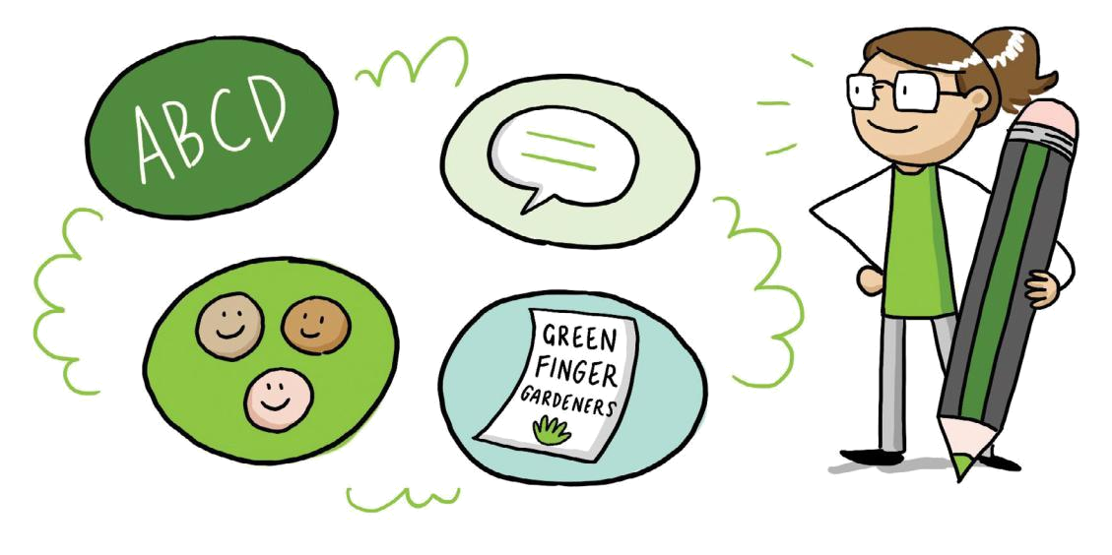

Developing inclusive person centred written communication

When developing or reviewing your written communication it is important to consider how you are going to communicate your service to existing and potential consumers. You will also need to consider how your internal forms (intake, feedback, newsletters, session timetable) are designed and how your messages are communicated.

Language, content & style

Plain language

Communication is documented in plain language. Consider the literacy level. Keep messages clear, direct and specific (less is best). Avoid the use of acronyms, complex medical terminology, and jargon (social isolation, person centred, ASM). If you do use any term that may not be clear, provide an example to show what you mean. e.g. ‘We focus on your needs and wants’. Where possible translate material.

Target audience

The program’s key eligibility requirements and target audience needs to be easily identifiable. Consider the words, images and format that will best engage your target audience (current & potential). The target audience should align with the eligibility criteria of the program (and subsequent funding requirements) but should also encourage consumers to contact the service provider to discuss eligibility based on their individual circumstances, providing opportunity to explore options.

Motto’s and catch phrases

A well-written motto or catch phrase can quickly resonate with people and help them to feel a connection to your service. They can provide insight into your approach to service delivery and generally reflect your values, principles, mission or quality statement. Some local examples include ‘Be creative, laugh with friends- live well’ (Penumbra Centre), ‘Encourage, Connect, Inspire’ (Interchange Outer East).

Explaining your service or activity

Clearly name the service or activity you are offering.

For example:

- Active exercise class

- Social outing group. e.g. visit to the maritime museum

- Advice about food and cooking for one

Avoid names or acronyms that may be unfamiliar to consumers. e.g. PAG. Briefly describe the service and the benefits of attending the service. e.g. occupational therapy – supporting you to live independently at home and in the community.

- https://www.mindtools.com/CommSkll/ActiveListening.htm

- http://www.nova.edu/gsc/forms/mi-techniques-skills.pdf

22

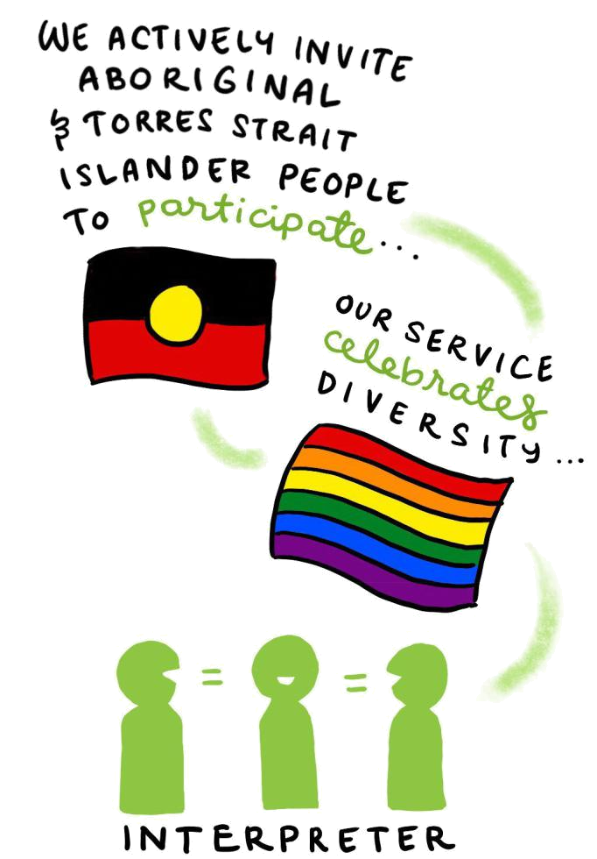

Using symbols, acknowledgments and flags Displaying symbols and written acknowledgements is a great way for service providers to demonstrate their commitment to providing a safe and inclusive environment. It is vital that before you use these flags or symbols, that staff understand why you are displaying them and how to respond if questioned by clients. If you are displaying the Aboriginal, Torres Strait Islander, Rainbow or Transgender flags in your communication it is recommended that it is accompanied with some text.

For example: ‘We acknowledge the Wurundjeri people as the traditional custodians of the land and actively invite and welcome Aboriginal and Torres Strait Islander people to participate in our service’ or stating ‘Our service celebrates diversity, is committed to having a safe and inclusive service and welcomes people who are same-sex attracted and gender diverse/ from the LGBTIQ community’. Displaying flags of different countries is a good way to demonstrate you are trying to reach particular communities, but a statement supporting the use of the flag is recommended. Display the interpreter symbol and ensure that staff understand how to support clients to access interpreting services.

Recommended resources

- Guidelines for producing readable text http://www.visionaustralia.org/business-and-professionals/print-accessibility-services http://www.visionaustralia.org/business-and-professionals/print-accessibility-services/inclusive-communication-strategies

- Access Easy English- interprets documents into everyday language, supported with images http://accesseasyenglish.com.au/
- Scope- Accessible information and Easy English http://www.scopeaust.org.au/service/accessible-information/
- Web content accessibility guidelines https://www.w3.org/TR/WCAG20/ http://www.mayer-johnson.com/what-is-boardmaker/

- Victorian Government Accessible Communication Guidelines http://healthissuescentre.org.au/images/uploads/resources/Accessible_Communication_Guidelines_ January_2014.pdf

- Banyule City Council- Inclusive Language Guide https://www.banyule.vic.gov.au/files/assets/public/.../inclusivelanguagefinal.pdf
- Tasmanian Department of Health https://www.education.tas.gov.au/documentcentre/Documents/Guidelines-for-Inclusive-Language.pdf

23

Design and format

Fonts, colour and communication platforms

Use a plain font with a reputation for readability e.g. arial or calibri. Minimise the use of italics, capitals, bolding and underlining. Text size should be between 10 -12 points depending on the document and communication. If you are promoting your communication towards an older demographic you may consider using 12 point font.

Use a background colour that does not conflict with the text such as a dark print on a light background. Do not put too much information on each page, use white space to draw the reader to the key messages, leave wide margins, space between paragraphs, and keep text to a minimum. Use columns and images to break up text.

Communication platforms may include newsletters, brochures, information booklets and packages, posters, flyers, media (radio or newsprint), websites, YouTube videos, CD/DVD, audio scripts and social media such as Facebook, Instagram and Twitter. Consider the use of

alternative communication aids (communication boards, large print, braille, pictograms and apps). The approach to communication is representative of the way the target audience accesses information.

Images reflect the consumers, service and the community

Where possible use images of consumers using your service, with permission. Reflect the diversity of your local area in images you use. For example: people who are transgender, in a same-sex relationship, have a disability or are from a CALD community. People from diverse communities need to be visible, but ensure your content supports your images. Use images that are empowering and positive e.g. ‘doing with, not for’ or people actively involved in activities. Targeted communication aimed at specific diversity groups is a great way to engage with

a particular group or community, but ensure there is something that speaks to all your potential consumers.

24

Diversity and inclusion

Communication should be explicitly welcoming of diversity broadly, as well as targeting specific diversity groups as appropriate. e.g. people who identify as LGBTIQ, local CALD groups, Aboriginal communities. It is important to consider any way in which communication may unintentionally marginalise or exclude a particular diversity group. Before stating that: ‘we offer a culturally appropriate and safe service for any diversity group’ it is vital that your organisation can deliver on this and that the message is not tokenistic.

Aboriginal and Torres Strait Islander peoples It is important to recognise the diversity that exists within Aboriginal and Torres Strait Islander peoples and communities. Individuals have diverse backgrounds, personal characteristics, preferences, experiences and cultures. There are however, some overarching considerations that need to be followed when developing communication that refers to Aboriginal and Torres Strait Islander peoples.

Always capitalise Aboriginal and Torres Strait Islander, Aboriginal, Indigenous and do not use abbreviations such as ATSI. The term Indigenous, is often used to describe Indigenous people worldwide and in Australia many Aboriginal people prefer that it is not used. If you can demonstrate that your organisation has a good relationship with the local Aboriginal and Torres Strait Islander communities; organisations and/or clients you may want to highlight this in your communication, along with your commitment to delivering a service that is cultural appropriate and inclusive. Referencing and acknowledging the local Aboriginal custodians where the services are based sends a positive message to the community.

Financial and social situations

Clearly state how much your services costs. If there is financial support or waivers available to people who cannot afford the service state this. For example, ‘financial support to access our services is available where needed, discuss this confidentially with a member of our team.’ Mentioning you have a fees policy in your communication won’t mean anything to clients, explain clearly and plainly how you can assist them if they are experiencing financial difficulty. It

is important that staff understand the organisations fees policy and support available and apply it consistently so clients are not excluded from receiving a service.

Gender

Gender stereotypes and gendered communication can create issues and alienate clients. Gender-neutral language should be used where possible. There may be specific reasons to offer gender-based services, but this should be justified and not based on perceptions that

an activity is appropriate or appealing to men/women. Promoting gender-based activities can also appear exclusionary to people who identity as gender diverse and gender non-binary.

People from Culturally and Linguistically Diverse (CALD) communities

Communication should demonstrate how the service is appropriate and welcoming for CALD communities or specific language groups. If there are particular communities you wish to target your communication to, consider what is culturally appropriate and appealing for these communities. If you have bi-lingual staff or volunteers reference this along with the languages they speak in your communication material. If your service has good engagement with CALD participants, promote this in your communication along with why your service is able to build good relationships with CALD communities. Demonstrate how your service or activities appeal to people regardless of culture or language and mention cultural diversity in positive terms. You may want to

use case studies that demonstrate how your service is culturally mixed and inclusive as a good way to engage with potential clients.

People living with dementia

Avoid using language with negative connotations, as an alternative use empowering language. The use of words such as ‘suffering, debilitating, afflicted, demented or exhausting’ is not appropriate. Instead use phrases such as ‘lives with dementia’, ‘symptoms of dementia’, ‘a diagnosis of dementia’. Using the term dementia in your communication materials may alienate potential clients and carers. Consider if it is appropriate and necessary to use the term. There are some CALD communities where there is not an appropriate translation for dementia or there is little understanding of dementia and stigma within the community.

People with a disability

The social model of disability acknowledges that it is the way society is constructed that excludes and is disabling, not individual impairments. This is true in the way we build and design our communities, but also in the attitudes society has towards people with different impairments and the language used to discuss disability. Focus on language that is respectful and enabling and does not define the person by their disability. Consider if it is necessary to mention disability and if it is, how you can structure your communication so it is empowering and enabling. e.g. ‘person with a physical disability’ or ‘person experiencing memory loss’. Print and online communications need to take into account alternate format materials, such as braille, large print, audio or

25

electronic text. Documents loaded on to your website need to be accessible in regards to their style, content and format, but also for document reading technology.

People who identify as Lesbian, Gay, Bisexual, Transgender, Intersex and Queer (LGBTIQ) Avoid using language that is heterosexist or only acknowledges opposite sex relationships. Focusing on strict ‘gendered’ groups may also unintentionally exclude people and send a message that people who

are gender diverse are not welcome. If using the LGBTIQ acronym make sure you spell out Lesbian, Gay, Bisexual, Transgender, Intersex and Queer first. You may chose not to use the acronym and prefer to use language such as same-sex attracted and gender diverse. It is good to overtly state that you welcome and encourage LGBTIQ people to use your services, but it is important that clients will receive appropriate and supportive services if they attend. If you promote an LGBTIQ inclusive service, be sure you can deliver it. Consider how can you demonstrate your commitment and show the community your service is safe. Attending pride events, developing policies, consulting with LGBTIQ community/ clients and other similar activities are all potential ways to demonstrate an inclusive service.
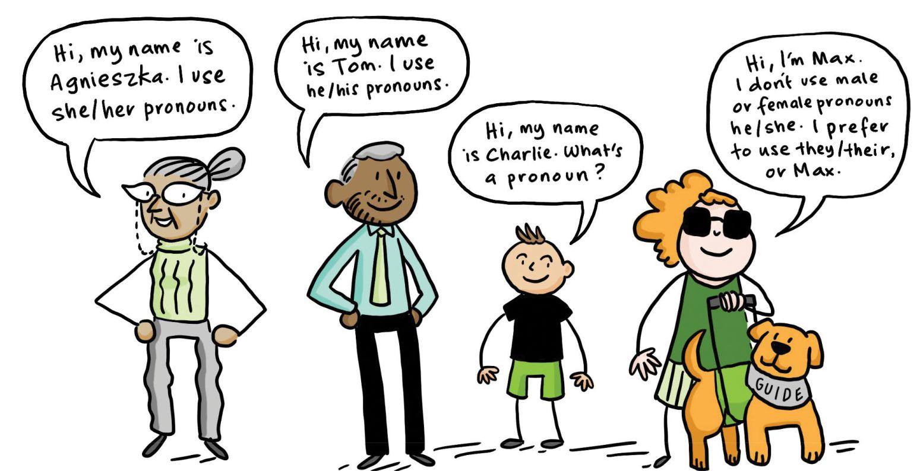

Older people

Be aware of underlying ageist attitudes that may unintentionally marginalise people. Rather than using language such as: frail, with limited mobility or socially isolated, which focus on negative aspects, turn the language around to focus on how your service can support people to maintain or improve their mobility, build social connections or friends and focus on positive aspects of their lives.

26

Wellness and Reablement

The Commonwealth Home Support Program is underpinned by a ‘wellness approach’, which focuses on maximising a client’s independence. Being person centred or taking a wellness approach means putting the person at the centre of the care, recognising that people have their own individual needs, and responding accordingly. Use positive words, phrases or visuals that are enabling and promote wellness, independence and connection to others. Use words or phrases that motivate people to think about ‘what is possible’. e.g. ‘the support we offer builds on what you can do or want to do’.

People’s values are respected

Understanding peoples values, means getting to know people, their hopes, preferences, priorities and aspirations. It demonstrates that we are interested in who they are and how they wish to live their life e.g. ‘We will work with you and take into account what is important to you’.

Use words that are affirming: ‘We listen; we value your life story and experiences’.

Building capacity

We all have strengths and capabilities even if we are not able to immediately recognise them. Service providers that use a strength-based approach operate with the premise that people have the ability to learn, grow and develop, regardless of their circumstances. Communication might describe how you help people to build their capacity to improve or retain the things that are important to them.

For example:

‘We help you to develop the confidence and skills to do the things you want’

‘We help you do things that you are able to do so you can remain independent’

‘We work with you to build on what you can do’ ‘We help people to live well’

Choice

Facilitating choice is a key principle of a person centred or strength based approach. This includes empowering people with information and strategies and taking into account a person’s right to make their own decisions. Communication might describe how you enable choice for clients, their scope of involvement and the degree to which choice is exercised.

For example:

‘We will keep you informed about things that affect your care’; ‘we will work with you to consider options that work for you’

Autonomy

Maintaining power, being in control of decisions or having the personal freedom to self-determine is innate in all of us. Communication should describe how service providers support a person’s independence, irrespective of how each person defines independence. Use language that empowers people.

For example:

‘We listen to you, you decide what’s important’ ‘You are at the centre of all decisions that affect your care’

‘We value your rights and understand that your independence is important’.

Planning

‘(Care) planning is the ongoing process through which staff and clients work together to collaboratively set goals, establish priorities and develop strategies to achieve positive and meaningful outcomes for clients’.36 Communication might describe how you support clients to develop a plan and the benefits of this approach. The idea of developing ‘goals’ may be daunting for some people, so think carefully about how you describe these.

For example:

‘We will work with you to make a plan about how we can work together to achieve the changes you want to make’ ‘We will work together to develop a plan that addresses what is important to you, your likes, needs and preferences’

Planning also includes the monitoring and review of plans.

For example:

‘We will maintain regular contact with you to understand whether the service is meeting your needs. We will work with you to adjust your plan as your circumstances, needs and priorities change’

- Pascale, K (2013). The Goal Directed Care Planning Toolkit: Practical strategies to support effective goal setting and care planning with HACC clients. Eastern Metropolitan Region (EMR) HACC Alliance

27

Working together

Use words, phrases and visuals that describe the extent to which people (including clients, family, friends or other service providers) are involved in the care process and how this partnership approach will shape the way services are planned and delivered.

For example:

‘We will work with you and the people important to you to deliver services that reflect your interests, needs and preferences’

‘We help you to stay in touch or reconnect with people, places or things you want or need to do’

If you work closely with other program areas or service providers, you might consider including this information in your communication to demonstrate your collaborative approach to care.

Flexible and responsive

Flexibility, responsiveness and adaptability are traits that most people value. Service providers may express their level of flexibility, responsiveness and adaptability in communication.

For example:

‘providing personalised responses’, ‘organising service around the person’, ‘focusing on the individual’, ‘providing unique support responses’, ‘tailoring to the individual’, ‘working with you in a way that best meets your needs’, ‘being responsive to changing needs, circumstances and preferences’
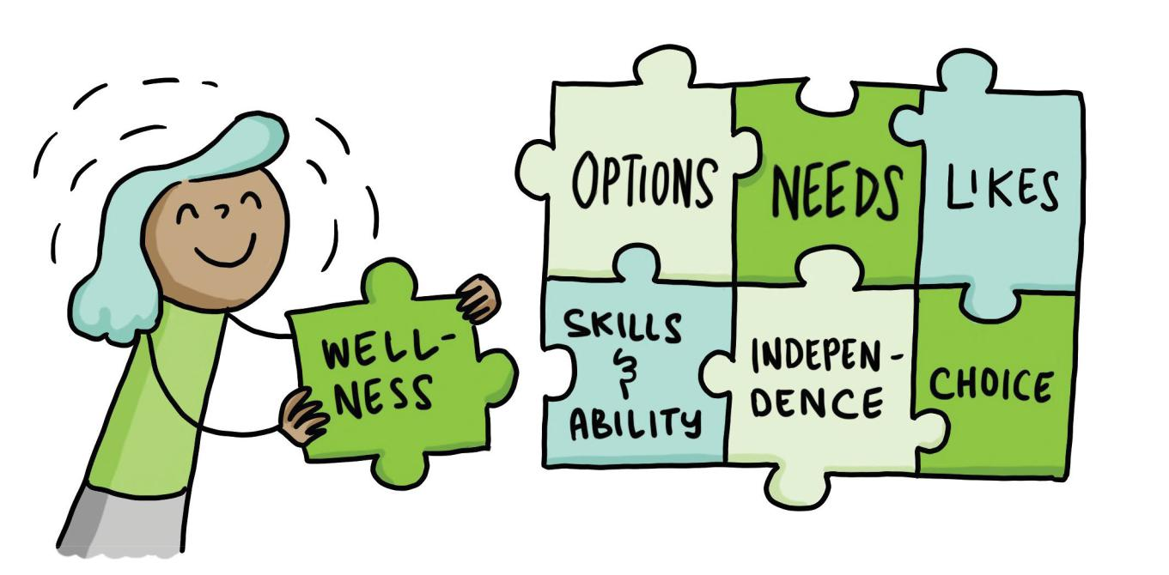

28

Section 4

Inclusive communication & language guide

About this section

This section contains the tools that you can use with your team and/or consumers when reviewing existing or developing new inclusive communication material. Working through the guide is a staged process. Allow the time and resources to do this and to action the improvements that you identify.

The guide contains:

- Diagram- ‘Staged approach to developing inclusive communication’

- Template

- Checklist

- Good practice examples including:

  - Phrase alternatives

  - EMR Alliance example

  - Website examples from service providers

29

Developing inclusive communication

Diagram 1 - A staged approach

Every interaction with current and prospective service users is different. Decisions about the communication approach, key messages and the depth of information to include in your communication requires you to consider three key elements: a) the purpose of the communication, b) the target audience and, c) how to maximise accessibility from a wellness and diversity perspective. The diagram below is a graphical representation of the template that follows.
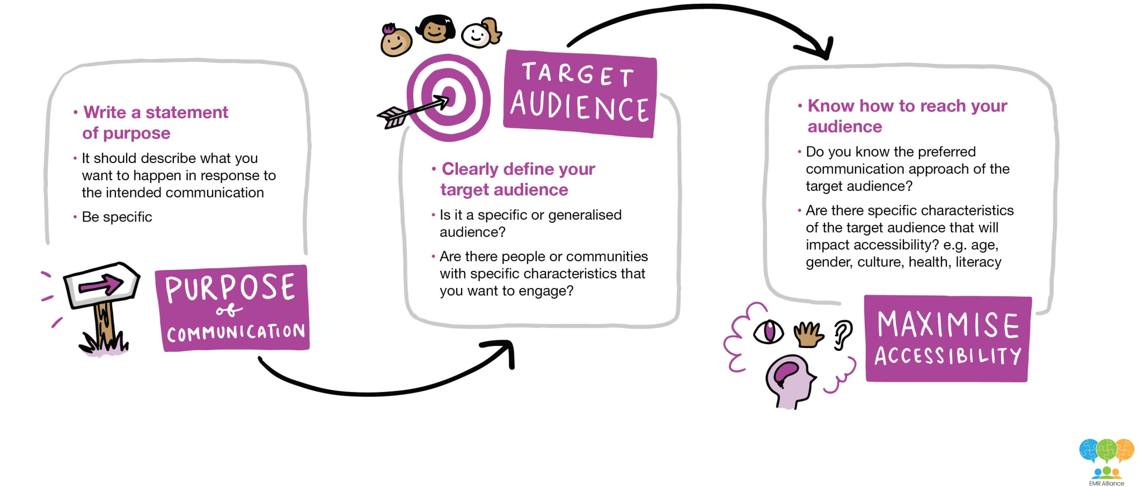

30

Template:
Developing inclusive communication

The following template is designed to assist you to develop/redevelop communication that incorporates inclusive messages based on an understanding of diversity. Work through the template to identify the 3 key elements: purpose of communication, target audience and maximising accessibility as discussed in diagram 1 (previous).

Brainstorm with your team, volunteers and/or consumers. Once you have completed this section you will be clear about what you want to communicate, why, who your target audience is and what platform/s you intend to use.

Steps | Actions and comments
Define the purpose of communication
Write a statement of purpose that describes what you want to happen in response to the intended communication (the
outcome). Be specific. e.g. We want to increase the number of people who attend the Friday social group by 10%
Clearly define your target audience
Who will be participating in your program? Do they have particular needs you should be aware of, or that your service
caters for?

Accessibility

Describe any specific characteristics of the target audience that will affect how they access your service information

Age | LGBTIQ | People with a disability | Socially isolated
Gender | Dementia | Homeless/at risk of homelessness | Other (please list)
Culture | Aboriginal & Torres Strait Island | Financial disadvantage
Describe any known preferred communication approaches of the target audience
Large print | Communication board
Braille | Other (please list)
Pictograms

Key messages

Identify the key messages you want to communicate

e.g. We offer you the opportunity to connect with others… Our priority is…. Having fun doing what you want…

Communication platform

Identify the communication platforms you intend to use

Newsletter | Poster | Newsprint | Instagram
Brochure | Online website | YouTube | Twitter
Information Booklet | Radio | Facebook | Other (please list)
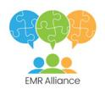

31

Inclusive communication and language checklist

How to use the checklist and supporting tools

Once you have completed the template, you can work through the checklist to identify areas of improvement. Remember, it is not necessary for every piece of communication to include all the elements of good practice detailed in the checklist below. Rather, each piece will include different elements depending on what you have identified as being a priority in the preceding template.

If you need more detailed information about a particular diversity group or area revisit section 1, 2 and 3 for more specific information. As you move forward think about the timelines, person/s responsible and relevant budget allocation to make this happen.

The checklist focuses on the following areas:

- Language and visuals

- Design and format

- Diversity, wellness & reablement

Checklist Process

Step 1:

Read each of the questions under the elements of good practice and decide if they apply to your communication material. Include any comments about changes needed and identify actions required

Step 2:

Review the results and discuss the required actions needed with your team

Step 3:

Develop and implement a plan to modify your communication material, you may want to involve consumers in this process. Revisit the phrase alternatives, EMR Alliance example and website examples to get ideas

Step 4:

Reassess your material using the checklist to ensure that everything is covered in your revised version
! Tip

Engage consumers,

clients, carers

and volunteers to

help you develop

your communication

material & test

for readability &

content
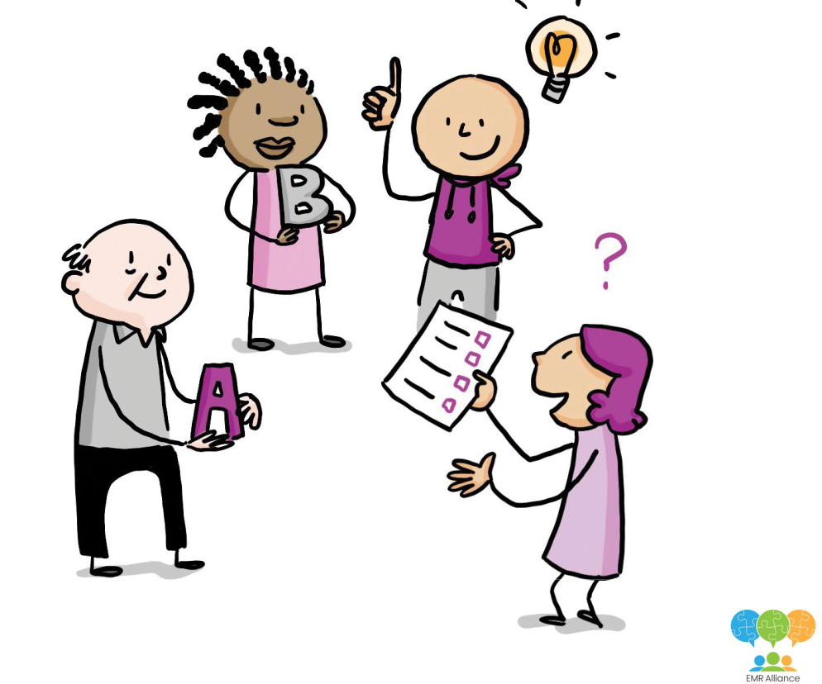

32

Inclusive communication and language checklist

Use the checklist to review your communication material (print or electronic) against the relevant elements of good practice.

The first two sections: ‘Language & Visuals’ and ‘Design & Format’ should always be considered when reviewing your communications material.

You will need to decide which elements within the Diversity, Wellness & Reablement section you wish to consider, depending on your target audience and the messages that you want to deliver.

Language & visuals

Elements of good practice (Indicate Yes, Sometimes or No) | Y | S | N | Comments and actions
Communication is documented in plain language
Are your key messages clear and direct? Do you avoid the use of acronyms, complex medical
terminology, and jargon (e.g. social isolation, person centred, ASM)?
Communication accurately describes your intended target audience
Is the intended target audience clearly identifiable? Are the program’s key eligibility requirements
identified and do these align with program funding requirements? Do you encourage people to
explore options based on their individual circumstances?
Using a motto or catch phrase
If you use a motto or catch phrase does it reflect your organisation’s values, principles, mission or
quality statement?
Service or activity is clearly described
Do you clearly name and describe the benefits of the service or activity you are offering? e.g. social
outing group, occupational therapy – supporting you to live independently at home
Using flags and symbols
Do you display symbols and written acknowledgements to demonstrate your commitment to
providing a safe and inclusive environment? If you are using the Aboriginal, Torres Strait Island,
Rainbow, Transgender flags or the interpreter symbol are they accompanied by supporting text? Do
staff understand why these are used and does staff practice align with the messages you are trying
to communicate?
Images reflect and empower our community
Do images reflect the diversity of your consumers, service and the community in general? Are the
images empowering and positive? e.g. ‘doing with, not for’ or people actively involved in activities

33

Inclusive communication and language checklist

Design & format

Elements of good practice (Indicate Yes, Sometimes or No) | Y | S | N | Comments and actions
Font is easy to read
Does the communication use a plain font that is easy to read? e.g. arial, calibri.
Do you use colours that enhance the communication and is easy to read? e.g. dark print
Communication layout maximises readability
Do the colours and format of your communication maximise readability? e.g. Have you
used white space, columns or images to break up text or draw the reader to the key
messages?
The communication platform is representative of the way the target audience
access information
Have you chosen a communication platform that is accessible and appropriate for your
target audience? e.g. newsletters, media (radio or newsprint).
Have you explored the use of alternative communication aids? e.g. communication
boards, large print, braille, pictograms?

34

Inclusive communication and language checklist
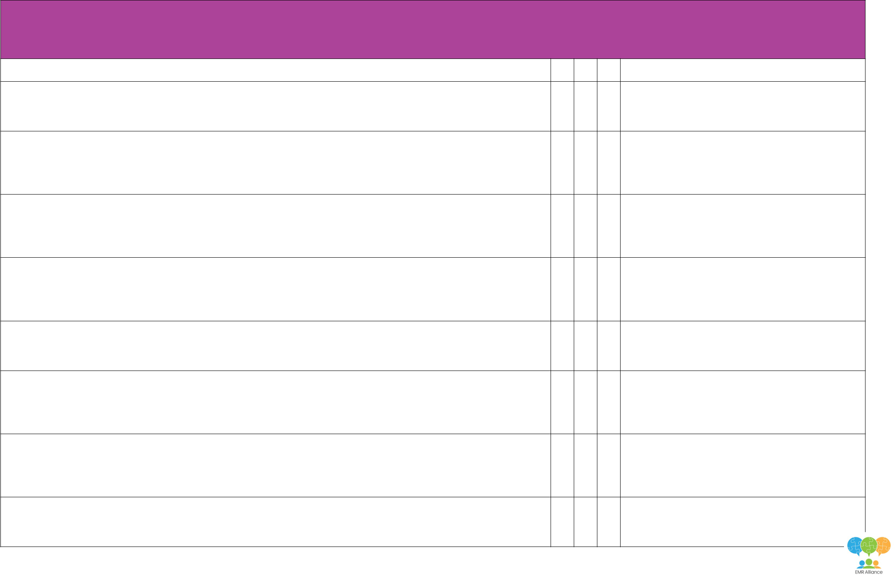

Diversity, wellness and reablement

The following questions relate to the information in section 3. These are a guide to inclusive communication. You will need to decide which elements within the Diversity, Wellness & Reablement section you wish to consider, depending on your target audience and the messages that you want to deliver.

Elements of good practice (Indicate Yes, Sometimes or No) | Y S N Comments and actions

People living with Dementia

Does your communication explain dementia in a way that is sensitive to people’s understanding of dementia including cultural considerations? Do you use empowering language?

Aboriginal and Torres Strait Islander peoples

Does your communication describe how you connect with, and/or are committed to supporting local Aboriginal clients/communities? Do you acknowledge Aboriginal and Torres Strait Islanders as the traditional owners of the land? Are you using correct terminology when talking about Aboriginal and Torres Strait Islander peoples?

People from CALD communities

Is your communication culturally appropriate and appealing for the targeted audience taking into account specific language, ethnic or cultural group/s? Does your promotion demonstrate your commitment to, or experience in working with CALD communities?

People who identify as LGBTIQ

Does your communication specifically address LGBTIQ people in a positive way and describe how your service is committed to being welcoming and safe? Do you promote a positive connection with LGBTIQ communities through cases studies or quotes? Do you use images, symbols or flags to promote a welcoming environment?

People with a disability

Do you use empowering, inclusive language and terminology that focuses on the strengths and capabilities of people with disabilities? Do you focus on ability rather than disability?

People experiencing financial and social disadvantage

Have you clearly communicated the costs of your services and any financial support or waivers for people who cannot afford the services? Have you communicated the fee structures and support available to all staff? Does your communication explain how people can form social connections?

People of all gender identities

Does your communication material positively represent men, women, transgender and gender diverse people?

Is your language gender neutral and free of stereotypes? Does it consider their preferences, needs and support?

Have you clearly communicated the rationale for any gender specific services?

Older people

Do you use words and images that reflect positive ageing? Do words and images promote independence or ‘doing with’ and not ‘doing for’?

35

Inclusive communication and language checklist

Wellness & reablement

Elements of good practice (Indicate Yes, Sometimes or No) | Y | S | N | Comments and actions
Promoting Wellness & Reablement
Does your communication use positive words, phrases or visuals that are enabling and promote wellness,
independence and connection to others?
Respecting peoples values
Do you include affirming language to demonstrate that you are interested in who people are and how they wish
to live their life? e.g. we listen; we value people’s life stories and experiences
Building capacity
Does the communication describe how you help people to build their capacity to improve or retain the things
that are important to them?
e.g. We will support you to get back to the things you enjoy doing
Enabling Choice
Does your communication describe how you enable choice for people, their scope of involvement and the
degree to which they can exercise choice?
e.g. We will work with you in a way that best meets your needs
Supporting autonomy
Does your communication describe how you support a person’s independence, irrespective of how each person
defines independence? Do you use language that empowers people, such as ‘we listen to you, you decide
what’s important’
Planning
Does your communication describe how you support clients to develop a plan and the benefits of this approach?
Working together
Do words, phrases and visuals describe the extent to which people (including clients, family, friends or other
service providers) are involved in the care process and how this partnership approach will shape the way
services are planned and delivered?
Being flexible and responsive
Does the communication convey flexibility, responsiveness and adaptability when supporting clients?
e.g. ‘providing unique support responses’

36

Phrase alternatives

Choosing the right language can be challenging when you are developing or modifying communication material.

The following strengths based phrase alternatives have been suggested as some good practice examples to consider when developing your communication material.

Instead of: | Use these strengths based alternatives
Our program helps frail, elderly people… | We can support you as you age….
 | Our program supports people over 65 years….
Our program reduces social isolation… | When you join …… you will meet people, make new friends and do the
 | things you enjoy
 | We want you to feel at home and connected…
Our PAG offers a range of programs and | We can support you to find an interest group that provides contact and
activities that can increase your socialisation | friendship within your community
and reduce isolation… | Our program offers you the choice to select the activities you want to do,
 | on your own or with other people in a relaxed and welcoming place …
We will take care of your loved one and make | We provide a welcoming, safe and supportive environment
sure they are safe….
The program offers mental stimulation… | We offer a broad range of programs and there are many new learning
 | opportunities
We seek to offer mental stimulation, enhanced | We can assist you to relax and choose the activities you enjoy in a
physical activity and reduce stress… | friendly environment
The program keeps your brain active and | We support you to engage with activities that are important and mean
provides mental stimulation… | something to you
The program will improve your balance and | We will support you to feel better, be active and get you back to doing
maintain your mobility… | the things you enjoy…
The program provides a 3 course cooked | We will support you to eat well and enjoy the company of family &
nutritious meal… | friends
Our staff can help you to go shopping and | We can support you to eat well, by assisting you with shopping, working
cook meals… | with you to prepare meals or providing you with a range of meal options…
We have culturally appropriate meals… | We offer a range of meal options to meet your religious or cultural needs…
We provide respite…. | Respite allows you to focus on your own wellbeing so you can provide
 | continued support to your loved one (primary carer focused)
 | We can support you and your partner to have some time out…
 | We will support you to get back to doing more things for yourself…
 | (primary carer focused)
Our program is for those suffering from | We support people who are living with dementia/living with health
dementia, MS, mental health issues… | conditions…
Our program helps isolated, frail elderly people | We can support you if you are living with dementia and want to enjoy
suffering from dementia connect with others | activities and spend time with others…
We offer podiatry, dietetics, physiotherapy and | We have podiatrist to help you look after your feet; dieticians to help
occupational therapy services… | you make food choices that are right for you; physiotherapists that
 | can support you to get back to doing the activities you enjoy and
 | occupational therapists who can support you to live independently at
 | home and in the community…

37

EMR Alliance annotated example

This example has been provided as an opportunity for you to consider the language, imagery and content used.

The analysis reflects areas that have been identified as requiring modification to reflect good practice.

1. Having a picture of |  | 2. Words such as frail, |  | 3. Avoid using ‘sector jargon’
someone being fed is |  | isolated, suffering from |  | such as person centred
an example of doing for, |  | create negative thoughts |  | and autonomy. Explain
not doing with. It is not |  | and images and people do |  | how you offer choice in
empowering and focuses |  | not want to be described |  | your program in way that
on the client’s limitations |  | in this way |  | is meaningful
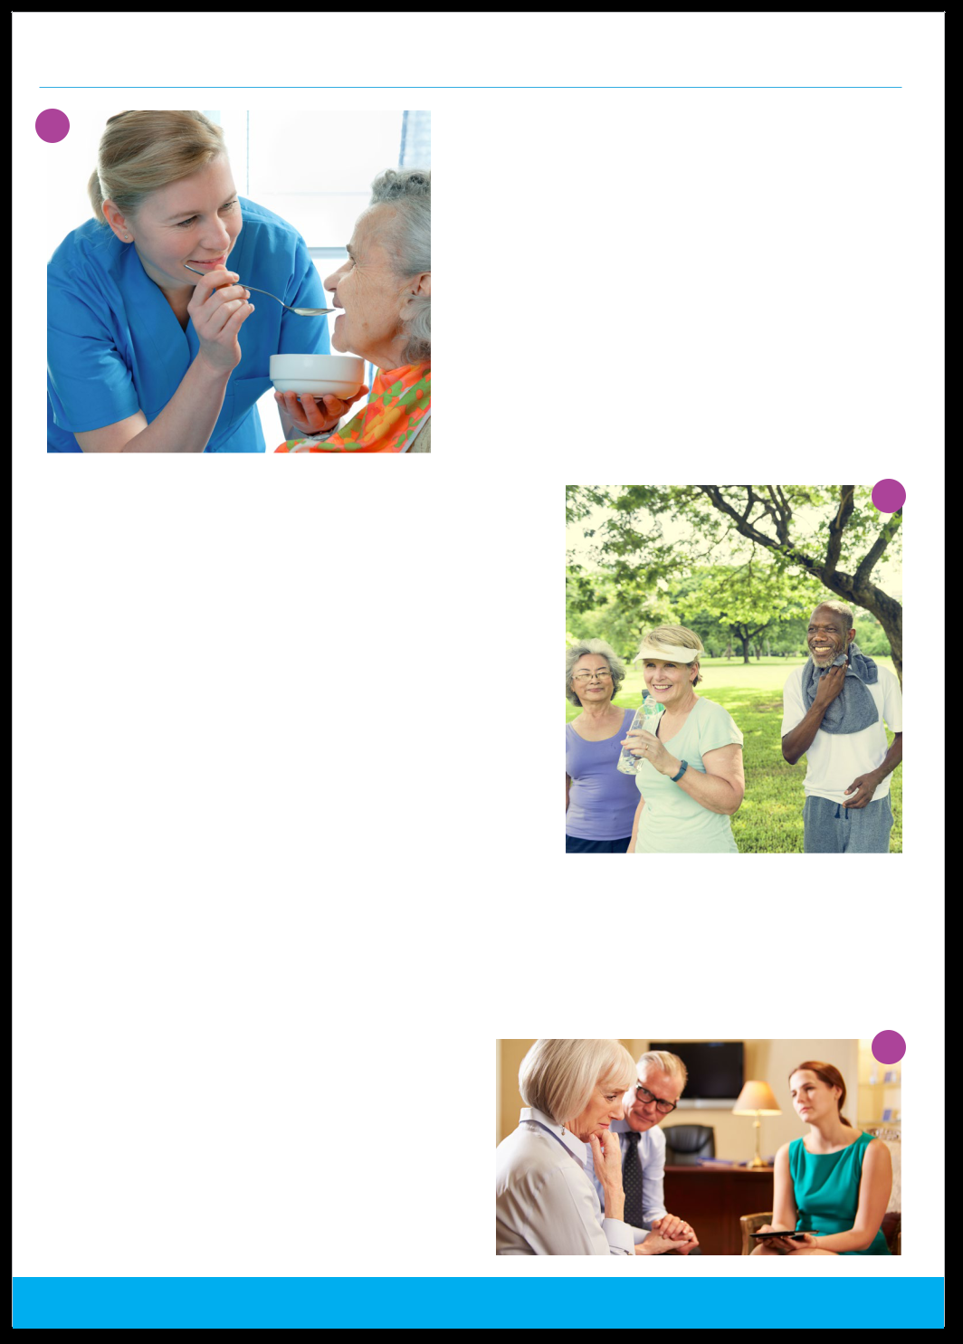

Golden Breeze Support Services

1 | About Us
 | Golden Breeze offers support services for people
 | experiencing dementia.
 | We support the frail and elderly living in the Eastern
 | suburbs of Melbourne suburbs to participate in
 | meaningful activities and achieve their goals.² We
 | operate in a person centred way that supports
 | autonomy, choice and independence.³ Our services
 | are open to all and our trained staff are friendly,
 | supportive and offer the best care for you or a
 | loved one.
Our Program | 4

Golden Breeze helps isolated people suffering from dementia² connect with others. We seek to offer mental stimulation, enhanced physical activity and reduced stress. Our staff are all trained to a minimum Cert III in Aged Care.⁵ They are committed to offering support and appropriate services to the client, ensuring that they are provided with the opportunity to engage in meaningful activities. We understand the amazing role carers play and offer advice, support and some rest when it is required.⁶ We aim to cater for all communities, religions and needs. Our bilingual staff help people who don’t speak English feel included and get the most out of their visit.⁷

We provide a safe environment that allows clients to walk around if they feel the need. Our building is designed to let people walk freely and securely ensuring they don’t end up frustrated by “dead ends.”

If you would like to find out more about our programs or speak with a member of the team, please call for a chat.
9
Sessions

Our PAG’s⁸ operate at 73 Turnmills Street, Monash on the following days:

Monday 9:00am – 2:00pm

Tuesday 10:00am – 3:00pm

Friday 10:30am – 2:30pm

Phone: 9857 9874 | Email: info@goldenbreeze.com.au | Website: www.goldenbreeze.com.au

- In the right context this is a positive image with people who appear happy in a community setting. If these were clients of Golden Breeze it would be good to note that under the photo to help it look authentic and not tokenistic. The text in the document could also positively mention the group is multicultural and welcomes people from all cultures

- It is expected you have trained and qualified staff, don’t include that they are Cert III qualified etc. However, if there is something unique or special about their skills or experience, promote it

- People may not respond

well to the way ‘rest’ is used. Focus on the positive things the client will get from attending rather than making the point that the role of care is/can be a burden

- Present your bi-lingual staff as an asset without referring to non-English speaking clients as a problem or deficit. It is recommended you highlight what languages staff speak

- Describe what your program offers and be clear about your unique selling points. ‘PAG’ or ‘Social Support’ are sector jargon/words and may sound restrictive and prescribed

- The clients look worried and concerned. It is not a photo that would encourage people to visit Golden Breeze. When you review your text think about what images would represent what you have written, if they are negative then rewrite it

38
weBsite exAmPles

Engaging, inspiring

motto, using positive,

active language

The following examples have been provided by EMR providers to showcase aspects of good practice including the use of plain language, inclusive empowering language, mottos and vision statements, analogies and imagery. These examples were current at the time of publishing.
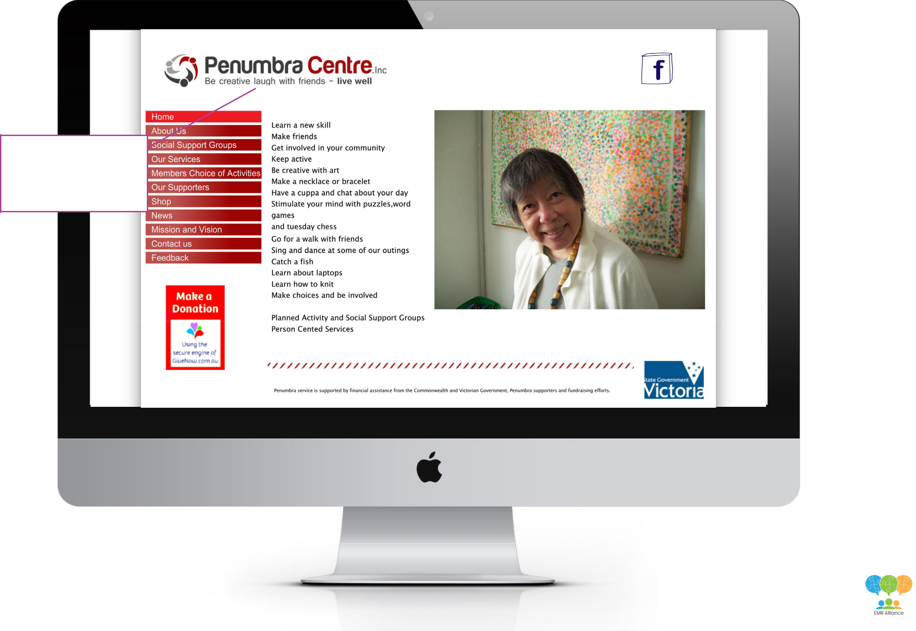

39

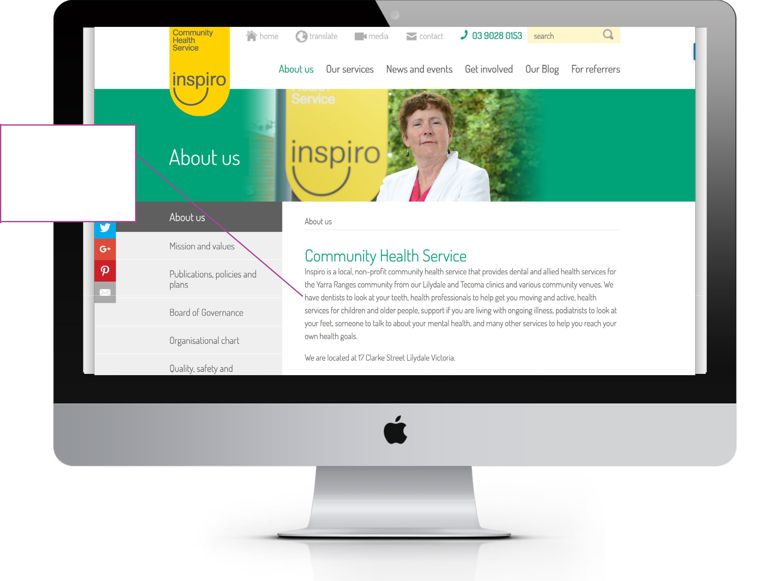

Inspiro has used easy

to understand language

to describe what clients

can expect to receive

from their allied health

services
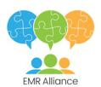

40

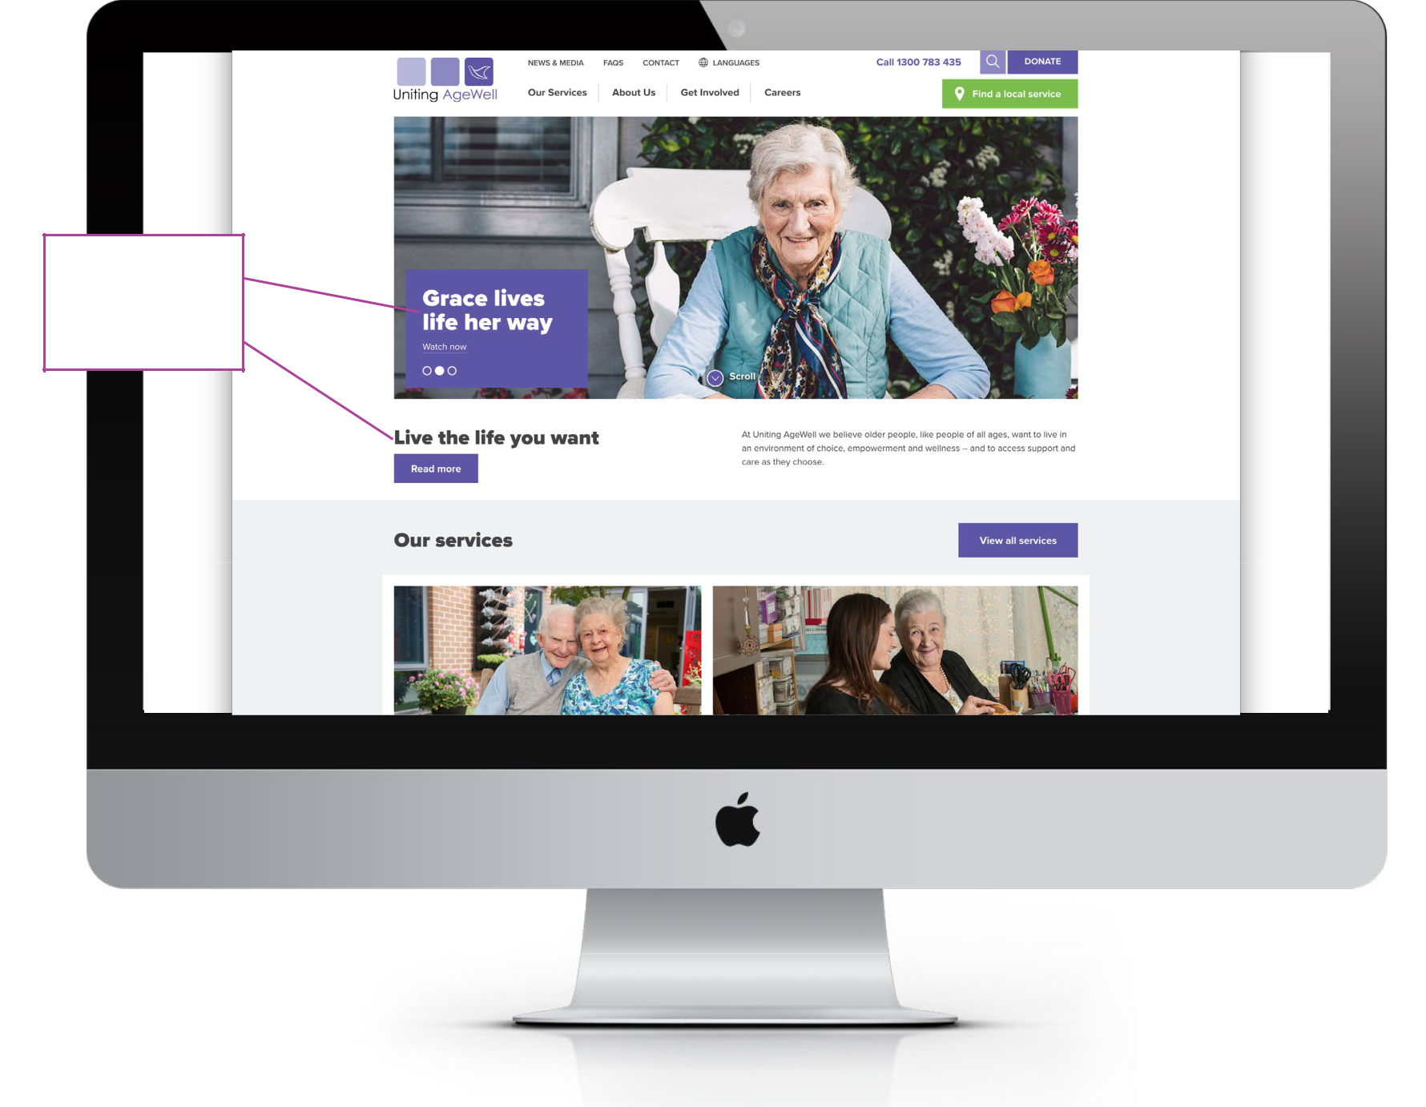

Direct, client and

outcomes focused

statements

41

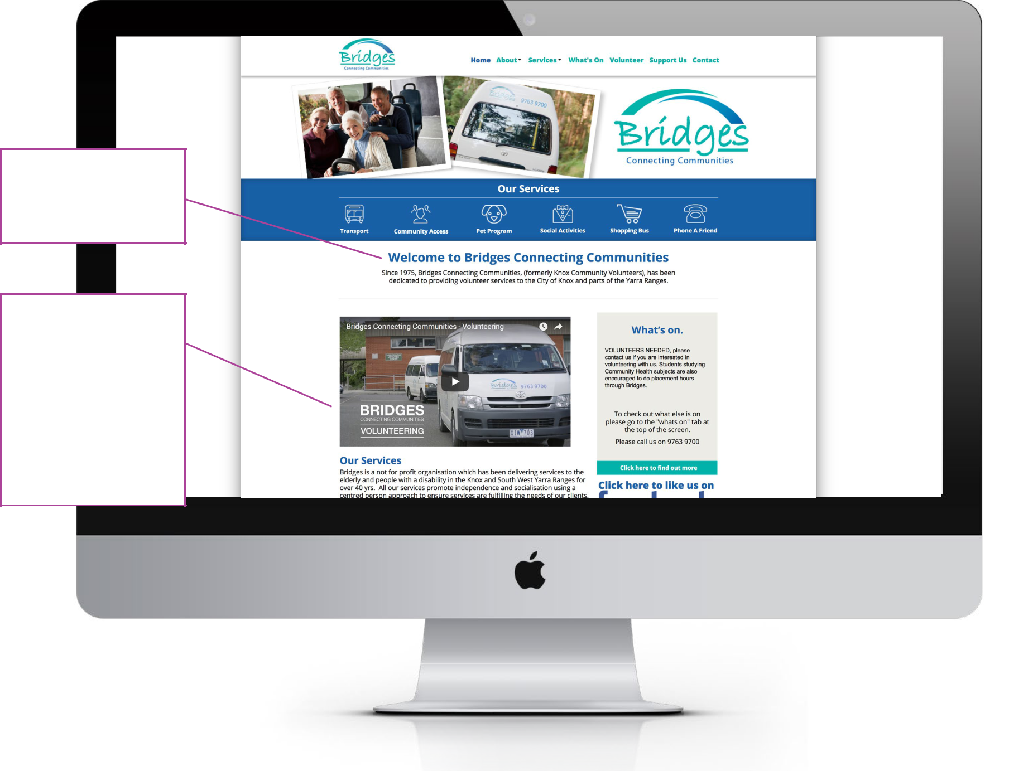

‘Bridges Connecting Communities’ speaks to belonging and linking to the community

The video, (click on the image to view) depicts the client centred organisational values and principles. The staff comments, volunteer testimonials, their actions and the images used

in the video, further reinforce this to reflect an inclusive environment

42

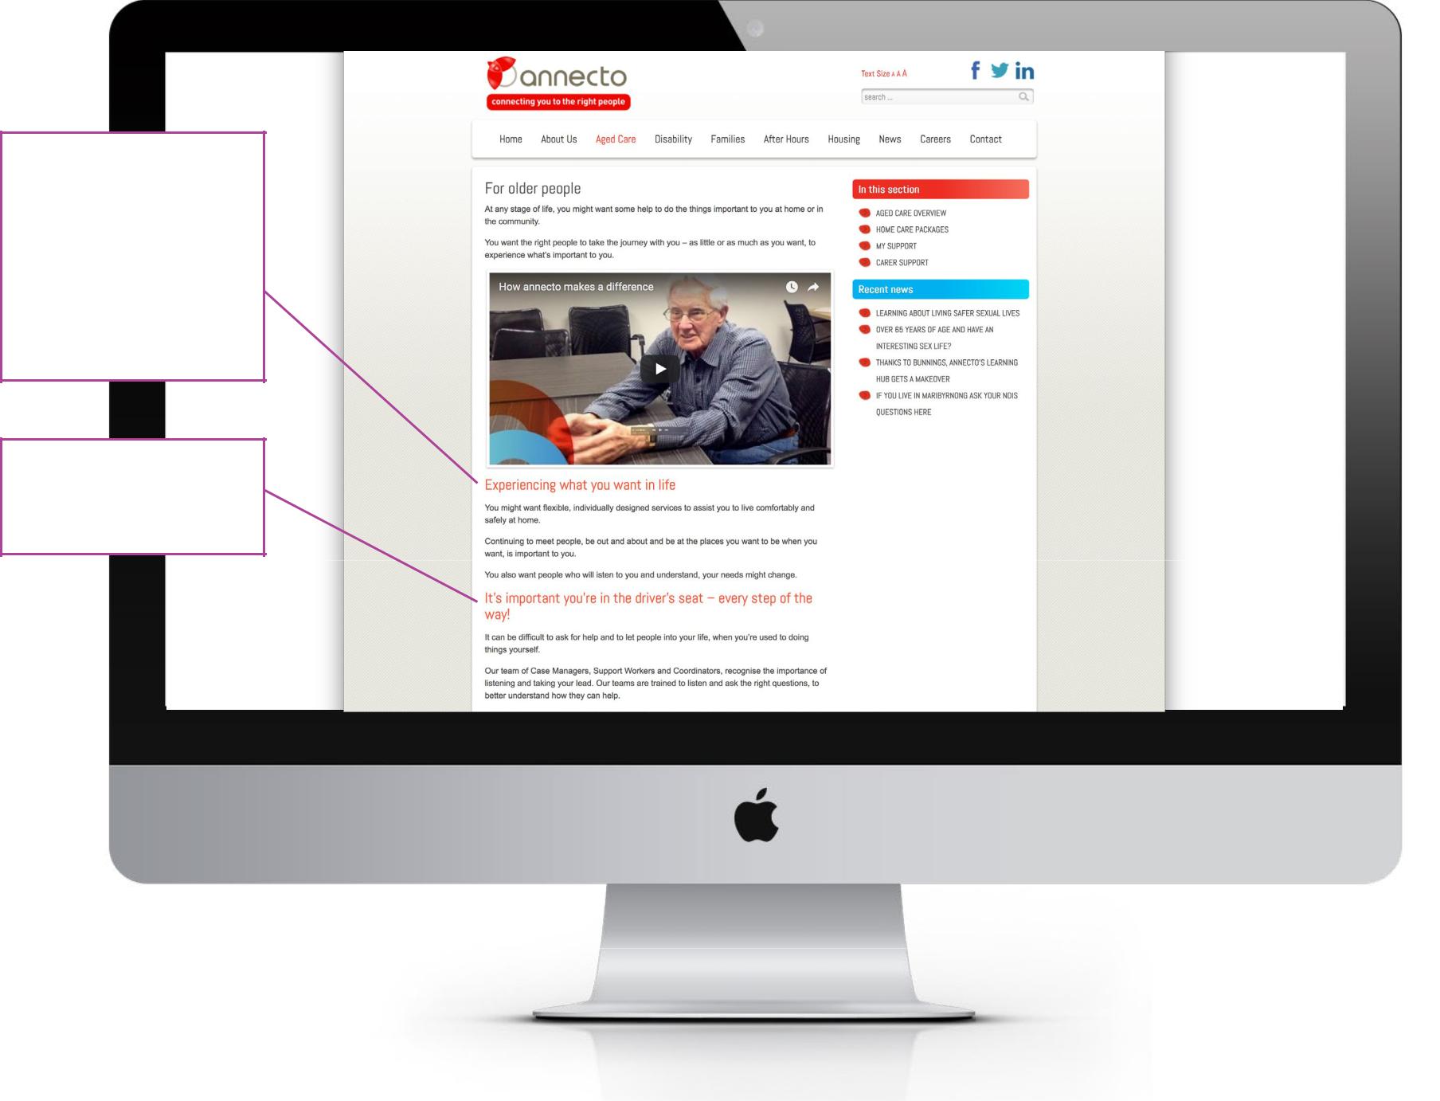

The use of key phrases that are person centred and empowering build positive client expectations. The statements beneath further reinforce this, using plain language.

Great analogy that speaks directly to consumers

43

The imagery speaks to nurturing, growing and making connections and friends

The Vision statement is clear and direct and says
exactly what they do. This is further supported by the selection of images above

Classes have been described using friendly and relatable language
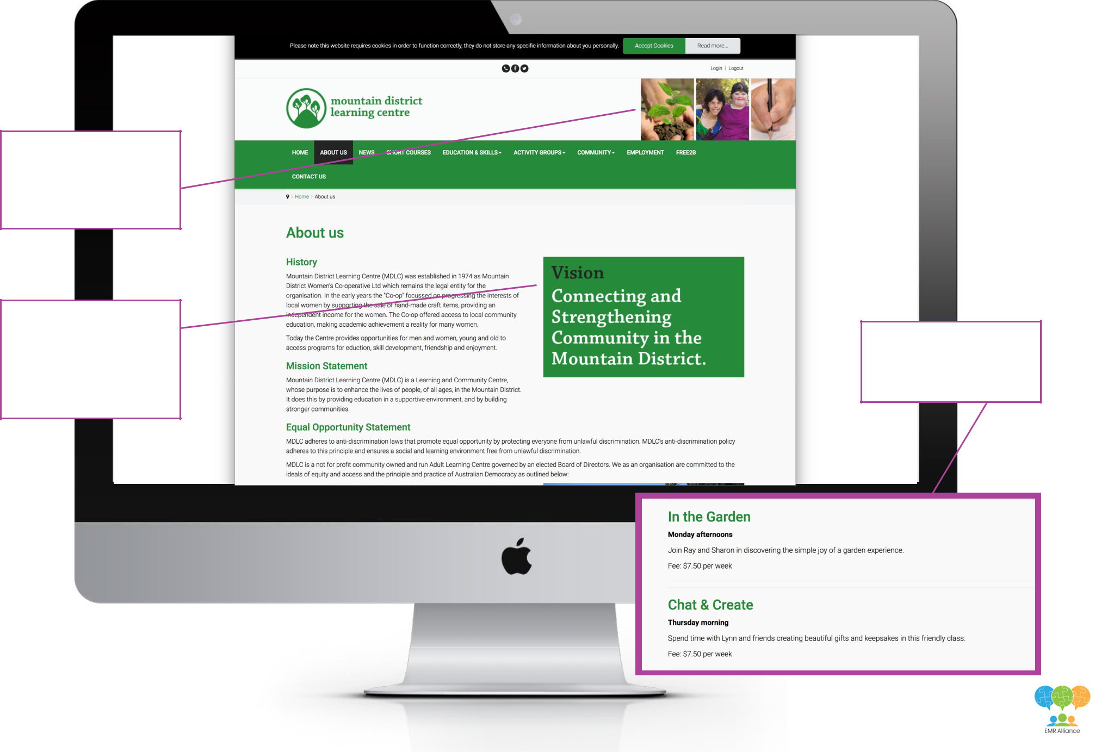

44

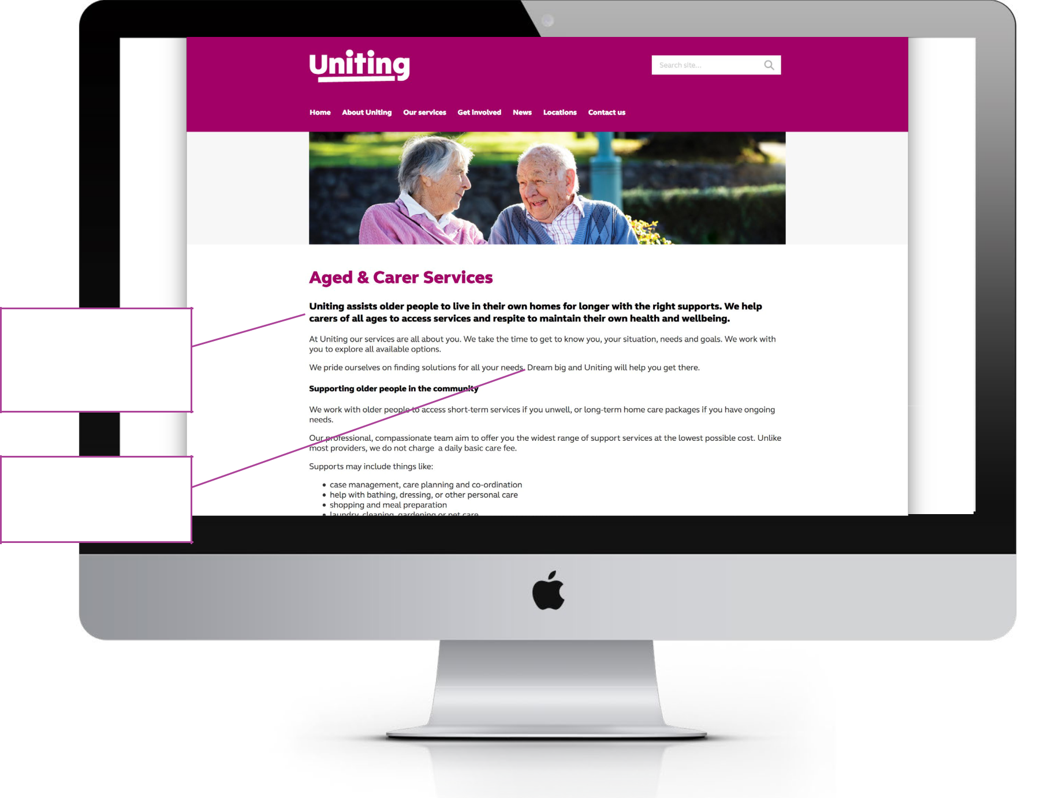

Clear sentences, that

send affirming messages

as to how Uniting will

work with consumers

Empowering sentence,

that creates engagement

with the consumer

45

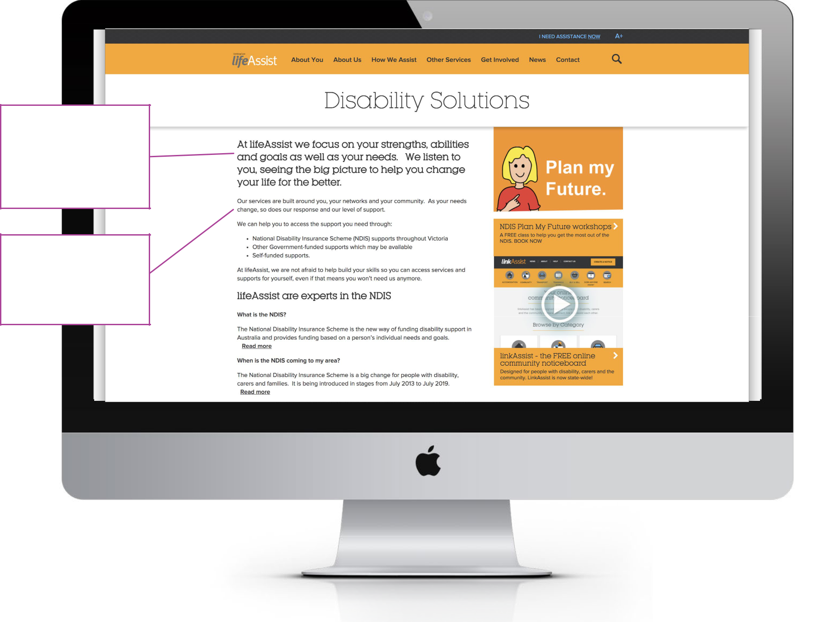

This opening paragraph

describes a person

centred approach, using

simple words. It sets

up for a positive client

experience

Using the first person

makes the reader feel

included. It indicates

a commitment to an

inclusive service

Note: Uniting Care Life Assist is now part of a single
organisation Uniting (Victoria and Tasmania)

46

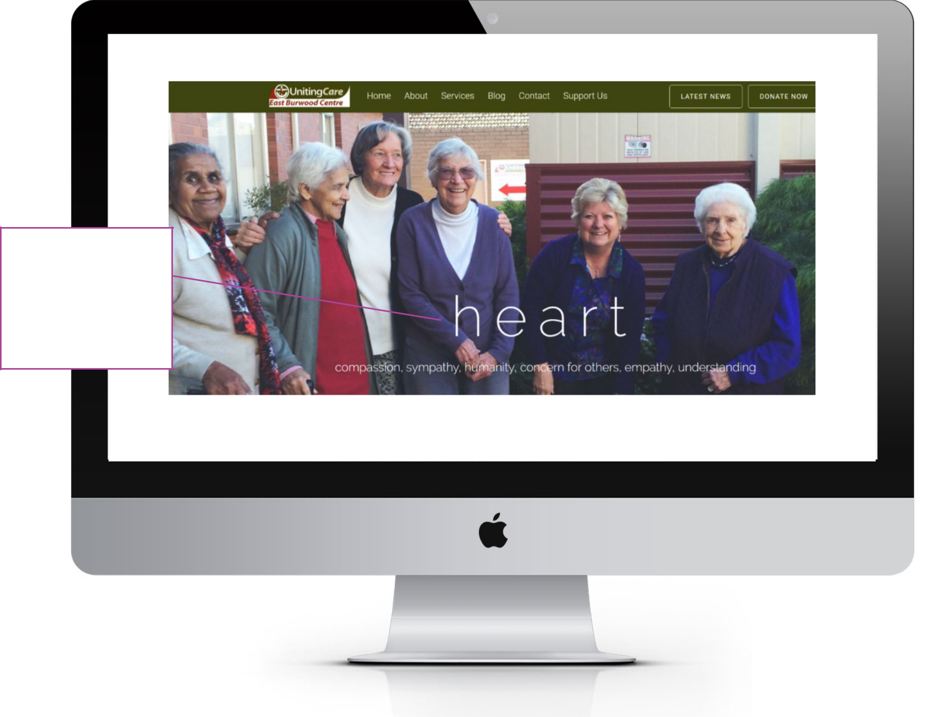

The use of the word ‘heart’ talks to the words beneath which reflect the organisational values. The image further supports this and reflects a diverse community

47
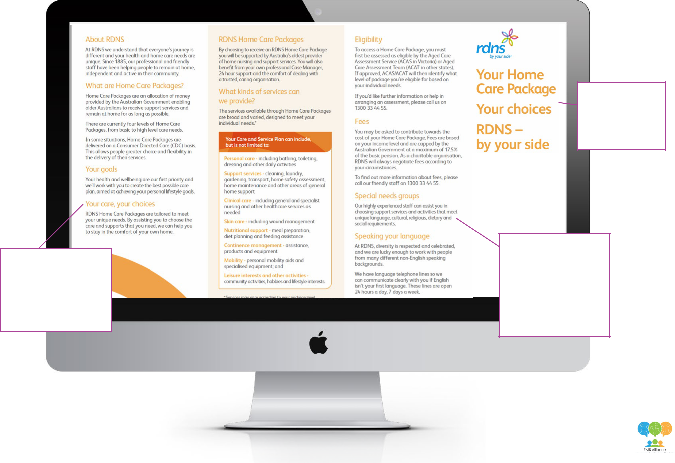

Inclusive person

centred language has

been used with simple

headers. Information

has been separated into

manageable sections.

Note: Brochure is from RDNS now known as Bolton Clarke
(formerly RSL Care & RDNS) and is no longer available online

The choice of words talks to empowering and connecting with the consumer

In this paragraph and the one below we clearly understand that the organisation is inclusive of diverse needs and there are mechanisms in place to support clients to engage with the service

48

