Embedding a strengths based approach in client conversations

Version 2 (June 2019)

Introduction

Australia’s aged care sector has undergone major reforms to enable older people across Australia to access more responsive, integrated and person centred services. The introduction of the Commonwealth Home Support Programme (CHSP) is a key part of these reforms, delivering a broad range of services that support older people to “remain living at home and in their communities” (DSS 2015). The CHSP is underpinned by a wellness approach which seeks to “promote each client’s opportunity to maximise their capacity and quality of life” by delivering services that:

- are client centred and tailored to the unique circumstances and cultural preferences of each client, their family and carers

- are flexible, responsive and build on the strengths, capacity and goals of individuals

- focus on retaining or regaining each client’s functional and psychosocial independence

- optimise consumers choice and encourage clients and carers to be actively involved in addressing their goals.

(DSS 2015, DH 2018)

Focussing on individual strengths and resources, recognising people’s autonomy and empowering people to make choices and design solutions that are right for them are all important parts of person centred care. Adopting this strengths based approach enables staff to deliver a wellness approach (DH 2017, DSS 2015) by helping you to:

- understand each client’s situation, priorities and needs in context

- identify meaningful goals

- create a care plan that is relevant and useful.

- make sure the plan reflects what is important to the client, their values and priorities.

What is a strengths based approach?

A strengths based approach is a way of working, rather than a set of rules or tools. It is informed by a range of models and perspectives from a number of disciplines and practice settings (e.g. asset based and solutions focussed interventions, recovery models and positive psychology). Strengths based approaches are driven by a set of key principles that include:

- Every person is unique and has the potential for change

- People’s expertise in their own life and their autonomy should be recognised and encouraged

- Collaboration between clients, carers and staff creates opportunities for success

- Staff’s role is to develop client’s resources, empower people and build their capacity to maximise their potential

- When provided with the relevant information and support, people can make meaningful choices about their health and health care.

(Hirst et al 2011, Chapin & Cox 2001, Rapp et al 2006)

“A strengths-based approach to care, support and inclusion says let’s look first at what people can do with their skills and their resources and what can the people around them do in their relationships and their communities. People need to be seen as more than just their care needs – they need to be experts and in charge of their own lives. “

Alex Fox, chief executive of the charity Shared Lives

Kate Pascale and Associates

Supporting Proactive and Informed Change

http://kpassoc.com.au

What’s different about a strengths based approach?

The following table includes a summary of some of the key differences between a traditional, deficits

(or problems) based approach and a strengths based approach. This list is not exhaustive, but highlights some of the important features of each approach, both from a theoretical and practical perspective.

Deficits / problem based approach Strengths based approach

Roles • Conversation is led by the

staff member

- Staff are the experts and use their professional judgement / expertise to determine the best approach

- Clients can become passive recipients of care / services

Focus • Problem oriented

• Focus on risks, problems,

challenges, issues and barriers

• Emphasis on diagnosis, symptoms

& staff’s perception of needs (can

limit options for potential solutions)

(biomedical model)

• Focus on outputs

Key • What’s wrong?

Questions • What’s the problem?

• What’s not working?

• What’s missing?

• What does the client need?

Language • Utilises professional language

(e.g. jargon)

Purpose • Intervention seeks to reduce the

negative factors

• Plan seeks to mitigate risks and

address problems by putting in

place services, supports, clinical

intervention etc.

  - Collaboration between staff and client / carer

  - Client is the expert and drives the decision making process

  - Staff’s role is to empower each client to identify solutions that are right for them, make informed choices and work collaboratively with staff

- Goal oriented

- Focus on understanding challenges and experiences in context of the person’s unique capabilities, strengths, resources and resilience (biopsychosocial model)

- Avoids stereotypes and assumptions

- Focus on outcomes

- What’s happening now? / Where are we now?

- What’s working and not working?

- What strengths, resources, knowledge and skills does the client have?
- How can we build on existing strengths to move forward?

- Utilises client language to make it meaningful and personalised

- Intervention seeks to build on, promote and enable positive action and client choice
- Emphasis on seeking opportunities to promote wellbeing and positive outcomes

- Plan seeks to build on client’s strengths, motivations and hope to work towards what the client wants to achieve

(Epstein 2008, Graybeal 2001, Hammond 2010, Rapp, Saleebey & Sullivan 2008, Orsulic-Jeras et. al 2003, Minimol 2016)

2

What are the benefits of adopting a strengths based approach?

Research suggests that client factors contribute

to the likelihood of a successful outcome, just as

much, if not more, than either the practitioner,

therapeutic rapport or the intervention (Hook

and Andres 2005, Pattoni 2012). Therefore, when

we work with clients, it’s essential that we think

about how to support our clients to engage and

participate effectively.

There is a strong body of evidence that describes how a strengths based approach can enhance the effectiveness of service delivery.

Some of the key advantages of a strengths based approach include that it can:

- Build self esteem, self efficacy and reinforce a positive sense of self worth and competence

- Empower clients and carers to take ownership and responsibility

- Enhance wellbeing and quality of life (particularly through the development of hope)

- Promote client autonomy and empower clients to be actively involved in making decisions about how to move forward

- Engage people in identifying and implementing resources and strategies that can support them to achieve their goals (therefore assisting your planning)

- Enhance motivation and likelihood that the client will make positive behaviour change

- Improve social networks and community empowerment

- Reduce the power differential between the staff member and the client

- Facilitate strengths based, person centred documentation

(Graybeal 2001, Murphy & Dillon 2011, Boehm & Staples 2004, Shapiro 1996, Smock et. al 2008, McLean 2011, Pattoni 2012, Mondoloch et. al. 2001, Scerra 2011, Gatchel et. al 2007, Schlegel et. al. 2011, Minimol 2016, Jansen et. al 2011)

“If we ask people to look for deficits, they will usually find them, and their view of the situation will be colored by this. If we ask people to look for successes, they will usually find them, and their view of the situation will be colored by this.“

(Kral 1989 p. 32)
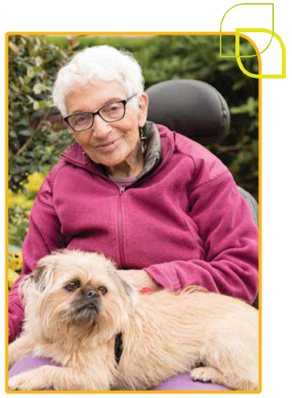

3

How can we implement a strengths based approach?

A strengths based approach can be embedded informally throughout all your conversations with clients and carers (Peacock et. al 2010). This is not just relevant to your assessment, but should inform how you work with each client throughout their initial engagement, assessment, planning, service delivery, transition and discharge planning.
“A strengths based approach, focusses on what works and how to generate more of it, rather than focussing on the deficits and problems.“

(Miller & Russell 2012 pg. 5)

Adopting a strengths based approach does not mean ignoring the client’s needs, challenges or barriers to achieving their goals. Instead, it seeks to view those things in the context of the person’s life and experience. You consider both the strengths and challenges, resources and barriers, needs, priorities and motivators to understand what is happening now. Together, that information will allow you to identify opportunities to build

on those strengths and determine how you will work together to support the person achieve their goals (Minimol 2016). This more holistic and balanced approach celebrates the differences in people, frames diversity as a strength and allows you to work with each person in a respectful and meaningful way.

“Focussing on strengths doesn’t mean ignoring challenges, or spinning struggles into strengths.“

(Pattoni 2012 p2).

Asking the right questions is an important part of a strengths based approach, but staff should also reflect on their approach more broadly. A strengths based approach is also reinforced through body language, active listening and the way you engage clients and carers in the conversation. Some key elements of a strengths based conversation are outlined below.

Actively explore each client’s strengths

When considering someone’s strengths, remember that the client is not an island. There are a wide range of strengths and resources within individuals, families, groups, organisations and communities that a person can utilise to work towards their goals. Strengths can include:

- Personal attributes (e.g. personal qualities, physical, psychological, spiritual & cultural)

- Skills, abilities and talents

- Knowledge and experience

- Community connections (e.g. family, friends, community groups, services)

- Resources (financial, physical, aids and equipment)

- Environmental assets.

Examples of strengths based questions are included on page 6 & 7.

4

Acknowledge and validate client’s strengths and resources

Often, people’s strengths emerge as a natural part of the conversation. As this happens, actively acknowledge and validate those strengths.

Remember that many strengths lay in people’s diversity and differences.

For example: If someone identifies their faith as being important to them, you could ask them about what their faith brings into their life, or how their faith supports them through challenges. This could bring up a range of strengths and resources related to their resilience, community connections etc. It is also useful to discuss how the person’s faith may impact on the way you work together (e.g. preferred gender of workers, considerations when working in certain areas of the person’s home, dietary requirements etc).

Sometimes, when people are facing significant challenges or they’re in a time of crisis, it can be challenging for them to identify their strengths. In those circumstances, it is particularly important for staff to listen for strengths and explicitly acknowledge the person’s strengths and resources. For some clients, seeking support and attending an appointment is a huge step and should also be acknowledged as a strength.

For example: If you are working with someone who does not have access to secure housing. You could reinforce that the person has built such strong relationships that they’re able to spend time staying with friends and family. You could also reinforce their resourcefulness, resilience and ability to work through challenges etc. Regardless of whether you have a role in supporting the client to secure housing, it will also be important to discuss with the client how this will impact on the way you work together (e.g. where and when you see the client, transport, impact on client fees etc.).

Encourage the client to lead the conversation and decision making process

- Work on what’s most important and meaningful to the client (consider their values, motivations and readiness to change)

- Ask open ended questions so the client has the opportunity to tell their story

- Ask the client what they’d like to get out of your conversation / work together

- Encourage the client to share their ideas about possible solutions, opportunities etc.

- If you’re doing a home visit, actively acknowledge that you’re a guest in the person’s home.

Ask them where they’d like to sit and be guided by them. When a client visits your workplace, ask them where they’d be most comfortable sitting etc.

- Consider the cultural, religious or social groups that the client identifies with and think about how to create a safe and inclusive conversation with the person

- Utilise your skills of observation and pick up on cues in the home environment to build rapport, improve conversation flow and direct the conversation in meaningful ways.

5

Examples of strengths based questions
It’s important for service providers to remember that your work builds on the holistic screening and assessment that the client has undertaken with the My Aged Care Contact Centre and Assessment staff (including Regional Assessment Services and/or Aged Care Assessment Teams). You should always review the information that has already been collected to avoid the client having to re-tell their story. The way that you apply the following strategies within your work will therefore vary, depending on the context and focus of your conversation.
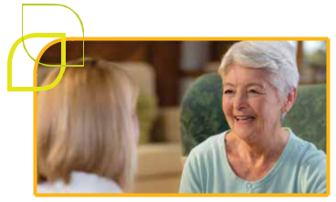

Outlined below are a list of questions that can be useful to explore a client’s strengths and resources. This list is not exhaustive, but it provides a range of examples that may be appropriate as a part of a strengths based conversation.

Some of these questions specifically explore client’s strengths, while other questions will help you to understand the person’s life experience, values, motivations, interests and preferences. The answers to these questions will support you to identify meaningful goals and create a care plan that is personalised, relevant, achievable and builds on the person’s strengths.

An assessment should not include all of these questions, nor should it avoid discussion of the challenges a client is experiencing. Staff should use their professional judgement to identify questions !that are relevant and appropriate for each client.

Exploring the current situation

- What are you doing / managing well?

- What are you currently doing independently?

- What are you feeling good about?

- What’s working well for you at the moment?

- What does a good day look like for you? What makes it a good day?

Skills, personal qualities / attributes, knowledge

- Tell me about something you are really proud of.

- What do you like about yourself?

- What do you think you do really well?

- What is something that your friends and family would say you’re great at?

- What would the people closest to you describe as your superpower?

Exploring interests, hobbies

- What do you enjoy?

- What are your interests?

- How do you like to spend your time?

Support network, community connections

- Who’s important to you?

- What connections do you have in your community? (e.g. family, friends, groups, services)

- What role do you play in the lives of the people you care about?

- Who supports you in your day to day life? In what way?

- Who can you count on?

6

Resources

(e.g. physical, financial)

- What resources do you have around you to make this easier?

- Do you have any equipment, aids or tools that are helpful for you?

- Is there anything in your environment that you do/can use?

Understand challenges in context

- Are there times when ‘the problem’ isn’t happening or ‘positive behaviour’ does happen? What happens on those days? What does that look like?

- How have you managed ‘the problem’ until now?

Exploring values

and motivation

- What’s important to you?

- What are the things in your life that you really value?

- What would you like to get out of our work together?

Exploring opportunities / strategies

- What’s worked for you in the past / what have you tried? (e.g. strategies / tools / resources / supports / skills)

- What strategies have you put in place?

- How have you adapted?

- What have you learned so far that could be helpful moving forward?

- How can we build on where you are now?

- What’s one thing that you could do to take a step in the right direction?
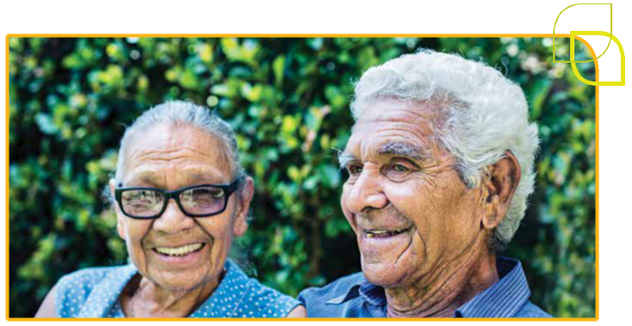

7

Resources

This information sheet has been developed as part of a suite of resources for CHSP service providers. Other resources in this suite include:

- Reducing duplication in service specific assessments

- Service specific goal setting and care planning***

- Monitoring and reviewing service specific care plans***

- This resource was an initiative of the North Metro and West Metro Wellness and Reablement Consultants.

The following resources contain useful information and ideas about how strengths based approaches can be applied in practice.
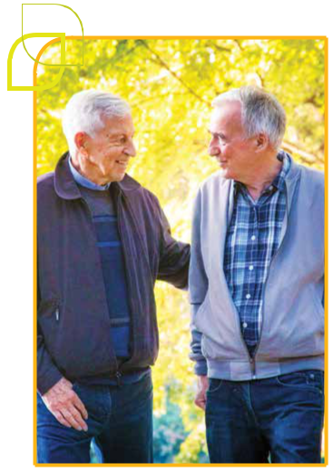

Reports / Articles

Pattoni, L (2012) Strengths-based approaches for working with individuals, Insights 16, May 2012. Glasgow: Institute for Research and Innovation in Social Services (IRISS). Available at: https://www. iriss.org.uk/sites/default/files/iriss-insight-16.pdf

SCIE (2015) Strengths-based approaches. London: Social Care Institute for Excellence (SCIE). Available at: https://www.scie.org.uk/care-act-2014/ assessment-and-eligibility/strengths-based-approach/

Toros, K. (2013) Solution-focused approach, Part 2: 2. Strengths-based Approach: Definition, History, Philosophy, Principles and Practice. Available at: https://sites.google.com/site/ solutionfocusedapproach/home

Harding, E. Wait, S. & Scrutton, J. (2015). The state of play in person-centred care. A pragmatic review of how person-centred care is defined, applied and measured. London: The Health Policy Partnership. Available at: http://www.healthpolicypartnership. com/wp-content/uploads/State-of-play-in-person-centred-care-full-report-Dec-11-2015.pdf

Hammond, W. (2010) Principles of Strength-Based Practice. Resiliency Initiatives. Available at: http:// www.ayscbc.org/Principles%20of%20Strength-2.pdf

Brooker, D. (2011) The Care Fit for VIPS toolkit, University of Worcester. Available at: https://www. worcester.ac.uk/about/academic-schools/school-of-allied-health-and-community/allied-health-research/ association-for-dementia-studies/ads-education-and-research/free-resources/care-fit-for-vips.aspx

Hirst, R.N., Lane, A.M. & Le Navenec, C. (2011). Strength-based Approaches for Mental Wellness in Seniors and Adults with Disabilities. Final Report Alberta Health Services – Addiction and Mental Health. Available at: https://www. albertahealthservices.ca/assets/info/res/mhr/if-res-mhr-strength-based-approach.pdf

8

Skills for Care (2014) Skills around the person. Implementing asset-based approaches in adult social care and end of life care. Leeds: Skills for Care. Available at: https://www.skillsforcare. org.uk/Document-library/NMDS-SC,-workforce-intelligence-and-innovation/community-skills/skills-around-the-person-web.pdf

Videos

SCIE (2015) Care Act: a strengths-based approach.

Available at: https://www.scie.org.uk/care-act-2014/assessment-and-eligibility/strengths-based-approach/care-act-video-eligibility-approach.asp

Toros, K. (2013) Solution-focussed approach. Available at: http://www.tlu.ee/opmat/st/Solution-focused%20approach/Solution-focused%20 approach.html

Brooker, D. (2013) Care Fit for VIPS Introduction. Available at: https://www.youtube.com/watch?v=F HUkuq6kfAY&feature=youtu.be

Commonwealth Home Support Programme

Information and resources about the Commonwealth Home Support Programme are available from the Department of Health’s website https://agedcare.health.gov.au/programs/ commonwealth-home-support-programme.

Key documents that describe the importance of a strengths based approach include:

- Department of Health (2018) Commonwealth Home Support Programme – Programme Manual 2018

- Department of Social Services (2015) Living well at home: CHSP Good Practice Guide

The Aged Care Quality Standards apply to all aged care services including residential care, home care and flexible care. The standards reflect that a strengths based, goal oriented and collaborative approach is integral to all aged care services in Australia. The standards and supporting materials are available at www.aacqa.gov.au and https:// agedcare.health.gov.au/quality/single-set-of-aged-care-quality-standards
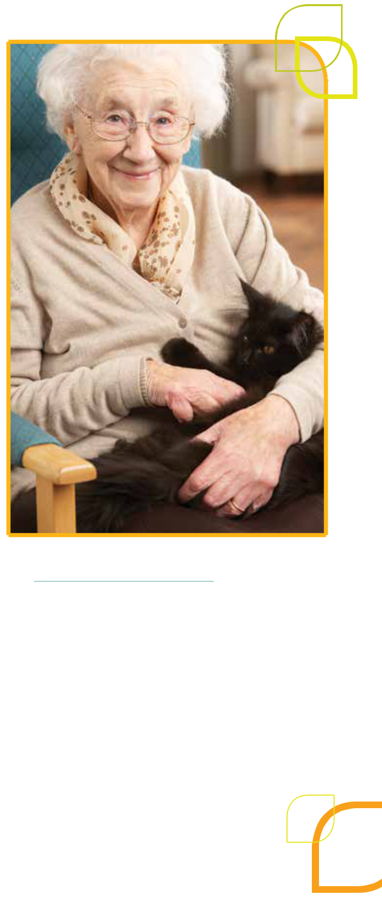

9

References

Boehm, A. & Staples, L.H. (2004) Empowerment: The point of view of consumers. Families in Society, 85, p 270–280

DH (2018) Commonwealth Home Support Programme: Program Manual 2018 Canberra: Department of Health (DH), Commonwealth of Australia.

DSS (2015) Living well at home: CHSP Good Practice Guide Department of Social Services. Canberra: Department of Social Services (DSS), Commonwealth of Australia.

DH (2017) Commonwealth Home Support Programme: Programme Manual 2017 Canberra: Department of Health (DH), Commonwealth of Australia.

Murphy, B.C. & Dillon, C. (2011) Interviewing in action in a multicultural world (4th Edition). California USA: Brooks/Cole, Cengage Learning.

Kral, R. (1989) Strategies that work: Techniques for solutions in the schools. Milwaukee, WI: Brieg Family Therapy Center.

Hammond, W. (2010) Principles of Strengths-Based Practice. Alberta Canada: Resiliency Initiatives. Brun, C. & Rapp, R. (2001) Strengths-based

case management: Individuals’ perspectives on strengths and the case manager relationship. Social Work, 46(3), 1–11.

McCashen, W. (2005) The Strengths Approach.

Victoria: St Luke’s Innovative Resources.

Foot, J. & Hopkins, T. (2010) A glass half full: How an asset approach can improve community health and wellbeing. London: Improvement and Development Agency.

McLean, J. (2011) Asset based approaches for health improvement: redressing the balance. Glascow: Glascow Centre for Population Health

Morgan, A. & Ziglio, E. (2007) Revitalising the evidence base for public health: An assets model. International Journal of Health Promotion and Education, Supplement 2, pp 17–22

Rapp, C., Saleebey, C. & Sullivan, P.W. (2006)

The future of strengths-based social work practice, in Saleebey, D. (ed) (2006) The strengths based perspective in social work practice, (4th Edition). Boston: Pearson Education

Staudt, M., Howard, M.O. & Drake, B. (2001) The operationalization, implementation and effectiveness of the strengths perspective: A review of empirical studies, Journal of Social Service Research, 27(3), pp 1–21

Pattoni, L (2012) Strengths-based approaches for working with individuals, Insights 16, May 2012. Glasgow: Institute for Research and Innovation in Social Services (IRISS)

Scerra, N. (2011) Strengths-Based Practice: The Evidence. Parramatta, NSW: Uniting Care Social Justice Unit

Mondoloch, M.V., Cole, D.C. & Frank, J.W. (2001) Does how you do depend on how you think you’ll do? A systematic review of the evidence for a relation between patients’ recovery expectations and health outcomes. Can Med Assoc J. 2001; 165(2) pp 174–179.

Rapp, C.A., Pettus, C.A. & Goscha, R.J. (2006) Principles of strengths-based policy. Journal of Policy Practice 5 (4) pp 3–18

Chapin, R. & Cox, E.O. (2001) Changing the paradigm: Strengths-based and empowerment-oriented social work with frail elders. Gerontological Social Work Practice: Issues, Challenges and Potential, 36, pp 165–179

Peacock et. al. (2010) The positive aspects of the caregiving journey with dementia: Using a strengths-based perspective to reveal opportunities. Journal of Applied Gerontology, 29, pp 640–659

10

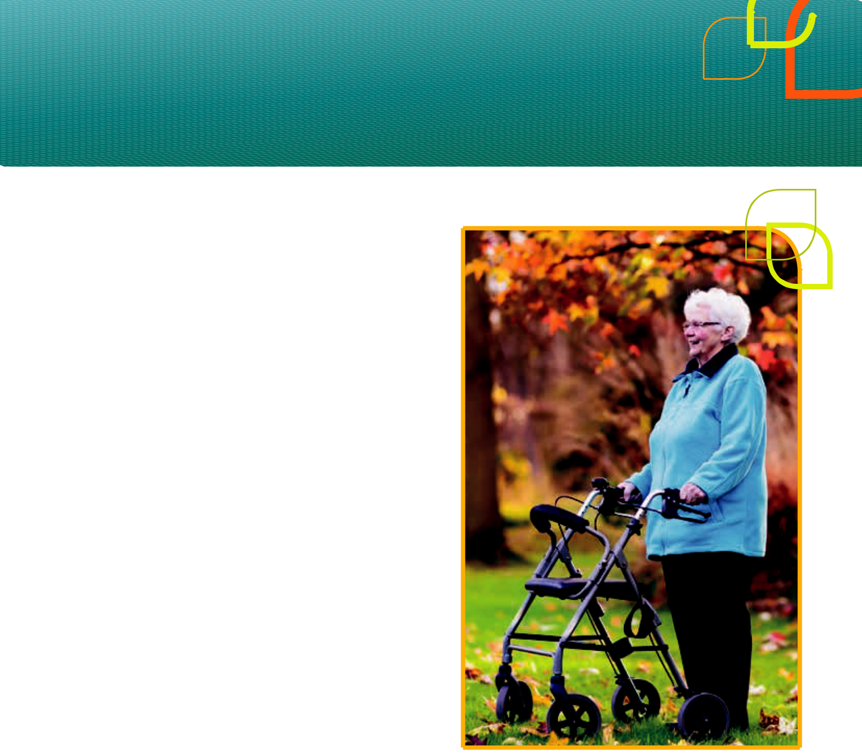

Rashid, T. (2009) Positive interventions in clinical practice. Journal of Clinical Psychology, 65, pp 461–466

Rashid, T. & Ostermann, R.F. (2009) A strengths based assessment in clinical practice. Journal of clinical psychology: In Session, 65, pp 488–498

Miller, L. & Russell, C. (2012) A strengths-based approach to ageing well: the Housing Dimension. Housing LIN Viewpoint 30. Housing Learning & Improvement Network (LIN)

Minimol, K. (2016) Risk Assessment and Strengths Based Care Management in Elderly Care – Scope of Social Work Practice. ArthaJ SocSci 15, 2 (2016) pp 121–133

Gatchel, R.K., Peng, Y.B., Peters, M.L., Fuchs, P.N.

- Turk, D.C. (2007) The biopsychosocial approach to chronic pain: Scientific advances and future directions. Psychological Bulletin 133 pp 681–624

Janssen, M.B., Regenmortel, V., Abma, A.T. (2011) Identifying sources of strength: resilience from the perspective of older people receiving community long-term care, European Journal of Ageing. Sept 2011; 8(3); pp 145–156

Orsulic-Jeras, S., Shephard, J.B., Britton, P.J.

(2003) Counselling older adults with HIV/AIDS: A

strengths-based model of treatment. Journal of

Mental Health Counselling, 25(3) pp 233–244

Schlegel, J. A., Hicks, L. A. King, and J. Arndt.

(2011) Feeling like you know who you are:

perceived true self-knowledge and meaning in life.

Personality and Social Psychology Bulletin, vol. 37,

no. 6, pp. 745–756

Scerra, N. (2011) Strengths-based practice:

The evidence. A discussion paper.

NSW: UnitingCare, Social Justice Unit

Graybeal, C. (2001) Strengths-based social work

assessment: Transforming the dominant paradigm.

Families in Society: The Journal of Contemporary

Human Services, 82(3), pp 233–242

11

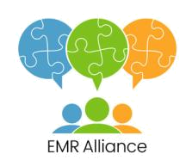

This resource was developed by Kate Pascale and Associates Pty. Ltd. as part of the Inclusive Service Specific Assessment and Planning (ISSAP) project, which was an initiative of the EMR Alliance.

Sector Development Teams are funded by the Australian Government Department of Health. The material contained herein does not necessarily represent the views or policies of the Australian Government.

© Copyright Kate Pascale and Associates Pty. Ltd. June 2019 (Version 2)

Hard copy and electronic materials may be reproduced for non-commercial, personal use only in accordance with the provisions of the Copyright Act 1968 (the Act). No part of this work may be reproduced or communicated for resale or commercial distribution.

