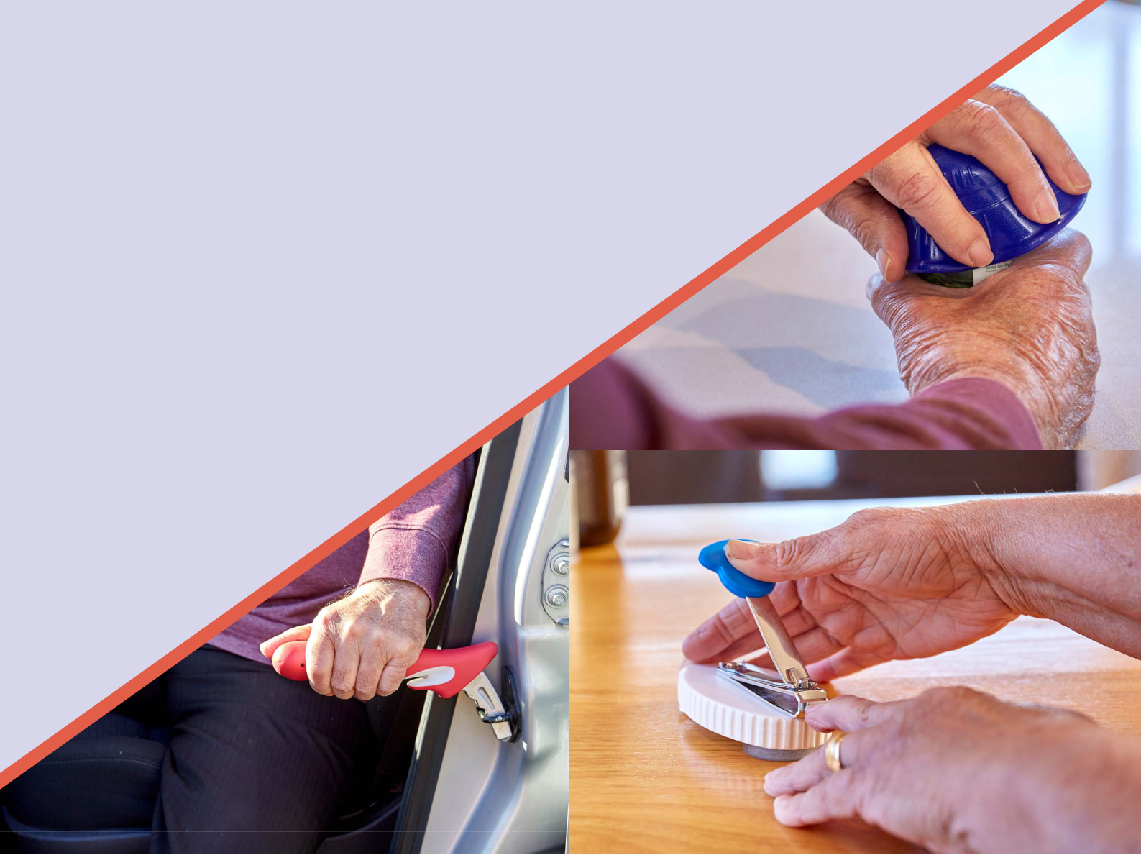
Funded Easy Living Equipment geat2GO funding program provided through Indigo

If your client is having difficulty paying for Easy Living Equipment, they can access geat2GO equipment funding through Indigo. Indigo is the national Goods Equipment and Assistive Technology (GEAT) provider, offering

more choice and opportunity to deliver assistive technology items to older people. Australian geat2GO is funded under the Commonwealth Home Support Programme (CHSP).

STEPS TO ACCESS FUNDING

- Contact your supervisor and follow your organisation’s processes to request a Support Plan Review

- Support Plan Review process occurs

- The Assessor will contact the client, discuss their equipment needs and organise a referral to geat2Go as appropriate

For more information about geat2GO go to bit.ly/geat2GO

