Monitoring, Feedback and Review

of service specific care plans

for Commonwealth Home Support Programme (CHSP) service providers

Introduction

This resource is designed to support Commonwealth Home Support Programme (CHSP) service providers utilise and maintain service specific care plans via ongoing monitoring, feedback and review practices. An overview of the key requirements is provided, followed by a range of practical strategies that support effective practice, including how to:

- actively monitor your work with clients

This information sheet has been developed as part of a suite of resources for CHSP service providers. Also included in the suite of CHSP Assessment and Planning resources are:

- Embedding a strengths based approach in client conversations***

- Reducing duplication in service specific assessments***

- Service specific goal setting and care planning

- utilise formal and informal feedback from clients, carers and staff to support and guide ongoing goal setting and planning

- conduct and document care plan reviews in line with the relevant quality standards and practice guidelines

- establish tools, policies and systems that support effective care plan monitoring, feedback and reviews.
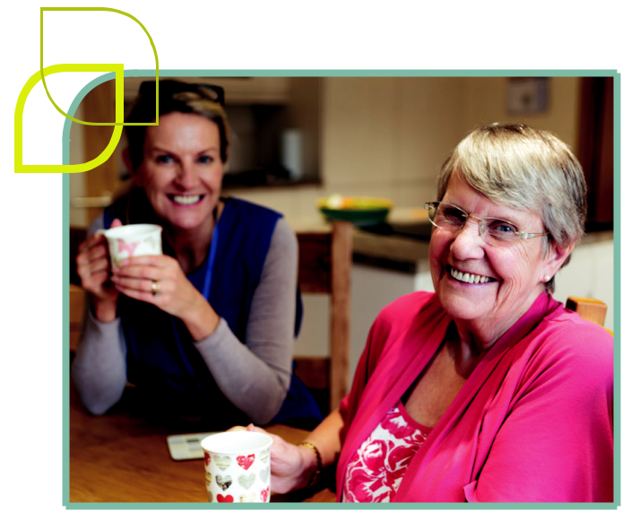

- These resources were developed as part of an initiative of the EMR Alliance.
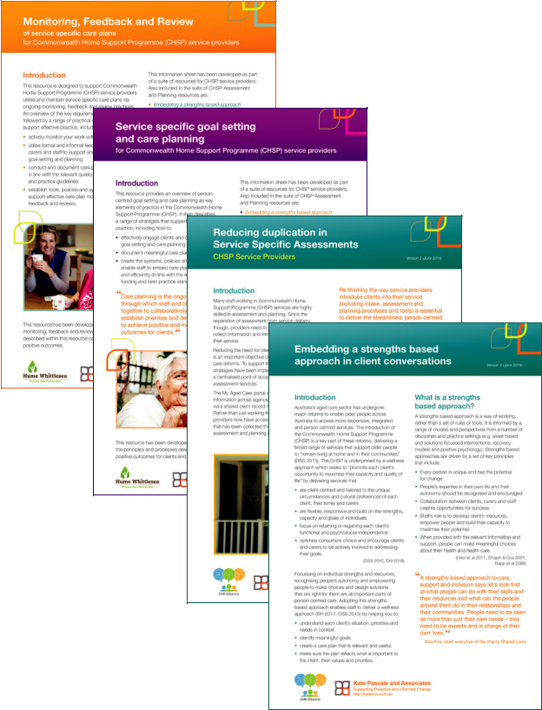

This resource has been developed within the context of the CHSP. Regardless of the funding source, monitoring, feedback and review are an important component of effective practice. Therefore, the processes described within this resource can support the working relationships between staff and clients and promote positive outcomes.

Kate Pascale and Associates

Supporting Proactive and Informed Change

http://kpassoc.com.au

The ongoing use of care plans

Person centred goal setting and care planning are evidence based approaches that can deliver significant benefits for staff and clients, including the ability to enhance client engagement, satisfaction, and outcomes (Cook and Miller 2012, Glendinning, Jones et. al. 2010, Molony et. al 2018, Pascale 2015, Robertson, Emerson et. al. 2010, Sanderson 2000).

Care planning is an ongoing process, through which staff and clients work together to collaboratively set goals, establish priorities and develop strategies to achieve positive and meaningful outcomes for clients.

Within the CHSP, ongoing assessment and planning is identified as a key element of a wellness approach. The process of goal setting and planning should evolve as you and your client work together and guide your decision making in relation to identifying and prioritising actions and determining your next steps.

The CHSP Program Manual and Aged Care Quality Standards describe key responsibilities of service providers to maintain their service specific care plans, including that:

- clients (and carers) are actively involved in developing, monitoring and reviewing their care plan

- care plans are reviewed and updated throughout the client’s episode of care so that they remain relevant, responsive and reflective of changing circumstances, needs and goals

- feedback is sought from clients and carers to determine the effectiveness and appropriateness of their plan and they are invited to request

a review of their plan at any time

- care plans are provided to clients in an appropriate format (including providing updated plans that reflect changes).

(AACQA 2018, DH 2018)

Care plans should be ‘living documents’ that are reviewed and updated regularly to ensure they remain relevant and useful.

Service providers need to embed systems, tools and processes that support the ongoing use of care plans, so that the care plan remains a living document and informs ongoing service delivery. This is achieved through:

- Monitoring and feedback

Through observation and ongoing conversation with clients (and the people involved in their care), staff understand the client’s progress and/ or their changing situation and provide feedback to inform ongoing service delivery and planning.

- Care plan reviews

Care plan reviews utilise feedback from clients, carers (and the people involved in their care), along with other information (e.g. functional review, clinical indicators etc) to guide a conversation about how the plan has been implemented, the difference it has made

and agree on the next steps.

2

Monitoring and feedback
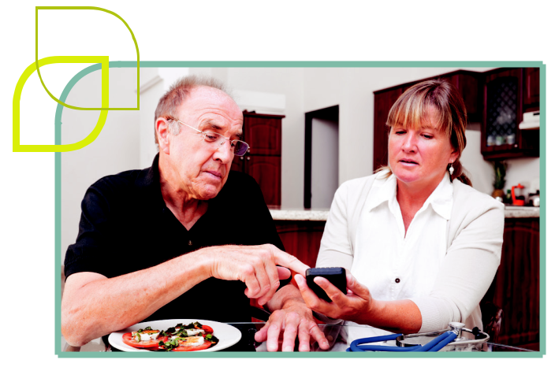

The CHSP Program Manual includes that service delivery requires “monitoring over a period of time” (DH 2018 pg. 25).

Monitoring and feedback helps shape future planning and ensures that services remain relevant, appropriate and effective.

Monitoring and feedback supports the delivery of effective and appropriate service delivery by providing the opportunity to:

- ensure that the care plan is relevant, meaningful and being implemented as agreed

- share information between, clients, carers and staff

- acknowledge client achievements and progression towards goals, recognising the input of the people involved

- measure client outcomes and understand the impact of services and/or client and carer actions

- understand enablers and barriers (i.e. what’s working and not working)

- identify changing needs, circumstances and priorities and respond in a timely way (including revising the care plan)

- clarify each person’s role and promoting shared accountability.

This process forms what can also be referred to as the Support Loop.

 |  |  |  | E
 |  |  | EMNT
 |  | L |  |  | A
 | P |  |  |  |  | TI
M |  |  |  |  |  |  | O
I |  |  |  |  |  |  |  | N

 |  | B
 | EDAC
E |  |  | K
F

People involved in | CLIENTS | People involved in
delivering care |  | developing GDCP

M

O

N

I

T

O R I N G

P

L

A

N N I N G

This diagram has been adapted with permission from The Support Loop (Hastrich 2016 pg. 9)

Please refer to The Support Loop for a range of ideas and tips which support a system for monitoring and feedback (see Support Loop essentials).

“Monitoring and feedback is the communication exchange that involves the client and the team (and any other services involved) to ensure that [the way you are working together is] appropriate, relevant and responsive to the changing needs and circumstances of the client.“

(Hastrich 2016)

3

Monitoring and feedback in practice

Monitoring and providing feedback are active, ongoing processes, in which staff, clients and carers continually ‘check in’ about the client’s circumstances, status and progress towards their goals. This can be achieved through:

- ongoing discussion with the people involved in implementing the care plan (including the client, carer/s, staff and other service providers)

- observing the client and carer during regular interactions

- actively seeking formal and informal feedback about care plan implementation and progress

- ensuring that observations, discussions and feedback are consistently recorded, shared and used to inform care plans reviews

- acknowledging all participants (clients, carers and staff) as equally valuable contributors and empowering them to provide input.

Everyone involved in delivering a client’s care plays a vital role in monitoring and feedback. The team may include:

- clients, carers, family members or support people

- staff involved in developing the care plan (e.g. clinicians, assessment staff, team leaders, group leaders)

- staff involved in delivering care (e.g. Community Support Workers, social support program staff). These staff are often the ‘eyes and ears’ of a service who build relationships with clients and are able

to recognise changes in their health, function and mood

- other service providers who work with that client.

4

Practical strategies and systems to support monitoring and feedback

- Have a conversation with the client to discuss the importance of providing feedback and actively encourage them to share their ideas and thoughts (ensuring they understand how, what, when and why feedback can be provided)

- Share the care plan with everyone involved in the client’s care (given client consent) and ensure that everyone has the information they need to support the client effectively

- Make sure that everyone is clear about each person’s role in monitoring the plan and providing feedback

- Provide clear guidelines about the type of feedback that is relevant, when and how it should be provided (e.g. positive achievements, progress, challenges, concerns and barriers)

- Create tools to consistently collect and record feedback

- Embed systems that guide how feedback will be used to support individual planning and broader quality improvement.

It’s useful to create a range of mechanisms that allow clients, carers and staff to provide feedback in a variety of ways.

This may include:

- feedback forms (electronic and/or hard copy)

- verbal feedback

- meetings (e.g. case planning meetings, team meetings or client review meetings).

Ensure that you have a clear system to collate this feedback and record it in the client’s file.

Providing feedback may be new to clients. Make sure you let your clients know why their feedback is important and how it will help you work together. You can do this by:

- talking to clients and carers about the importance of monitoring and feedback

- actively encouraging clients and carers to provide feedback

- ensuring clients and carers know how to provide feedback and how their feedback will be used

- letting clients know that monitoring their care plan and providing feedback about their progress is an important component of workers’ roles and the support provided by the service.

5

Care plan reviews

A review is a formal opportunity to revisit and update the care plan to ensure it remains relevant, meaningful and reflects the client’s evolving goals, needs, priorities and preferences. It also provides an opportunity to consider whether the way

you are working together promotes the client’s independence and autonomy, in line with a wellness approach.

Care plan reviews should guide decision making about ongoing service delivery including whether the:

- goals continue to reflect the client’s priorities, needs and circumstances

- client, carer/s and staff are working together in the most effective and efficient way that is tailored to the client’s goals and needs including whether the:

– service type remains the most appropriate and relevant way to support the client achieve their goals

– timing, amount and frequency of service delivery meets the client’s needs

- client is ready to transition and/or be discharged from the service (either because all relevant actions have been completed, the client has achieved their goals or the service is no longer meeting the client’s needs or preferences).

(Australian Government 2017)

Refer to the ‘Goal Directed Care Planning Toolkit’ for more information and examples of tools to support goal setting, care planning and review conversations.

How to complete reviews

The client’s existing care plan should be used to guide the review conversation. In line with initial care planning processes, staff work collaboratively with clients and/or carers to:

- review the feedback that has been collected

- discuss the implementation of the care plan to date (including completed actions, variations to the plan, client and staff experience of working together)

- understand the impacts of the completed actions and how these have affected the client’s situation, health and wellbeing (i.e. the outcomes)

- identify ongoing needs and priorities.

The Goal Directed Care Planning toolkit includes a number of tools that can support effective review conversations. In particular ‘What’s working / Not working’ and ‘4 + 1 questions’ can be useful to support clients and carers to provide feedback, clarify priorities and identify opportunities to refine the care plan.

WHAT’S WORKING WHAT’S NOT WORKING

4 + 1 QUESTIONS

What have we tried?

What have we learned?

What are we pleased about?

What are we concerned about?

Given what we know, what next?

6

Reviews can be completed in person, or over the phone. The most appropriate way to complete a review will depend on a number of client factors (including the feedback that’s been collected) and the nature of the service being delivered (e.g. whether the staff member completing the review has regular face to face contact with the client). Your approach should be determined on an individual basis with each client.

Reviews can be effectively completed over the phone when:

- you are confident that the client will accurately self-report and feel confident to provide feedback

- the client can effectively communicate over the phone (consider English literacy, hearing etc.)

- only you and your client need to be involved in the conversation (e.g. you don’t need

to include carers, support people or other staff) because you are validating information that has already been collected through the monitoring and feedback process.

At times, clients can be hesitant to discuss challenges, concerns or opportunities for improvement. In those cases, it may be more effective to complete reviews in person, where staff can use cues from the environment, observation and non-verbal communication to support their conversation.

Sometimes, a review may be commenced over the phone, but then convert to a face to face conversation.

7

When to conduct reviews

All clients require periodic care plan reviews! Within the CHSP, service specific care plan reviews need to be completed at least once a year. When developing the care plan, staff should work with the client and/or carer/s, to determine when it is appropriate to schedule a review.

When (and how frequently) reviews are completed, should be determined by the client and staff, depending on the client’s circumstances, needs, goals and the nature and intensity of services being delivered.

Once established, the review date should be documented on the client’s care plan (and all subsequent reviews).

In addition to scheduled reviews, a care plan

review can be completed any time:

- following a request from the client,

carer or other person involved in their care

- based on changes to the client’s circumstances, function, needs or priorities

- to support reflective practice, acknowledging and/or validating client achievements, outcomes etc.

8

The way you schedule reviews will depend on a number of client factors and the nature of the service you’re delivering.

For example:

In some nursing or allied health services, you may schedule reviews based on when you believe the actions of your current care plan will be completed. For example, a physiotherapist may schedule 6 weekly appointments and a daily exercise program as part of the care plan for a client who experiences neck pain. A review could then be scheduled in 6 weeks to discuss the client’s progress and determine the next steps (e.g. continue current program,

revise the treatment strategy or consider discharge planning).

When a new client joins a weekly social support group, you may schedule an initial review after

3 months. That would provide an opportunity to review how they are settling into the group and whether the group is meeting their needs.

Once the client is settled into the group, you may schedule reviews annually (knowing that you have strong monitoring and feedback systems in place to identify any changes to their circumstances, function or needs).

Reviews may be needed more frequently when:

- the client has a degenerative condition (and is therefore likely to experience changes to their level of function)

- the client is in crisis, or experiencing major life changes

- there are queries about the sustainability of the caring relationship or significant carer stress.

Given that care plan reviews are often scheduled several months in advance, systems need to be established to ensure they are completed at the appropriate time.

Systems can include:

- the use of reminder systems within client management systems (e.g. utilising the waitlist function or scheduling reviews as upcoming actions)

- creating a calendar for reminders that all members of the team can access (preferably within an electronic diary or scheduling application).

Scheduling reviews in the individual staff member’s diary is generally not appropriate as it does not allow for staff leave, changeover etc.

9

What are the possible outcomes of a review?

Following a care plan review, staff should work with the client to determine the next steps and ensure that updated information is provided to the people involved (including the client, carers, support people, staff and other service providers, as appropriate). Potential outcomes may include:

Revised care plan

Following each review, the client’s care plan should be updated to reflect the outcomes of your discussion. This may include:

- identifying or modifying the client and/or carer’s goals that guide how you are working together

- agreeing on new or modified actions to support the client achieve their goal

- working towards finalising/ending a service (i.e. discharge planning).

See ‘Documenting reviews’ below for more details.

Service specific e-assessment

A re-assessment is a formal assessment process which provides an opportunity to re-evaluate the client’s situation, circumstances, needs, priorities and goals (within the service type). Indicators for a re-assessment include:

- changes in the client and/or carer’s function, health status or situation

- client and/or carer stress

- safety concerns identified via feedback from clients, carers, staff or other service providers

- a request from the client or carer.

A re-assessment will usually result in the development of a new care plan (describing goals and actions that are relevant to the client’s new circumstances). This will often occur alongside a Support Plan review (see below).

Note: There is no requirement for service providers to complete re-assessments periodically.

Request a Support Plan review or new assessment

When a service specific care plan review or reassessment highlights that the client’s needs or goals are beyond the scope of that service, or the client may benefit from other services, service providers should request a review of their broader Support Plan (to be completed by a RAS or ACAT assessor).

Service providers can request a Support Plan review via the My Aged Care Provider Portal or by calling the My Aged Care contact centre.

The RAS or ACAT assessor will complete a review with the client (by phone or in person) to discuss the client’s circumstances and the appropriateness of the recommendations in place to meet their goals. Based on their review, the assessor will update the Support Plan (including increasing, decreasing or changing services as appropriate). Where there is a significant change in the client’s needs or circumstances, the assessor may complete a new assessment with the client.

Following a Support Plan review, or re-assessment, the assessor will contact the referring service provider to discuss the results of the review

and recommendations that relate to delivery of the service.

Refer to Support Plan review and New Assessment

– Key principles and guidance for further information. Additional resources are included in the resource section on page 13 and 14.

Documenting reviews

Care plans should be living documents, that are actively used and updated to reflect the work that has been done and how services evolve over time. This includes documenting when actions have been completed and the outcomes of formal reviews.

10

The following table includes a summary of the information that should be documented following a client’s care plan review.

REQUIRED INFORMATION

How and when the review was completed

WHAT TO INCLUDE

Who was involved

When the review was completed

How the review was completed (in person, by phone).

DOCUMENTATION TIPS

Document the names (and roles) of everyone who contributed to the review.

An update | A brief summary of the client’s | Focus on key changes that have occurred since
of the client’s | current status, highlighting | the care plan was developed (or last reviewed).
current situation / | changes that have occurred | Note whether actions were completed as
circumstances | since the development of the
 |  | planned and the rationale for any changes
 | care plan (or previous review).
 |  | to the plan.
The impact | How the completed actions | Goal achievement can be reported using a
of completed | have contributed to: | scale (e.g. Achieved / Partially Achieved /
actions | • the client achieving their goal/s | Not Achieved) however, this should also be
 |  | supported by a brief description of the
 | • their situation, function etc.
 |  | progress and changes that have occurred.
Next steps | New, or revised goals | You do not have to set new goals or actions
 | and actions | after every review.
 | Any other follow up required | Don’t forget to document actions that will
 | (e.g. request for a review | be continued (noting revised timeframes
 | of the client’s Support Plan). | where applicable).
Plan for ongoing | Who the updated care plan | After a review, the updated care plan needs
use of the plan | has been provided to (including | to be provided to the client.
 | the client and other people | Given client consent, it should also be shared with
 | involved in their care).
 |  | other people involved in their care (e.g. carers,
 | Date for next review. | family members, support people and staff).

Client A brief statement that describes

acknowledgement what the client is agreeing to

Client signature.

Client acknowledgement can be completed by asking the client to sign the care plan or by documenting verbal consent (in line with organisational policies).

A brief summary of the care plan review should also be documented in the My Aged Care provider portal. This supports reduced duplication and improves continuity of care by ensuring that other people involved in the client’s care have access to up to date information (e.g. other service providers, assessors and My Aged Care contact centre staff).

11

Organisational systems and tools to support effective monitoring, feedback and reviews

Appropriate tools

and templates

There is no mandated template to document feedback or care plan reviews for CHSP service providers. Creating a standard feedback template can be useful to promote consistency and ensure that feedback is embedded in a systematic way.

Please refer to ‘The Support Loop’ for more information and an example of a feedback template.

Care plan reviews can be documented on the original care planning template, or on a separate tool. Organisations should determine the most appropriate way to document reviews, based on what will be meaningful to the client, practical and easy to use for staff and clients. When choosing (or designing) a review template, think about

the practicalities of how the document will be completed, updated and stored. Consider:

- whether care plans are handwritten or typed

- how care plans are stored and accessed in the future

- whether your client management system enables tools to be updated and revised over time.

A number of care planning templates (including a specific eview template) are available to download from: http://kpassoc.com.au/resources/gdcp-resources/.

Supportive policies and procedures

Organisational policies and procedures should clearly describe the organisation’s approach to the ongoing use of care plans, including:

- the indicators and processes for monitoring, providing feedback and reviews (including relevant roles and responsibilities)

- communication and feedback systems / mechanisms that enable all participants to provide feedback and contribute to goal setting and planning in meaningful ways

- how feedback is recorded and used to inform the ongoing use of care plans

- how learnings from care plan reviews are used to inform broader quality improvement processes and systems.

Please refer to ‘The Support Loop’ for a checklist of systems, processes and tools that support effective monitoring and feedback.

Human resources

Ensure that Human Resources systems and documents support staff to deliver effective, goal directed care and participate in monitoring, feedback and reviews, including:

- clear expectations regarding all staff member’s roles in monitoring, feedback and reviews are outlined within key documents (e.g. position descriptions)

- staff training is provided to ensure that staff have the skills, knowledge and confidence t deliver care in line with their clients’ care plan and participate in effective monitoring, provide feedback and complete reviews (as appropriate within the scope of their role).

12

Resources

This information sheet has been developed as part of a suite of resources for CHSP service providers. Other resources in this suite include:

- Embedding a strengths based approach in client conversations***

- Reducing duplication in service specific assessments***

- Service specific goal setting and care planning

- These resources were developed as part of an initiative of the EMR Alliance.

Care plan monitoring, feedback and reviews

The Goal Directed Care Planning toolkit provides further information and resources to assist organisations understand and embed effective care planning practice. The toolkit and a number of additional tools are available at: http://kpassoc. com.au/resources/gdcp-resources/.

The Support Loop resource was designed to provide a feedback and monitoring framework to support organisations who have responsibility for HACC PYP and CHSP services. It includes a number of practical tools and strategies that can be used to support effective monitoring and feedback. Available at: http://www.hwpcp.org.au/the-support-loop/

Commonwealth Home Support Programme (CHSP)

The Commonwealth Department of Health has developed a range of resources to assist providers deliver services under the CHSP. These resources, including program manuals, guidelines and CHSP provider updates are available on the Department’s website: https://agedcare.health.gov.au/programs/ commonwealth-home-support-programme/ resources

Following a care plan review (or re-assessment), service providers should document a brief update in the My Aged Care provider portal. The Quick Reference Guide – Recording and updating client service delivery information using the My Aged Care provider portal provides further information about how to do this. Available at: https:// agedcare.health.gov.au/sites/g/files/net1426/f/ documents/06_2018/qrg_-_recording_and_ updating_service_delivery_information.pdf

Aged Care Assessment and Support Planning (RAS & ACAT)

The Commonwealth Department of Health have developed a range of resources that describe the key elements of assessment and planning across the aged care sector. These are available at: https:// agedcare.health.gov.au/our-responsibilities/ageing-and-aged-care/programs-services/my-aged-care/ information-for-service-providers

The following tools are designed to support service providers understand and initiate Support Plan reviews:

- Support Plan Review and New Assessment – Key principles and guidance

- When to request a Support Plan Review

- How to request a Support Plan review for a client (Video)

- Actioning changes to a client’s support plan (Fact sheet)

13

The Aged Care Quality Standards

The Aged Care Quality Standards apply to all aged care services including residential care, home care and flexible care. The standards reflect that a strengths based, goal oriented and collaborative approach is integral to all aged care services in Australia. The standards and supporting materials are available at http://www.aacqa.gov.au/ and https://agedcare.health.gov.au/quality/single-set-of-aged-care-quality-standards. Of particular relevance to care plan monitoring, feedback and review are:

- Standard 2: Ongoing assessment and planning with consumers, describes the ongoing nature of planning and outlines key requirements to support effective monitoring, feedback and reviews.

- Standards 3 & 4 describe specific requirements in relation to the delivery of personal care and clinical care (Standard 3) and services and supports for daily living (Standard 4).

14

References

AACQA (2018) Guidance and resources for providers to support the new Aged Care Quality Standards (August 2018). Australian Government, Australian Aged Care Quality Agency (AACQA), Canberra.

Australian Government (2017) Support Plan Review and New Assessment June 2017. Australian Government, My Aged Care. Canberra: Department of Health (DH), Commonwealth of Australia.

Cook, A. and E. Miller (2012). Talking Points: Personal outcomes approach: Practical guide. Joint Improvement Team. Edinburgh.

DH (2018) Commonwealth Home Support Programme: Program Manual 2018 Canberra: Department of Health (DH), Commonwealth of Australia.

DSS (2015a) Living well at home: CHSP Good Practice Guide Department of Social Services. Canberra: Department of Social Services (DSS), Commonwealth of Australia.

Glendinning, C., K. Jones, K. Baxter, P. Rabiee, L. A. Curtis and A. Wilde (2010). Home care re-ablement services: investigating the longer-term impacts (prospective longitudinal study). York, Social Policy Research Unit, University of York.

Hastrich, R (2016). The Support Loop: Managing support plans, client goals and feedback from Community Support Workers to ensure reliable, client focussed care. Hume Whittlesa Primary Care Partnership (HWPCP), Melbourne, Victoria.

Molony, S., Kolanowski,K., Van Haitsma, K., Rooney, K. (2018) Person-Centered Assessment and Care Planning. Gerontologist 18 Jan 18;58(S1):S32-S47.

Pascale, K (2015). The Goal Directed Care Planning Toolkit: Practical strategies to support effective goal setting and care planning with HACC clients (2nd Ed). Eastern Metropolitan Region (EMR) HACC Alliance, Outer Eastern Health and Community Services Alliance, Melbourne, Victoria.

Robertson, J., E. Emerson, C. Hatton, J. Elliot, R. Romeo, M. Knapp, H. Sanderson, M. Routledge, P. Oakes and T. Joyce (2010). The Impact of Person Centred Planning. United Kingdom, Institute for Health Research, Lancaster University.

Sanderson, H. (2000). Person Centred Planning: Key Features and Approaches. London, Helen Sanderson Associates (HSA).

15

This resource was developed by Kate Pascale and Associates Pty. Ltd. in collaboration with the Northern Metropolitan Melbourne and Western Metropolitan Melbourne Wellness and Reablement Consultants.

The development of this resource is supported by the Hume Whittlesea Primary Care Partnership (HWPCP). Sector Development Teams are funded by the Australian Government Department of Health. The material contained herein does not necessarily represent the views or policies of the Australian Government.

© Copyright Kate Pascale and Associates Pty. Ltd. June 2019

Hard copy and electronic materials may be reproduced for non-commercial, personal use only in accordance with the provisions of the Copyright Act 1968 (the Act). No part of this work may be reproduced or communicated for resale or commercial distribution.

