Service specific goal setting and care planning

for Commonwealth Home Support Programme (CHSP) service providers

Introduction

This resource provides an overview of person centred goal setting and care planning as key elements of practice in the Commonwealth Home Support Programme (CHSP). It then describes

a range of strategies that support effective practice, including how to:

- effectively engage clients and carers in the goal setting and care planning process

- document meaningful care plans

- create the systems, policies and tools that enable staff to embed care planning effectively and efficiently (in line with the relevant quality, funding and best practice standards).

“Care planning is the ongoing process, through which staff and clients work together to collaboratively set goals, establish priorities and develop strategies to achieve positive and meaningful outcomes for clients. “

(Pascale 2015)
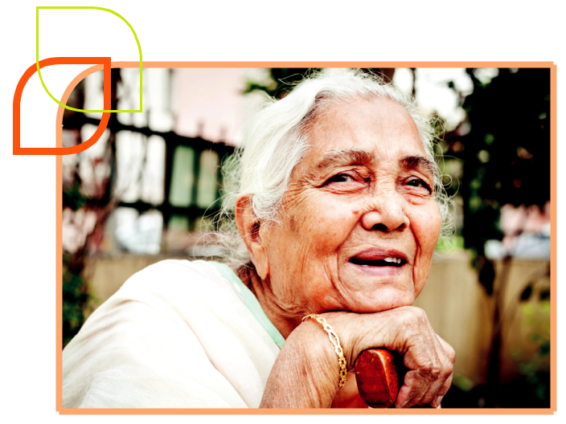

This information sheet has been developed as part of a suite of resources for CHSP service providers. Also included in the suite of CHSP Assessment and Planning resources are:

- Embedding a strengths based approach in client conversations***

- Reducing duplication in service specific assessments***

- Monitoring, feedback and review of service specific care plans

- These resources were developed as part of an initiative of the EMR Alliance.
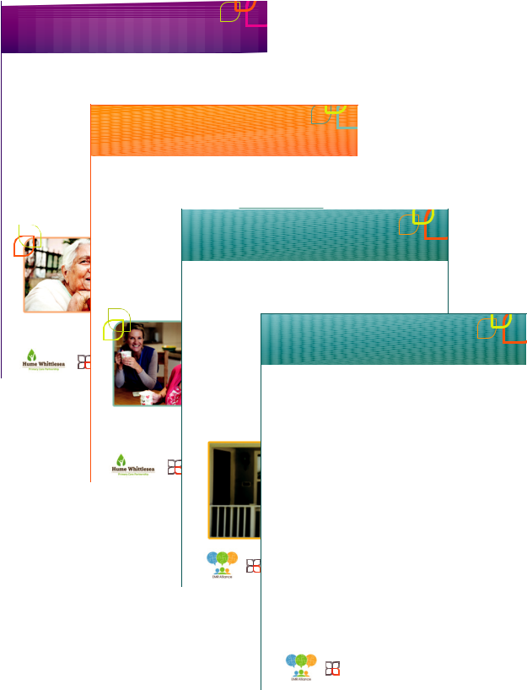

Service specific goal setting
and care planning
for Commonwealth Home Support Programme (CHSP) service providers
Introduction |  |  |  |  |  | This information sheet has been developed as part
This resource provides an overview of person |  |  |  |  |  | of a suite of resources for CHSP service providers.
 |  |  |  |  |  | Also included in the suite of CHSP Assessment
centred goal setting and care planning as key
 |  |  |  |  |  | and Planning resources are:
elements of practice in the Commonwealth Home
 |  |  |  |  |  | • | Embedding a strengths based approach
Support Programme (CHSP). It | then describes
a range of strategies that support effective |  |  |  |  |  |  | in client conversations***
practice, including how to: |  |  |  |  |  | • | Reducing duplication in service specific
• effectively engage clients and carers in theMonitoring, Feedback and Review
 |  |  |  |  |  |  | assessments***
goal setting and care planning process |  |  |  |  |  | • | Monitoring, feedback and review of service
• document meaningful care plans |  |  |  |  | of service specific_{specificcare}care_{plans}plans
 |  |  |  |  | for Commonwealth Home Support Programme (CHSP) service providers
• create the systems, policies and tools that |  |  |  |  |  | *** These resources were developed as part of an
enable staff to embed care planning effectively |  |  |  |  |  | initiative of the EMR Alliance.
and efficiently (in line with the relevant quality,
funding and best practice standards).
“Care planning is the ongoing |  |  |  |  | Introduction |  |  |  | This information sheet has been developed as part
 |  | process, |  |  |  |  |  |  | of a suite of resources for CHSP service providers.
 |  |  |  |  | This resource is designed to support Commonwealth |  |  |  | Also included in the suite of CHSP Assessment
through which staff and clients work
 |  |  |  |  | Home Support Programme (CHSP) service providers |  |  |  | and Planning resources are:
together to collaboratively set |  |  | goals,
 |  |  |  |  | utilise and maintain service specific care plans via
establish priorities and develop strategiesongoingmonitoring, feedback and review practices. |  |  |  |  |  |  |  |  | • | Embedding a strengths based approach
to achieve positive and meaningfulAn overview of the key requirements |  |  |  |  |  |  |  | is provided, |  | in client conversations***
outcomes for clients.“ |  |  |  |  | followed by a range of practical strategies that |  |  |  | • | Reducing duplication in service specific
 |  |  |  |  | support effective practice, including how to: Reducingassessmentsduplication*** |  |  |  |  |  |  | in
 |  |  |  | (Pascale 2015)

- actively monitor your work with clientsService^{•Service}Specific^{spifcgoal setting}Assessments^{andcareplanning}

• utilise formal and informal feedback from clients, | *** These resources were developed as part of an
carers and staff to support and guide ongoing^{CHSP Service}initiativeof the^{Providers}EMRAlliance. |  | Version 2 (June 2019)
goal setting and planning

- conduct and document care plan reviews in line with the relevant quality standards
 |  | and practice guidelines |  |  | Introduction |  |  |  |  |  |  |  |  | Re-thinking the way service providers
 |  | • establish tools, policies and systems that |  |  | Many staff working in | Commonwealth Home |  |  |  |  |  |  |  | introduce clients into their service
 |  | support effective care plan monitoring, |  |  | Support Programme | (CHSP) services are highly |  |  |  |  |  |  |  | (including intake, assessment and
 |  | feedback and reviews. |  |  |  |  |  |  |  |  |  |  |  | planning processes and tools) is essential
 |  |  |  |  | skilled in assessment | and planning. Since the
 |  |  |  |  |  |  |  |  |  |  |  |  |  | to deliver the streamlined, person centred
 |  |  |  |  | separation of assessment from |  |  |  |  |  | service delivery
 |  |  |  |  | though, providers need to |  |  | re-think the way they |  |  |  |  |  | and consistent approach outlined in the
 |  |  |  |  |  |  |  |  |  |  |  |  |  | aged care reforms.
This resource has been developed within the context of the CHSP. Regardless of the funding^{collect}source,information and introduce clients into
the principles and processes described within this resource can support effective practice^{their}and^{service.}promote |  |  |  |  |  |  |  |  |  |  |  |  |  | This resource provid s a very brief overview of
positive outcomes for clients and organisations working in the community care sector. |  |  |  |  | Reducing the need for clients to re-tell theirEmbeddingstory_{theassessment}astrengths_{andplanningprocess}based_{andthe}
 |  |  |  |  | is an important objective of the Australian aged
 |  |  |  |  | care reforms. To support this, a numberapproach in client conversations
 |  |  |  |  |  |  |  |  |  |  |  | of |  | tools used to gather information (i.e. the N tional
 |  | Kate Pascale and Associates |  |  |  |  |  |  |  |  |  |  |  | Screening and Assessment form [NSAF]). |  |  |  | Version 2 (June 2019)
 |  |  |  |  | strategies have been implemented, including
 |  |  |  |  |  |  |  |  |  |  |  |  |  | It then focusses on practical strategies that
 |  | Supporting Proactive and Informed Change |  |  | a centralised point of access and dedicated
 |  | http://kpassoc.com.au |  |  |  |  |  |  |  |  |  |  |  | service providers can use to reduce duplication
 |  |  |  |  | assessment services.
 |  |  |  |  |  |  |  |  |  |  |  |  |  | and streamline their assessment processes
 |  |  |  |  | The My Aged Care portal also enables staff to share |  |  |  |  |  |  |  |  | for staff and clients.
 |  |  |  |  | information across agencies (and with coIntroductionsumer/s) |  |  |  |  |  |  |  |  |  |  | What is a strengths
 |  |  |  |  | via a shared client record that is available_{Australia’s}online. _{aged care sector has undergone} |  |  |  |  |  |  |  |  |  |  | based approach?
 |  |  |  |  | Rather than just working from a referral, service |  |  |  |  |  |  |  |  |  |  | A strengths based approach is a way of working,
 |  |  |  |  |  |  |  |  |  |  | major reforms to enable older people across
 |  |  |  |  | providers now have access to all of the information |  |  |  |  |  |  |  |  |  |  | rather than a set of rules or tools. It is informed by a
 |  |  |  |  |  |  |  |  |  |  | Australia to access more responsive, integrated
 |  |  |  |  | that has been collected through the initial |  |  |  |  |  |  |  |  |  |  | range of models and perspectives from a number of
 |  |  |  |  |  |  |  |  |  |  | and person centred services. The introduction of
 |  | This resource has been developed within the context_{assessment}ofthe_{and}CHSP._{planning}Regardless_{processes.}ofthe funding source, |  |  |  |  |  |  |  |  |  |  |  |  |  | disciplines and practice settings (e.g. asset based
 |  |  |  |  |  |  |  |  |  |  | the Commonwealth Home Support Programme
 |  | monitoring, feedback and review are an important component of effective practice. Therefore, the processes |  |  |  |  |  |  |  |  |  |  |  |  |  | and solutions focussed interventions, recovery
 |  |  |  |  |  |  |  |  |  |  | (CHSP) is a key part of these reforms, delivering a
 |  | described within this resource can support the working relationships between staff and clients and promote |  |  |  |  |  |  |  |  |  |  |  |  |  | models and positive psychology). Strengths based
 |  | positive outcomes. |  |  |  |  |  |  |  |  | broad range of services that support older people
 |  |  |  |  |  |  |  |  |  |  | to “remain living at home and in their communities” |  |  |  |  | approaches are driven by a set of key principles
 |  |  |  |  |  |  |  |  |  |  | (DSS 2015). The CHSP is underpinned by a wellness |  |  |  |  | that include:
 |  |  |  |  |  |  |  |  |  |  | approach which seeks to “promote each client’s |  |  |  |  | • | Every person is unique and has the potential
 |  |  |  | Kate Pascale and Associates |  |  |  |  |  |  | opportunity to maximise their capacity and quality of
 |  |  |  |  |  |  |  |  |  |  | life” by delivering services that: |  |  |  |  |  | for change
 |  |  |  | Supporting Proactive and Informed Change |  |  |  |  |  |  |  |  |  |  |  | • | People’s expertise in their own life and their
 |  |  |  | http://kpassoc.com.au |  |  |  |  |  |  | • are client centred and tailored to the unique
 |  |  |  |  |  |  |  |  |  |  |  |  |  |  |  |  | autonomy should be recognised and encouraged
 |  |  |  |  |  |  |  |  |  |  |  | circumstances and cultural preferences of each
 |  |  |  |  |  |  |  |  |  |  |  |  |  |  |  | • | Collaboration between clients, carers and staff
 |  |  |  |  |  |  |  |  |  |  |  | client, their family and carers
 |  |  |  |  |  |  |  |  |  |  | • are flexible, responsive and build on the strengths, |  |  |  |  |  | creates opportunities for success
 |  |  |  |  |  |  |  |  |  |  |  |  |  |  |  | • | Staff’s role is to develop client’s resources,
 |  |  |  |  |  |  |  |  |  |  |  | capacity and goals of individuals
 |  |  |  |  |  |  |  |  |  |  | • focus on retaining or regaining each client’s |  |  |  |  |  | empower people and build their capacity to
 |  |  |  |  |  |  |  |  |  |  |  |  |  |  |  |  | maximise their potential
 |  |  |  |  |  |  |  |  |  |  |  | functional and psychosocial independence
 |  |  |  |  |  |  |  |  |  |  |  |  |  |  |  | • When provided with the relevant information and
 |  |  |  |  |  |  |  |  |  |  | • optimise consumers choice and encourage clients
 |  |  |  |  |  |  |  |  |  |  |  |  |  |  |  |  | support, people can make meaningful choices
 |  |  |  |  |  |  |  |  |  |  |  | and carers to be actively involved in addressing
 |  |  |  |  |  |  |  |  |  |  |  |  |  |  |  |  | about their health and health care.
 |  |  |  |  |  |  |  |  |  |  |  | their goals.
 |  |  |  |  |  |  |  |  |  |  |  |  |  |  |  |  | (Hirst et al 2011, Chapin & Cox 2001,
 |  |  |  |  |  |  |  |  |  |  |  |  |  |  | (DSS 2015, DH 2018)
 |  |  |  |  |  |  |  |  |  |  |  |  |  |  |  |  |  | Rapp et al 2006)
 |  |  |  |  |  |  |  |  |  |  | Focussing on individual strengths and resources, |  |  |  |  | “A strengths-based approach to care,
 |  |  |  |  |  |  |  |  |  | ^{Kate Pascale}recognising^{and} people’s^{Associates}autonomy and empowering
 |  |  |  |  |  |  |  |  |  | Supporting Proactive and Informed Change |  |  |  |  |  |  | support and inclusion says let’s look first
 |  |  |  |  |  |  |  |  |  | _{http://kpassoc}people_{.cm.au}to make choices and design solutions |  |  |  |  |  |  | at what people can do with their skills and
 |  |  |  |  |  |  |  |  |  |  | that are right for them are all important parts of
 |  |  |  |  |  |  |  |  |  |  | person centred care. Adopting this strengths |  |  |  |  |  | their resources and what can the people
 |  |  |  |  |  |  |  |  |  |  | based approach enables staff to deliver a wellness |  |  |  |  |  | around them do in their relationships and
 |  |  |  |  |  |  |  |  |  |  | approach (DH 2017, DSS 2015) by helping you to: |  |  |  |  |  | their communities. People need to be seen
 |  |  |  |  |  |  |  |  |  |  | • understand each client’s situation, priorities and |  |  |  |  |  | as more than just their care needs – they
 |  |  |  |  |  |  |  |  |  |  |  |  |  |  |  |  | need to be experts and in charge of their
 |  |  |  |  |  |  |  |  |  |  |  | needs in context |  |  |  |  | own lives.“
 |  |  |  |  |  |  |  |  |  |  | • identify meaningful goals
 |  |  |  |  |  |  |  |  |  |  | • create a care plan that is relevant and useful. |  |  |  |  |  | Alex Fox, chief executive of the charity Shared Lives
 |  |  |  |  |  |  |  |  |  |  | • make sure the plan reflects what is important to
 |  |  |  |  |  |  |  |  |  |  |  | the client, their values and priorities.
 |  |  |  |  |  |  |  |  |  |  |  |  |  |  | Kate Pascale and Associates
 |  |  |  |  |  |  |  |  |  |  |  |  |  |  | Supporting Proactive and Informed Change
 |  |  |  |  |  |  |  |  |  |  |  |  |  |  | http://kpassoc.com.au

This resource has been developed within the context of the CHSP. Regardless of the funding source, the principles and processes described within this resource can support effective practice and promote positive outcomes for clients and organisations working in the community care sector.

Kate Pascale and Associates

Supporting Proactive and Informed Change

http://kpassoc.com.au

What are the benefits of goal setting and care planning?
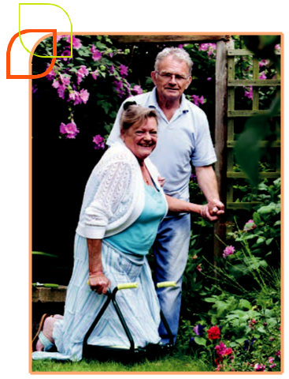

Person centred care planning is a core component of the CHSP program and a key requirement of the Aged Care Quality Standards and the CHSP Program Manual (AACQA 2018, DH 2018, DSS 2015). In order to meet these requirements, CHSP service providers are required to embed goal setting and care planning as standard parts of service delivery. There is also a strong body of evidence that describes how effective, person centred goal setting and planning can add value for clients, staff and organisations.

The first step to achieving great results is to be really clear about what your client wants to achieve.

2

Benefits for clients

- Be empowered to be actively involved in making decisions about their health and the way they engage with services.

- Feel an increased sense of ownership and shared responsibility to achieve positive results.

- Experience an increased level of satisfaction (when clients feel listened to, valued and supported in a personalised, meaningful way).

- Be more motivated to take steps towards their goals (e.g. by making positive changes to their lifestyle, behaviour and/or environment).

- Have clear information about everyone’s roles and responsibilities.

- Achieve better health and wellbeing outcomes (maximising positive outcomes is primarily linked to improved engagement).

Goal setting and care planning can enhance client satisfaction, engagement and outcomes.

Benefits for staff

- Gain a better understanding of each client’s unique circumstances and priorities, which enables more appropriate, focussed planning (making the most of your time with clients).

- Create a shared understanding with the client, carers, support people, staff and other service providers about how you are working together and what you are working towards.

- Provide an effective strategy to clearly communicate with clients (and others) about your approach, track their progress and guide conversations about ongoing work (e.g. engaging other services, transition and discharge planning).

- Improve role satisfaction (e.g. achieved by being able to deliver effective, meaningful services).

- Increase client engagement (including reduced service disengagement, increased compliance with treatment recommendations and likelihood that the client will follow recommendations).

Benefits for organisations

- Deliver more effective, appropriate, targeted and responsive service delivery.

- Reduce duplication and enhance efficiency, collaboration and continuity of care.

- Demonstrate that services are being delivered in line with a wellness approach and the broader principles of CHSP (i.e. flexible, individualised services designed in consultation with clients and delivered in line with their individual circumstances, needs, priorities, goals

and preferences).

- Enable meaningful review and evaluation of the outcomes that are achieved through service delivery and support outcomes based reporting (i.e. demonstrate the impact of service delivery and the associated client and carer outcomes).

(Cook and Miller 2012, DH 2011, Glendinning, Jones et. al. 2010, Harding et al 2015, Molony et. al 2018, Pascale 2015, Robertson, Emerson et. al. 2010, NDS 2014, Sanderson 2000, Sanderson and Smull 2010)

Effective goal setting guides the way you work, allows you to track progress and understand whether you’ve been effective.
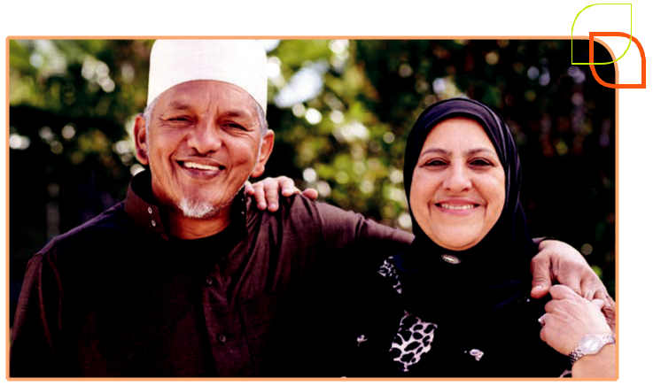

3

Service providers responsibilities in service specific assessment and care planning

In line with the Aged Care Quality Standards, the CHSP Program Manual (DH 2018) describes that CHSP service providers are required to adopt a client centred approach and demonstrate that they:

- actively involve clients in decision making and support clients to make choices about their health and the way they interact with services

- work in partnership with clients to understand their circumstances, priorities and needs

- utilise a strengths based approach that recognises and builds on each client’s strengths and resources

- develop an individualised care plan that describes how they will work collaboratively with each client to achieve their goals

- deliver services and support that are tailored to the client’s needs, goals, values and preferences (including providing individual and group services, empowering clients with information and assisting clients to link in to other services as appropriate)

- remain responsive to clients’ changing needs and/or circumstances, including monitoring and reviewing each person’s plan.

CHSP service providers are required to consider goal setting and care planning for all clients.

Clients accessing individual or group programs on a short term, episodic or ongoing basis should be supported to create an individualised care plan.

Your service specific care plan will guide the way you work together and demonstrate how you will support the client and/or carer to achieve the broad goals identified within their Support Plan.

PREPARE FOR

AN ASSESSMENT

Review the client’s support plan and assessment information (e.g. National Screening and Assessment Form [NSAF] ).

Encourage the client to invite their carer or support people if they would like

to include them in the decision making process.

CONDUCT A SERVICE SPECIFIC ASSESSMENT

Have a conversation with the client (and carer) to build on the information provided during their aged care assessment.

Focus on using your specific expertise to better understand the client’s current situation as it relates to your service / role.

CREATE A SERVICE | MONITOR AND
SPECIFIC CARE PLAN | REVIEW CARE PLAN

Utilise the Support Collect feedback

Plan as a starting point from everyone involved

for your discussion in implementing

about goals. the plan.

Work with the client Monitor the client’s

to clarify and specify progress towards

their goals. achieving their goals.

Determine a plan Conduct periodic

about how you will reviews of the

work together to care plan.

achieve those

goals (including

specific actions).

Refer to ‘Reducing duplication in service specific assessments’ for more information about streamlining service specific intake and assessment processes and conversations.

4

The link between Support Plans and service specific care planning

Within the current aged care system, clients work with dedicated assessment services (Regional Assessment Service [RAS] & Aged Care Assessment Team [ACAT]) to complete a holistic assessment and create a Support Plan.

The Support Plan is an overarching plan that reflects the broad, holistic assessment conversation and focusses on linking each client to appropriate services and supports that can assist them achieve their goals.

Each service provider then builds on the collected information to complete their own focussed, service specific assessment and develop a service specific care plan.

Within your service specific assessment, you will use your expertise to further explore the issues

and areas of concern outlined in the Support Plan. Based on your more detailed exploration of the client’s situation, strengths and priorities, you will be able to clarify and specify the client’s goals and develop a plan that describes how you will work together to achieve those goals.

Your service specific care plan describes what can be achieved in your work with the client. This allows you to complete more focussed goal setting – using the goals identified in their Support Plan as the starting point for your conversation.

REGIONAL ASSESSMENT SERVICE (RAS) AND/OR AGED CARE ASSESSMENT TEAM (ACAT)

Support Plan provides an overview of the assessment conversation (assessment summary), key issues

- priorities to be addressed (areas of concern), the client’s goals and recommendations about how they can be achieved (including service recommendations and general recommendations).

SERVICE PROVIDERS

Service specific assessment builds on information in the Support Plan and NSAF to further explore the client’s current circumstances, strengths, challenges, needs and goals. Also includes discussion about the way the service will be delivered and other considerations that will impact on how you will work together (e.g. service delivery preferences, scheduling).

Service specific care plan is created in collaboration with the client, based on your assessment conversation. Clarify the client’s goals and develop a plan about actions that you will each take to achieve those goals.

There will be times when broader issues are identified during the service specific assessment and care planning process (e.g. the client raises issues or concerns that were not initially identified in their RAS or ACAT assessment or the client’s circumstances or needs change). When issues arise that are beyond the scope of your service, a Support Plan review should be initiated (and completed by the relevant assessment service).

Refer to ‘Support Plan Review and New Assessment – Key principles and guidance’ for more information about support plan reviews.

5

Practical strategies to support effective Goal Directed Care Planning
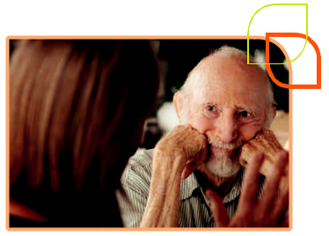

The quality standards, practice guidelines and best practice evidence provide guidance about how CHSP providers can create meaningful care plans.

The primary aim is to create a plan that is meaningful and useful for your client. The plan will guide the way you work together, ensuring that the client’s priorities, goals and preferences determine your approach.

Set the tone early and provide consistent messages about your assessment and planning approach

To set clients up for success, organisations need to consider how they communicate that the organisation adopts a person centred, strengths based and collaborative approach to planning and service delivery. Without using jargon, staff need to discuss and demonstrate these concepts as they interact with clients (and the broader community). It’s also important to ensure that these messages are consistent with the information that is available across different platforms.

Consider how you describe the way you work to:

- your clients

– in person, during initial contact, intake / triage, assessment, planning and service delivery

– in writing, through appointment letters, service agreements etc

- potential clients and the broader community

– My Aged Care

– websites

– service information brochures.

It’s important to communicate with clients about the way you work so that they have clear expectations and are ready to engage in effective planning.

For example:

If you send a letter out to clients to confirm their first appointment, you could include a statement that describes your approach:

Before your first appointment, we will review the information that you provided during your recent assessment, so that we understand what’s happening for you at the moment. This will save you from having to re-tell your story.

During your first appointment, we’ll have a conversation with you to better understand what’s most important to you and what you’d like to achieve in our work. We will work with you to create a plan and decide on the next steps.

If there is someone that you’d like to include in making decisions about your health and how we can support you, please invite them along to attend your appointment with you.

Refer to ‘Connecting through Inclusive Communication Practice’ for more information about using appropriate language and communication approaches.

6

Adopt a strengths based approach to assessment

Assessment and planning are intrinsically linked. They are ongoing processes based on collaboration with the client – first to understand what’s happening now (the assessment), what the client wants to achieve (their goals) and how you will work together to achieve those goals (the plan).

Within a strengths based approach, the client is recognised as the expert in their own life. Strengths based conversations put the client in the driver’s seat and provide you with a more holistic picture.

Focus on understanding the client’s challenges and experiences, in context of their unique circumstances, strengths and resources.

This provides you with a more holistic picture of the client, sets you up to discuss goals and provides the foundation required to create a person centred care plan.

To support a strengths based approach:

- ask broad, open ended questions that focus on what’s important to the client

- actively explore the clients’ strengths and resources

- collect information about what’s working and what’s not working

- encourage the client to discuss their ideas and identify strategies they think might be helpful to achieve their goals

- use positive, strengths based language (in person and in writing).

Refer to Embedding a strengths based approach in client conversations for more information and practical strategies.
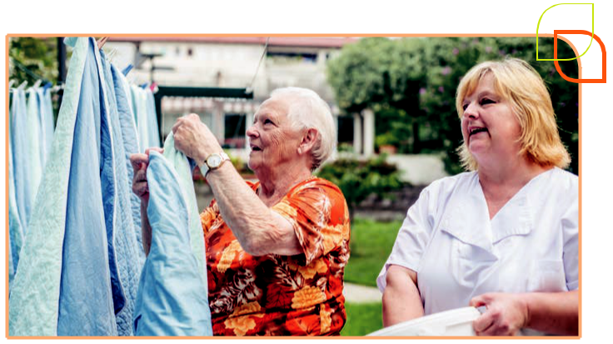

7

Introduce goal setting and care planning to your clients

For some older people, the word ‘goal’ is meaningless and the process of setting goals and working collaboratively with service providers may be unfamiliar. This does not mean that the goal setting and care planning process is irrelevant or meaningless.

Introduce the concepts of goal setting and care planning to clients in a way that is meaningful to them, so they can effectively engage in the process and create a care plan that is useful. There is no one-size-fits-all approach. Be creative and think about language that will make sense to your clients.

There are lots of ways to describe what goals are, without needing to use the word goal.

For example:

- ‘what you want to achieve / work towards’

- ‘the outcomes you’re hoping to achieve’

- ‘what success would look like for you’

- ‘what you’d like to be different (or stay the same)’

- ‘where you want to be in the future’

- ‘what you are aiming for’

- ‘what you’d like to get out of working together’

- ‘what it would look like for you if things were better’.

When describing goal setting and care planning, avoid jargon. Brainstorm a range of words and approaches you can use to describe the key concepts to your clients.

It’s useful to have a range of ways to describe the key elements of the plan and process, including:

- what goals are (i.e. define the concept of goals)

- why you ask clients to set goals (and why you document them)

- how goals are used to inform the way you work

- what is included on a care plan

and why you create them (i.e. the purpose of the care plan)

- how and when the care plan can be used (by staff and clients).

For example:

‘The care plan is a simple summary of how we are going to work together. It includes information about what you’d like to work towards and what each of us will do to support you to work on what’s most important to you.

Over time, we will use your care plan to check back in and make sure that you are getting the most out of our work together. Just because it’s written down, doesn’t mean it’s set in stone. We can come back to your care plan at any time and adjust it.

I use the care plan as a reminder of the things that I’ve agreed to do and tick things off as we go. You might like to do the same.

Your care plan is also an easy way for you to let other people know about how we are working together. You may want to share it with your family and take it along to other appointments so that you don’t have to remember everything off the top of your head’.

8

Be flexible about how and when you commence goal setting and care planning

There is no requirement to complete an assessment, set goals and/or complete a care plan within a single session (or a set timeframe). Staff need to use their professional judgement and be flexible about how and when care planning is introduced and completed.

Staff need to adopt a flexible approach and work collaboratively with each person to create a plan that is meaningful and useful for them.

When your client is engaged with multiple disciplines or service providers, you may consider working together to create a shared care plan with your client.
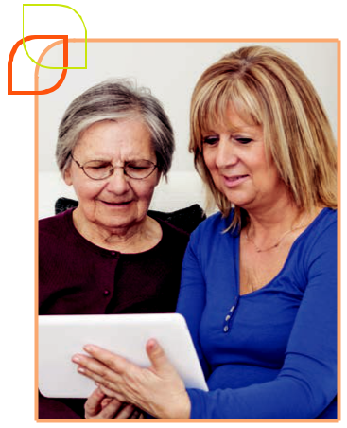

Consider when and how you can set goals and create a care plan with each client so they’ll get the most out of the process.

You can approach goal setting and service specific planning in a range of ways – based on the client’s situations, priorities, abilities and readiness to engage.

For example, some clients:

- arrive with a very clearly defined goal and planning flows easily from your assessment conversation. A care plan can be documented and provided to the client at the end of

the first session

- benefit from time to consider their goals.

It can be useful to introduce the concept of goal setting at the end of one session and encourage them to think about what they’d like to achieve. Let them know that during their next appointment, you’ll work together to create a plan about the next steps

- need to ‘try out’ a service and understand whether it’s a good fit for them before you can even start a conversation about goals. This is particularly relevant in social support groups, where clients are often unfamiliar with the groups and are frequently referred based on someone else’s recommendation or experience. Within a social support setting, it is often helpful to wait until a client is established in the group before discussing formal goals and creating a care plan

- may find it useful to start by identifying one small goal and creating a simple care plan. Over time, as the client becomes more familiar with the service, you can build on your care plan, setting new goals (or refining existing goals) and identifying actions in line with the person’s priorities.

9

Ensure care planning is an ongoing process

The process of goal setting and planning should evolve as you work together and guide your decision making in relation to identifying and prioritising actions and determining your next steps.

Care plans should be ‘living documents’ that are reviewed and updated regularly to ensure they remain relevant and useful.

Care plans should be updated regularly, including:

- recording when actions are completed

- utilising monitoring and feedback to keep the plan up to date and relevant

- updating the care plan to reflect the client’s changing needs, priorities and circumstances. This may include setting new goals, modifying existing goals and/or identifying new actions to support goal achievement

- completing formal reviews of the care plan periodically (at least once a year) and at the end of an episode of care.

Refer to the ‘Monitoring, feedback and review of service specific care plans’ information sheet for more detailed information and strategies to support the ongoing use of care plans.

- To improve readability, the word ‘client’ is used throughout this document to describe the person accessing service/s. In practice, clients may be supported by their carers, family members or other support people throughout the care planning process.

The CHSP is delivered in alignment with the Carer Recognition Act 2010 which acknowledges the essential role of carers. As such, service providers are expected to deliver services in alignment with the National Disability Strategy and The Carer Recognition Act 2010.

As directed by the client, carers, family members and support people should be invited to participate in planning and a copy of the care plan provided to them. Goal setting and planning can be conducted with clients and/or carers, depending on the client’s circumstances. In many cases, care plans can reflect the needs, priorities and goals of both clients and carers. If a client is unable

to participate (e.g. due to advanced dementia or significant intellectual disability), goal setting and care planning can be conducted

_{independently with carers.}Roleofcarersincare planning

10

Organisational tools, systems

and policies to support good practice

Staff need to be supported by systems, policies and tools that allow them to embed good practice, effectively and efficiently. This includes ensuring that:

- a whole of organisation and/or whole team approach is adopted so that staff are supported via strong leadership, integration of person centred planning principles into broader organisational planning and system design etc

- policies and procedures are in place that support a best practice approach

- person centred goal setting and care planning are identified as core components of service delivery and reflected in broader organisational and/or team documentation (including quality improvement, Human Resources documentation, client management systems, marketing and promotional materials)

- staff have adequate training, practice and support to develop, embed and refine their goal setting and care planning skills and practice

- staff are empowered to utilise their expertise and professional judgement to implement the principles of effective care planning in a meaningful way with each client (including tailoring the way goal setting is approached, care plans are documented and used to support and guide service delivery)

- care planning tools and templates are easy to use and read and enable staff to document all of the required elements.

Refer to the ‘Goal Directed Care Planning Toolkit’ for more information and examples of best practice tools and templates.

There is no single tool or approach that works for every client.

Staff need to use their professional judgement and work collaboratively with clients to apply the principles of goal setting and planning in a meaningful way.
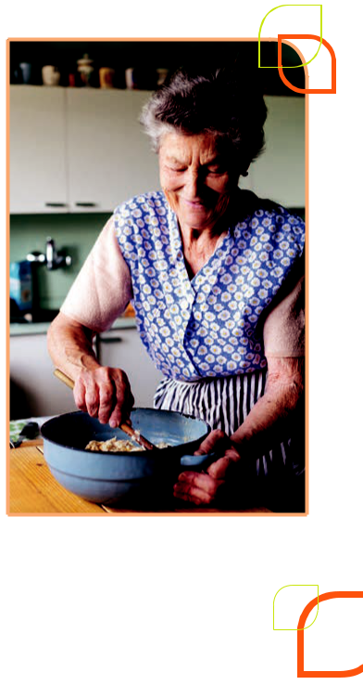

11

Documenting meaningful care plans

Existing evidence has highlighted that the quality of care plans and how useful they are for clients is determined by:

- staff’s ability to actively engage clients and carers in the goal setting and planning process

- the content and format of the care plan tool / template

- the way that information is written on the plan.

The way a care plan is documented must be meaningful and relevant to the individual client!

For many staff, supporting clients to set goals and focussing on what’s important to them is a standard part of the way they practice. Therefore, the broad principles of goal setting and planning are easy to understand and implement. Documenting care plans in a way that is meaningful for the client can be more of a challenge.

Given the broad range of skills, experiences and abilities of CHSP clients, it is clear that there is no single template, tool or writing style that will work for everyone. Staff need to be flexible, and work with the client to identify the best way for them to take away care plan information. Developing this skill, takes time and requires practice.

If you’re not sure about the best way to document a care plan, ask the client!

Their care plan will not be the first document they’ve come across – ask them about how you could create a plan that will be useful for them.

Outlined below, are some practical strategies to support effective documentation and an overview of the key elements that need to be documented in a service specific care plan.
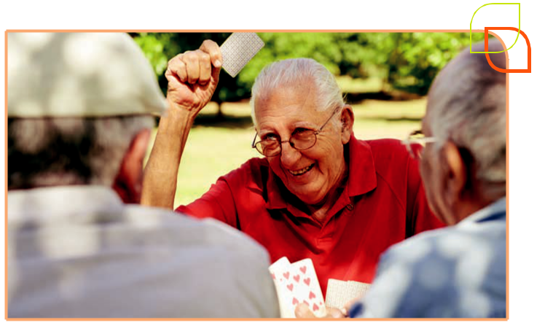

12

Using meaningful language

Care planning provides a key opportunity to demonstrate that you are working in a person centred, strengths based way. Each client’s plan should reflect that you’ve listened to them, understood what’s important to them and created a plan that is specific and tailored for them.

The content, tone and language used within the care plan are therefore, all important.

Using meaningful language within a care plan is essential to ensure that the plan is relevant and useful to the client. This can be supported by:

- ensuring that the language used in the care plan is reflective of the client’s abilities, communication styles and level of literacy (including English and health literacy)

- avoiding the use of jargon and acronyms

- using the client’s own words to describe key feelings, events or challenges

- working with the client to identify and describe their goals in a meaningful way. It is not necessary to record client goals verbatim

- being consistent in your documentation style throughout the plan (e.g. You can document plans using a first or third person perspective [I want vs. Joshua wants] but be consistent throughout the plan).

Note: You do not need to use quotation marks or phrases such as ‘client stated / reported …’ within a care plan. It is assumed that the care plan has been developed collaboratively with the client and reflects their circumstances, needs and experience.

Key elements of care plan documentation

A client’s care plan should tell a story. Each element of the plan should logically link together, demonstrating that the actions, clearly relate to the client’s goals, which have been developed in response to the current situation and the client’s priorities, needs and preferences.

A care plan should include a brief overview of what’s happening now (current situation), what the client wants to achieve (goals) and how you will work together to support the client achieve their goals (actions).

13

The following table includes a summary of the information that should be included in a client’s care plan.

REQUIRED INFORMATION WHAT TO INCLUDE

THE CLIENT’S CURRENT SITUATION / CIRCUMSTANCES

What is happening now (be specific)

What is important to the client

What has triggered them to work with you (i.e. key changes, issues or challenges).

GOALS | Client and/or carer goals
 | (i.e. the specific OUTCOMES they want to achieve).
ACTIONS | The specific person responsible for each action (WHO)
 | The specific action, or task that will be complete (is doing WHAT)
 | The timeframe in which the action will be completed (WHEN).
HOW AND WHEN THE PLAN | Who was involved in developing the plan
WAS DEVELOPED | When the plan was developed.
PLAN FOR ONGOING USE | Evidence that the care plan has been provided (or offered)
OF THE PLAN | to the client
 | Who the care plan has been (or will be) shared with
 | (e.g. carers, family, staff and/or other services)
 | Date for review.
CLIENT ACKNOWLEDGEMENT | A brief statement that describes what the client is agreeing to
 | Client signature.

Please Note: There are also specific requirements for documenting care plan reviews.

These are outlined in the ‘Monitoring, feedback and review of service specific care plans’ information sheet.

14

DOCUMENTATION TIPS

The current situation provides the context for the care plan. It should reflect the client and/or carer’s values, priorities and preferences and make it clear why the goals and actions are relevant and appropriate.

To support a person centred, strengths based approach, don’t just write a list of issues, problems or concerns.

Instead, consider:

- what’s working and not working

- client and carer strengths and/or resources

- strategies or support the client has in place (or has tried) and their effectiveness / sustainability.

Keep it simple and relevant – you do not need to record an overview of your complete assessment. The plan is for the client – it should not be documented in the same way you would write a referral to another service provider.

Goals should be:

- individualised / personalised (not just describe generic themes or areas for improvement)

- owned by an individual (e.g. I want or Phil wants…).

Actions should clearly describe the next steps that will be taken to support the client achieve their goals.

To reflect your collaborative approach, make sure you include actions that will be completed by the client, carers, family members and/or other support people. It should not just include a list of actions that staff will complete.

If you are having trouble describing who is responsible or the timeframe for an action, the action is probably not written clearly enough. Review the action and consider whether it needs to be broken down further, or reworded.

Document who was involved in developing the care plan such as the client, carers, staff members (not who is involved in the person’s care more broadly).

It’s useful to include staff member’s names and role. e.g. Christos (Podiatrist).

Ensure that space to document these elements is provided on your care plan template.

Care plans should be shared with other people in line with client consent, privacy legislation and standards.

Clients can consent to share all, or part of their care plan with other people. Sharing specific parts of a care plan can be particularly relevant when the care plan contains potentially sensitive or private information that is not relevant to others.

Consent to share a client’s care plan can be documented on the care plan or on another document, in line with your organisation’s policies related to sharing information.

Client acknowledgement can be completed by asking the client to sign the care plan or by documenting verbal consent (in line with organisational policies).

15

Resources

This information sheet has been developed as part of a suite of resources for CHSP service providers. Other resources in this suite include:

- Embedding a strengths based approach in client conversations***

- Reducing duplication in service specific assessments***

- Monitoring, feedback and review of service specific care plans

- These resources were developed as part of an initiative of the EMR Alliance.

Goal setting and care planning practice

The Goal Directed Care Planning toolkit provides further information and resources to assist organisations understand and embed effective care planning practice. The toolkit and a number of additional tools are available at: http://kpassoc. com.au/resources/gdcp-resources/

The following tools may be of particular interest:

- Top Tips for documenting Goal Directed Care Plans

- What is a care plan

Audit tools to evaluate your care planning tools, documentation and approach:

- Goal Directed Care Planning template audit tool

- Completed care plan audit tool

- Checklist of organisational systems to support effective Goal Directed Care Planning

The following organisations have developed a range of user friendly tools and resources to support goal setting and care planning and person centred practice more broadly:

Helen Sanderson and Associates:

http://helensandersonassociates.co.uk/

The Learning Community for Person Centered Practices: http://tlcpcp.com/

The Picker Institute: http://cgp.pickerinstitute

NSW Family and Community Service’s ADHC Lifestyle Planning Guidelines. Available at: http:// www.adhc.nsw.gov.au/publications/policies/ policies_a-z/?result_237652_result_page=L. The following tools may be of particular interest: What tools to use & One page profiles

PAG Make it meaningful: Assessment and care planning guidelines and tools. Available at: https://www2.health.vic.gov.au/about/publications/ policiesandguidelines/pag-service-specific-assessment-care-planning-guidelines-tools

Commonwealth Home Support Programme (CHSP)

The Commonwealth Department of Health has developed a range of resources to assist providers deliver services under the CHSP. These resources, including program manuals, guidelines and CHSP provider updates are available on the Department’s website: https://agedcare.health.gov.au/programs/ commonwealth-home-support-programme/ resources

Further information about the Aged Care assessment and planning pathway is available at:

- My Aged Care: https://www.myagedcare.gov.au/

- My Aged Care information for service providers: https://agedcare.health.gov.au/our-responsibilities/ageing-and-aged-care/programs-services/my-aged-care/information-for-service-providers

16

The Aged Care Quality Standards

The Aged Care Quality Standards apply to all aged care services including residential care, home care and flexible care. The standards reflect that a strengths based, goal oriented and collaborative approach is integral to all aged care services in Australia.

The standards and supporting materials are available at http://www.aacqa.gov.au/ and https:// agedcare.health.gov.au/quality/single-set-of-aged-care-quality-standards

Of specific relevance to goal setting and care planning is Standard 2: Ongoing assessment and planning with consumers.

Additional elements of effective goal setting and care planning practice are outlined in Standards

3 & 4. Effective assessment and planning is linked to an organisation’s ability to deliver services in line with the broader quality standards (particularly standards 1, 3, 4, 7 & 8).

Quality Reporting

The Department of Social Services (DSS) has implemented the Data Exchange framework to streamline reporting requirements, automate reporting processes and shift the focus of performance measurement from outputs to more meaningful information about service delivery outcomes. To support this, DSS has developed the Partnership Approach, which enables organisations to report against a set of client outcomes known as SCORE (Standard Client/Community Outcomes Reporting).

Further information about this approach is available from the Department’s website (https://dex.dss.gov. au/about/). Of particular interest may be:

- A Partnership Approach to reporting outcomes: Working collaboratively with the sector to facilitate innovation in service delivery and produce better outcomes for the community. Available at: https://dex.dss.gov.au/about/a_ partnership_approach_to_reporting_outcomes/

- Using SCORE to report outcomes.

Available at: https://dex.dss.gov.au/wp-ontent/ uploads/2015/09/using_score_to_report_ outcomes.pdf

17

References

AACQA (2018) Guidance and resources for providers to support the new Aged Care Quality Standards (August 2018). Australian Government, Australian Aged Care Quality Agency (AACQA), Canberra.

ACSQHC (2008) Australian Charter of Healthcare Rights. Australian Commission on Safety and Quality in Healthcare (ACSQHC), Canberra.

Cook, A. and E. Miller (2012). Talking Points: Personal outcomes approach: Practical guide. Joint Improvement Team. Edinburgh.

DH (2011). Strengthening assessment and care planning. A guide for HACC assessment services in Victoria. Aged Care Branch, Victorian Government Department of Health (DH). Melbourne, Victoria.

DH (2018) Commonwealth Home Support Programme: Program Manual 2018. Commonwealth of Australia, Department of Health (DH) Canberra.

DSS (2015a) Living well at home: CHSP Good Practice Guide Department of Social Services. Canberra: Department of Social Services (DSS), Commonwealth of Australia.

DSS (2015b) Using SCORE to report outcomes. Australian Government, Department of Social Services (DSS) Canberra.

DSS (2016) Carer Recognition Act 2010 Guidelines: A guide for Australian Public Service Agencies for the implementation of the Carer Recognition Act 2010. Australian Government, Department of Social Services (DSS) Canberra.

DSS (2017) A Partnership Approach to reporting outcomes: Working collaboratively with the sector to facilitate innovation in service delivery and produce better outcomes for the community. Australian Government, Department of Social Services (DSS) Canberra.

Glendinning, C., K. Jones, K. Baxter, P. Rabiee, L. A. Curtis and A. Wilde (2010). Home care re-ablement services: investigating the longer-term impacts (prospective longitudinal study). York, Social Policy Research Unit, University of York.

Hammond, W. (2010). Principles of strengths based practice. Alberta, Canada, Resiliency Initiatives.

Harding, E. Wait, S. & Scrutton, J. (2015). The state of play in person-centred care. A pragmatic review of how person-centred care is defined, applied and measured. London: The Health Policy Partnership.

Molony, S., Kolanowski,K., Van Haitsma, K., Rooney, K. (2018) Person-Centered Assessment and Care Planning. The Gerontologist, Volume 58, Issue suppl_1, 18 January 2018, Pages S32–S47.

NDS (2014). Progress for Providers – Checking your progress in using person-centred approaches (Managers). National Disability Services (NDS) and Helen Sanderson Associates (Australia) on behalf of NSW Industry Development Fund. Department of Family and Community Services, Ageing Disability and Home Care. Sydney, NSW.

Parliament of Australia (2010) Carer Recognition Act 2010 No. 123, 2010.

18

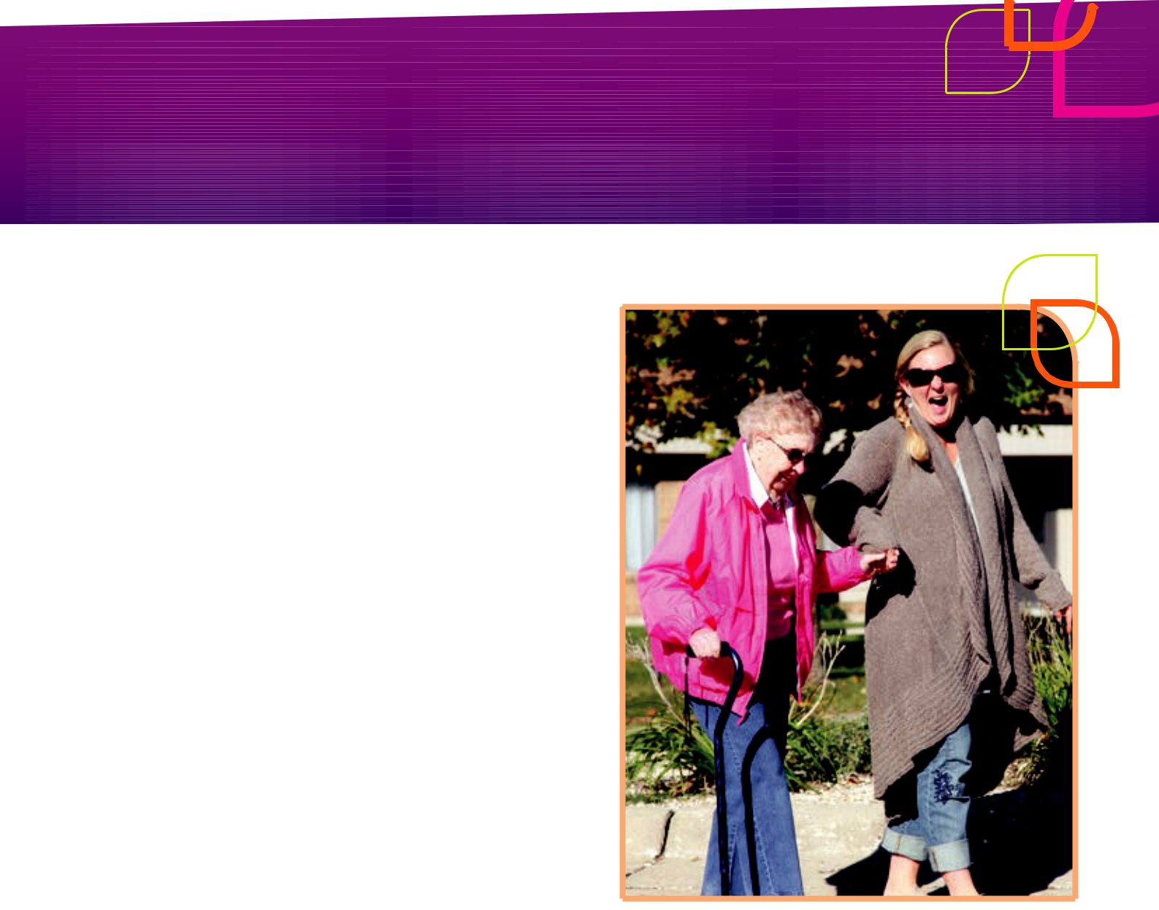

Pascale, K (2015). The Goal Directed Care Planning Toolkit: Practical strategies to support effective goal setting and care planning with HACC clients (2nd Ed). Eastern Metropolitan Region (EMR) HACC Alliance, Outer Eastern Health and Community Services Alliance, Melbourne, Vic.

Robertson, J., E. Emerson, C. Hatton, J. Elliot, R. Romeo, M. Knapp, H. Sanderson, M. Routledge, P. Oakes and T. Joyce (2010). The Impact of Person Centred Planning. United Kingdom, Institute for Health Research, Lancaster University.

Sanderson, H. (2000). Person Centred Planning: Key Features and Approaches. London, Helen Sanderson Associates (HSA)

Sanderson, H. and M. Smull (2010). Person centred thinking and planning. London, Helen Sanderson Associates (HSA)

WHO (2015a). WHO global strategy on people-centred and integrated health services. Geneva, World Health Organization (WHO)

19

This resource was developed by Kate Pascale and Associates Pty. Ltd. in collaboration with the Northern Metropolitan Melbourne and Western Metropolitan Melbourne Wellness and Reablement Consultants.

The development of this resource is supported by the Hume Whittlesea Primary Care Partnership (HWPCP). Sector Development Teams are funded by the Australian Government Department of Health. The material contained herein does not necessarily represent the views or policies of the Australian Government.

© Copyright Kate Pascale and Associates Pty. Ltd. June 2019

Hard copy and electronic materials may be reproduced for non-commercial, personal use only in accordance with the provisions of the Copyright Act 1968 (the Act). No part of this work may be reproduced or communicated for resale or commercial distribution.

