Putting
Person-Centred
Care into Practice
Supported by the Australian Government Department of Health. Although funding for these workshops has been provided by the Australian Government, the
material contained within does not necessarily represent the views or policies of the Australian Government.
Tools referenced in this resource were developed by Helen Sanderson Associates Australia based on previously developed work and resources. These include
person-centred concepts, principles and materials used from The Learning Community for Person Centred Practices (TLCPCP)
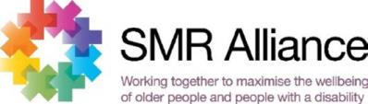

Putting Person-Centred
Care into Practice
Helen Sanderson Associates Australia (HSA) facilitated a six-part workshop series in March 2022 for
Social Support Group staﬀ and Home Care Coordinators in the Southern Metropolitan and Grampians
Regions of Victoria. The workshops provided an overview of how to work in a person-centred way
that focuses on, the importance of understanding the person, who they are, and what is important to
them.
This information has been compiled utilising the references and resources provided by HSA throughout
the workshop series.
This resource aims to:
•
•
Remind and reinforce participants of the learnings from the workshop series.
Increase the awareness, knowledge and understanding of person-centred care practice
and tools.
•
•
Support service providers to have conversations to understand each client’s story as well
as their needs and goals.
Provide practical strategies and techniques to apply new skills and knowledge, and embed
practice change.
PG 2
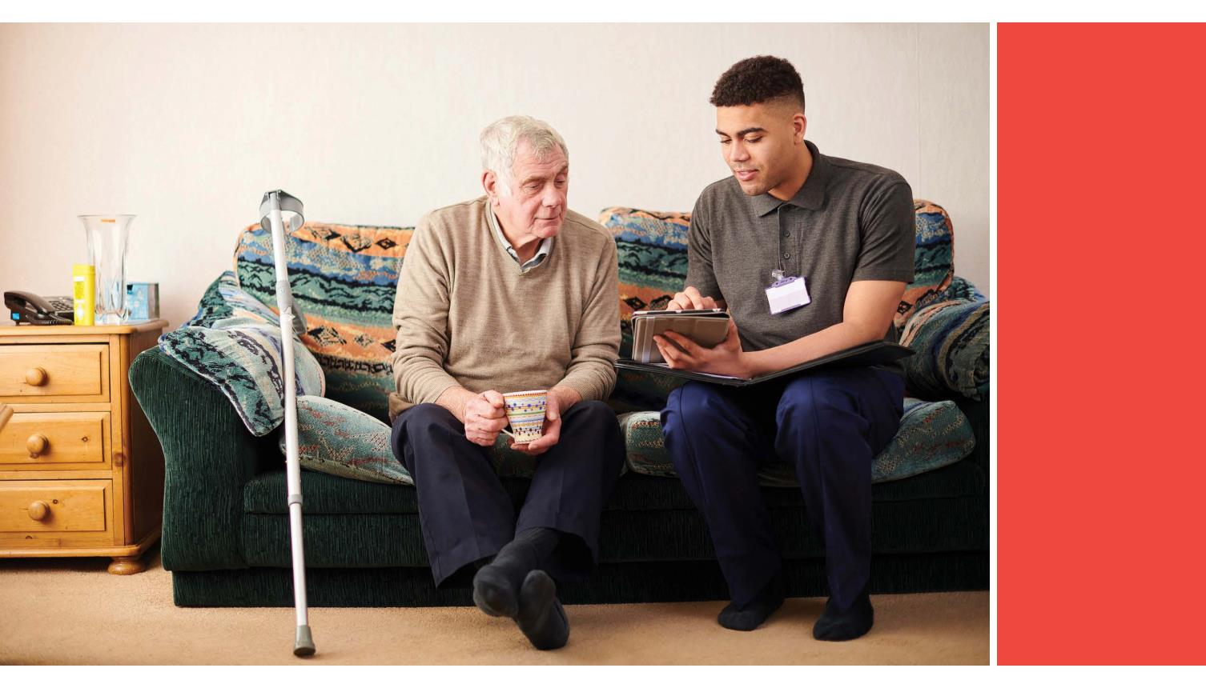

What are
Person-Centred Tools?
Person-centred tools are a set of easy-to-use templates that can be used to give structure to
conversations with clients. Using them provides a practical way to capture information that feeds into
care and support planning, as well as improving understanding, communication, and relationships.
(Person-Centred Thinking Tools | HSA | Consultancy | Training (helensandersonassociates.co.uk)
Introducing person-centred tools into practice does not need to be an overwhelming process or require
change to policies and procedures. Rather, it is about making small changes to guide conversations in
your person-centred practice to beneﬁt both clients’ and staﬀ experience and wellbeing.
It is important that each organisation has policies and processes regarding Client Service Speciﬁc
assessments. These person-centred tools will enhance the gathering of information to inform your
assessment and care planning, they do not replace your policies and processes.
Tips, Tools, and a framework that can help you
develop goals with your clients can be found here
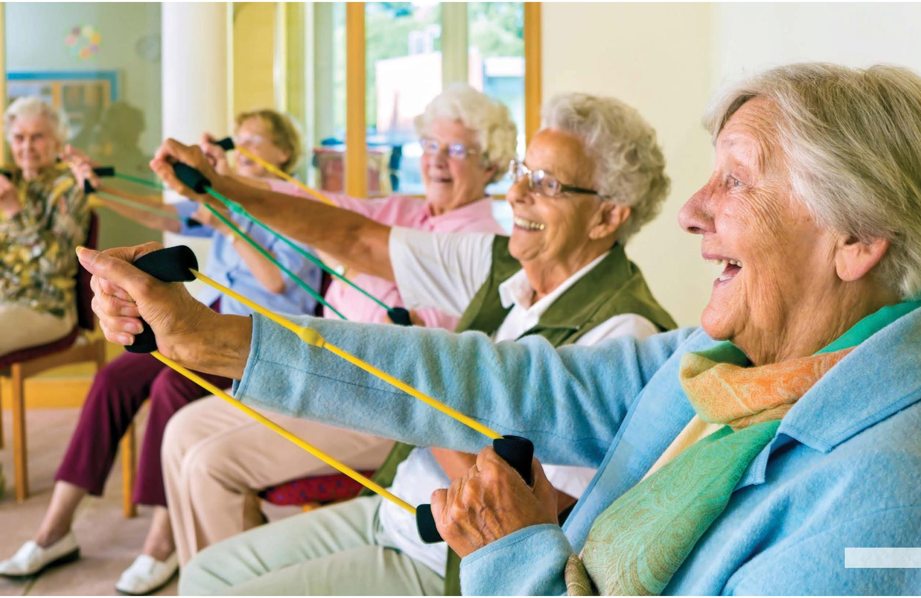

Aged Care Quality
Standards
The Aged Care Quality Standards (Quality Standards) focus on outcomes for clients. Organisations are
formally assessed and must be able to provide evidence of their compliance with, and performance
against, the Quality Standards.
Documenting your use of these tools will allow you to demonstrate that you are working in a person-
centred way, and particularly apply to Standards One, Two and Four.
See here for more information:
https://www.agedcarequality.gov.au/providers/standards
Understanding consumers (their identity,
culture, diversity, and level of cognitive
and functional ability) is central
to Standard 1 – Consumer dignity and
choice, along with ensuring consumers
are treated with dignity and respect.
Engaging consumers in their care
planning is the focus of Standard 2 –
Ongoing assessment and planning
with consumers. It is expected that
consumers will partner in ongoing
assessment and planning that helps
them to get the care and service they
need for their health and well-being.
The consumer gets the services and
supports for daily living that are important
for their health and well-being and that
enables them to do the things they
want to do is the focus for Standard 4 –
Services and supports for daily living.
PG 4
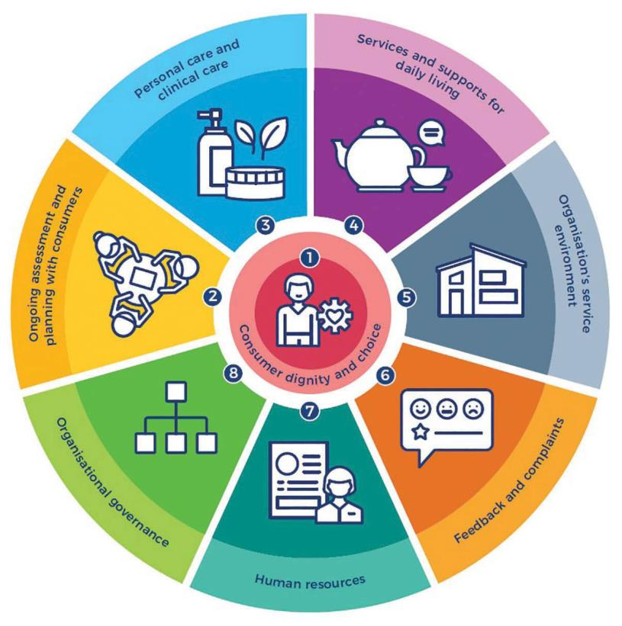

Person-Centred Tools
One Page Proﬁles support people by:
One Page
Proﬁles
•
Helping to build better relationships
by truly understanding what matters
to the person and how they want to
be supported to live their lives.
One Page Proﬁles provide an insight into who
people are as individuals; their qualities and
interests, the things that matter to them, and
how they can be supported. A one-page proﬁle
captures all the important information about a
person on a single sheet of paper under three
simple headings: What people appreciate
about me?, What’s important to me? and How
best to support me? The information collected
must be detailed, speciﬁc and purposeful to
the person reading it.
•
Providing a record that can
accompany the person as they may
work with diﬀerent staﬀ; transition
from service to service or use multiple
services.
•
•
•
Being regularly updated to reﬂect
people’s changing circumstances and
aspirations.
Assisting staﬀ to feel like they can
get to know the person they are
supporting.
Contributing to more person-centred
teams when used with staﬀ, where
individual strengths are recognised,
and diﬀerent ways of working are
considered.
One Page Proﬁles
One-page proﬁle and description
tips
PG 5
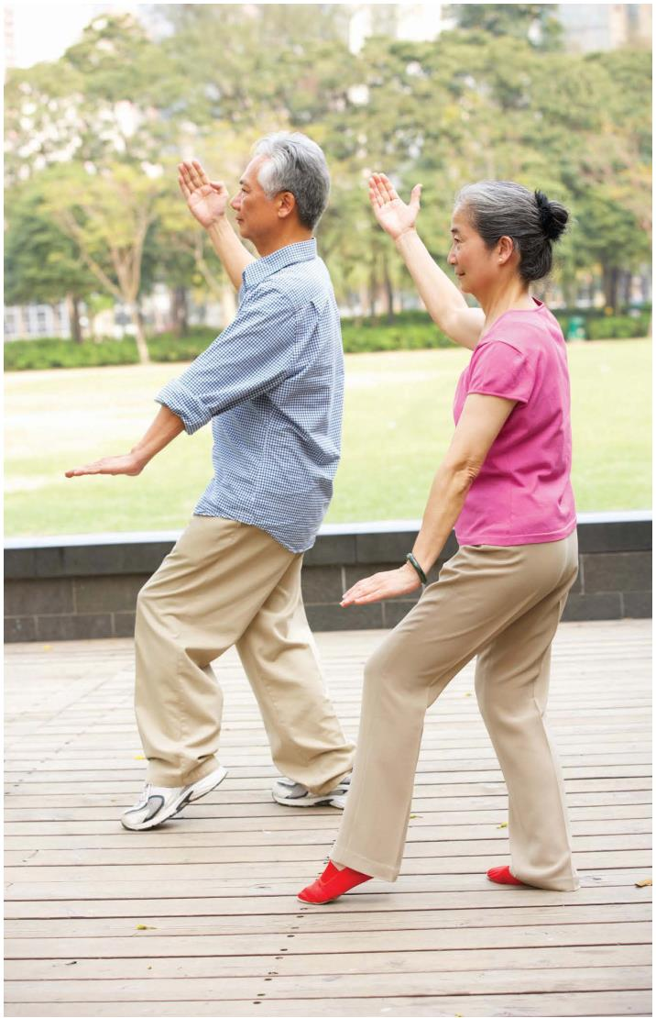

Important
to and
Important
for
Good Day/
Bad Day
The ‘Good Day / Bad Day’ tool is a way to
learn about what matters to someone and
what support they need to have good days and
avoid bad days.
The ‘Important to and Important for’ tool
identiﬁes what is important to someone
(what makes the person happy, content, and
increases well-being), from what is important
for them (the help or support they need to
stay healthy, safe, well and valued within the
community) while working towards a balance
between the two.
It is a simple list of what makes a good day
on one side of a page and what makes a bad
day on the opposite side. This is a way to start
or add to one-page proﬁles for clients, and to
decide on actions together. Once you have
worked through how best to support the person
to have more good days and less bad days, this
should be recorded in the care plan that is easily
visible for staﬀ working with the person.
Important to and Important for
instructions
Practice example to put into
practice of Important to and for
Tip
This tool can also be used with
colleagues to understand how to best
work together as a team.
Good day / Bad Day
Video explaining Good Day/Bad Day
PG 6

What’s
Using this tool can assist to identify:
Working? /
What’s not
Working?
•
•
•
what everyone agrees needs to stay
the same.
what everyone agrees needs to be
diﬀerent.
By exploring what is and isn’t working for
a person right at this moment, gives an
understanding of what needs to change and
what needs to stay the same. It’s a way of
working out what is important to a person and
how best to support them and supports the
More Good Days approach.
where there are disagreements
needing further discussion to reach
an agreed understanding or outcome.
You can use this to help the person and others
to review current goals or supports; and identify
speciﬁc life areas that they want to address.
Whats working/Whats not working
instructions
What’s working/not working
template
PG 7

Tip
4 + 1
When working in a group setting it is
important to hear everyone’s views.
Using ﬂipcharts and markers, or post-it
notes are useful so that everyone in the
room gets to provide input. Repeat this
process regularly so that it’s not a one oﬀ
exercise and people anticipate this and
can be prepared.
Questions
The 4 + 1 Questions tool can be used
with clients or staﬀ; individually or in group
situations. You could use this as a tool to
review activities in a social group setting.
The tool can help people to think about a
particular challenge or situation, and plan for
change. Where the 4 + 1 Questions tool is used
with more than one person, it groups together
learnings from diﬀerent perspectives.
4 + 1 Questions Guide
Video with examples of use 4+1
Questions
It can be used to update a One Page Proﬁle, or
to review a project or plan. It is a quick way to
work out better ways of supporting people or
working together.
4+1 Template
It asks:
1. What have you tried?
2. What have you learned?
3. What are you pleased about?
4. What are you concerned about?
+1 Based on what we’ve learned from the
4 questions...what should we do?
PG 8

Making the most of a
Learning Experience
Participating in a training program or learning experience is more than attending a workshop or
training day. For training to be eﬀective, staﬀ need to be supported to practice and apply new skills
and knowledge and establish new habits to embed practice change.
Regardless of which person-centred tools you decide to use, it is important to transfer these learnings
into practice so that awareness, knowledge, and understanding can be shared and utilised.
Here are some tips that can be used to support this transfer of learning into your own lived experience.
You do not need to use every tip, we suggest focusing on one or two that you are comfortable with.
For Managers and
•
•
Factor in time for staﬀ to explore and
practice learnings. This may require
adjusting their workload.
Supervisors
•
Allocate time to have conversations with
staﬀ, individually or in a group, and reﬂect
on the information covered in the sessions
(refer to PowerPoint presentations).
It is important to acknowledge that, for
many staﬀ, this represents a signiﬁcant
shift in thinking and will take time to embed
practice change.
•
•
Provide staﬀ with opportunities to practice
and role-play how they talk with clients and
their families/carers using the diﬀerent tools.
At an Individual
Practice Level
Lead a discussion about any barriers or
challenges using the tools. You could
utilise 4+1 Questions tool to guide the
discussion.
•
•
•
Talk to your manager /supervisor about how
to practice and apply your new skills and
knowledge.
Spend time practicing using the tools with
colleagues or family and friends so you feel
comfortable and familiar using them.
•
•
Make links to the person-centred tools
available on your organisation’s Intranet/
webpage and promote this to your staﬀ.
Ask a trusted colleague to provide feedback
on any observations they have made whilst
you are using them.
Proﬁle a diﬀerent person-centred tool as
part of your organisation’s regular internal
communication (eNews, staﬀ newsletter); or
at staﬀ meetings and training days.
•
•
Talk with your colleagues about how you
can apply your new skills to your work.
•
•
Include person-centred tools as part of your
intake and assessment quality processes.
Be prepared to try diﬀerent things,
accepting that some may not work.
Encourage staﬀ to share stories (verbal
or written) that demonstrate how they
are using or applying the principles and
approaches described in the Putting Person
Centred Care into Practice training or More
Good Days approach.
PG 9

Appendix
Session 1 Managers – Learning and Supervision
Session 2 All Staﬀ - Exploration of tools and resources
Session 3 All Staﬀ – Learning about the person
Session 4 All Staﬀ – Getting started with goals
Session 5 All Staﬀ – Implementing goals
PowerPoint presentations – not
to be reused in any publishing
or presentations
Session 6 Managers – Coaching staﬀ
Additional person-centred tool are available on the Helen Sanderson website
Five areas to explore that promote good wellbeing and
mental health 5 ways to wellbeing
5 Ways to Wellbeing
Connect, Be active, Take notice, Keep Learning and Give
https://5waystowellbeing.org.au/
The communication chart shares information on how
to communicate with a person around various situations
which may be confusing or upsetting. For example, how
Communication chart
to respond to a situation such as a question about ‘going
home’ or where a person is. By working out roughly
what age the person feels they can be responded to in a
supported way.
How to decide how to move forward with this regarding
your organisation.
Decision Making in
Implementation
Decision making in implementation
The most powerful social support groups are formed
by listening well to the participants who will attend
them, and ideally building the group alongside them.
Diﬀerent person-centred practices can help to make
this go well and feel more meaningful to everyone
involved.
From Individual learning to
group planning
https://docs.google.com/document/d/1QJZqDel2gO
FrxnrdeMHBH6gPLKF0N6WL/edit
PG 10

External Resources
https://www.agedcarequality.gov.au/providers/
standards
Aged Care Quality Standards
https://www.agedcarequality.gov.au/sites/default/
ﬁles/media/acqsc_working_with_aged_care_
consumers_-_resource.pdf
Organisation Self-assessment
tool
https://www.health.gov.au/resources/publications/
organisational-self-assessment-tool
Conversational tips – talking
with clients and their families
https://www.health.gov.au/sites/default/ﬁles/
documents/2021/01/conversational-tips.pdf
More Good Days Wellness
Wheel
https://www.health.gov.au/resources/publications/
more-good-days-wellness-wheel
Goal Directed Care Planning
Resources
https://kpassoc.com.au/resources/gdcp-resources/
https://drive.google.com/drive/
folders/12YXfnvpdiGIgkzZBB8IshZYE2VK9Uisr
Google drive with resources
PG 11

Putting
Person-Centred
Care into Practice

